Name ____________________________________________ **Unit 2 Sample Multiple Choice**

1) When the following equation is balanced the coefficient of water is: ____Ca + ____H2O → ____Ca(OH)2 + ____H2

A) 1 B) 2 C) 3 D) 4

2) When the following equation is balanced the coefficient of nitric acid is: ____N2O5 + ____H2O → ____HNO3

A) 1 B) 2 C) 3 D) 5

3) When the following equation is balanced the coefficient of water is: ____C4H8O2 + ____O2 →

A) 3 B) 4 C) 5 D) 6

4) If one knows the mole ratio of a reactant and product in a chemical reaction, one can

A) estimate the energy released in the reaction

B) calculate the speed of the reaction

C) calculate the mass of the product produced from a known mass of reactant

D) decide whether the reaction is reversible

5) Which of the following is NOT true about “yield”?

A) The value of the actual yield must be given in order for the percent yield to be calculated.

B) The actual yield may be different from the theoretical yield because insufficient limiting reactant was used.

C) The actual yield may be different from the theoretical yield because reactions do not always go to completion.

D) The percent yield is the ratio of the actual yield to the theoretical yield.

6) If equal masses of the following compounds undergo complete combustion, which will yield the greatest mass of CO2?

A) Benzene, C6H6 B) Cyclohexane, C6H12 C) Glucose, C6H12O6 D) Methane, CH4

7) A 23.0 g sample of a compound contains 12.0 g of C, 3.0 g of H, and 8.0 g of O.

Which of the following is the empirical formula of the compound?

A) CH3O B) C2H6O C) C3H9O2 D) C4H12O2

8) The diagram represents H2(*g*)and N2(*g*)in a closed container. Which of the following diagrams would represent the results if the reaction below were to proceed as far as possible?

N2(*g*) + 3 H2(*g*)  2 NH3(*g*)

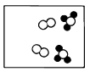

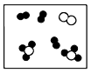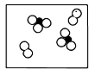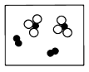 A) B) C) D)

9) Which of the following particulate diagrams best shows the formation of water vapor from hydrogen gas and oxygen gas in a rigid container at 125oC ?

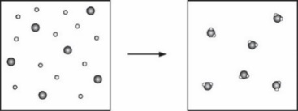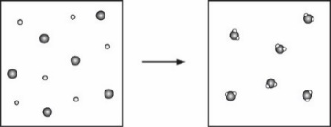

A) B)

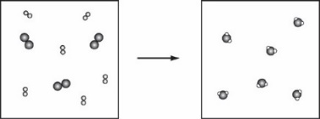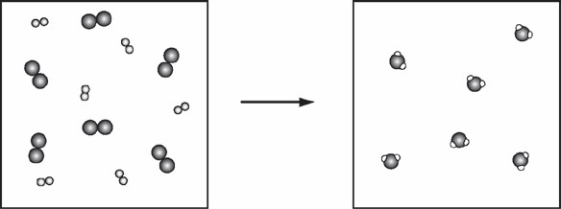 C) D)

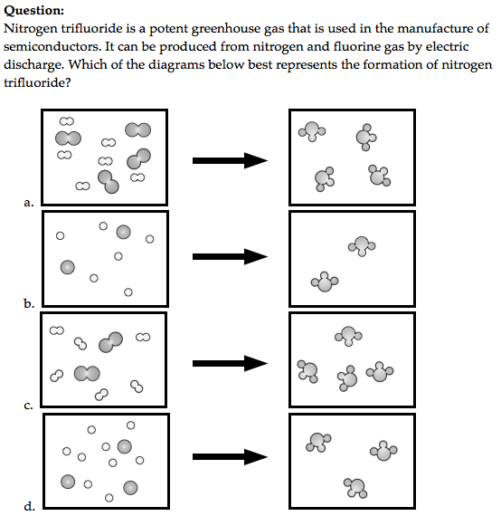10)

***Short Answer***

Solid potassium bicarbonate is used in “dry” chemical fire extinguishers. Use your knowledge of chemical reactions to briefly explain 2-3 ways in which it would suppress/extinguish a fire. *(2pts)*

11) A mixture of CO(*g*) and O2(*g*) is placed in a container, as shown below. A reaction occurs, forming CO2(*g*).Which of the following best represents the contents of the box after the reaction has proceeded as completely as possible?

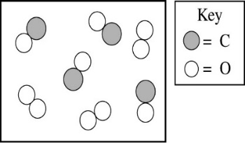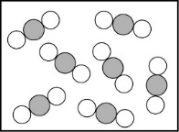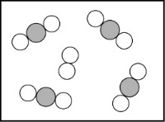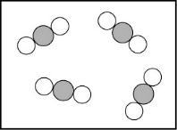 A) B) C) D)

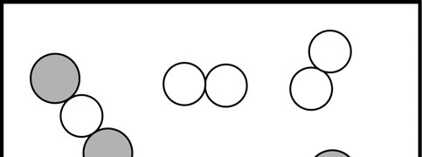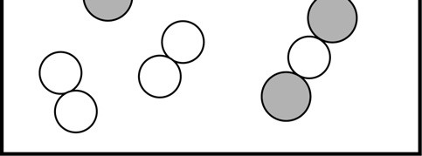

12) A sample of a solid labeled as NaCl may be impure. A student analyzes the sample and determines that it contains 75 percent chlorine by mass. Pure NaCl(*s*) contains 61 percent chlorine by mass.

Which of the following statements is consistent with the data?

A) The sample contains only NaCl(*s*). B) The sample contains NaCl(*s*) and NaI(*s*).

C) The sample contains NaCl(*s*) and KCl(*s*). D) The sample contains NaCl(*s*) and LiCl(*s*).

13) If a pure sample of an oxide of sulfur contains 40. percent sulfur and 60. percent oxygen by mass, then the empirical formula of the oxide is A) SO3 B) SO4 C) S2O6 D) S2O8