Name ________________________________________________

2 NaHCO3(*s*) → Na2CO3(*s*) + CO2(*g*) + H2O(*g*)

2) NaHCO3(*s*) (baking soda) decomposes upon heating to produce Na2CO3(*s*) and two gaseous products, as shown by

the equation above. practice exam 2016 2

a) A student claims that the reaction is an oxidation-reduction reaction because the oxidation number of carbon changes. Do you agree with the claim? In your answer include the oxidation number of carbon in each of the three carbon-containing species in the reaction. *(1pt)*

The student conducts an experiment to determine the composition of a mixture of NaHCO3 (molar mass 84.01 g/mol) and Na2CO3 (molar mass 105.99 g/mol). The student places a sample of the mixture into a preweighed test tube that is attached to a container that holds a drying agent. The student heats the test tube strongly with a Bunsen burner for 10 minutes, during which time all of the water produced by the reaction is captured by the drying agent. The following table shows the data the student recorded during the experiment.

|  |  |
| --- | --- |
| Mass of empty test tube | 15.825 g |
| Mass of test tube and mixture before heating | 17.648 g |
| Mass of drying agent before reaction | 2.134 g |
| Mass of drying agent and water after reaction | 2.303 g |

b) Calculate the number of moles of NaHCO3(*s*) present in the mixture in the test tube before the reaction was initiated. *(2pt)*

c) Determine the mass percent of NaHCO3(*s*) in the mixture. *(2pt)*

d) If the student spills some of the mixture out of the test tube after weighing the test tube and mixture and before heating, how would this error affect the mass percent of NaHCO3 calculated in part (c) ? Justify your answer. *(1pt)*

M + I2 → MI2

3) To determine the molar mass of an unknown metal, M, a student reacts iodine with an excess of the metal to form the water-soluble compound MI2, as represented by the equation above. The reaction proceeds until all of the I2 is consumed. The MI2(*aq*) solution is quantitatively collected and heated to remove the water, and the product is dried and weighed to constant mass. The experimental steps are represented below, followed by a data table. 2016 3

|  |  |
| --- | --- |
| Data for Unknown Metal Lab | |
| Mass of beaker | 125.457g |
| Mass of beaker + metal M | 126.549g |
| Mass of beaker + metal M + I2 | 127.570g |
| Mass of MI2, first weighing | 1.284g |
| Mass of MI2, second weighing | 1.284g |

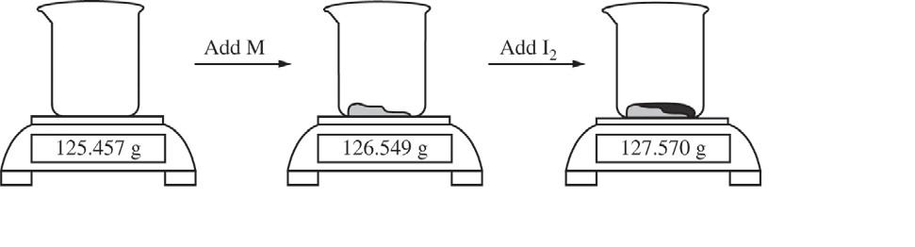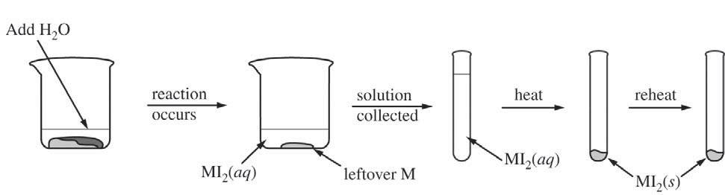

a) Given that the metal M is in excess, calculate the number of moles of I2 that reacted. *(1pt)*

b) Calculate the molar mass of the unknown metal M. *(1pt)*

The student hypothesizes that the compound formed in the synthesis reaction is ionic.

c) Propose an experimental test the student could perform that could be used to support the hypothesis.

Explain how the results of the test would support the hypothesis if the substance was ionic. *(2pts)*