**SAMPLE MULTIPLE CHOICE UNIT 3 Names ____________________________________________________**

1) A student performed an analysis to determine the amount of AgNO3(*aq*) in a solution. Excess NaCl(*aq*) was added to the solution, and the Ag+(*aq*) precipitated as AgCl(*s*). The precipitate was collected by gravity filtration and dried in an oven. Three trials were performed, and in each case, according to the instructor, the mass of precipitate recovered was 5 percent higher than the actual mass of AgCl(*s*) that should have formed. Which of the following could account for the error? AgNO3(*aq*) + NaCl(*aq*) → AgCl(*s*) + NaNO3(*aq*)

A) The pores in the filter paper were too large.

B) Not all of the precipitate was transferred to the filter paper.

C) The NaCl(*aq*) solution was too concentrated.

D) The precipitate was not rinsed with deionized water before drying.

2) When a student adds 30.0 mL of 1.00 *M* HCl to 0.56 g of powdered Fe, a reaction occurs according to the equation below. When the reaction is complete at 273 K and 1.0 atm, which of the following is true?

A) HCl is in excess, and 0.100 mol of HCl remains unreacted. Fe(*s*) + 2 HCl(*aq*) → FeCl2(*aq*) + H2(*g*)

B) HCl is in excess, and 0.020 mol of HCl remains unreacted.

C) 0.015 mol of FeCl2 has been produced.

D) 0.22 L of H2 has been produced.

3) A 0.30 mole sample of NaNO2 (s) and a 0.10 mole sample of Al(NO2)3 (s) are dissolved in water and diluted to 300mL.

What is the concentration of NO2−  in the solution?

A) 0.50M B) 2.0M C) 0.30M D) 1.0M

BaCl2(aq) + 2AgNO3(aq) → Ba(NO3)2(aq) + 2AgCl(s)

4) How many moles of AgCl are produced when 30.mL of 0.10M barium chloride is added to 20.mL of 0.20M silver nitrate?

A) 0.010 B) 0.0040 C) 0.0050 D) 0.0060

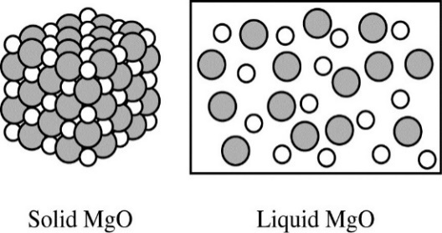5) Based on the diagram, which of the following best helps to explain why MgO(*s*) is not able to conduct electricity, but MgO(*l*) is a good conductor

of electricity?

A) MgO(*s*) does not contain free electrons, but MgO(*l*) contains free electrons that can flow.

B) MgO(*s*) contains no water, but MgO(*l*) contains water that can conduct electricity.

C) MgO(*s*) consists of separate Mg2+ ions and O2− ions, but MgO(*l*) contains MgO molecules that can conduct electricity.

D) MgO(*s*) consists of separate Mg2+ ions and O2− ions held in a fixed lattice, but in MgO(*l*) the ions are free to move and conduct electricity.

**Questions 6-8 refer to the following information.**  Cu(*s*) + 4 HNO3(*aq*) → Cu(NO3)2(*aq*) + 2 NO2(*g*) + 2 H2O(*l*)

Each student in a class placed a 2.00 g sample of a mixture of Cu and Al in a beaker and placed the beaker in a fume hood. The students slowly poured 15.0 mL of 15.8 *M* HNO3(*aq*) into their beakers. The reaction between the copper in the mixture and the HNO3(*aq*) is represented by the equation above. The students observed that a brown gas was released from the beakers and that the solutions turned blue, indicating the formation of Cu2+(*aq*).

The solutions were then diluted with distilled water to known volumes.

6) Which of the following is true about the reaction?

A) It is a Brønsted-Lowry acid-base reaction, because the solution is neutral at the end.

B) It is a Brønsted-Lowry acid-base reaction, because HNO3(*aq*) is a strong acid.

C) It is a redox reaction, because Cu(*s*) is oxidized and H+(*aq*) is reduced.

D) It is a redox reaction, because Cu(*s*) is oxidized and the nitrogen atom in NO3−(*aq*) is reduced.

|  |  |
| --- | --- |
| [Cu2+] | Absorbance |
| 0.025 | 0.059 |
| 0.050 | 0.235 |
| 0.100 | 0.117 |
| 0.200 | 0.468 |
| Unknown  (from sample of mixture) | 0.330 |

7) To determine the number of moles of Cu in the sample of the mixture, the students measured the absorbance of known concentrations of Cu(NO3)2(*aq*) using a spectrophotometer. A cuvette filled with some of the solution produced from the sample

of the mixture was also tested. The data recorded by one student are shown in the table. On the basis of the data provided, which of the following is a possible error that the student made?

A) The Cu(NO3)2(*aq*) from the sample of the mixture was not diluted properly.

B) The spectrophotometer was calibrated with tap water instead of distilled water.

C) The student labeled the cuvettes incorrectly, reversing the labels on two of the solutions of known concentration.

D) The spectrophotometer was originally set to an inappropriate wavelength, causing the absorbance to vary unpredictably.

8) The students determined that the reaction produced 0.010 mol of Cu(NO3)2 . Based on the measurement, what was the percent of Cu by mass in the original 2.00 g sample of the mixture?

A) 16% B) 32% C) 64% D) 96%

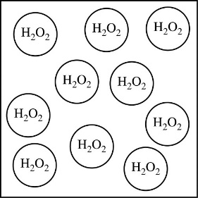

9) A particle view of a sample of H2O2(*aq*) is shown. The H2O2(*aq*) is titrated with KMnO4(*aq*), as represented by the equation below.

2 MnO4−(*aq*) + 5 H2O2(*aq*) + 6 H+(*aq*) → 2 Mn2+(*aq*) + 5 O2(*g*) + 8 H2O(*l*)

Which of the following particle views best represents the mixture when the titration is halfway to the equivalence point? (H2O molecules and H+ ions are not shown.)

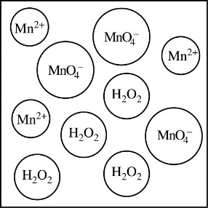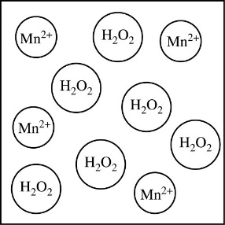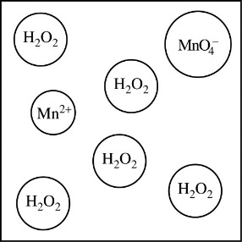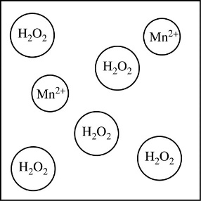 A) B) C) D)