[Video 1](https://www.youtube.com/watch?v=OSts9bfX6cA) (FF to 1:34) [Video 2](https://www.youtube.com/watch?v=P19YixuzuU0&t=118s)

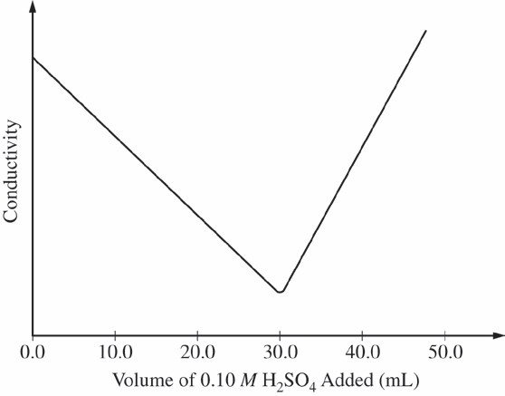

A student performs an experiment in which the conductivity of a solution of Ba(OH)2 is monitored as the solution is titrated with 0.10 *M* H2SO4. The

original volume of the Ba(OH)2 solution is 25.0 mL. A precipitate of BaSO4

(*Ksp* = 1.0 × 10−10) formed during the titration. The data collected from the experiment are plotted in the graph.

a) As the first 30.0 mL of 0.10 *M* H2SO4 are added to the Ba(OH)2 solution, two types of chemical reactions occur simultaneously. On the lines provided below, write the balanced net-ionic equations for (i) the neutralization reaction and (ii) the precipitation reaction. *(assume the reactions take place instantaneously)*

i) Equation for neutralization reaction: ___________________________________________________ *(1pt)*

ii) Equation for precipitation reaction: ____________________________________________________ *(1pt)*

b) The conductivity of the Ba(OH)2 solution decreases as the volume of added 0.10 *M* H2SO4 changes from

0.0 mL to 30.0 mL.

i) Identify the chemical species that enable the solution to conduct electricity as the first 30.0 mL of

0.10 *M* H2SO4 are added. *(1pt)*

ii) On the basis of the equations you wrote in part (a), explain why the conductivity decreases. *(1pt)*

c) Using the information in the graph, calculate the molarity of the original Ba(OH)2 solution. *(2pts)*

d) Explain why the conductivity of the solution begins to increase after the equivalence point. Identify the species that enable the solution to increase in conductivity. *(1pt)*