**Unit 3 Test Sample FRQs Name______________________________________________**

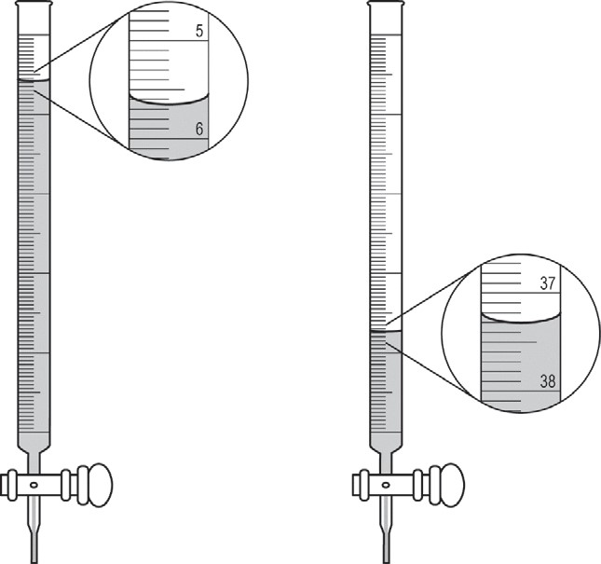A student is given a 25.0 mL sample of a solution of an unknown monoprotic acid and asked to determine the concentration of the acid by titration. The student uses a standardized solution of 0.110 *M* NaOH(*aq*), a buret, a flask, an appropriate indicator, and other laboratory equipment necessary for the titration. 2016 7

a) The images show the buret before the titration begins (left) and at the end point (right). What should the student record as the volume of NaOH(*aq*) delivered to the flask? *(1pt)*

b) Based on the given information and your answer to part (a), determine the value of the concentration of the acid that should be recorded in the student’s lab report. *(1pt)*

c) In a second trial, the student accidentally added more NaOH(*aq*) to the flask than was needed to reach the end point, and then recorded the final volume. Would this error increase, decrease, or have no effect on the calculated acid concentration for the second trial? Justify your answer. *(2pts)*

|  |  |  |  |
| --- | --- | --- | --- |
|  | Solution 1 | Solution 2 | Solution 3 |
| Solution 1 |  | black precipitate |  |
| Solution 2 |  |  | no reaction |
| Solution 3 |  |  |  |

Answer the following questions that relate to laboratory observations and procedures. 2005 #5c

c) Each of three beakers contains a 0.1 *M* solution of one of the following solutes: potassium chloride, silver nitrate, or sodium sulfide. The three beakers are labeled randomly as solution 1, solution 2, and solution 3. Shown here is a partially completed table of observations made of the results of combining small amounts of different pairs of the solutions.

(i) Write the chemical formula of the black precipitate. *(1pt)*

(ii) Describe the expected results of mixing solution 1 with solution 3. *(1pt)*

(iii) Identify each of the solutions 1, 2, and 3. *(1pt)*

A 75.0 mL sample of 0.250M MgCl2 is added to 225.0 mL of 0.0550M AgC2H3O2 solution. Answer the following questions about this reaction. (molar mass of silver chloride = 143.32 g/mol)

a) Write the net ionic equation for the reaction that occurs. *(2pts)*

b) Calculate the mass of the precipitate produced by this reaction. *(4pts)*

c) Determine the molarity of each ion present in *solution* at the end of the reaction.

i) Identify the ions in the solution at the end of the reaction *(1pt)*

ii) Find the molarity of each spectator ion first *(6pts)*

iii) One ion was not completely used in the reaction – find the “leftover” moles to determine its molarity *(6pts)*



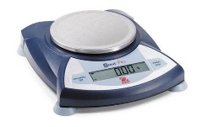

balance



An experiment is to be performed to determine the mass percent of sulfate in an unknown soluble sulfate salt. The

equipment shown above is available for the experiment. A drying oven is also available. 1997

a) Briefly list/describe the steps needed to carry out this experiment. (4pts)

b) List the experimental data to be collected to calculate the mass percent of sulfate in the unknown. (2pts)

c) List the calculations necessary to determine the mass percent of sulfate in the unknown. (3pts)

d) Would 0.20-molar MgCl2 be an acceptable substitute for the BaCl2 solution provided for this experiment? Explain. (1pt)

A student is instructed to determine the concentration of a solution of CoCl2 based on absorption of light (spectrometric/colorimetric method). The student is provided with a 0.10 *M* solution of CoCl2 with which to prepare standard solutions with concentrations of 0.020 *M*, 0.040 *M*, 0.060 *M*, and 0.080 *M.* **2003 #5**

a) Describe the procedure for diluting the 0.10 *M* solution to a concentration of 0.020 *M* using distilled water, a 100 mL volumetric flask, and a pipet or buret. Include specific amounts where appropriate.

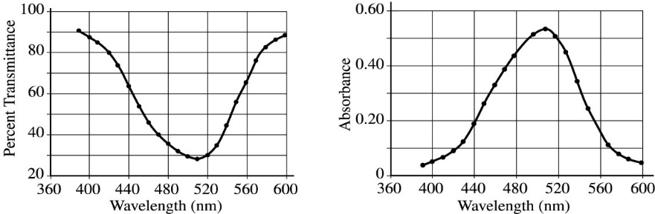The student takes the 0.10 *M* solution and determines the percent transmittance and the absorbance at various wavelengths. The two graphs represent the data.

b) Identify the optimum wavelength for the analysis.

_____________

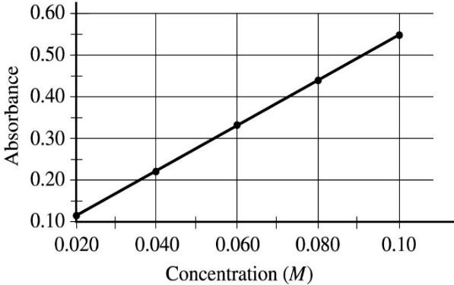

The student measures the absorbance of the 0.020 *M*, 0.040 *M*, 0.060 *M*, 0.080 *M*, and 0.10 *M* solutions. The data are plotted in the graph.

c) The absorbance of the unknown solution is 0.275.

What is the concentration of the solution?

______________

d) Beer’s Law is an expression that includes three factors that determine the amount of light that passes through a solution. Identify two of these factors.

e) The student handles the sample container (e.g., test tube or cuvette) that holds the unknown solution and leaves fingerprints in the path of the light beam. How will this affect the calculated concentration of the unknown?

Explain your answer.

f) Why is this method of determining the concentration of CoCl2 solution appropriate, whereas using the same method for measuring the concentration of NaCl solution would not be appropriate?

A 0.2726g sample of an unknown metal “X” was reacted with 50.00mL of 0.5000M HCl. After all the metal had reacted, the left-over acid was titrated with 0.1054M Ba(OH)2. If 12.18 mL of 0.1054M Ba(OH)2 was required to neutralize the leftover acid, determine the identity of the metal. The metal forms the X2+ ion upon reaction with HCl. *(12pts)*

a) write net ionic equation for the titration reaction

b) determine moles HCl leftover

c) find moles of HCl originally available

d) find moles of HCl used

e) write equation for reaction of metal “X” with HCl

f) determine molar mass of “X”

In a laboratory class, a student is given three flasks that are labeled *Q*, *R*, and *S*. Each flask contains one of the following solutions: 1.0 *M* Pb(NO3)2 , 1.0 *M* NaCl, or 1.0 *M* K2CO3 . The student is also given two flasks that are labeled *X* and *Y*. One of these flasks contains 1.0 *M* AgNO3, and the other contains 1.0 *M* BaCl2. This information is summarized in the diagram below. 2004 #5

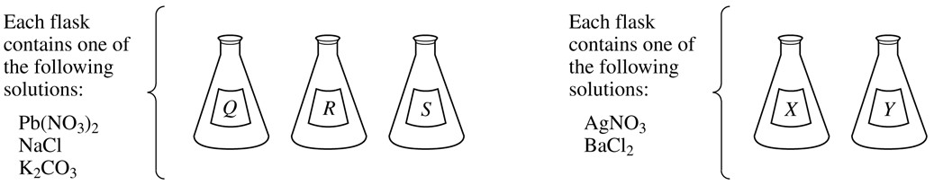

a) When the student combined a sample of solution *Q* with a sample of solution *X*, a precipitate formed. A precipitate also formed when samples of solutions *Q* and *Y* were combined.

(i) Identify solution *Q. (1pt)*

(ii) Write the chemical formulas for each of the two precipitates. *(1pt)*

b) When solution *Q* is mixed with solution *R*, a precipitate forms. However, no precipitate forms when solution *Q* is mixed with solution *S*.

(i) Identify solution *R* and solution *S*. *(1pt)*

(ii) Write the chemical formula of the precipitate that forms when solution *Q* is mixed with solution *R*. *(1pt)*

c) The identity of solution *X* and solution *Y* are to be determined using only the following solutions: 1.0 *M* Pb(NO3)2 , 1.0 *M* NaCl, and 1.0 *M* K2CO3 .

(i) Describe a procedure to identify solution *X* and solution *Y*. *(1pt)*

(ii) Describe the observations that would allow you to distinguish between solution *X* and solution *Y*. *(1pt)*

(iii) Explain how the observations would enable you to distinguish between solution *X* and solution *Y*. *(1pt)*

|  |  |  |  |
| --- | --- | --- | --- |
| Compound | pH of an Aqueous  Solution of the  Compound | Result of Adding  1.0 *M* NaOH to a  Solution of the  Compound | Result of Adding  1.0 *M* HCl Dropwise to the Solid Compound |
| *X* | > 7 | No observed reaction | Evolution of a gas |
| *Y* | 7 | No observed reaction | No observed reaction |
| *Z* | 7 | Forms white precipitate | No observed reaction |

Three pure, solid compounds labeled *X*, *Y*, and *Z* are placed on a lab bench with the objective of identifying each one. It is known that the compounds (listed in random order) are KCl , Na2CO3 , and MgSO4 . A student performs several tests on the compounds; the results are summarized in the table below. 2006 #5

a) Identify each compound based on the observations Compound *X* ______________________

recorded in the table. *(2pts)*

Compound *Y* ______________________

Compound *Z* ______________________

b) Write the chemical formula for the precipitate produced when 1.0 *M* NaOH is added to a solution of compound *Z*. *(2pts)*

c) Explain why an aqueous solution of compound *X* has a pH value greater than 7.

Write an equation as part of your explanation. *(2pts)*

d) One of the testing solutions used was 1.0 *M* NaOH. Describe the steps for preparing 100. mL of 1.0 *M* NaOH from a stock solution of 3.0 *M* NaOH using a 50 mL buret, a 100 mL volumetric flask, distilled water, and a small dropper.

*(2pts)*

e) Describe a simple laboratory test that you could use to distinguish between Na2CO3(*s*) and CaCO3(*s*).

In your description, specify how the results of the test would enable you to determine which compound was Na2CO3(*s*) and which compound was CaCO3(*s*). *(2pts)*

A 0.150 g sample of solid lead(II) nitrate is added to 125 mL of 0.100 *M* sodium iodide solution. Assume no change in volume of the solution. The chemical reaction that takes place is represented by the following equation. 2008B 3

Pb(NO3)2(*s*) + 2 NaI(*aq*) → PbI2(*s*) + 2 NaNO3(*aq*)

a) List an appropriate observation that provides evidence of a chemical reaction between the two compounds. *(1pt)*

b) Calculate the number of moles of each reactant. *(2pts)*

c) Identify the limiting reactant. Show calculations to support your identification. *(2pts)*

d) Calculate the molar concentration of NO3−(*aq*) in the mixture after the reaction is complete. *(2pts)*

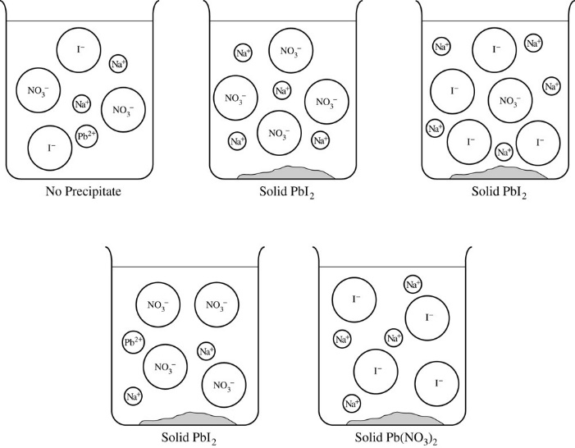 e) Circle the diagram that best represents the results after the mixture reacts as completely as possible.

Explain the reasoning used in making your choice. *(2pts)*

2 Al(*s*) + 2 KOH(*aq*) + 4 H2SO4(*aq*) + 22 H2O(*l*) → 2 KAl(SO4)2 ∙2H2O(*s*) + 3 H2(*g*)

In an experiment, a student synthesizes alum, KAl(SO4)2 ∙12H2O(*s*), by reacting aluminum metal with potassium hydroxide and sulfuric acid, as represented in the balanced equation above. 2005B 5

a) In order to synthesize alum, the student must prepare a 5.0 *M* solution of sulfuric acid. Describe the procedure for preparing 50.0 mL of 5.0 *M* H2SO4 using any of the chemicals and equipment listed below.

Indicate specific amounts and equipment where appropriate. *(4pts)*

10.0 *M* H2SO4 50.0 mL volumetric flask Distilled water 50.0 mL buret

100 mL graduated cylinder 25.0 mL pipet 100 mL beaker 50 mL beaker

b) Calculate the minimum volume of 5.0 *M* H2SO4 that the student must use to react completely with 2.7 g of aluminum metal. *(3pts)*

c) As the reaction solution cools, alum crystals precipitate. The student filters the mixture and dries the crystals, then measures their mass.

i) If the student weighs the crystals before they are completely dry, would the calculated percent yield be greater than, less than, or equal to the actual percent yield? Explain. *(1pt)*

ii) Cooling the reaction solution in an ice bath improves the percent yield obtained. Explain. *(1pt)*

d) The student heats crystals of pure alum, KAl(SO4)2 ∙12H2O(*s*), in an open crucible to a constant mass. The mass of the sample after heating is less than the mass before heating. Explain. *(1pt)*

NaHCO3(*s*) + HC2H3O2(*aq*) → NaC2H3O2(*aq*) + H2O(*l*) + CO2(*g*) 2016 FRQ#2

2) A student designs an experiment to study the reaction between NaHCO3 and HC2H3O2. The reaction is represented by the equation above. The student places 2.24 g of NaHCO3 in a flask and adds 60.0 mL of 0.875 *M* HC2H3O2. The student observes the formation of bubbles and that the flask gets cooler as the reaction proceeds.

a) Identify the reaction represented above as an acid-base reaction, precipitation reaction, or redox reaction. Justify your answer. *(2pts)*

b) Based on the information above, identify the limiting reactant. Justify your answer with calculations. *(2pts)*

2 NaHCO3(*s*) → Na2CO3(*s*) + CO2(*g*) + H2O(*g*) 2016 Practice #2

2) NaHCO3(*s*) (baking soda) decomposes upon heating to produce Na2CO3(*s*) and two gaseous products, as shown by the equation above.

a) A student claims that the reaction is an oxidation-reduction reaction because the oxidation number of carbon changes. Do you agree with the claim? In your answer include the oxidation number of carbon in each of the three carbon-containing species in the reaction. *(1 pt)*