Unit 4 Practice FRQs Name_______________________________

Sodium chlorate decomposes when heated producing oxygen gas. An impure sample of sodium chlorate with a mass of 0.2765g was heated until no more oxygen was produced. A total of 57.20 mL of oxygen was collected over water at a temperature of 22oC at an atmospheric pressure of 0.9558atm. The vapor pressure of water at 22oC is 19.8mmHg. Note: the impurity is sodium chloride which does not decompose when heated.

a) Write a balanced equation for the reaction that occurs.

b) Calculate the mass percent of sodium chlorate in the original sample.

A sealed balloon is filled with 1.00L of helium at 23oC and 745mmHg. The balloon rises to a point in the atmosphere where the pressure is 225mmHg and the temperature is -31oC.

a) What will be the new volume of the balloon? *(2pts)*

b) Explain how the changes in temperature and pressure affected the volume of the balloon. Which change was more influential? Explain how you know. *(2pts)*

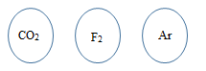

These circles represent three identical balloons, each filled with the pure gas indicated, to the same volume at 25oC and 1.00atm.

a) Which balloon contains the greatest mass of gas? Explain how you know. *(1-2pts)*

b) Twelve hours after being filled, all balloons have decreased in size. Predict which balloon would be the smallest.

Explain your reasoning. *(1-2pts)*

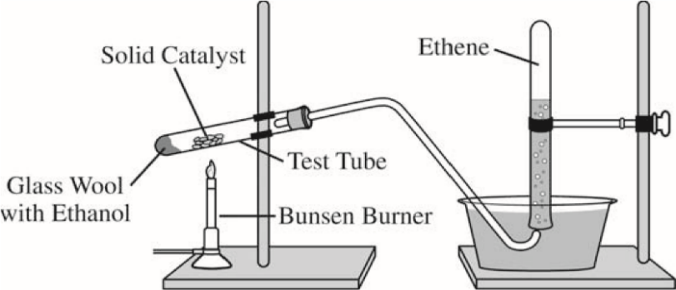Ethene, C2H4(*g*) (molar mass 28.1 g/mol), may be prepared by the dehydration of ethanol, C2H5OH(*g*) (molar mass 46.1 g/mol), using a solid catalyst. A setup for the lab synthesis is shown in the diagram. 2015 FRQ 2

The equation for the dehydration reaction is given below.

C2H5OH(*g*) --catalyst→ C2H4(*g*) + H2O(*g*)  *ethanol* *ethene* *water*

A student added a 0.200 g sample of C2H5OH(*l*) to a test tube using the setup shown above. The student heated the test tube gently with a Bunsen burner until all of the C2H5OH(*l*) evaporated and gas generation stopped. When the reaction stopped, the volume of collected gas was 0.0854 L at 0.822 atm and 305 K.

(The vapor pressure of water at 305 K is 35.7 torr.)

a) Calculate the number of moles of C2H4(*g*)

(i) that are actually produced in the experiment and measured in the gas collection tube and *(2-4pts)*

(ii) that would be produced if the dehydration reaction went to completion. *(1-2pts)*

b) Calculate the percent yield of C2H4(*g*) in the experiment. *(1-2pts)*

A sample of a pure, gaseous hydrocarbon is introduced into a previously evacuated rigid 1.00 L vessel.

The pressure of the gas is 0.200 atm at a temperature of 127°C. 2012 2

a) Calculate the number of moles of the hydrocarbon in the vessel. *(2pts)*

b) O2(*g*) is introduced into the same vessel containing the hydrocarbon. After the addition of the O2(*g*), the total pressure of the gas mixture in the vessel is 1.40 atm at 127°C. Calculate the partial pressure of O2(*g*) in the vessel.

*(1pt)*

*The mixture of the hydrocarbon and oxygen is sparked so that a complete combustion reaction occurs, producing CO2(g) and H2O(g). The partial pressures of these gases at 127°C are 0.600 atm for CO2(g) and 0.800 atm for H2O(g).*

*There is O2(g) remaining in the container after the reaction is complete.*

c) Use the partial pressures of CO2(*g*) and H2O(*g*) to calculate the partial pressure of the O2(*g*) consumed in the combustion. *(2-4pts)*

d) On the basis of your answers above, write the balanced chemical equation for the combustion reaction and determine the formula of the hydrocarbon. *(2-3pts)*

e) Calculate the mass of the hydrocarbon that was combusted. *(2pts)*

f) As the vessel cools to room temperature, droplets of liquid water form on the inside walls of the container. Predict whether the pH of the water in the vessel is less than 7, equal to 7, or greater than 7. Explain your prediction. *(1pt)*

Answer the following questions related to hydrocarbons. 2004B FRQ2

a) Determine the empirical formula of a hydrocarbon that contains 85.7 percent carbon by mass. *(3pts)*

b) The density of the hydrocarbon in part (a) is 2.0 g L–1 at 50°C and 0.948 atm.

i) Calculate the molar mass of the hydrocarbon. *(2-3pts)*

ii) Determine the molecular formula of the hydrocarbon. *(1pt)*

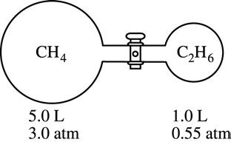

c) Two flasks are connected by a stopcock as shown. The 5.0 L flask contains CH4 at a pressure of 3.0 atm, and the 1.0 L flask contains C2H6 at a pressure of 0.55 atm. Calculate the total pressure of the system after the stopcock is opened. Assume that the temperature remains constant. *(2-3pts)*

d) Octane, C8H18(*l*), has a density of 0.703 g mL–1 at 20°C. A 255 mL sample of C8H18(*l*) measured at 20°C reacts completely with excess oxygen as represented by the equation below.

2 C8H18(*l*) + 25 O2(*g*) → 16 CO2(*g*) + 18 H2O(*g*)

Calculate the total number of moles of gaseous products formed. *(2-3pts)*