**Practice Multiple Choice Unit 4 Gases Name(s) _____________________________________________________**

1) When a sample of oxygen gas in a closed container of constant volume is heated until its absolute temperature is double, Which of the following is also doubled?

A) The density of the gas. B) The pressure of the gas.

C) The average velocity of the gas. D) The potential energy of the gas.

2) When the actual gas volume is greater than the volume predicted by the ideal gas law, the explanation lies in the fact that the ideal gas law does NOT include a factor for molecular…

A) volume B) mass C) velocity D) attractions E) shape

3) Which of the following gases deviates most from ideal behavior?

A) SO2 B) Ne C) CH4 D) N2

4) A hot-air balloon starts to rise. Which of the following is the best explanation for this observation?

A) The pressure on the walls of the balloon increases with increasing temperature.

B) The difference in temperature between the air inside and outside the balloon produces convection currents.

C) The cooler air outside the balloon pushes in on the walls of the balloon.

D) The rate of diffusion of cooler air is less than that of warmer air.

E) The air density inside the balloon is less than that of the surrounding air.

5) A rigid metal tank contains oxygen gas. Which of the following applies to the gas in the tank when additional oxygen is added at constant temperature?

A) The volume of the gas increases. B) The average distance between the gas molecules increases.

C) The average speed of the gas molecules remains the same.D) The pressure of the gas decreases.

6) A 0.02 mol sample of NH4NO3(s) decomposes completely according to the balanced equation below. The total pressure in the flask measured at 400 K is closest to which of the following? NH4NO3(s) → N2O(g) + 2 H2O(g)

A) 2 atm B) 1 atm C) 0.5 atm D) 0.1 atm *(Container volume = 1L)*

7) Equal numbers of moles of He(g), Ar(g), and Ne(g) are placed in a glass vessel at room temperature. If the vessel has a pinhole-sized leak, which of the following will be true regarding the relative values of the partial pressures of the gases remaining in the vessel after some of the gas mixture has effused?

A)PAr < PNe < PHeB) PHe < PAr < PNe C) PNe < PAr < PHe D) PHe < PNe < PAr

8) Samples of F2 gas and Xe gas are mixed in a container of fixed volume. The initial partial pressure of the F2 gas is 8.0atm and that of the Xe gas is 1.7atm. When all of the Xe gas reacted, forming a solid compound, the pressure of the unreacted F2 gas was 4.6atm. The temperature remained constant. What is the formula of the compound?

A) XeF B) XeF3 C) XeF4 D) XeF6

9) A sample of an ideal gas is cooled from 50.0 °C to 25.0 °C in a sealed I. The average molecular mass of the gas

container of constant volume. Which of the following values for the II. The average distance between the molecules  
 gas will decrease? III. The average speed of the molecules

A) I only B) II only C) III onlyD) II and III

*Questions 10-13 refer to the following gases at 0°C and 1 atm.* A) Ne B) O2 C) CO D) NO

10) Has an average atomic or molecular speed closest to that of N2 molecules at 0°C and 1 atm.

11) Has the greatest density.

12) Has the greatest rate of effusion through a pinhole.

13) A flask contains 0.25 mole of SO2(g), 0.50 mole of CH4(g), and 0.50 mole of O2(g). The total pressure of the gases in the flask is 800 mmHg. What is the partial pressure of the SO2(g) in the flask?

A) 600 mmHg B) 250 mmHg C) 200 mmHg D) 160mmHg

14) A 20 L container will hold about 20 g of which of the following gases at 500K and 1 atm?

A) NOB) Ne C) COD) Ar

15) The ideal gas law best describes the properties of which of the following gases at 0°C and 1 atm?

A) PH3  B) HBr C) SO2 D) N2

16) When 4.0 L of He(*g*), 6.0 L of N2(*g*), and 10. L of Ar(*g*), all at 0°C and 1.0 atm, are pumped into an evacuated 8.0 L rigid container, the final pressure in the container at 0°C is A) 0.5 atm B) 1.0 atm C) 2.5 atm D) 4.0 atm

17) The distribution of speeds of N2(*g*) molecules at 273 K and 1 atm is shown in the diagram. Which of the following best shows the speed distribution of Ne(*g*) atoms under the same conditions of temperature and pressure?

N2 ─── Ne -------

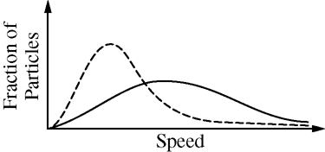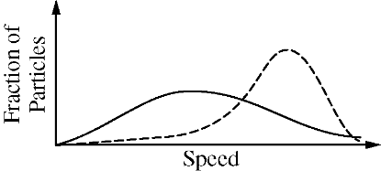 A) B)

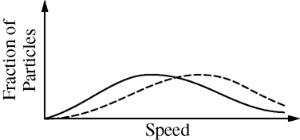

C) D)