**Thermochemistry Practice Multiple Choice**

1) Which of the following describes the pathway of reaction that is endothermic and has high activation energy?

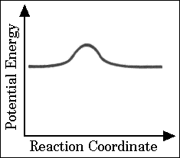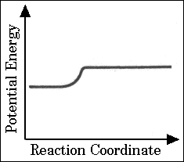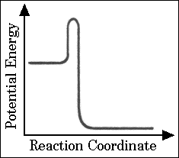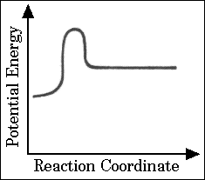 A) B) C) D)

2) Based on the information in the table, what is the standard enthalpy

change for the following reaction: Na2O(s) + H2O(*l*) → 2 NaOH(s)

|  |  |
| --- | --- |
| H2(g) + ½ O2(g) → H2O(*l*) | ∆H° = x |
| 2 Na(s) + ½ O2(g) → Na2O(s) | ∆H° = y |
| Na(s) + ½ O2(g) + ½ H2(g) → NaOH(s) | ∆H° = z |

A) x + y + z B) x + y − z C) x + y − 2z D) 2z − x −y

Questions 3-4 refer to an experiment to determine the heat of fusion of ice. A student used a calorimeter consisting of a styrofoam cup and a thermometer. The cup was weighed, then filled halfway with warm water, then weighed again. The temperature of the water was measured, and some ice cubes from a 0oC ice bath were added to the cup. The mixture was gently stirred as the ice melted, and the lowest temperature reached by the water in the cup was recorded. The cup and its contents were weighed again.

3) The purpose of weighing the cup and its contents again at the end of the experiment was to

A) determine the mass of ice that was added B) determine the mass of thermometer

C) verify the mass of water that was cooled D) verify the mass of the calorimeter cup

4) Suppose that during the experiment, a significant amount of water from the ice bath adhered to the ice cubes.

How does this affect the calculated value for the heat of fusion of ice?

A) The calculated value is too large because less warm water had to be cooled.

B) The calculated value is too small because the amount of ice added was actually less than calculated.

C) The calculated value is too small because the total mass of the calorimeter contents was too large.

D) There is no effect on the calculated value.

5) Which equation represents the heat of formation, ΔHof, for MgCl2?

A) Mg2+ (aq) + 2 Cl– (aq) → MgCl2(s) B) Mg(s) + 2 Cl(g) → MgCl2(s)

C) MgCl2(s) → Mg2+ (aq) + 2 Cl– (aq) D) Mg(s) + Cl2(g) → MgCl2(s)

6) How much heat is required to convert solid sulfur to ΔH° (kJ/mol)

gaseous sulfur at 298 K and 1 atm pressure? S(s) + O2(g) → SO2(g) –300

A) –875 kJ/mol B) +275 kJ/mol S(g) + O2(g) → SO2(g) –575

C) –275 kJ/mol D) +875 kJ/mol

|  |  |
| --- | --- |
|  | Δ Hof (kJ/mol) |
| H2O (*l*) | -300 |
| CO2 (g) | -400 |
| C3H8 (g) | -100 |

7) Using the ΔHof values given, calculate the ΔH combustion for propane, C3H8.

A) -800 kJ/mol B) -2300 kJ/mol

C) -600 kJ/mol D) +2300 kJ/mol

8) The heat of vaporization of methane, CH4, at its boiling point is 9 kJ/mol. How much heat energy is required to vaporize 64 g of methane at its boiling point?

A) 576 kJ B) 18 kJ C) 36 kJ D) 2.3 kJ

9) If ΔH for a reaction is positive, …

A) the reaction rate is generally very fast.

B) the enthalpy change of the reverse reaction is positive.

C) the enthalpy of the products is greater than the enthalpy of the reactants.

D) the energy released during bond formation is greater than the energy absorbed during bonding breaking for the reaction.

10) A chemical reaction that absorbs heat from the surroundings is _________________ and has a ________________ΔH at constant pressure.

A) endothermic; negative B) exothermic; negative C) endothermic; positive D) exothermic; positive

11) For an exothermic reaction, the energy of the system is ___________ and the energy of the surroundings is ________.

A) increased; decreased B) decreased; decreased C) decreased; increased D) increased; increased

12) When 5.0 g of NH4ClO4(*s*) is added to 100. mL of water in a calorimeter, the temperature of the solution formed decreases by 3.0°C. If 5.0 g of NH4ClO4(*s*) is added to 1000. mL of water in a calorimeter initially at 25.0°C, the final temperature of the solution will be approximately A) 22.0°C B) 24.7°C C) 25.3°C D) 28.0°C

13) Based on the following information, which compound has the strongest intermolecular forces?

***Substance ΔHvap (kJ/mol)***

Argon (Ar) 6.3 A) Argon

Benzene (C6H6) 31.0 B) Benzene

Ethanol (C2H5OH) 9.3 C) Ethanol

Water (H2O) 40.8 D) Water

14) For which one of the following equations is ΔHorxn equal to ΔHfo for the product?

A) 2C(graphite) + 2H2(g) → C2H4(g) C) N2(g) + O3(g) → N2O3(g) E) C(diamond) + O2(g) → CO2(g)

B) 2H2(g) +O2(g) → 2H2O(l) D) 2CO(g) +O2(g) → 2CO2(g)

15) For the reaction A → B; ∆H = -10.0 kcal/mole For the reaction B → C; + 20 kcal/mole

Rank the enthalpy of A, B, and C in order of increasing enthalpy.

A) B, A, C B) C, A, B C) A, B, C D) B, C, A

16) In an experiment a student mixes a 50.0 mL sample of 0.100 *M* AgNO3(*aq*) with a 50.0 mL sample of 0.100 *M* NaCl(*aq*) at 20.0°C in a coffee-cup calorimeter. Which of the following is the enthalpy change of the precipitation reaction if the final temperature of the mixture is 21.0°C? (Assume that the total mass of the mixture is 100. g and that the specific heat capacity of the mixture is 4.2 J/(g °C).) AgNO3(*aq*) + NaCl(*aq*) → AgCl(*s*) + NaNO3(*aq*)

A) −84 kJ/mol*rxn*  B) −0.42 kJ/mol*rxn*  C) 0.42 kJ/mol*rxn*  D) 84 kJ/mol*rxn*