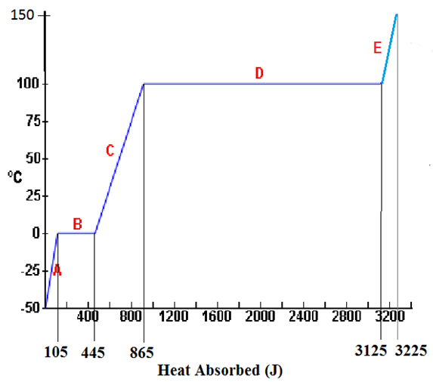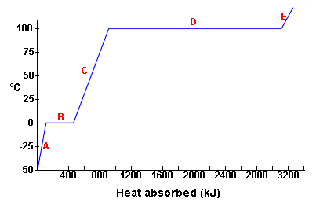

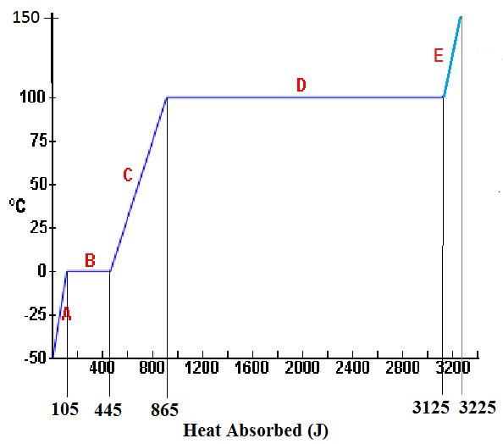

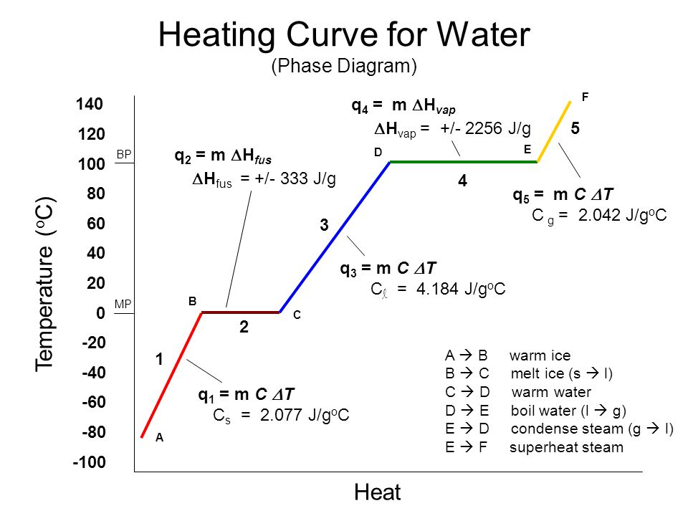**d from right to left, it is a Cooling Curve.**

The diagram below illustrates the steps involved to convert 10 g of solid ice at -20°C to 10 g of gaseous steam at 140°C.



A-B

B-C

C-D

D-E

E-F

H2O(s) at -20°C H2O(s) at 0 °C H2O(l) at 0°C H2O(l) at 100°C H2O(g) at 100°C H2O(g) at 140°C

10 g 10 g 10 g 10 g 10 g 10 g

**A. Solid Phase**

Solids are easily recognized by their ability to retain a fixed shape and definite volume. Particles making up a solid are held together in a rigid form. They are not free to move about or slide past one another and the solid does not have the ability to flow. (Although the particles of a solid do not move position to position, they do have motion in that they are constantly vibrating.

To change the temperature of a solid, heat energy must be added. The amount of heat energy that changes the temperature of 1.0 g of a solid by 1.0°C is called its **specific heat (c).**  Each substance has its own specific heat. The **specific heat of ice is 2.1 Joules/g°C**. In other words we must supply 1.0 gram of ice with 2.1 Joules of heat energy to raise its temperature by 1.0 °C.

The general equation for calculating heat energy to change the temperature of a solid is:

**Heat = Mass x Specific Heat (solid) x Temperature Change**

**Q = m c** DT



A-B

B-C

C-D

D-E

E-F

H2O(s) at -20°C H2O(s) at 0 °C H2O(l) at 0°C H2O(l) at 100°C H2O(g) at 100°C H2O(g) at 140°C

10 g 10 g 10 g 10 g 10 g 10 g

Calculate the heat necessary to change 10 g of ice(s) at -20 °C to 10 g of ice(s) at 0°C. (A-B)

# Q = mc∆T = (10 g) (2.1 J/g°C) (20°C) = 420 J

If you continue to add heat energy once the temperature of the ice reaches 0°C , the heat absorbed is called the **heat of fusion (Lf)**. This heat is used to cause a change of phase (from a solid to a liquid). This heat is increasing the potential energy of the molecules of the solid. No temperature change takes place. Each substance has its own heat of fusion. The heat of fusion for ice is 340 Joules/g. Exactly the same amount of heat is given up when 1.0 g of water is changed to ice. This heat is called the **heat of crystallization.**

The general equation for calculating heat energy to change a solid to a liquid is:

## Heat = Mass x Heat of Fusion

**Q = m Lf**

Calculate the heat necessary to change 10 g of ice(s) at 0°C to 10 g of water(l) at 0°C.(B-C)

# Q = mLf = (10 g)( 340 J/g) = 3400 J

## B. LIQUID PHASE

Liquids have a definite volume, but assume the shape of their container. If a drop of colored dye is placed into a beaker of liquid, the dye will slowly spread throughout the liquid (without being stirred) until it is equally dispersed. The movement of the dye indicates that the particles of the liquid are in constant motion and through collisions push the dye throughout the liquid in the beaker. The particles of a liquid are not held together as tightly as the particles of a solid. To change the temperature of a liquid, heat energy must be added. The amount of heat energy that changes the temperature of 1.0 g of a liquid by 1.0°C is called its **specific heat (c).**  Each liquid has its own specific heat. **The specific heat of water(l) is**

**4.2 Joules/g°C.** In other words we must supply 1.0 gram of water with 4.2 Joules of heat energy to raise its temperature by 1.0 °C.

The general equation for calculating heat energy to change the temperature of a liquid is:

**Heat = Mass x Specific Heat (liquid) x Temperature Change**

**Q = m c** DT



A-B

B-C

C-D

D-E

E-F

H2O(s) at -20°C H2O(s) at 0 °C H2O(l) at 0°C H2O(l) at 100°C H2O(g) at 100°C H2O(g) at 140°C

10 g 10 g 10 g 10 g 10 g 10g

Calculate the heat necessary to change 10 g of H2O(l) at 0 °C to 10 g of H2O(l) at 100°C. (C-D).

# Q = mc∆T = (10 g) (4.2 J/g°C) (100°C) = 4200 J

If you continue to add heat energy once the temperature of the water reaches 100°C ,the boiling temperature, the heat absorbed is called the **heat of vaporization (Lv)**. This heat is used to cause a change of phase (from a liquid to a vapor). This heat is increasing the potential energy of the molecules of the liquid No temperature change takes place. Each substance has its own heat of vaporization. The heat of vaporiza tion for water is 2270 Joules/g. Exactly the same amount of heat is given up when 1.0 g of water vapor is changed to liquid water. This heat is called the **heat of condensation.**

The general equation for calculating heat energy to change a liquid to a gas (vapor) is:

## Heat = Mass x Heat of Vaporization

**Q = m Lv**



A-B

B-C

C-D

D-E

E-F

H2O(s) at -20°C H2O(s) at 0 °C H2O(l) at 0°C H2O(l) at 100°C H2O(g) at 100°C H2O(g) at 140°C

10 g 10 g 10 g 10 g 10 g 10g

Calculate the heat necessary to change 10 g of H2O(l) at 100°C to 10 g of H2O(g) at 100°C.(D-E)

# Q = mLv = (10 g) (2270 J/g) = 22700 J

**C. Gas Phase**

Unlike a solid or a liquid, a gas completely fills its container, and its volume is drastically changed by temperature and pressure changes. On the average, gaseous molecules are many times farther apart from each other than molecules of solids and liquids.

To change the temperature of a gas, heat energy must be added. The amount of heat energy that changes the temperature of 1.0 g of a gas by 1.0°C is called its **specific heat (c).**  Each substance has its own specific heat. The **specific heat of steam is 2.02 Joules/g°C**. In other words we must supply 1.0 gram of steam with 2.02 Joules of heat energy to raise its temperature by 1.0 °C.

The general equation for calculating heat energy to change the temperature of a vapor is:

**Heat = Mass x Specific Heat (vapor) x Temperature Change**

**Q = m c** DT



A-B

B-C

C-D

D-E

E-F

H2O(s) at -20°C H2O(s) at 0 °C H2O(l) at 0°C H2O(l) at 100°C H2O(g) at 100°C H2O(g) at 140°C

10 g 10 g 10 g 10 g 10 g 10 g

Calculate the heat necessary to change 10 g of H2O(g) at 100 °C to 10 g of H2O(g) at 140°C. (E-F).

# Q = m c ∆T = (10 g) (2.02 J/g°C) ( 40°C) = 808 J

**Total heat for converting 10 g of solid ice at -20°C to 10 g of gaseous steam at 140°C is the sum of all steps.**

**QTot = 420J + 3400J + 4200J + 22700 J + 808 J = 31,528 J**

# Practice Problems

Calculate the total heat energy needed to convert 100 g of ice at -10°C to steam at 110°C.

## CHEMISTRY HEATING CURVE WORKSHEET

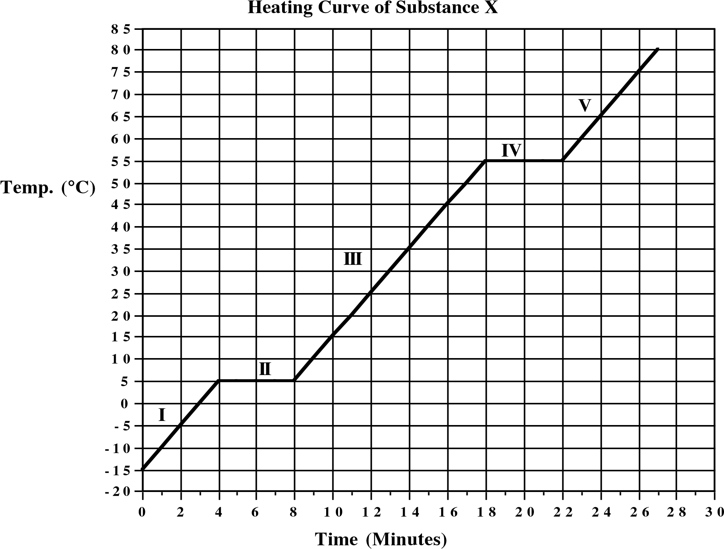

**The heating curve shown above is a plot of temperature vs time. It represents the heating of substance X at a constant rate of heat transfer. Answer the following questions using this heating curve:**

______1. In what part of the curve would substance X have a definite shape and definite volume?

______2. In what part of the curve would substance X have a definite volume but no definite shape?

______3. In what part of the curve would substance X have no definite shape or volume?

______4. What part of the curve represents a mixed solid/liquid phase of substance X?

______5. What part of the curve represents a mixed liquid/vapor phase of substance X?

______6. What is the melting temperature of substance X?

______7. What is the boiling temperature of substance X?

## CHEMISTRY HEATING CURVE WORKSHEET

____________8. In what part(s) of the curve would increasing kinetic energy be displayed?

____________9. In what part(s) of the curve would increasing potential energy be displayed?

____________10. In what part of the curve would the molecules of substance X be farthest apart?

____________11. In what part of the curve would the molecules of X have the lowest kinetic energy?

____________12. In what part of the curve would the molecules of X have the greatest kinetic energy?

|  |
| --- |
| **Given the following information for substance X:**  **Specific Heat (c) of solid phase: 2.0 J/g°C**  **Heat of Fusion (Lf): 100 J/g**  **Specific Heat (c) of liquid phase: 5.0 J/g°C**  **Heat of Vaporization (Lv): 1000 J/g Specific Heat (c) of vapor phase: 1.0 J/g°C Heat Equations:**  **Q = mc∆T Q = mLf Q = mLv** |

_______________13. Calculate the total heat energy in Joules needed to convert 20 g of substance X from -10°C to 70°C?