AP® Chemistry: PES Sample Items

(available for classroom use, formative, or summative assessments):

1. Which element could be represented by the complete PES spectrum below?

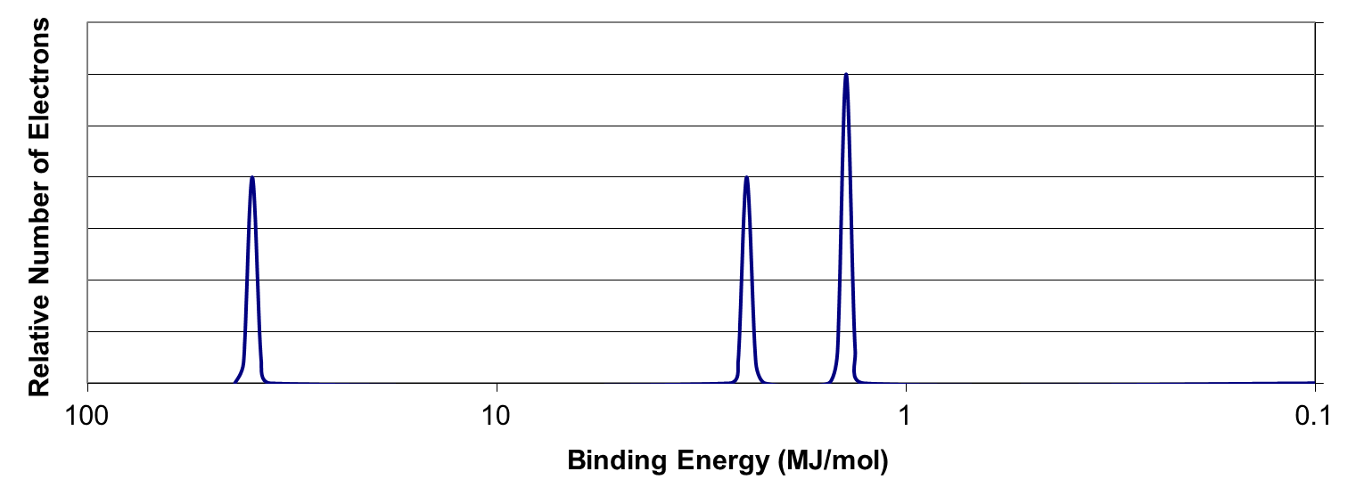

* 1. Li
  2. B
  3. N
  4. Ne

1. Which of the following best explains the relative positioning and intensity of the 2s peaks in the following spectra?

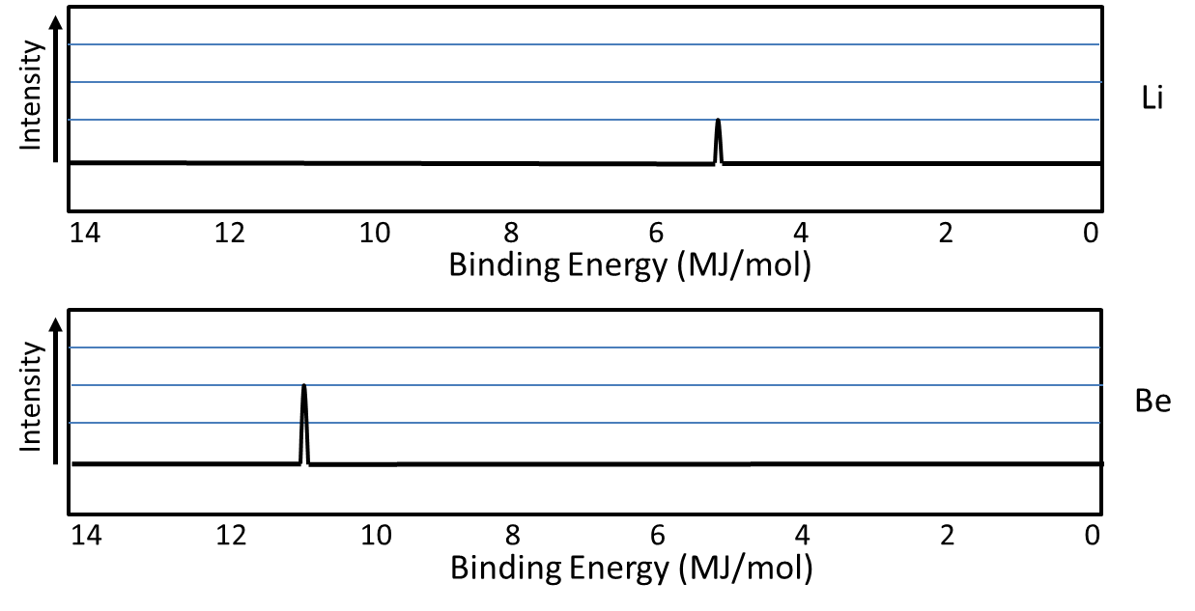

* 1. Be has a greater nuclear charge than Li and more electrons in the 2s orbital
  2. Be electrons experience greater electron-electron repulsions than Li electrons
  3. Li has a greater pull from the nucleus on the 2s electrons, so they are harder to remove
  4. Li has greater electron shielding by the 1s orbital, so the 2s electrons are easier to remove

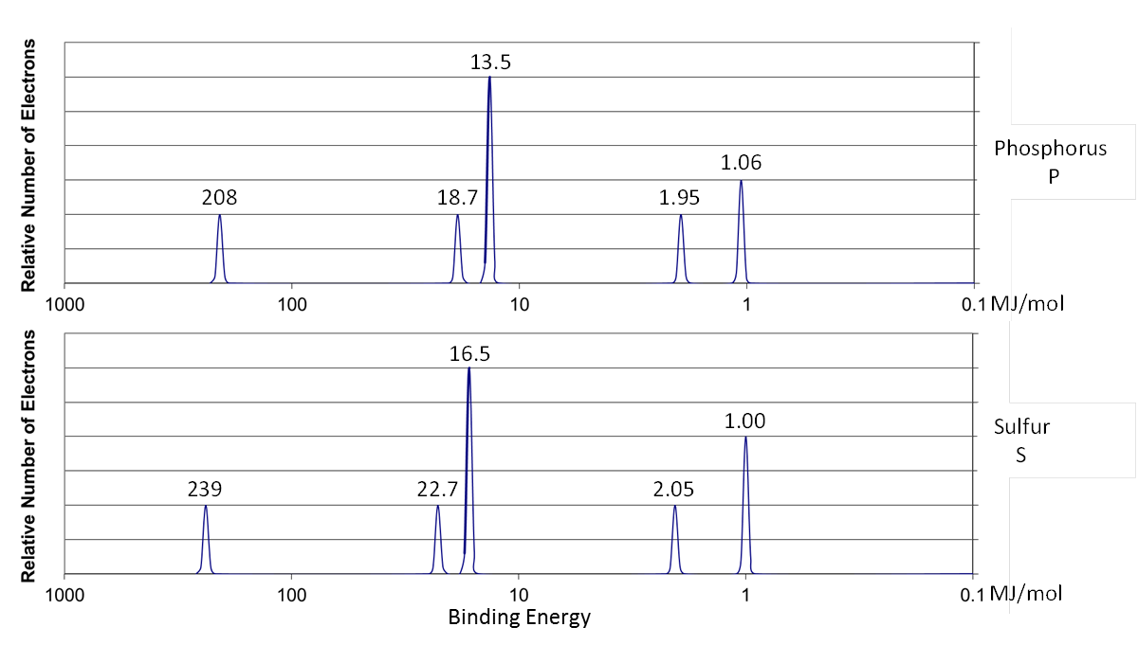

1. Given the photoelectron spectra above for phosphorus, P, and sulfur, S, which of the following best explains why the 2p peak for S is further to the left than the 2p peak for P, but the 3p peak for S is further to the right than the 3p peak for P?
   1. S has a greater effective nuclear charge than P, and the 3p sublevel in S has greater electron repulsions than in P.
   2. S has a greater effective nuclear charge than P, and the 3p sublevel is more heavily shielded in S than in P.
   3. S has a greater number of electrons than P, so the third energy level is further from the nucleus in S than in P.
   4. S has a greater number of electrons than P, so the Coulombic attraction between the electron cloud and the nucleus is greater in S than in P.

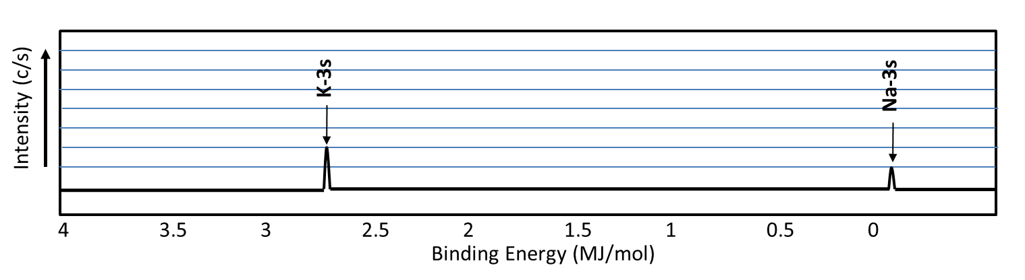

1. Looking at the spectra for Na and K above, which of the following would best explain the difference in binding energy for the 3s electrons?
   1. K has a greater nuclear charge than Na
   2. K has more electron-electron repulsions than Na
   3. Na has one valence electron
   4. Na has less electron shielding than K



1. Looking at the spectra for Na and K above, which of the following would best explain the difference in ***signal intensity*** for the 3s electrons?
   1. K has a greater nuclear charge than Na
   2. K has more electron-electron repulsions than Na
   3. Na has one valence electron
   4. Na has less electron shielding than K

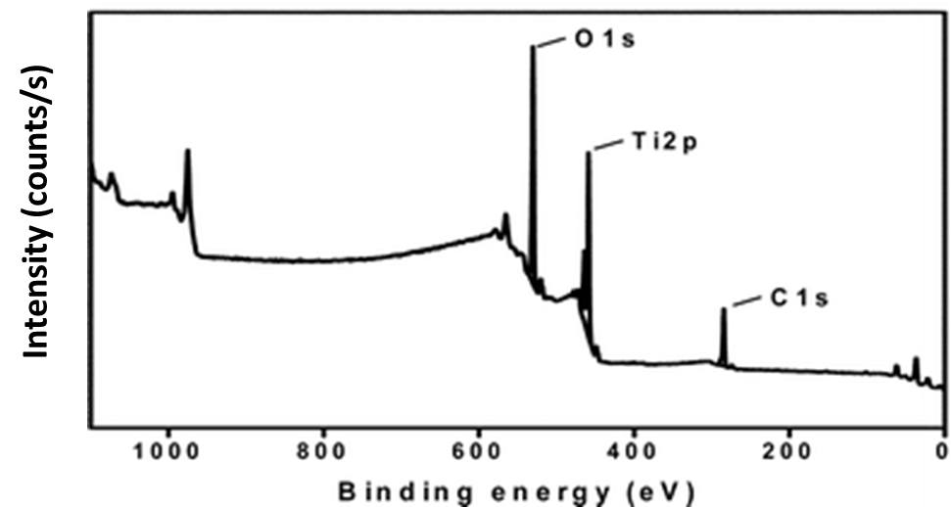

1. Given the photoelectron spectrum above, which of the following best explains the relative positioning of the peaks on the horizontal axis?
   1. O has more valence electrons than Ti or C, so more energy is required to remove them
   2. O has more electron-electron repulsions in the 2p sublevel than Ti and C
   3. Ti atoms are present in a greater quantity than O than C in the mixture.
   4. Ti has a greater nuclear charge, but the 2p sublevel experiences greater shielding than the 1s sublevel.

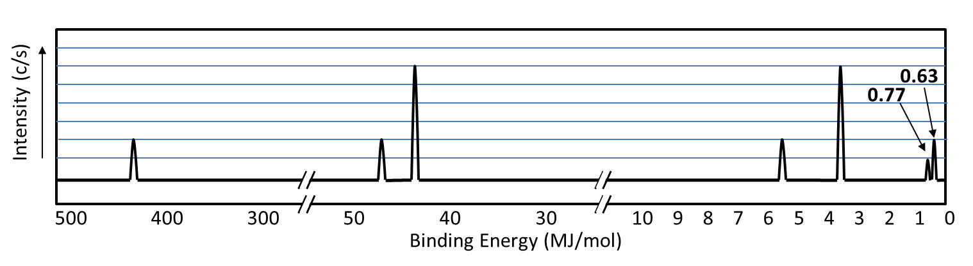

1. Given the photoelectron spectrum of Scandium above, which of the following best explains why Scandium commonly makes a 3+ ion as opposed to a 2+ ion?
   1. Removing 3 electrons releases more energy than removing 2 electrons.
   2. Scandium is in Group 3, and atoms only lose the number of electrons that will result in a noble gas electron configuration
   3. The amount of energy required to remove an electron from the 3d sublevel is close to that for the 4s sublevel, but significantly more energy is needed to remove electrons from the 3p sublevel.
   4. Removing 2 electrons alleviates the spin-pairing repulsions in the 4s sublevel, so it is not as energetically favorable as emptying the 4s sublevel completely.

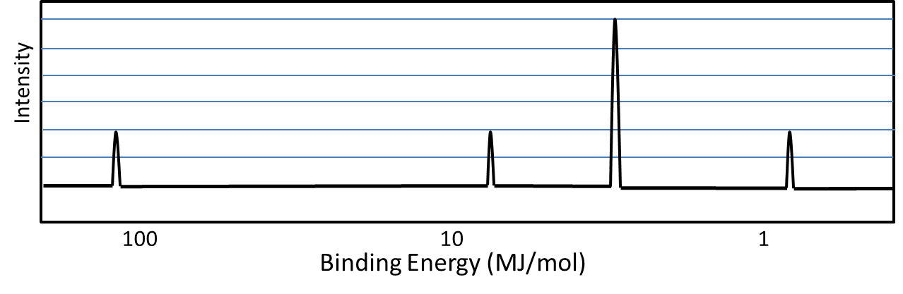

1. On the photoelectron spectrum for magnesium given above, draw the spectrum for aluminum.