*Unit 6 Test Practice Multiple Choice Name(s) ____________________________________________________*

1) The table shows the first ionization energy and atomic radius of several elements.

Which of the following best helps to explain the deviation of the first ionization

energy of oxygen from the overall trend?

A) The atomic radius of oxygen is greater that the atomic radius of fluorine.

B) The atomic radius of oxygen is less that the atomic radius of nitrogen.

C) There is repulsion between paired electrons in oxygen’s 2p orbitals.

D) There is attraction between paired electrons in oxygen’s 2p orbitals.

2) A sample containing atoms of C and F was analyzed using x-ray

photoelectron spectroscopy. The portion of the spectrum showing

the 1s peaks for atoms of the two elements is shown. Which of the following correctly identifies the 1s peak for the F atoms and provides an appropriate explanation?

A) Peak X, because F has a smaller first ionization energy than C has.

B) Peak X, because F has a greater nuclear charge than C has.

C) Peak Y, because F is more electronegative than C is.

D) Peak Y, because F has a smaller atomic radius that C has.

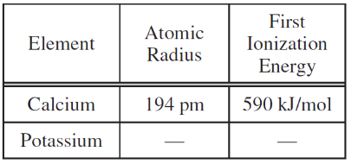3) Based on periodic trends and the data in the table, which of the following are the most probable values of the atomic radius and the first ionization energy for potassium, respectively? A) 242 pm, 633 kJ/mol C) 120 pm. 633 kJ/mol

B) 242 pm, 419 kJ/mol D) 120 pm, 419 kJ/mol

4) Which of the following correctly identifies which has the higher first-ionization energy, Cl or Ar, and supplies the best justification?

A) Cl, because of its higher electronegativity B) Cl, because of its higher electron affinity

C) Ar, because of its completely filled valence shell D) Ar, because of its higher effective nuclear charge

|  |  |
| --- | --- |
|  | Ionization Energy  (kJ/mol) |
| First | 801 |
| Second | 2,430 |
| Third | 3,660 |
| Fourth | 25,000 |
| Fifth | 32,820 |

5) The first five ionization energies of a second-period element are listed in the table. Which of the following correctly identifies the element and best explains the data in the table?

A) B, because it has five core electrons

B) B, because it has three valence electrons

C) N, because it has five valence electrons

D) N, because it has three electrons in the *p* sublevel

6) Which of the following transitions in the Bohr hydrogen atom will result in the emission of the highest energy photon?

A) n=2 → n=1 B) n=3 → n=2 C) n=4 → n=3 D) n=5 → n=4

7) Which ionization energy would be the largest? A) I1 of Na B) I2 of Na C) I2 of Mg D) I3 of Mg

8) The halogens all have the valence shell configuration of

A) ns2  B) ns2np2 C) ns2nd7 D) ns2np5

9) The configuration [Kr] 5s14d25p3 is an *excited state* for A) Sb B) Ag C) Mo D) Zr

10) Below are shown the photoelectron spectra of the electrons in the second energy level for nitrogen and oxygen. Based on the spectra which of the following best explains the difference in binding energy of the electrons in nitrogen and oxygen?

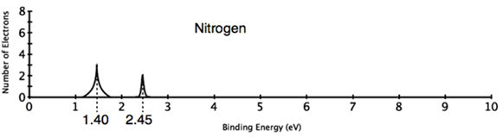*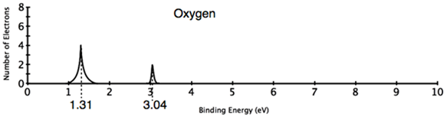 Note: energy increases to the RIGHT!*

A) The oxygen electrons have more binding energy because oxygen has more protons in its nucleus than nitrogen does.

B) The oxygen electrons in the 2s orbital have higher binding energy because oxygen has more protons, while oxygen’s

2p electrons have lower binding energy due to greater electron-electron repulsion.

C) The nitrogen electrons in the 2s orbital are closer to the nucleus and experience a stronger attractive force giving them a higher binding energy.

D) The nitrogen electrons have more binding energy because nitrogen has less electron-electron repulsion.

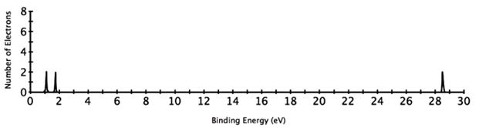

11) The photoelectron spectrum of carbon is shown. Which of the following is the best explanation for the large difference in binding energy between the peaks on the left and the right.

A) The electrons generating the peak on the right are further away from the nucleus.

B) There are four electrons all together in the group on the left.

C) The electrons generating the peak on the right have greater electron shielding.

D) The electrons generating the peak on the left are further from the nucleus and experience greater electron shielding.

12) Which of the following regions of the periodic table are the elements most likely to have a low first ionization energy?

A) Alkali metals B) Transition metals C) Noble gases D) Halogens

13) Which of the following elements would have the lowest first ionization energy?

A) N B) O C) F D) Ne

14) The species F-, Ne, Na+ all have the same number of electrons. Which of the correct order when they are arranged in order of decreasing size (largest first).

A) F- > Ne > Na+ B) Na+ > Ne > F- C) Na+ > F- > Ne D) Ne > Na+ > F-

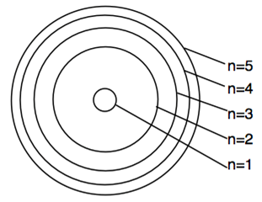15) The energy level diagram for a hydrogen atom is shown to the right.

Based on the diagram which energy transition would give a photon

with the shortest wavelength?

A) 5 → 4 B) 4 → 2 C) 3 → 2 D) 2 → 1

16) When an atom of hydrogen absorbs a photon of light which of the following happens?

A) a proton is converted into a neutron B) the hydrogen atom bonds to another hydrogen atom

C) an electron jumps to a higher energy level D) the photon makes the nucleus vibrate

|  |  |
| --- | --- |
| X(*g*) → X+(*g*) + *e*− | IE1 = 740 kJ/mol |
| X+(*g*) → X2+(*g*) + *e*−  X2+(*g*) → X3+(*g*) + *e*− | IE2 = 1450 kJ/mol  IE3 = 7730 kJ/mol |

17) For element X represented above, which of the following is the most likely explanation for the large difference between the second and third ionization energies?

A) The effective nuclear charge decreases with successive ionizations.

B) The shielding of outer electrons increases with successive ionizations.

C) The electron removed during the third ionization is, on average, much closer to the nucleus than the first two electrons removed were.

|  |  |
| --- | --- |
|  | Ionization Energy (kJ/mol) |
| First | 577 |
| Second | 1,816 |
| Third | 2,745 |
| Fourth | 11,577 |
| Fifth | 14,482 |

D) The ionic radius increases with successive ionizations.

18) Based on the ionization energies of element X given in the table, which of the

following is most likely the empirical formula of an oxide of element X?

A) XO2  B) X2O C) X2O3 D) X2O5

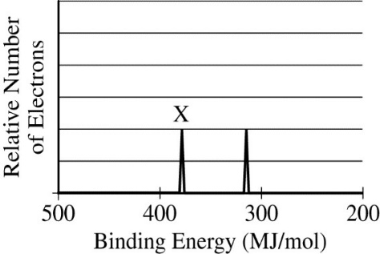

19) The photoelectron spectra of the 1*s* electrons of two isoelectronic species, Ca2+ and Ar, are shown. Which of the following correctly identifies the species associated with peak X and provides a valid justification?

A) Ar, because it has completely filled energy levels

B) Ar, because its radius is smaller than the radius ofCa2+

C) Ca2+, because its nuclear mass is greater than that of Ar

D) Ca2+, because its nucleus has two more protons than the nucleus of Ar has

|  |  |
| --- | --- |
| Element | Known Oxides |
| H | H2O, H2O2 |
| Li | Li2O, Li2O2 |
| Na | Na2O, Na2O2, NaO2 |
| K | K2O, K2O2, KO2 |

20) Based on the information in the table and periodic trends, which of the following is the best hypothesis regarding the oxide(s) formed by Rb?

A) Rb will form only Rb2O.

B) Rb will form only RbO2.

C) Rb will form only Rb2O and Rb2O2.

D) Rb will form Rb2O, Rb2O2, and RbO2.

21) Which of the following species has the electron configuration 1*s*2 2*s*2 2*p*6 3*s*2 3*p*6 ?

A) O B) Ne C) K+ D) C1+