**Unit 6 AP Test Review**

*Ch 8 Quantum Model and Ch 9 Periodic Trends*

EM radiation (radio to gamma) λ, υ, E E = h υ c = λ υ E = hc/λ

Spectrum: continuous vs line-spectrum (emission/bright line vs absorption/dark line)

How produced? Examples? Ground vs excited states

Electron configurations (levels and sublevels; complete vs Noble gas configuration; orbital notation

Exceptions Cu/Ag (s2d9 vs s1d10) Cr/Mo (s2d4 vs s1d5)

Isoelectronic (examples) S-2 is isoelectronic with what noble gas? ___ list another ion which it is isoelectronic with ___

Size of ions?

Identify a paramagnetic/diamagnetic element/ion.

Photoelectric effect (UV) PES (xray): interpret diagrams (# of e’s, identify peaks, position based on effective nuclear charge/distance

Periodic Trends

Across periods/rows vs down groups/families: Atomic radius; IE, EA COULOMB’S LAW

Write equation for IE vs EA (exo vs endo)

Explain “dips” in IE graph across period 2 or 3 (relate to electron configuration, repulsion)

Successive IE’s always increase (large jumps indicate?)

Ionic radius (compare to parent atom)

FRQs

1) PES graph: interpret and write configuration to ID element; calculate the energy and frequency of photon needed

Answer questions about the element.

2) Write complete configurations for 2 elements. Discuss IE and EA (compare/explain/justify); metallic character; examine ions, radii

3) Relate heat energy to light energy through calculations

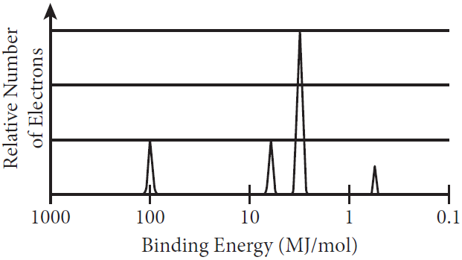1) The complete photoelectron spectrum of an unknown element is given.

a) Draw an X above the peak that corresponds to the orbital with electrons that are, on average, closest to the nucleus. Justify your answer in terms of Coulomb’s law. *2019 CED*

b) Based on the spectrum, write the complete electron configuration of the element.

c) On the graph, draw the peak(s) corresponding to the valence electrons of the element that has one more proton in its nucleus that the unknown element has.

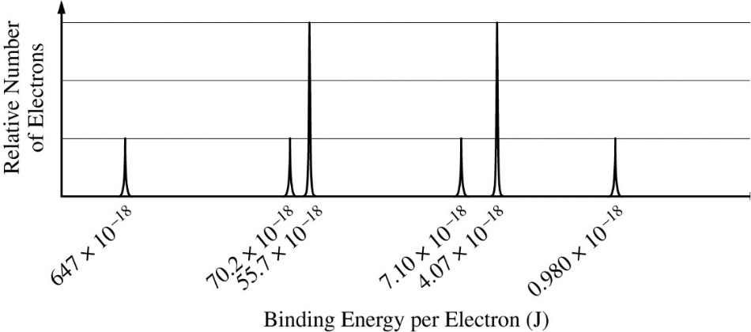

5) The complete photoelectron spectrum of an element in its ground state is represented

by the diagram. *2019 FRQ*

a) Based on the spectrum,

i) write the ground-state electron configuration of the element, and

(ii) identify the element.

b) Calculate the wavelength, in meters, of electromagnetic radiation needed to remove an electron from the valence shell of an atom of the element.

Answer the following questions related to sulfur and one of its compounds. 2009 6

a) Consider the two chemical species S and S2-.

i) Write the complete electron configuration of each species. *(2pts)*

ii) Explain why the radius of the S2− ion is larger than the radius of the S atom. *(1pt)*

iii) Which of the two species would be attracted into a magnetic field? Explain. *(1pt)*

b) The S2− ion is isoelectronic with the Ar atom. From which species, S2− or Ar, is it easier to remove an electron? Explain. *(1pt)*

|  |  |
| --- | --- |
| Atom | First Ionization Energy  (kJ mol−1) |
| F | 1,681.0 |
| O | 1,313.9 |
| Xe | ? |

Using principles of atomic and molecular structure and the information in the table, answer the following questions about atomic fluorine, oxygen, and xenon, as well as some of their compounds. 2008 5

a) Write the equation for the ionization of atomic fluorine that requires 1,681.0 kJ mol−1.

*(1pt)*

b) Account for the fact that the first ionization energy of atomic fluorine is greater than that of atomic oxygen. (You must discuss both atoms in your response.) *(1pt)*

c) Predict whether the first ionization energy of atomic xenon is greater than, less than, or equal to the first ionization energy of atomic fluorine. Justify your prediction. *(1pt)*