**Unit 7 Chemical Bonding Practice Multiple Choice Name(s):**

1) Which of the following metals would produce a chloride compound with the lowest lattice energy?

A) Mg B) Ba C) Na D) Cs

2) Which of the following molecules would have the shortest bond length?

A) N2 B) O2 C) Cl2 D) I2

3) The angle between sp hybridized orbitals is A) 45o B) 90o C) 109.5o D) 120o  E) 180o

4) The Lewis dot structure of which of the following molecules shows only one unshared pair of electrons.

A) H2 B) NH3 C) H2O D) CO

5) A molecule with the formula AB2 can have ________________ molecular shape.

A) linear or bent B) trigonal planar C) linear or trigonal planar D) T-shaped

6) Which of the following ions exhibit delocalized bonding?

A) NO2- B) NH4+ and NO2- C) N3- and NO2- D) N3-

7) For which of the following molecules is the molecular geometry the same as the electron domain geometry?

(i) PF3 (ii) CF4 (iii) XeF4 (iv) SF6

A) i and ii B) ii and iii C) iii and iv D) ii and iv

8) Which of the molecules in the previous question would have a dipole moment?

A) i B) ii C) iii D) iv

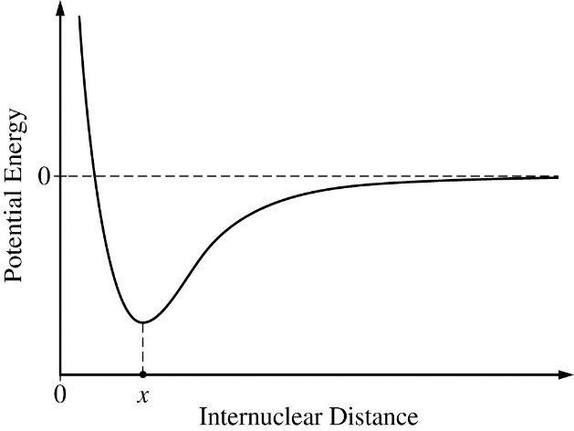9) The potential energy of a system of two atoms as a function of

their internuclear distance is shown in the diagram above. Which

of the following is true regarding the forces between the atoms

when their internuclear distance is x ?

A) The attractive and repulsive forces are balanced, so the atoms

will maintain an average internuclear distance x.

B) There is a net repulsive force pushing the atoms apart, so

the atoms will move further apart.

C) There is a net attractive force pulling the atoms together, so

the atoms will move closer together.

D) It cannot be determined whether the forces between atoms are balanced, attractive, or repulsive, because the diagram shows

only the potential energy.

10) The decomposition of hydrogen peroxide is represented by: 2H2O2 (aq) → 2H2O (l) + O2 (g) ∆Ho = -196kJ/molrxn

Assume that the bond enthalpies of the oxygen-hydrogen bonds in H2O are not significantly different from those in H2O2. Based on the value of ∆Ho of the reaction, which of the following could be the bond enthalpies (in kJ/mol) for the bonds broken and formed in the reaction?

O—O O=O O—H

in H2O2 in O2

A) 300 500 500

B) 150 500 500

C) 500 300 150

D) 250 300 150

|  |  |
| --- | --- |
| Bond | Average Bond Energy (kJ/mole) |
| I−I | 150 |
| Cl−Cl | 240 |
| I−Cl | 210 |

11) According to the data in the table, what is the value of ∆H° for the reaction below?

I2(g) + 3 Cl2(g)  → 2 ICl3(g)

A) −870 kJ B) −390 kJ C) +390 kJ D) +1,260 kJ

12) The melting point of MgO is higher than that of NaF. Explanations for this observation include which of the following?

I. Mg2+ is more positively charged than Na+

II. O2− is more negatively charged than F−

III. The O2− ion is smaller than the F− ion

A) II only B) I and II only C) I and III only D) I, II, and III

13) Of the following molecules, which has the largest dipole moment?

A) CO B) CO2 C) HF D) F2

14) The geometry of the SO3 molecule is best described as…

A) trigonal planar B) trigonal pyramidal C) T-shaped D) tetrahedral

15) According to the VSEPR model, the progressive decrease in the bond angles in the series of molecules CH4, NH3, and H2O is best accounted for by the…  
 A) decreasing repulsion between hydrogen atoms B) decreasing size of the central atom  
 C) increasing electronegativity of the central atom D) increasing number of unshared pairs of electrons

16) Which of the following has the bonds arranged in order of decreasing polarity?

A) H−F > N−F > F−F B) H−I > H−Br > H−F C) O−N > O−S > O−Te D) Sb−I > Sb−Te > Sb−Cl

17) Based on the diagram, which of the following best helps to explain why MgO(*s*) is not able to conduct electricity, but MgO(*l*) is a good conductor of electricity?

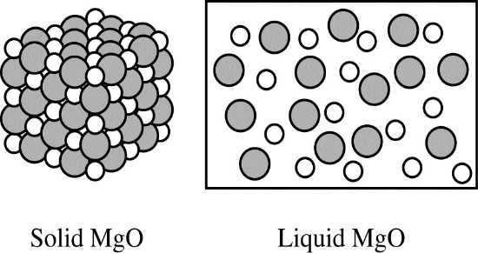 A) MgO(*s*) does not contain free electrons, but MgO(*l*) contains free electrons that can flow.

B) MgO(*s*) contains no water, but MgO(*l*) contains water that can conduct electricity.

C) MgO(*s*) consists of separate Mg2+ ions and O2− ions, but MgO(*l*) contains MgO molecules that can conduct electricity.

D) MgO(*s*) consists of separate Mg2+ ions and O2− ions held in a fixed lattice, but in MgO(*l*) the ions are free to move and conduct electricity.

18) A student is given a sample of a pure, white crystalline substance. Which of the following would be most useful in providing data to determine if the substance is an ionic compound?

A) Examining the crystals of the substance under a microscope

B) Determining the density of the substance

C) Testing the electrical conductivity of the crystals

D) Testing the electrical conductivity of an aqueous solution of the substance

19) NH3 reacts with BF3 to form a single species. Which of the following structural diagrams is the most likely representation of the product of the reaction?

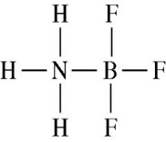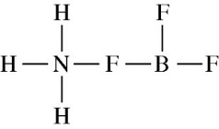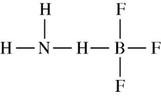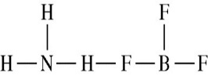 A) B) C) D)

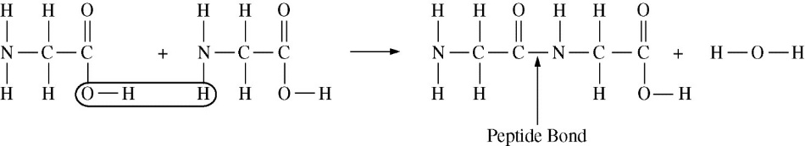Two molecules of the amino acid glycine join through the formation of a peptide bond, as shown. Δ*Ho*298 = +12 kJ/mol*rxn*

|  |  |
| --- | --- |
| Bond | Bond Energy  (kJ/mol) |
| C−O | 360 |
| N−H | 390 |
| O−H | 460 |

20) Based on the bond energies listed in the table, which of the following is closest to the

bond energy of the C−N bond?

A) 200 kJ/mol B) 300 kJ/mol C) 400 kJ/mol D) 500 kJ/mol

21) The compound CCl4 is nonflammable and was once commonly used in fire extinguishers. On the basis of the periodic properties, which of the following compounds can most likely be used as a fire-resistant chemical?

A) BCl3  B) CH4 C) CBr4 D) PbCl2

22) The exothermic process represented by the equation 2 H2O2(*l*) → 2 H2O(*l*) + O2(*g*) is best classified as a A) physical change because a new phase appears in the products.

B) physical change because O2(*g*) that was dissolved comes out of solution.

C) chemical change because entropy increases as the process proceeds.

D) chemical change because covalent bonds are broken and new covalent bonds are formed.

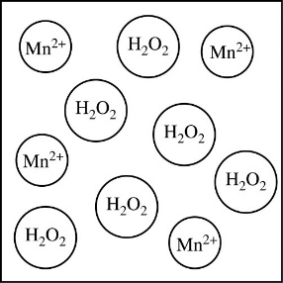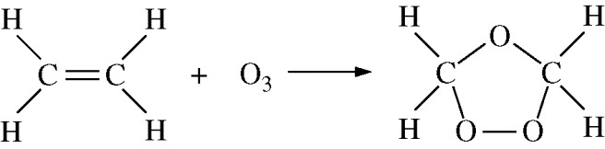23) In the reaction represented below, what is the hybridization of the C atoms before and after the reaction occurs?

|  |  |  |  |
| --- | --- | --- | --- |
|  | Before |  | After |
| A)  B) C)  D) | *sp*  *sp*  *sp*2  *sp*2 |  | *sp*2 *sp*3 *sp**sp*3 |

Unit 6 Bonding Test Practice Problems Names ____________________________________________________

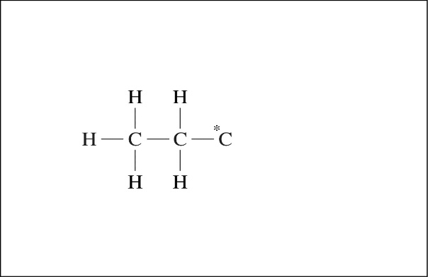1) Propanoic acid, C2H5COOH, is an organic acid that is a

liquid at room temperature. 2016 practice 6

a) An incomplete Lewis diagram for the propanoic acid molecule is provided in the box. Complete the diagram, showing how the remaining atoms in the molecule are arranged around the carbon atom marked with an asterisk (*). Your structure should minimize formal charge and include any lone pairs of electrons.

*(1pt)*

b) Identify the hybridization of the carbon atom marked with the asterisk. _________ *(1pt)*

c) Propanoic acid has a lower boiling point than butanoic acid, C3H7COOH.

i) Identify all the types of intermolecular forces present among the molecules in propanoic acid. *(1pt)*

ii) Which of the types of intermolecular forces that you identified in part (c)(i) is most responsible for the difference in boiling points of the two acids? *(1pt)*

2) Answer the following about two isomers, methyl methanoate and ethanoic acid.

The molecular formula of the compounds is C2H4O2 . *(2015 Practice 5)*

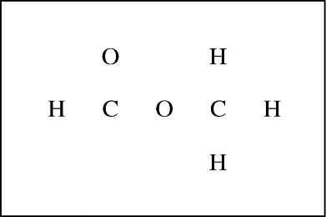

a) Complete the Lewis electron-dot diagram of methyl methanoate in the box.

Show all valence electrons. *(1pt)*

b) Based on your structure of propanoic acid in #2a, draw the Lewis electron-dot structure for ethanoic acid. *(1pt)*

c) Explain why methyl methanoate and ethanoic acid are isomers. *(1pt)*

d) Identify the geometry and approximate bond angles around the central atom of each structure. *(1pt)*

methyl methanoate ____________________________ ethanoic acid ________________________________

Answer the following questions that relate to chemical bonding. 2005 6

a) In the boxes provided, draw the complete Lewis structure (electron-dot diagram) for each of the three molecules represented below. *(3pts)*

CF

4

PF

5

SF

4

b) On the basis of the Lewis structures drawn above, answer the following questions about the particular molecule indicated.

i) What is the hybridization of the valence orbitals of C in CF4 ? ________ *(1pt)*

ii) What are the two different bond angles in PF5 ? ________ and _________ *(1pt)*

iii) What is the geometric shape formed by the atoms in SF4 ? __________________ *(1pt)*

c) Two Lewis structures can be drawn for the OPF3 molecule, as shown.

i) How many sigma bonds and how many pi bonds are in structure 1 ?

sigma ____ pi ___ *(2pts)*

ii) Which one of the two structures best represents a molecule of OPF3 ? Justify your answer in terms of formal charge.

Answer the following questions about ozone. 2017 Practice 3a-c

a) The O3 molecule has a central oxygen atom bonded to two outer oxygen atoms that are not bonded to one another. Draw the Lewis electron-dot diagram of the O3 molecule. Include all valid resonance structures. *(2pts)*

b) Based on the diagram you drew in part (a), what is the shape of the ozone molecule? ___________________ *(1pt)*

Ozone decomposes according to the reaction represented by: 2 O3(*g*) → 3 O2(*g*) Δ*H*° = − 285 kJ/mol*rxn*

c) The bond enthalpy of the oxygen-oxygen bond in O2 is 498 kJ/mol. Based on the enthalpy of the reaction represented above, what is the average bond enthalpy, in kJ/mol, of an oxygen-oxygen bond in O3 ? *(2pts)*

c) S2Cl2 is a product of the reaction: CS2(*g*) + 3 Cl2(*g*) → CCl4(*g*) + S2Cl2(*g*)

i) Complete the Lewis electron-dot diagram for the S2Cl2 molecule Cl ─ S ─ S ─ Cl

by drawing in all of the electron pairs. *(1pt)* 2017 1c

ii) What is the approximate value of the Cl−S−S bond angle in the S2Cl2 molecule

that you drew in part (c)(i) ? (If the two Cl−S−S bond angles are not equal, include both angles.) *(1pt)*

Identify the approximate bond angles marked (a), (b), and (c) in the molecule.

Identify the hybridization producing the angles.

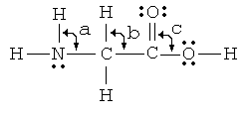

*Angle Hybridization*

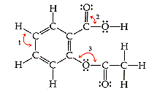 a) _____ ______

b) _____ ______

c) _____ ______

1) _____ ______

2) _____ ______

3) _____ ______

Two possible structures are shown for sulfur dioxide.

a) Calculate the formal charge for each and circle the

structure which is more likely. *(1pt)*

Using principles of chemical bonding and molecular geometry, explain each of the following observations. *Lewis electron- dot diagrams and sketches of molecules may be helpful as part of your explanations.* For each observation, your answer must include references to both substances. 2002 6

a) The bonds in nitrite ion, NO2−, are shorter than the bonds in nitrate ion, NO3−. *(2pts)*

b) CH2F2 molecule is polar, whereas the CF4 molecule is not. *(2pts)*

c) The atoms in a C2H4 molecule are located in a single plane, whereas those in a C2H6 molecule are not. *(2pts)*

d) The shape of a PF5 molecule differs from that of an IF5 molecule. *(1pt)*

e) HClO3 is a stronger acid than HClO. *(1pt)*

6) Draw a Lewis structure for **sulfur trioxide** that obeys the octet rule. Calculate the formal charges for each atom.

a) How many total resonance structures are possible? What does it mean to say that the ***π component*** of the double

bond is ***delocalized***? What orbitals are involved?

b) What is the hybridization of the sulfur atom? What are the bond angles?

c) What is the electron domain geometry and what is the molecular geometry?

d) Is the structure polar or nonpolar?

e) Draw another structure for sulfur trioxide where the sulfur atom expands the octet until the formal charge on the sulfur goes to zero. What happens to the formal charges on the oxygens?

Draw Lewis structures for **selenium tetrachloride** and **xenon tetrachloride**.

1. Identify the ***electron domain geometry*** and ***molecular geometry*** for each.
2. Indicate the bond angles in each structure.
3. Both molecules contain polar bonds. Indicate if each molecule is polar or nonpolar.
4. Determine the hybridization of the central atom in each molecule.

e) Briefly explain why oxygen tetrachloride cannot exist.