**Unit 8 Test Practice Multiple Choice** Names_______________________________________________________

|  |  |
| --- | --- |
| Ion | Ionic Radius (pm) |
| Li+ | 60 |
| Na+ | 95 |
| Ca2+ | 99 |
| In3+ | 81 |

1) In which of the following liquids do the intermolecular forces include dipole-dipole forces?

A) F2(*l*) B) CH4(*l*) C) CF4(*l*) D) CH2F2(*l*)

2) Based on Coulomb’s law and the information in the table, which of the following cations is most likely to have the weakest interaction with an adjacent water molecule in an aqueous solution?

A) Li+  B) Na+ C) Ca2+ D) In3+

3) At room temperature I2(*s*) is a molecular solid. Which of the following provides a characteristic of I2(*s*) with a correct explanation?

A) It has a high melting point because it has weak intermolecular forces.

B) It is hard because it forms a three dimensional covalent network.

C) It is not a good conductor of electricity because its valence electrons are localized in bonding and nonbonding pairs.

D) It is very soluble in water because its molecules are polar.

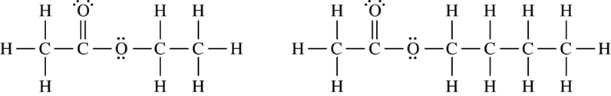

Ethyl Acetate Butyl Acetate

4) A mixture containing equal numbers of moles of ethyl acetate and butyl acetate was separated using distillation. Based on the diagrams shown above, which of the following identifies the substance that would be initially present in higher concentration in the distillate and correctly explains why that occurs?

A) Ethyl acetate, because it has fewer C─C bonds to break

B) Ethyl acetate, because it has a shorter carbon chain and weaker London dispersion forces

C) Butyl acetate, because it has more C─C bonds to break

D) Butyl acetate, because it has a longer carbon chain and weaker dipole-dipole attractions

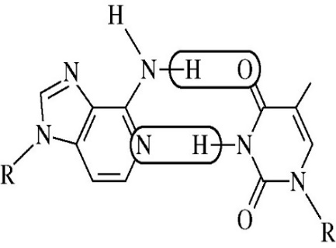

5) Which of the following is the strongest type of interaction that occurs between the atoms within the circled areas of the two molecules represented to the right?

A) Polar covalent bond

B) Nonpolar covalent bond

C) Hydrogen bond

D) London dispersion forces

6) Which of the following would not produce a solution?

A) elemental iodine in ethanol (CH3CH2OH) B) potassium chloride in CCl4 C) acetic acid in water

7) Which of these is probably true for a solid solute with a highly endothermic heat of solution when dissolved in water?

A) The solid has a low lattice energy. B) As the solute dissolves, the temperature of the solution increases.

C) The solid is more soluble at higher temperatures. D) the solid has a high energy of hydration.

8) A 0.10 M aqueous solution of sodium sulfate, Na2SO4, is a better conductor of electricity than a 0.10 M aqueous solution of sodium chloride, NaCl. Which of the following best explains this observation?

A) Na2SO4 is more soluble in water than NaCl is.

B) Na2SO4 has a higher molar mass than NaCl has.  
 C) More moles of ions are present in a given volume of 0.10 M Na2SO4 than in the same volume of 0.10 M NaCl.  
 D) The degree of dissociation of Na2SO4 in solution is significantly greater than that of NaCl.

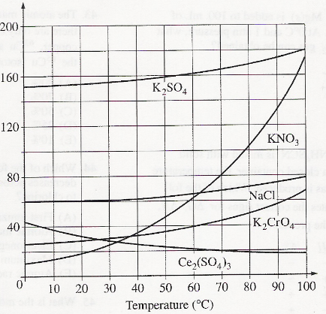

9) On the basis of the solubility curves shown, the greatest percentage of which compound can be recovered by cooling a saturated solution of that compound

from 90°C to 30°C ?

A) NaCl B) KNO3 C) Ce2(SO4)3 D) K2SO4

10) If 200. mL of 0.60 M MgCl2(aq) is added to 400. mL of distilled water, what is the concentration of Cl1−(aq) in the resulting solution? (Assume volume are additive.)

A) 0.20 M B) 0.30 M C) 0.40 M D) 0.60 M

11) The boiling points of the elements helium, neon, argon, krypton, and xenon increase in that order. Which of the following statements best accounts for this increase?  
 A) The polarizability of the electron cloud increases. B) The dipole-dipole forces increase.  
 C) The chemical reactivity increases. D) The molar mass increases.

12) At 298 K and 1 atm, Br2 is a liquid with a high vapor pressure, and Cl2 is a gas. Those observations provide evidence that under the given conditions, the

A) forces among Br2 molecules are stronger than those among Cl2 molecules

B) forces among Cl2 molecules are stronger than the Cl−Cl bond

C) Br−Br bond is stronger than the Cl−Cl bond

D) Cl−Cl bond is stronger than the Br−Br bond

13) Which of these substances has the highest boiling point, and why? Ne, HF, C2H6, CH4

A) Ne, because its atoms have the largest radius

B) HF, because its molecules form hydrogen bonds

C) C2H6, because each molecule can form multiple hydrogen bonds

D) CH4, because its molecules have the greatest London dispersion forces

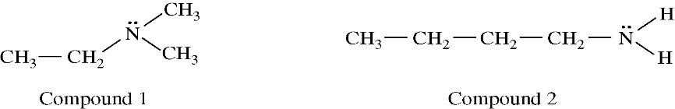

14) Based on the structures shown above, which of the following statements identifies the compound with the higher boiling point and provides the best explanation for the higher boiling point?

A) Compound 1, because it has stronger dipole-dipole forces than compound 2

B) Compound 1, because it forms hydrogen bonds, whereas compound 2 does not

C) Compound 2, because it is less polarizable and has weaker London dispersion forces than compound 1

D) Compound 2, because it forms hydrogen bonds, whereas compound 1 does not

|  |  |  |  |
| --- | --- | --- | --- |
| Type of Steel | % Carbon | Characteristics | Uses |
| Low-carbon steel | < 0.2 % | Malleable and ductile | Chains and nails |
| High-carbon steel | 0.6 –1.5 % | Hard and brittle | Cutting tools |

15)

The table above provides some information about two types of steel, both of which are alloys of iron and carbon.

Which of the following best helps to explain why high-carbon steel is more rigid than low-carbon steel?

A) Elemental carbon is harder than elemental iron.

B) The additional carbon atoms within the alloy make the high-carbon steel less dense.

C) The additional carbon atoms within the alloy increase the thermal conductivity of the high-carbon steel.

D) The additional carbon atoms within the alloy make it more difficult for the iron atoms to slide past one another.

**Unit 8 Test Practice FRQs** Name(s):

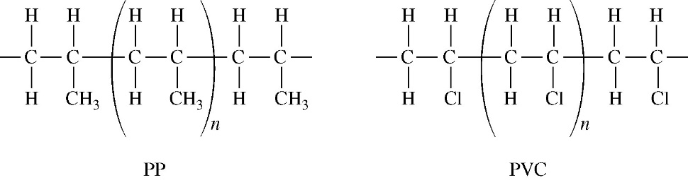1) A student places a mixture of plastic beads consisting of polypropylene (PP) and polyvinyl chloride (PVC) in a 1.0 L beaker containing distilled water. After stirring the contents of the beaker vigorously, the student observes that the beads of one type of plastic sink to the bottom of the beaker and the beads of the other type of plastic float on the water. The chemical structures of PP and PVC are represented by the diagrams, which show segments of each polymer. 2014 practice 6

a) Given that the spacing between polymer chains in PP and PVC is similar, the beads that sink are made of which polymer? Explain. *(1pt)*

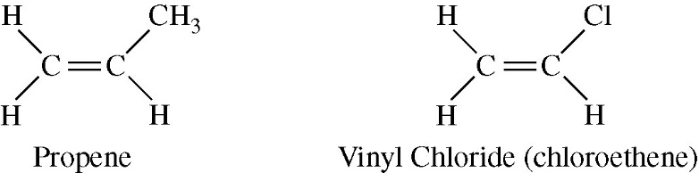

PP is synthesized from propene, C3H6, and PVC is synthesized from vinyl chloride, C2H3Cl. The structures

of the molecules are shown.

b) The boiling point of liquid propene (226 K) is lower than the boiling point of liquid vinyl chloride (260 K).

Account for this difference in terms of the types and strengths of intermolecular forces present in each liquid. *(1-2pts)*

In a separate experiment, the student measures the enthalpies of combustion of propene and vinyl chloride. The student determines that the combustion of 2.00 mol of vinyl chloride releases 2300 kJ of energy, according to the equation below.

2 C2H3Cl(*g*) + 5 O2(*g*) → 4 CO2(*g*) + 2 H2O(*g*) + 2 HCl(*g*) Δ*H*° = −2300 kJ/mol*rxn*

c) Using the table of standard enthalpies of formation below, determine whether the combustion of 2.00 mol of propene releases more, less, or the same amount of energy that 2.00 mol of vinyl chloride releases. Justify your answer with a calculation. The balanced equation for the combustion of 2.00 mol of propene is below the table. *(2pts)*

|  |  |  |  |  |  |  |
| --- | --- | --- | --- | --- | --- | --- |
| Substance | C2H3Cl(*g*) | C3H6(*g*) | CO2(*g*) | H2O(*g*) | HCl(*g*) | O2(*g*) |
| Standard Enthalpy of Formation (kJ/mol) | 37 | 21 | −394 | −242 | −92 | 0 |

2 C3H6(*g*) + 9 O2(*g*) → 6 CO2(*g*) + 6 H2O(*g*)

|  |  |  |  |
| --- | --- | --- | --- |
| Molecule | Boiling Point of Compound (K) | Dipole Moment (debyes) | Polarizability  (10−24 cm3) |
| HCl | 188 | 1.05 | 2.63 |
| HBr | 207 | 0.80 | 3.61 |
| HI | 238 | 0.38 | 5.44 |

2) The boiling points, dipole moments, and polarizabilities of three hydrogen halides are given in the table above.

2015 practice 4

a) Based on the data in the table, what type of intermolecular force among the molecules HCl(*l*), HBr(*l*), and HI(*l*) is able to account for the trend in boiling points? Justify your answer. *(2pts)*

b) Based on the data in the table, a student predicts that the boiling point of HF should be 174 K. The observed boiling point of HF is 293 K. Explain the failure of the student’s prediction in terms of the ***types*** and strengths of the intermolecular forces that exist among HF molecules. *(1-2pts)*

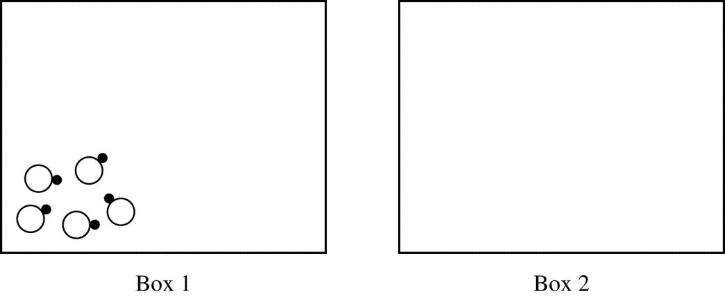c) A representation of five molecules of HBr in the liquid state is shown in box 1. In box 2, draw a representation of the five molecules of HBr after complete vaporization has occurred. *(1pt)*

3) A student investigates the enthalpy of solution, Δ*Hsoln*, for two alkali metal halides, LiCl and NaCl.

In addition to the salts, the student has access to a calorimeter, a balance with a precision of ±0.1 g, and a thermometer with a precision of ±0.1°C. 2016 1

a) To measure Δ*Hsoln* for LiCl, the student adds 100.0 g of water initially at 15.0°C to a calorimeter and adds 10.0 g of LiCl(*s*), stirring to dissolve. After the LiCl dissolves completely, the maximum temperature reached by the solution is 35.6°C.

i) Calculate the magnitude of the heat absorbed by the solution during the dissolution process, assuming that the specific heat capacity of the solution is 4.18 J/(g·°C). Include units with your answer. *(2pts)*

ii) Determine the value of Δ*Hsoln* for LiCl in kJ/mol*rxn*. *(2pts)*

|  |  |
| --- | --- |
| Ion | Ionic Radius (pm) |
| Li+ | 76 |
| Na+ | 102 |

To explain why Δ*Hsoln* for NaCl is different than that for LiCl, the student investigates factors that affect Δ*Hsoln* and finds that ionic radius and lattice enthalpy (which can be defined as the Δ*H* associated with the separation of a solid crystal into gaseous ions) contribute to the process.

The student consults references and collects the data shown in the table.

b) Write the complete electron configuration for the Na+ ion in the ground state. *(1pt)*

c) Using principles of atomic structure, explain why the Na+ ion is larger than the Li+ ion. *(1pt)*

d) Which salt, LiCl or NaCl, has the greater lattice enthalpy? Justify your answer. *(1pt)*

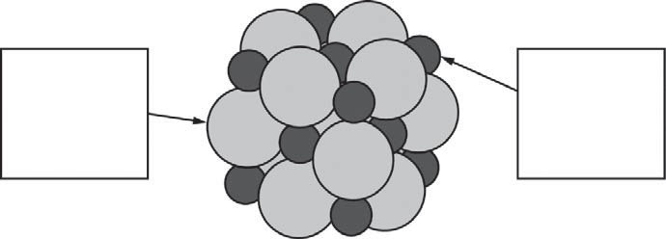

e) Here is a representation of a portion of a crystal of LiCl. Identify the ions in the representation by writing the appropriate formulas (Li+ or Cl− ) in the boxes. *(1pt)*

f) The lattice enthalpy of LiCl is positive, indicating that it takes energy to break the ions apart in LiCl. However, the dissolution of LiCl in water is an exothermic process. Identify all particle-particle interactions that contribute significantly to the dissolution process being exothermic. For each interaction, include the particles that interact and the specific type of intermolecular force between those particles. *(2pts)*

4) Explain why I2 is a solid at room temperature whereas Br2 is a liquid. Your explanation should clearly reference the types and relative strengths of the intermolecular forces present in each substance. *(2pts)* 2016 3d

5) Propanoic acid, C2H5COOH, is an organic acid that is a liquid at room temperature. 2016 practice 6

a) An incomplete Lewis diagram for the propanoic acid molecule is provided in the box below. Complete the diagram, showing how the remaining atoms in the molecule are arranged around the carbon atom marked with an asterisk (*). Your structure should minimize formal charge and include any lone pairs of electrons. *(1pt)*

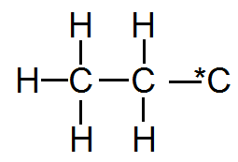

b) Identify the hybridization of the carbon atom marked with the asterisk. ________ *(1pt)*

c) Propanoic acid has a lower boiling point than butanoic acid, C3H7COOH.

i) Identify all the types of intermolecular forces present among the molecules in propanoic acid. *(1pt)*

ii) Which of the types of intermolecular forces that you identified in part (c)(i) is most responsible for the difference in boiling points of the two acids? *(1pt)*