|  |  |  |  |
| --- | --- | --- | --- |
| ­Experiment | Initial [NO]  (mol L−1) | Initial [Br2]  (mol L−1) | Initial Rate of  Appearance of NOBr  (mol L-1 s-1) |
| 1 | 0.0160 | 0.0120 | 3.24 x 10-4 |
| 2 | 0.0160 | 0.0240 | 6.38 x 10-4 |
| 3 | 0.0320 | 0.0060 | 6.42 x 10-4 |

1) A rate study of the reaction represented below was conducted at 25°C. The data that were obtained are shown in the table. 1999 3

2 NO(*g*) + Br2(*g*) → 2 NOBr(*g*)

a) Calculate the initial rate of disappearance of Br2(*g*) in experiment 1. *(1pt)*

b) Determine the order of the reaction with respect to each reactant, Br2(*g*) and NO(*g*). In each case, explain your reasoning. *(3pts)*

c) For the reaction,

i) write the rate law that is consistent with the data, and *(1pt)*

ii) calculate the value of the specific rate constant, *k*, and specify units. *(2pts)*

d) The following mechanism was proposed for the reaction: Br2(*g*) + NO(*g*) → NOBr2(*g*) *slow* NOBr2(*g*) + NO(*g*) → 2 NOBr(*g*) *fast*

Is this mechanism consistent with the given experimental observations? Justify your answer. *(2pt)*

|  |  |  |  |
| --- | --- | --- | --- |
| Time (minutes) | [X]  (mol L− 1) | ln [X] | [X] – 1  (L mol −1 ) |
| 0 | 0.00633 | −5.062 | 158 |
| 10. | 0.00520 | −5.259 | 192 |
| 20. | 0.00427 | −5.456 | 234 |
| 30. | 0.00349 | −5.658 | 287 |
| 50. | 0.00236 | −6.049 | 424 |
| 70. | 0.00160 | −6.438 | 625 |
| 100. | 0.000900 | −7.013 | 1,110 |

X → 2 Y + Z

5) The decomposition of gas X to produce gases Y and Z is represented

by the equation above. In a certain experiment, the reaction took place

in a 5.00 L flask at 428 K. Data from this experiment were used to produce the information in the table below, which is plotted in the graphs that follow. 2005B 3

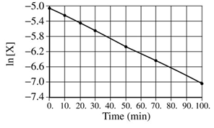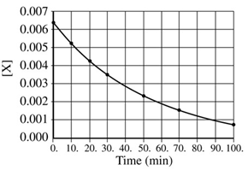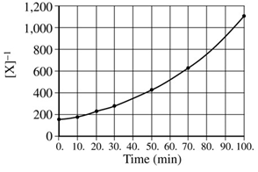

a) How many moles of X were initially in the flask? *(1pt)*

b) How many molecules of Y were produced in the first 20. minutes of the reaction? *(2pts)*

c) What is the order of this reaction with respect to X? Justify your answer. *(1pt)*

d) Write the rate law for this reaction. *(1pt)*

e) Calculate the specific rate constant for this reaction. Specify units. *(2pts)*

f) Calculate the concentration of X in the flask after a total of 150. minutes of reaction. *(2pts)*

|  |  |  |  |
| --- | --- | --- | --- |
| Experiment | Initial [H2]  (mol L−1) | Initial [Cl2]  (mol L−1) | Initial Rate of Formation of HCl (mol L−1 s−1) |
| 1 | 0.00100 | 0.000500 | 1.82 × 10−12 |
| 2 | 0.00200 | 0.000500 | 3.64 × 10−12 |
| 3 | 0.00200 | 0.000250 | 1.82 × 10−12 |

H2(*g*) + Cl2(*g*) → 2 HCl(*g*)

9) The table gives data for a reaction rate study of the reaction represented above.

2010B 6

a) Determine the order of the reaction with respect to H2 and justify your answer. *(1pt)*

b) Determine the order of the reaction with respect to Cl2 and justify your answer. *(1pt)*

c) Write the overall rate law for the reaction. _____________________ *(1pt)*

d) Write (determine) the units of the rate constant.*(1pt)*

e) Predict the initial rate of the reaction if the initial concentration of H2 is 0.00300 mol L−1 and the initial concentration of Cl2 is 0.000500 mol L−1. *(1pt)*

The gas-phase decomposition of nitrous oxide has the following two-step mechanism. Step 1: N2O → N2 + O

Step 2: O + N2O → N2 + O2

f) Write the balanced equation for the overall reaction. *(1pt)*

g) Is the oxygen atom, O, a catalyst for the reaction or is it an intermediate? Explain. *(1pt)*

h) Identify the slower step in the mechanism if the rate law for the reaction was determined to be *rate* = *k* [N2O].

Justify your answer. *(1pt)*

|  |  |  |
| --- | --- | --- |
| [X]  (*M*) | Absorbance | Time (min) |
| ? | 0.600 | 0.0 |
| 4.00 × 10– 5 | 0.200 | 35.0 |
| 3.00 × 10– 5 | 0.150 | 44.2 |
| 1.50 × 10– 5 | 0.075 | ? |

The first-order decomposition of a colored chemical species, X, into colorless products is monitored with a spectrophotometer by measuring changes in absorbance over time. Species X has a molar absorptivity constant of

5.00 × 103 cm–1 *M* –1 and the path length of the cuvette containing the reaction mixture is 1.00 cm. The data from the experiment are given in the table. 2004 3

a) Calculate the initial concentration of the colored species. *(1pt)*

b) Calculate the rate constant for the first-order reaction using the values given for concentration and time.

Include units with your answer. *(2pts)*

c) Calculate the number of minutes it takes for the absorbance to drop from 0.600 to 0.075. *(2pts)*

d) Calculate the half-life of the reaction. Include units with your answer. *(2pts)*