**Kinetics Practice Multiple Choice**

1) Which of the following best helps explain why an increase in temperature increases the rate of a chemical reaction?

A) At higher temperatures, reactions have a lower activation energy.

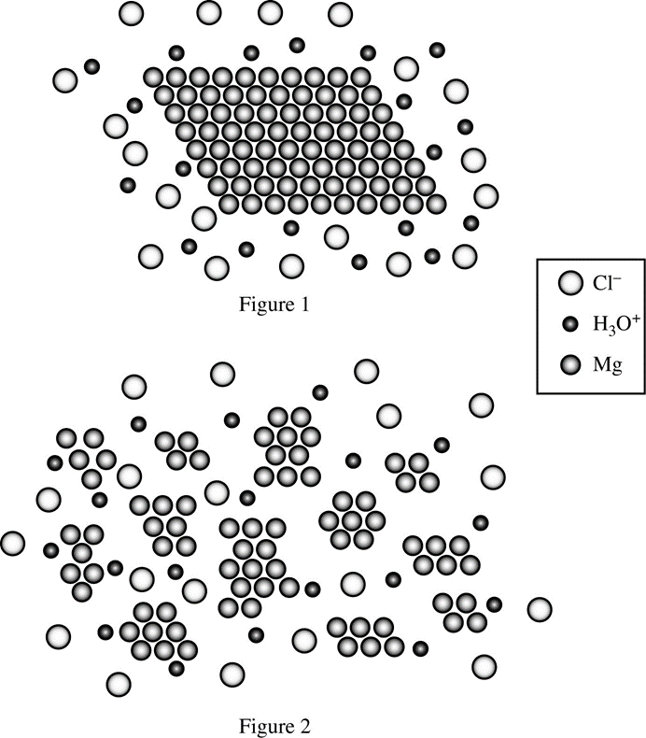 B) At higher temperatures, reactions have a higher activation energy.

C) At higher temperatures, every collision results in the formation of product.

D) At higher temperatures, high-energy collisions happen more frequently.

2) Two samples of Mg(*s*) of equal mass were placed in equal amounts of HCl(*aq*) contained in two separate reaction vessels. Particle representations of the mixing of Mg(*s*) and HCl(*aq*) in the two reaction vessels are shown in Figure 1 and 2.

Water molecules are not included in the particle representations.

Which of the reactions will initially proceed faster, and why?

A) The reaction in Figure 1, because the atoms of Mg are more concentrated than those in Figure 2

B) The reaction in Figure 1, because the Mg(*s*) in Figure 1 has a larger mass than the Mg(*s*) in Figure 2

C) The reaction in Figure 2, because more Mg atoms are exposed to HCl(*aq*) in Figure 2 than in Figure 1

D) The reaction in Figure 2, because the Mg(*s*) in Figure 2 has less surface area than the Mg(*s*) in Figure 1

3) Which of the following will most likely increase the rate of the following reaction? C2H4(*g*) + H2(*g*) → C2H6(*g*)

A) Decreasing the temperature of the reaction system B) Adding a heterogeneous catalyst to the reaction system C) Increasing the volume of the reaction vessel using a piston D) Removing some H2(*g*) from the reaction system

2 NO2(*g*) + F2(*g*) → 2 NO2F(*g*)

4) The rate law for the reaction represented by the equation above is rate = *k* [NO2][F2]. Which of the following could be the first elementary step of a two-step mechanism for the reaction if the first step is slow and the second step is fast? A) F2(*g*) → 2 F(*g*) B) NO2(*g*) + F2(*g*) → NO2F(*g*) + F(*g*)

C) NO2(*g*) + F(*g*) → NO2F(*g*) D) 2 NO2(*g*) + F2(*g*) → 2 NO2F(*g*)

NO2(*g*) + CO(*g*) → NO2(*g*) + CO2(*g*)

5) The reaction between NO2(*g*) and CO(*g*) is represented above. The elementary steps of a proposed reaction

mechanism are represented here: Step 1: 2 NO2(*g*) → NO(*g*) + NO3(*g*) (*slow*)

Step 2: NO3(*g*) + CO(*g*) → NO2(*g*) + CO2(*g*) (*fast*)

Which of the following is the rate law for the overall reaction that is consistent with the proposed mechanism?

A) Rate = *k* [NO2][CO] B) Rate = *k* [NO2]2  C) Rate = *k* [NO3][CO] D) Rate = *k* [NO2][NO3][CO]

Cl−(*aq*) + ClO−(*aq*) + 2 H+(*aq*) → Cl2(*g*) + H2O(*l*)

6) What effect will increasing [H+] at constant temperature have on the reaction represented above?

A) The activation energy of the reaction will increase.

B) The activation energy of the reaction will decrease.

C) The frequency of collisions between H+(*aq*) ions and ClO−(*aq*) ions will increase.

D) The value of the rate constant will increase.

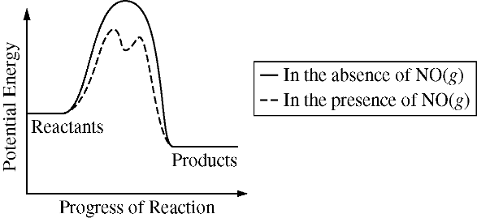

7)

|  |  |
| --- | --- |
| A) 2 O3(*g*) + 2 NO(*g*) → 4 O2(*g*) + N2(*g*) | *slow* |
| B) O3(*g*) + NO(*g*) → NO2(*g*) + O2(*g*) | *slow* |
| NO2(*g*) + O(*g*) → NO(*g*) + O2(*g*) | *fast* |
| C) NO2(*g*) + O3(*g*) → NO(*g*) + 2 O2(*g*) | *slow* |
| NO(*g*) + O(*g*) → NO2(*g*) | *fast* |
| D) NO2(*g*) + O(*g*) → NO3(*g*) | *slow* |
| NO3(*g*) + O3(*g*) → NO2(*g*) + 2 O2(*g*) | *fast* |

The decomposition of O3(*g*) in the upper atmosphere is represented by the equation O3 (*g*) + O(*g*)→ 2 O2 (*g*). The potential energy diagram for the decomposition of O3(*g*) in the presence and absence of NO(*g*) is given. Which of the following mechanisms for the catalyzed reaction is consistent with the equation and diagram?

**Questions 8-10 refer to the investigation described below.**  C25H30N3+ (*aq*) + OH− (*aq*) → C25H30N3OH (*aq*)

*violet colorless*

The reaction between C25H30N3+(*aq*) and OH− (*aq*), as represented above, is first order with respect to C25H30N3+ (*aq*) in the presence of excess OH− (*aq*). A 10.0 mL sample of 0.10 *M* NaOH(*aq*) is mixed with a 10.0 mL sample of 2.5 x 10−5 *M* C25H30N3+ (*aq*). A 5.0 mL sample of the mixture is quickly transferred to a clean cuvette and placed in a spectrophotometer, and the progress of the reaction is measured. The data are given in the table below.

|  |  |  |  |  |  |  |  |  |  |  |  |
| --- | --- | --- | --- | --- | --- | --- | --- | --- | --- | --- | --- |
| Time (s) | 0 | 30 | 60 | 90 | 120 | 150 | 180 | 210 | 240 | 270 | 300 |
| Absorbance | 0.62 | 0.54 | 0.47 | 0.41 | 0.36 | 0.31 | 0.27 | 0.23 | 0.20 | 0.17 | 0.15 |

8) Approximately how long did it take for 75 percent of the initial amount of C25H30N3+(*aq*) to react?

A) 75 s B) 225 s C) 300 s D) 600 s

9) What would be the effect on the reaction rate if the solution of C25H30N3+(*aq*) is diluted by a factor of two?

A) It would be higher. B) It would be lower.

C) It would not change. D) It would initially be higher but then rapidly decrease.

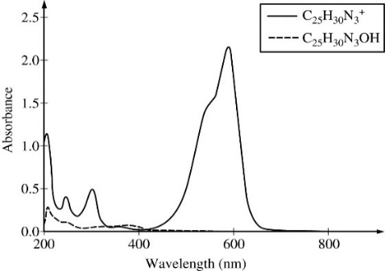

10) To choose a wavelength to analyze the progress of the reaction, a student records the absorbance spectra of both C25H30N3+(*aq*) and C25H30N3OH(*aq*)in the range of 200-800 nm. The two spectra are presented in the graph.

The student wants to use the spectrophotometer to measure [C25H30N3+] with the greatest sensitivity as the reaction progresses. Which of the following indicates the best wavelength setting and explains why it is best?

A) 205 nm, because the colorless form of the molecule will absorb significantly at this wavelength

B) 205 nm, because both forms of the molecule will absorb significantly at this wavelength

C) 590 nm, because only the violet form of the molecule will absorb significantly at this wavelength

D) 590 nm, because this wavelength falls in the violet region of the visible light spectrum

Use this equation for #11 - 13: 2NO(*g*) + O2(*g*) → 2NO2(*g*)

|  |  |  |  |
| --- | --- | --- | --- |
| Trial | [O2] | [NO] | Initial Rate of Formation of NO2 (*M* s −1) |
| 1 | 0.020 | 0.050 | 0.038 |
| 2 | 0.020 | 0.100 | 0.152 |
| 3 | 0.080 | 0.100 | 0.608 |

11) Nitrogen monoxide and oxygen gas were combined in a flask at 25◦C and allowed to react as shown above. The concentration of the reactants were varied according to the table to the right, and initial rates were calculated. Which of the following is the rate law for the reaction?

A) Rate = k[O2]2 [NO]2

B) Rate = k[NO]2

C) Rate = k[O2][NO]2

D) Rate = k[O2][NO]

12) Which mechanism agrees with the rate law above?

|  |  |
| --- | --- |
| Step 1: NO(g) + O2(*g*) → NO2(*g*) + O(g) | (*slow*) |
| Step 2: NO(*g*) + O(*g*) → NO2(*g*) | (*fast*) |

|  |  |
| --- | --- |
| Step 1: NO(g) + O2(*g*) → NO2(*g*) + O(g) | (*fast*) |
| Step 2: NO(*g*) + O(*g*) → NO2(*g*) | (*slow*) |

A) B)

13) Which substance is acting as intermediate in each mechanism?

A) NO B) NO2 C) O D) O2