**Practice MCQS: Acid Base Equilibria**

1) When 200. mL of 2.0M NaOH(aq) is added to 500. mL of 1.0M HCl (aq), the pH of the resulting mixture is closest to

A) 1.0 B) 3.0 C) 7.0 D) 13.0

2) An acetate buffer solution is prepared by combining 50. mL of 0.20 *M* acetic acid, Acetate Species pH

HC2H3O2(*aq*), and 50. mL of 0.20 *M* sodium acetate, NaC2H3O2(*aq*). A 5.0 mL A) HC2H3O2 < 4.7

sample of 0.10 *M* NaOH(*aq*) is added to the buffer solution. Which of the following B) HC2H3O2> 4.7

is a correct pairing of the acetate species present in greater concentration and of the C) C2H3O2− < 4.7

pH of the solution after the NaOH(*aq*) is added? (The p*Ka* of acetic acid is 4.7.) D) C2H3O2− > 4.7

3) A solution is prepared by mixing 50 mL of 1*M* NaH2PO4  H3PO4 ⇋ H+ + H2PO4− *Ka*1 = 7.2 × 10−3

with 50 mL of 1*M* Na2HPO4. On the basis of the informationH2PO4− ⇋ H+ + HPO42− *Ka*2 = 6.3 × 10−8

which of the following species is present in the solution HPO42− ⇋ H+ + PO43− *Ka*3 = 4.5 × 10−13

at the lowest concentration?

A) Na+  B) HPO42− C) H2PO4− D) PO43−

|  |  |  |
| --- | --- | --- |
| Solution | Acid | Ka |
| 1 | CH3CO2H | 1.75 x 10−5 |
| 2 | CF3CO2H | 1.0 x 100 |

4) Acid-dissociation constants of two acids are listed in the table. A 20. mL sample of a 0.10 *M* solution of each acid is titrated to the equivalence point with 20.mL of 0.10 *M*  NaOH. Which of the following is a true statement about the pH of the solutions at the equivalence point?

A) Solution 1 has a higher pH at the equivalence point because CH3CO2H is the stronger acid.

B) Solution 1 has a higher pH at the equivalence point because CH3CO2H has the stronger conjugate base.

C) Solution 1 has a lower pH at the equivalence point because CH3CO2H is the stronger acid.

D) Solution 1 has a lower pH at the equivalence point because CH3CO2H has the stronger conjugate base.

5) Which of the following accounts for the observation that the pH of pure water at 37°C is 6.8 ?

A) At 37oC water is naturally acidic.

B) At 37oC the autoionization constant for water, *Kw*, is larger than it is at 25oC.

C) At 37oC water has a lower density than it does at 25oC; therefore, [H+] is greater.

D) At 37oC water ionizes to a lesser extent than it does at 25oC.

6) The dissociation of the weak acid HF in water is represented by the equation: HF(*aq*) + H2O(*l*) ⇌ H3O+(*aq*) + F−(*aq)* Adding a 1.0 mL sample of which of the following would increase the percent ionization of HF(*aq*) in 10 mL of a solution of 1.0 *M*  HF ? A) 1.0 *M*  KF B) 1.0 *M*  H2SO4  C) 10.0 *M*  HF D) Distilled water

7) HX(*aq*) + Y−(*aq*) ⇋ HY(*aq*)+ X−(*aq*) *Keq* > 1 A solution of a salt of a weak acid HY is added to a solution of another weak acid HX. Based on the information given above, which of the following species is the strongest base?

A) HX(*aq*) B) Y−(*aq*) C) HY(*aq*) D) X−(*aq*)

8) H2C2O4 + 2 H2O ⇄ 2 H3O+ + C2O42− Oxalic acid, H2C2O4, is a diprotic acid with K1 = 5 x 10−2 and K2 = 5 x 10−5. Which of the following is equal to the equilibrium constant for the reaction represented above?

A) 1000  B) 1 x 10−3  C) 2.5 x 10−6  D) 2.5 x 10−7

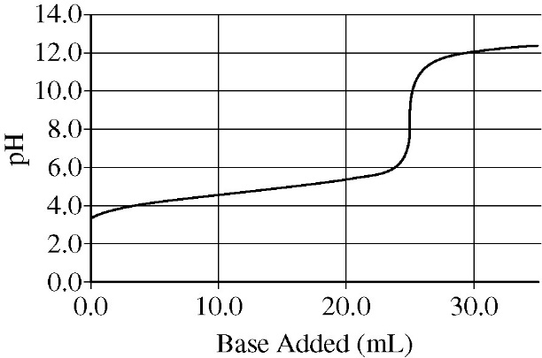**Questions 9-12 refer to the following information.**

A 0.35 g sample of Li(*s*) is placed in an Erlenmeyer flask containing

100 mL of water at 25°C. A balloon is placed over the mouth of the

flask to collect the hydrogen gas that is generated. After all of the Li(*s*) has reacted with H2O(*l*), the solution in the flask is added to a clean, dry buret and used to titrate an aqueous solution of a monoprotic acid.

The pH curve for this titration is shown in the diagram.

9) Which of the following changes will most likely increase the rate of reaction between Li(*s*) and water?

A) Using 125 mL of water instead of 100 mL

B) Using a 0.25 g sample of Li(*s*) instead of a 0.35 g sample

C) Using a 0.35 g sample of Li(*s*) cut into small pieces

D) Decreasing the water temperature before adding the Li(*s*)

10) What will be the effect on the amount of gas produced if the experiment is repeated using 0.35 g of K(*s*) instead of 0.35 g of Li(*s*) ?

A) No gas will be produced when K(*s*) is used.

B) Some gas will be produced but less than the amount of gas produced with Li(*s*).

C) Equal quantities of gas will be produced with the two metals.

D) More gas will be produced with K(*s*) than with Li(*s*).

11) On the basis of the pH curve, the p*Ka* value of the acid is closest to A) 4 B) 5 C) 8 D) 12

12) Which of the following is the balanced net-ionic equation for the reaction between Li(*s*) and water?

A) 2 Li(*s*) + 2 H+(*aq*) + 2 OH−(*aq*) → 2 Li+(*aq*) + 2 OH−(*aq*) + H2(*g*) C) 2 Li(*s*) + 2 H2O(*l*) → 2 LiOH(*s*) + H2(*g*)

B) 2 Li(*s*) + 2 H2O(*l*) → 2 Li+(*aq*) + 2 OH−(*aq*) + H2(*g*) D) 2 Li(*s*) + 2 H2O(*l*) → 2 LiH(*s*) + H2(*g*)

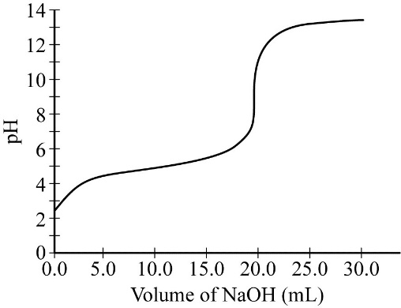

|  |  |  |
| --- | --- | --- |
|  | p*Ka* | [NaOH] |
| **A** | 4.7 | 0.050 *M* |
| **B** | 4.7 | 0.10 *M* |
| **C** | 9.3 | 0.050 *M* |
| **D** | 9.3 | 0.10 *M* |

13) Data collected during the titration of a 20.0 mL sample of a 0.10 *M* solution of a monoprotic acid with a solution of NaOH of unknown concentration are plotted in the graph. Based on the data, which of the following are the approximate p*Ka* of the acid and the molar concentration of the NaOH?

14) In a saturated solution of Zn(OH)2 at 25°C , the value of [OH−] is 2.0 × 10−6M.

What is the value of the solubility-product constant, Ksp, for Zn(OH)2 at 25°C ?   
 A) 4.0 × 10−18 B) 8.0 × 10−18 C) 1.6 × 10−17 D) 4.0 × 10−12

|  |  |
| --- | --- |
| Compound | *Ksp* |
| PbCl2 | 1.2 × 10−5 |
| CuCl | 1.6 × 10−7 |
| AgCl | 1.8 × 10−10 |
| Hg2Cl2 | 1.4 × 10−18 |

15) Based on the *Ksp* values in the table, a saturated solution of which of the following compounds has the highest [Cl−] ?

A) PbCl2 B) CuClC) AgCl D) Hg2Cl2

16) Based on the information given below, which of the following is the strongest acid?

A) HX(*aq*) B) Y− (*aq*) C) HY(*aq*) D) X− (*aq*) HX(*aq*) + Y− (*aq*) ⇄ HY(*aq*) + X− (*aq*) *Keq* > 1

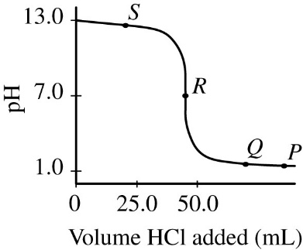**Questions 17-18 refer to the following information.**

NaOH(*aq*) + HCl(*aq*) → NaCl(*aq*) + H2O(*l*)

To determine the concentration of a NaOH(*aq*) solution, a student titrated a 50. mL sample with 0.10 *M* HCl(*aq*). The reaction is represented by the equation above. The titration is monitored using a pH meter, and the experimental results are plotted in the graph below.

17) At the point labeled *R* on the pH curve, which of the following ions are present in the reaction mixture at a concentration greater than 0.01 *M* ?

A) Na+ and Cl− only B) Na+,Cl−, andH+ only C) Na+,Cl−, andOH− only D) Na+,Cl−,H+, andOH−

18) One student titrated the NaOH(*aq*) with 1.0 *M* HCl(*aq*) instead of 0.10 *M* HCl(*aq*). How would the student’s titration curve differ from the original curve?

A) The initial pH would be 11 instead of 13.

B) The pH at the equivalence point would be 5 instead of 7.

C) The pH far beyond the equivalence point would be higher than in the original curve.

D) The pH far beyond the equivalence point would be lower than in the original curve.

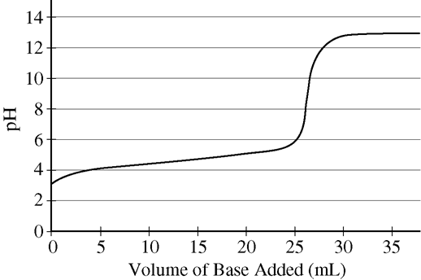19) A student performs an acid-base titration and plots the experimental results in the graph. Which of the following statements best explains the experimental findings?

A) A strong acid was titrated with a strong base, as evidenced by the equivalence point at pH = 7.

B) A strong acid was titrated with a strong base, as evidenced by the equivalence point at pH > 7.

C) A weak acid was titrated with a strong base, as evidenced by the equivalence point at pH > 7.

D) A weak acid was titrated with a weak base, as evidenced by the equivalence point at pH approximately 7.

|  |  |
| --- | --- |
| **Compound** | ***Ksp* at 298 K** |
| Ag2SO4 | 1 x 10−5 |
| PbSO4 | 1 x 10−8 |

20) A 1.0 L solution of AgNO3(*aq*) and Pb(NO3)2(*aq*) has a Ag+ concentration of 0.020 *M* and a Pb2+ concentration of 0.0010 *M.* A 0.0010 mol sample of K2SO4(*s*) is added to the solution. Based on the information in the table above, which of the following will occur? (Assume that the volume change of the solution is negligible.)

A) No precipitate will form. B) Only Ag2SO4(*s*) will precipitate.

C) Only PbSO4(*s*) will precipitate. D) Both Ag2SO4(*s*) and PbSO4(*s*) will precipitate.

21) The pH of a 0.01 *M* HNO2(*aq*) solution is in which of the following ranges? (For HNO2(*aq*), *Ka* = 4.0 × 10−4)

A) Between 1 and 2 B) Between 2 and 3 C) Between 4 and 5 D) Between 6 and 7

|  |  |  |
| --- | --- | --- |
| Acid | Concentration | pH |
| X | 0.005 *M* | 2.3 |
| Y | 2.0 *M* | 2.8 |
| Z | 3.0 *M* | 2.8 |

22) Which of the following correctly ranks the three monoprotic acids listed in the table from the weakest to the strongest?

A) X < Y < Z B) X < Z < Y

C) Y < Z < X D) Z < Y < X

|  |  |  |
| --- | --- | --- |
| Solution | Solute | *Ksp* at 25°C |
| X | AgBr | 5.0 × 10−13 |
| Y | AgCl | 1.8 × 10−10 |
| Z | AgI | 8.3 × 10−17 |

23) Three saturated solutions (X, Y, and Z) are prepared at 25°C. Based on the information in the table above, which of the following lists the solutions in

order of increasing [Ag+] ?

A) X < Z < Y B) Y < X < Z

C) Z < Y < X D) Z < X < Y

24) What are the relative strengths of the acids and bases in the reaction represented by the equation below?

Acid Strength Base Strength

A) HClO2 < HCOOH ClO2− < HCOO− ClO2−(*aq*) + HCOOH(*aq*) ⇆ HClO2 (*aq*) + HCOO−(*aq*)

B) HClO2 < HCOOH ClO2− > HCOO− *Keq* < 1

C) HClO2 > HCOOH ClO2− > HCOO−

D) HClO2 > HCOOH ClO2− < HCOO−

25) A student prepares a solution by combining 100 mL of 0.30 *M* HNO2(*aq*) and 100 mL of 0.30 *M* KNO2(*aq*). Which of the following equations represents the reaction that best helps to explain why adding a few drops of 1.0 *M* HCl(*aq*) does not significantly change the pH of the solution?

A) K+(*aq*) + Cl−(*aq*) → KCl(*s*) B) HNO2(*aq*) → H+(*aq*) + NO2−(*aq*)

C) H+(*aq*) + OH−(*aq*) → H2O(*l*) D) H+(*aq*) + NO2−(*aq*) → HNO2(*aq*)

**Practice FRQs Acid/Base Equil.**

1) In a saturated solution of MgF2 at 18° C, the concentration of Mg2+ is 1.21 x 10−3M. The equilibrium is represented by the equation: MgF2(*s*) ⇋ Mg2+(*aq*) + 2 F−(*aq*) **1994 #1**

a) Write the expression for the solubility-product constant, K*sp*, and calculate its value at 18° C. *(2pts)*

b) Calculate the equilibrium concentration of Mg2+ in 1.000 L of saturated MgF2 solution at 18° C to which 0.100 mole of solid KF has been added. KF dissolves completely. Assume the volume change is negligible. *(2pts)*

c) Predict whether a precipitate of MgF2 will form when 100.0 mL of a 3.00 x 10−3M Mg(NO3)2 solution is mixed with 200.0 mL of 2.00 x 10−3M NaF solution at 18° C. Calculations to support your prediction must be shown.

*(3pts)*

d) At 27° C the concentration of Mg2+ in a saturated solution of MgF2 is 1.17 x 10−3M. Is the dissolving of MgF2 in water endothermic or exothermic? Give an explanation to support your conclusion. *(2pts)*

2) Potassium sorbate, KC6H7O2 (molar mass 150. g/mol) is commonly added to diet soft drinks as a preservative. A stock

solution of KC6H7O2(*aq*) of known concentration must be prepared. A student titrates 45.00 mL of the stock solution

with 1.25 *M* HCl(*aq*) using both an indicator and a pH meter. The value of *Ka* for sorbic acid, HC6H7O2, is 1.7 × 10−5.

a) Write the net-ionic equation for the reaction between KC6H7O2(*aq*) and HCl(*aq*). *(1pt)* **2015 #3**

b) A total of 29.95 mL of 1.25 *M* HCl(*aq*) is required to reach the equivalence point. *(2pts)*

Calculate [KC6H7O2] in the stock solution.

|  |  |
| --- | --- |
| Indicator | p*Ka* |
| Phenolphthalein | 9.3 |
| Bromothymol blue | 7.0 |
| Methyl red | 5.0 |
| Thymol blue | 2.0 |
| Methyl violet | 0.80 |

c) The pH at the equivalence point of the titration is measured to be 2.54. Which of the following indicators would be the best choice for determining the end point of the titration? Justify your answer. *(2pts)*

d) Calculate the pH at the half-equivalence point. *(1pt)*

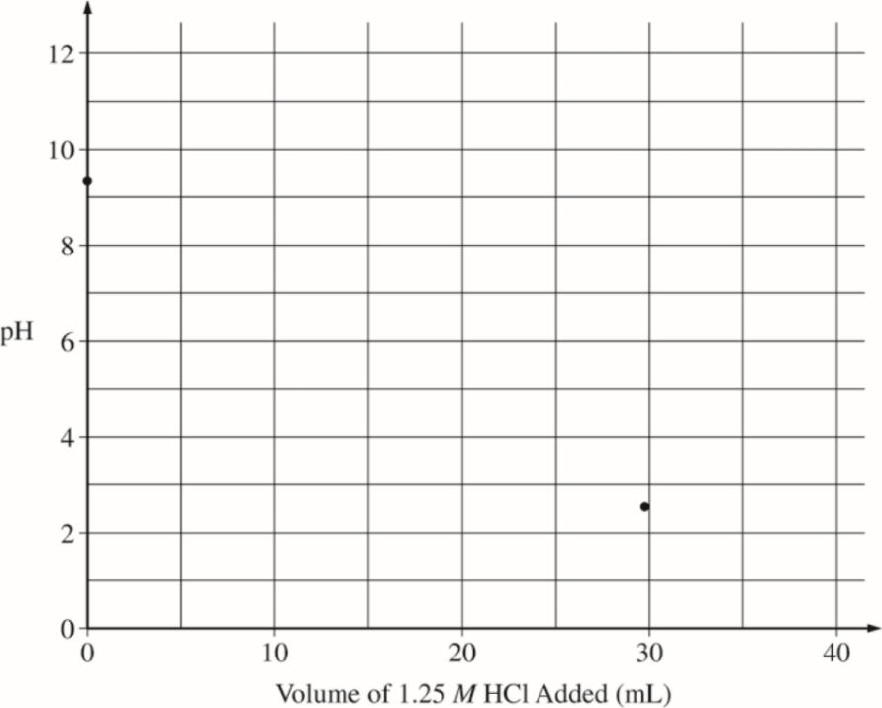

e) The initial pH and the equivalence point are plotted on the graph. Accurately sketch the titration curve on the graph below. Mark the position of the half-equivalence point on the curve with an X. *(3pts)*

f) The pH of the soft drink is 3.37 after the addition of the KC6H7O2(*aq*). Which species, HC6H7O2 or C6H7O2− , has a higher concentration in the soft drink? Justify your answer. *(1pt)*

A student is instructed to prepare 100.0 mL of 1.250 *M* NaOH from a stock solution of 5.000 *M* NaOH. 2011B 5

The student follows the proper safety guidelines.

a) Calculate the volume of 5.000 *M* NaOH needed to accurately prepare 100.0 mL of 1.250 *M* NaOH solution.

b) Describe the steps in a procedure to prepare 100.0 mL of 1.250 *M* NaOH solution using 5.000 *M* NaOH and equipment selected from the list below.

Balance 25 mL Erlenmeyer flask 100 mL graduated cylinder 100 mL volumetric flask

50 mL buret 100 mL Florence flask 25 mL pipet 100 mL beaker

Eyedropper Drying oven Wash bottle of distilled H2O Crucible

c) The student is given 50.0 mL of a 1.00 *M* solution of a weak, monoprotic acid, HA. The solution is titrated with the 1.250 *M* NaOH to the endpoint. (Assume that the endpoint is at the equivalence point.)

i) Explain why the solution is basic at the equivalence point of the titration.

Include a chemical equation as part of your explanation.

|  |  |
| --- | --- |
| Indicator | p*Ka* |
| Methyl red | 5 |
| Bromothymol blue | 7 |
| Phenolphthalein | 9 |

ii) Identify the indicator in the table below that would be best for the titration. Justify your choice.

d) The student is given another 50.0 mL sample of 1.00 *M* HA, which the student adds to the solution that had been titrated to the endpoint in part (c). The result is a solution with a pH of 5.0.

i) What is the value of the acid-dissociation constant, *Ka* , for the weak acid? Explain your reasoning.

ii) Explain why the addition of a few drops of 1.250 *M* NaOH to the resulting solution does not appreciably change its pH.

HC9H7O4(*aq*) + H2O(*l*) ⇋ H3O+(*aq*) + C9H7O4−(*aq*)

The molecular formula of acetylsalicylic acid, also known as aspirin, is HC9H7O4. The dissociation of HC9H7O4(*aq*) is represented by the equation above. The pH of 0.0100 *M* HC9H7O4(*aq*) is measured to be 2.78.

a) Write the expression for the equilibrium constant, *Ka*, for the reaction above. *(1pt)* 2015 Practice 7

b) Calculate the value of *Ka*  for acetylsalicylic acid. *(2pts)*

c) An aqueous solution of aspirin is buffered to have equal concentrations of HC9H7O4(*aq*) and C9H7O4−(*aq*). Calculate the pH of the solution. *(1pt)*

A volume of 30.0 mL of 0.10 *M* NH3(*aq*) is titrated with 0.20 *M* HCl(*aq*). The value of the base-dissociation constant, *Kb*, for NH3 in water is 1.8 x10-5 at 25C. 2000 #8

a) Write the net-ionic equation for the reaction of NH3(*aq*) with HCl(*aq*). *(1pt)*

b) Using the axes provided, sketch the titration curve

that results when a total of 40.0 mL of

0.20 *M* HCl(*aq*) is added dropwise to the

30.0 mL volume of 0.10 *M* NH3(*aq*). *(3pts)*

|  |  |
| --- | --- |
| **Indicator** | **p*Ka*** |
| Methyl Red | 5.5 |
| Bromothymol Blue | 7.1 |
| Phenolphthalein | 8.7 |

c) From the table, select the most appropriate indicator for the titration.

Justify your choice. *(2pts)*

d) If equal volumes of 0.10 *M* NH3(*aq*) and 0.10 *M* NH4Cl(*aq*) are mixed, is the resulting solution acidic, neutral, or basic? Explain. *(2pts)*