**Practice MCQs Thermochemistry and Electrochemistry**

**Questions 1-2 refer to the following information.**

2 H2O2(*aq*) → 2 H2O(*l*) + O2(*g*) *E*° = 0.55 V

The equation and standard cell potential for the decomposition

of H2O2(*aq*) in acidic solution at 25°C is given. O2(*g*) + 4 H+(*aq*) + 4 *e*− → 2 H2O(*l*) *E*° = 1.23 V

The reduction half-reactions for the process are also listed. O2(*g*) + 2 H+(*aq*) + 2 *e*− → H2O2(*aq) E*° = ?

1) Determine the missing standard reduction potential. A) −1.78 V B) −0.68 V C) +0.68 V D) +1.78 V

***Note: The voltage value for the decomposition of hydrogen peroxide is incorrectly given as 0.55V – it should be 1.10V. Also the 2 half reactions exchange 4 electrons where the overall reaction only exchanges 2 electrons. This reaction should not have been used. The “correct” answer for the question can be found by treating it as if the exchange was equal.***

2) Which of the following is true for the decomposition of H2O2(*aq*) ?

A) ∆*G°* > 0 and *Keq* > 1 B) ∆*G°* > 0 and *Keq* < 1 C) ∆*G°* < 0 and *Keq* > 1 D) ∆*G°* < 0 and *Keq* < 1

|  |  |  |  |
| --- | --- | --- | --- |
| Trial | Volume of 0.10 *M* HCl | Volume of 0.10 *M* NaOH | Amount of Heat  Released |
| 1 | 50. mL | 50. mL | X |
| 2 | 100. mL | 50. mL | Y |

3) A student conducted an experiment to determine ∆*H*o*rxn* for the reaction between HCl(*aq*) and NaOH(*aq*). The student ran two trials using the volumes of HCl(*aq*) and NaOH(*aq*) indicated in the table, and determined the amount of heat released. Which of the following best explains the relationship between X and Y?

A) Y = 2X, because the volume of HCl(*aq*) used in trial 2 is twice the volume used in trial 1.

B) Y = X, because the number of moles of acid and base reacting with each other is the same in both trials.

C) Y = 2X/3 because the heat is distributed over more particles in trial 2 than in trial 1.

D) The relationship between X and Y cannot be predicted.

4) A student mixes a 10.0 mL sample of 1.0 *M* NaOH(*aq*) with a 10.0 mL sample of 1.0 *M* HCl(*aq*) in a polystyrene container. The temperature of the solutions before mixing was 20.0°C. If the final temperature of the mixture is 26.0°C, what is the experimental value of ∆*H* o*rxn*?

(Assume that the solution mixture has a specific heat of 4.2 J/(g•K) and a density of 1.0 g/mL.)

A) −50. kJ/mol*rxn* B) −25 kJ/mol*rxn* C) −5.0 × 104 kJ/mol*rxn* D) −5.0 × 102 kJ/mol*rxn*

5) At 1.0 atm a sample of ice is heated to liquid water and then to water vapor. The heating

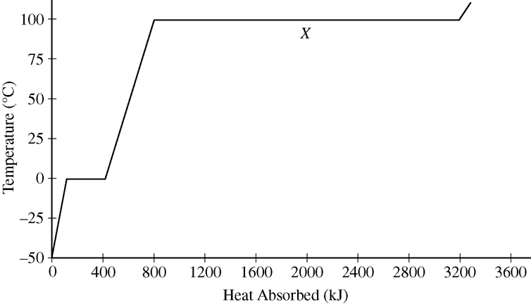 curve is shown in the graph. Which of the

following lists the signs for the changes in enthalpy and entropy for the process corresponding to segment *X*, going from left to

right?

∆*H*o ∆*S*o

A) Positive Negative

B) Positive Positive

C) Negative Negative

D) Negative Positive

**Questions 6-9 refer to the following.** CH3OH(*g*) → CO(*g*) + 2 H2(*g*) ∆*H*° = +91 kJ/mol*rxn*

The reaction represented above goes essentially to completion. The reaction takes place in a rigid, insulated vessel

that is initially at 600 K.

6) What happens to the temperature of the contents of the vessel as the reaction occurs?

A) The temperature must increase, because according to Le Châtelier’s principle, an increase in temperature causes more products to form.

B) The temperature must decrease, because the reaction takes place at a temperature above room temperature.

C) The temperature must decrease, because the reaction is endothermic.

D) The temperature does not change, because the vessel is insulated.

7) A sample of CH3OH(*g*) is placed in the previously evacuated vessel with a pressure of *P*1 at 600 K. What is the final pressure in the vessel after the reaction is complete and the contents of the vessel are returned to 600 K?

A) P1 / 9 B) P1 / 3 C) P1 D) 3P1

8) What can be inferred about ∆*S°* for the reaction at 600 K?

A) It must be positive, since the reaction is thermodynamically unfavorable at 600 K.

B) It must be negative, since there are more moles of products than reactants.

C) It must be positive, since ∆*G°* is negative and ∆*H°* is positive.

D) It must be negative, since ∆*G°* is positive and ∆*H°* is positive.

9) Which of the following statements about the bonds in the reactants and products is most accurate?

A) The sum of the bond enthalpies of the bonds in the reactant is greater than the sum of the bond enthalpies of the bonds in the products.

B) The sum of the bond enthalpies of the bonds in the reactant is less than the sum of the bond enthalpies of the bonds in the products.

C) The length of the bond between carbon and oxygen in CH3OH is shorter than the length of the bond between carbon and oxygen in CO.

D) All of the bonds in the reactant and products are polar.

|  |  |
| --- | --- |
| Half-Reaction | *E*° (V) |
| Mg2+(*aq*) + 2 *e*− → Mg(*s*) | −2.37 |
| Cr3+(*aq*) + 3 *e*− → Cr(*s*) | −0.74 |

10) Based on the information in the table, which of *Eocell*(V) Δ*G0* (kJ/mol*rxn*)

the following shows the cell potential and the A) +1.63 −157 reaction that occurs in a standard Gibbs free B) +1.63 −944 energy change for the overall galvanic cell? C) +5.63 −543

D) +5.63 −3262

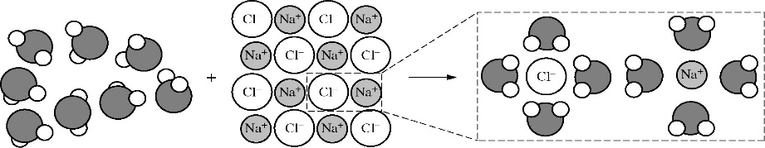11) The process of dissolution of NaCl(*s*) in H2O(*l*) is represented in the diagram above. Which of the following summarizes the signs of Δ*H*°and Δ*S*° for each part of the dissolution process?

|  |  |  |  |
| --- | --- | --- | --- |
|  | Breaking solvent-solvent interactions | Breaking solute-solute interactions | Forming solute-solvent interactions |
| Δ*H*° Δ*S*° | Δ*H*° Δ*S*° | Δ*H*° Δ*S*° |
| A) | + + | + + | − − |
| B) | + + | + + | − + |
| C) | − − | − − | + + |
| D) | − + | − + | + − |

**Questions 12-14 refer to the following information.**

|  |  |  |
| --- | --- | --- |
| Δ*Go*298 | Δ*Ho*298 | Δ*So*298 |
| +15 kJ/mol*rxn* | +12 kJ/mol*rxn* | −10 J/(K⋅mol*rxn*) |

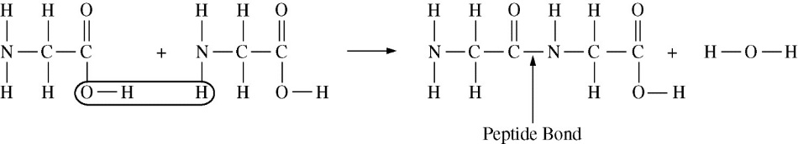Two molecules of the amino acid glycine join through the formation of a peptide bond, as shown. The thermodynamic data for the reaction are listed in the following table.

12) Under which of the following temperature conditions is the reaction thermodynamically favored?

A) It is only favored at high temperatures. B) It is only favored at low temperatures.

C) It is favored at all temperatures. D) It is not favored at any temperature.

|  |  |
| --- | --- |
| Bond | Bond Energy  (kJ/mol) |
| C−O | 360 |
| N−H | 390 |
| O−H | 460 |

13) Based on the bond energies listed in the table, which of the following is closest to the

bond energy of the C−N bond?

A) 200 kJ/mol B) 300 kJ/mol C) 400 kJ/mol D) 500 kJ/mol

14) Based on the thermodynamic data, which of the following is true at 298 K?

A) *Keq* = 0 B) 0 < *Keq* < 1 C) *Keq* = 1 D) *Keq* > 1

15) ∆S is positive for which of the following reactions?

A) 2H2(g) + O2(g) → 2H2O(g) B) 2Hg(l) + O2(g) → 2HgO(s)

C) CO2(g) → CO2(s) D) CaCl2(s) → Ca2+(aq) + 2Cl-(aq)

16) For which of the following processes would ∆S have a negative value? I. 2Fe2O3 (s) → 4Fe (s) + 3O2 (g)

A) I only B) I and II C) I and III D) II and III II. Mg2+ + 2OH− → Mg(OH)2 (s)

III. H2 (g) + C2H4 (g) → C2H6 (g)

17) N2 (g) + 3H2 (g) → 2NH3 (g)

The reaction indicated above is thermodynamically spontaneous at 298 K, but becomes nonspontaneous at higher temperatures. Which of the following is true at 298 K?

A) ∆G, ∆H, and ∆S are all positive. B) ∆G, ∆H, and ∆S are all negative.

C) ∆G and ∆H are negative, but ∆S is positive. D) ∆G and ∆S are negative, but ∆H is positive

18) Which of the following is always positive when a spontaneous process occurs?

A) ∆S(system) B) ∆H(surroundings) C) ∆S(universe) D) ∆H(system)