Answer the following questions about the thermodynamics of the reactions represented below. 2006B #3

Reaction *X*: ½ I2(*s*) + ½ Cl2(*g*) ⇆ ICl(*g*) ΔHo*f* = 18 kJ mol–1, Δo*S*298 = 78 J K–1 mol–1

Reaction *Y*: ½ I2(*s*) + ½ Br2(*l*) ⇆ IBr(*g*) ΔHo*f*  = 41 kJ mol–1, Δo*S*298 = 124 J K–1 mol–1

a) Is reaction *X ,* represented above, spontaneous under standard conditions? Justify your answer with a calculation. *(2pts)*

b) Calculate the value of the equilibrium constant, *Keq* , for reaction *X* at 25°C. *(1pt)*

c) What effect will an increase in temperature have on the equilibrium constant for reaction *X* ? Explain your answer.

*(1pt)*

d) Explain why the standard entropy change is greater for reaction *Y* than for reaction *X*. *(1pt)*

e) Above what temperature will the value of the equilibrium constant for reaction *Y* be greater than 1.0 ?

Justify your answer with calculations. *(2pts)*

f) For the vaporization of solid iodine, I2(*s*) → I2(*g*), the value of Δ*Ho*298 is 62 kJ mol–1.

Using this information, calculate the value of Δ*Ho*298 for the reaction represented below. *(2pts)*

I2(*g*) + Cl2(*g*) ←→ 2 ICl(*g*)

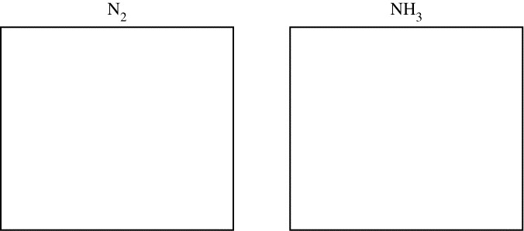Answer the following questions about nitrogen, hydrogen, and ammonia. 2009B #5

a) In the boxes, draw the complete Lewis electron-dot diagrams for N2 and NH3. *(2pts)*

b) Calculate the standard free-energy change, Δ*G*°, that occurs when 12.0 g of H2(*g*) reacts with excess N2(*g*) at 298 K according to the reaction: N2(*g*) + 3 H2(*g*) ⇆ 2 NH3(*g*) ΔGo298 = −34 kJ mol−1 *(2pts)*

c) Given that ΔHo298 for the reaction is −92.2 kJ mol−1, which is larger, the total bond dissociation energy of the reactants or the total bond dissociation energy of the products? Explain. *(1pt)*

d) The value of the standard entropy change, ΔSo298, for the reaction is −199 J mol−1K−1.

Explain why the value of ΔSo298 is negative. *(1pt)*

e) Assume that Δ*H*° and Δ*S*° for the reaction are independent of temperature.

i) Explain why there is a temperature above 298 K at which the algebraic sign of the value of Δ*G*° changes. *(1pt)*

ii) Theoretically, the best yields of ammonia should be achieved at low temperatures and high pressures. Explain.

*(2pts)*

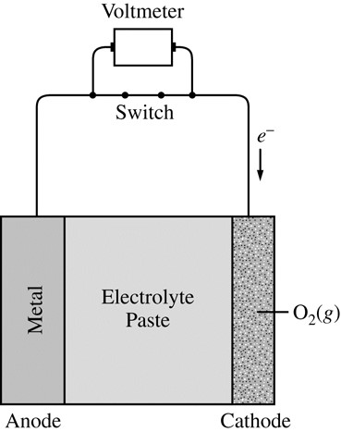Metal-air cells are a relatively new type of portable energy source consisting of a metal anode, an alkaline electrolyte paste that contains water, and a porous cathode membrane that lets in oxygen from the air. A schematic of the cell is shown. Reduction potentials for the cathode and three possible metal anodes are given in the table below. 2015 #1

|  |  |
| --- | --- |
| Half Reaction | *E* at pH 11 and 298 K (V) |
| O2(*g*) + 2 H2O(*l*) + 4 *e*− → 4 OH−(*aq*) | +0.34 |
| ZnO(*s*) + H2O(*l*) + 2 *e*− → Zn(*s*) + 2 OH−(*aq*) | –1.31 |
| Na2O(*s*) + H2O(*l*) + 2 *e*− → 2 Na(*s*) + 2 OH−(*aq*) | –1.60 |
| CaO(*s*) + H2O(*l*) + 2 *e*− → Ca(*s*) + 2 OH−(*aq*) | –2.78 |

a) Early forms of metal-air cells used zinc as the anode. Zinc oxide is produced as the cell operates according to the overall equation: 2 Zn(*s*) + O2(*g*) → 2 ZnO(*s*)

i) Using the data in the table above, calculate the cell potential for the zinc-air cell. *(1pt)*

ii) The electrolyte paste contains OH− ions. On the diagram of the cell above, draw an arrow to indicate the direction of migration of OH− ions through the electrolyte as the cell operates. *(1pt)*

b) A fresh zinc-air cell is weighed on an analytical balance before being placed in a hearing aid for use.

i) As the cell operates, does the mass of the cell increase, decrease, or remain the same? _______________ *(1pt)*

ii) Justify your answer to part (b)(i) in terms of the equation for the overall cell reaction. *(1pt)*

c) The zinc-air cell is taken to the top of a mountain where the air pressure is lower.

i) Will the cell potential be higher, lower, or the same as the potential at the lower elevation? ______________*(1pt)*

ii) Justify your answer to part (c)(i) based on the equation for the overall cell reaction and the information above. *(1pt)*

d) Metal-air cells need to be lightweight for many applications. In order to transfer more electrons with a smaller

mass, Na and Ca are investigated as potential anodes. A 1.0 g anode of which of these metals would transfer more electrons, assuming that the anode is totally consumed during the lifetime of a cell? Justify your answer with calculations. *(2pts)*

e) The only common oxide of zinc has the formula ZnO.

i) Write the electron configuration (Noble Gas shortcut) for a Zn atom in the ground state. *(1pt)*

ii) From which sublevel are electrons removed when a Zn atom in the ground state is oxidized? _____ *(1pt)*

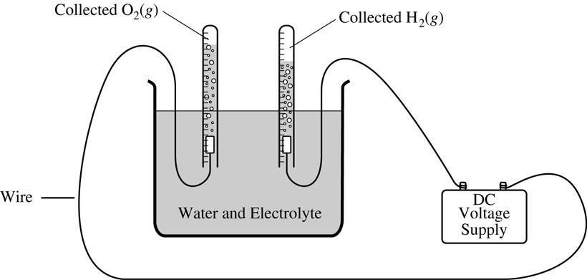1) Water was electrolyzed, as shown in the diagram, for 5.61 minutes using a constant current of 0.513 ampere. A small amount of nonreactive electrolyte was added to the container before the electrolysis began. The temperature was 298 K and the atmospheric pressure was 1.00 atm. 2005B #2

a) Write the balanced equations for the half reactions that took place at the anode and at the cathode. *(1pt)*

*(use your Table of Standard Reduction Potentials)*

*anode:*

*cathode:*

b) Calculate the amount of electric charge, in coulombs, that passed through the solution. *(2pts)*

c) Why is the volume of O2(*g*) collected different from the volume of H2(*g*) collected, as shown in the diagram? *(1pt)*

d) Calculate the number of moles of H2(*g*) produced during the electrolysis. *(2pts)*

e) Calculate the volume, in liters, at 298 K and 1.00 atm of dry H2(*g*) produced during the electrolysis. *(2pts)*

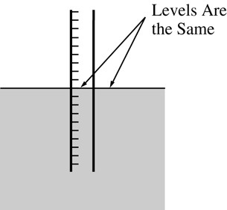 f) After the hydrolysis reaction was over, the vertical position of the tube containing the collected H2(*g*) was adjusted until the water levels inside and outside the tube were the same, as shown in the diagram below. The volume of gas in the tube was measured under these conditions of 298 K and 1.00 atm, and its volume was greater than the volume calculated in part (e). Explain why. *(1pt)*

|  |  |
| --- | --- |
| Half reaction | *E*° (V) |
| S4O62−(*aq*) + 2 *e*− → 2 S2O32−(*aq*) | 0.08 |
| I2(*s*) + 2 *e*− → 2 I−(*aq*) | 0.54 |
| O2(*g*) + 2 H+(*aq*) + 2 *e*− → H2O2(*aq*) | 0.68 |

While cleaning up an experiment, a student wishes to dispose of unused

solid I2 in a responsible manner. The student decides to convert the solid I2 to I−(*aq*) anion. The student has access to three solutions, H2O2(*aq*),Na2S2O3(*aq*), and Na2S4O6(*aq*), and the standard reduction table shown. 2016 3 e,f

e) Which solution should the student add to I2(*s*) to reduce it to I−(*aq*)? Circle your answer below.

Justify your answer, including a calculation of *E*° for the overall reaction. *(2pts)*

H2O2(*aq*) Na2S2O3(*aq*) Na2S4O6(*aq*)

f) Write the balanced net-ionic equation for the reaction between I2 and the solution you selected in part (e). *(1pt)*

The equations below represent reactions associated with the operation of a lead storage battery. The first is the overall reaction that occurs as the battery produces an electrical current, and the second is the half-reaction that occurs at the cathode. 2017 Practice 5

Overall reaction: Pb(*s*) + PbO2(*s*) + 2 H+(*aq*) + 2 HSO4−(*aq*) → 2 PbSO4(*s*) + 2 H2O(*l*) Eo = 2.05V

Cathode half-cell reaction: PbO2(*s*) + 3 H+(*aq*) + HSO4−(*aq*) + 2 *e*− → PbSO4(*s*) + 2 H2O(*l*) Eo = 1.69V

a) Determine the oxidation number of sulfur in the overall reaction. _______ *(1pt)*

b) Write the equation for the half-reaction that occurs at the anode as the battery operates. *(1pt) What is the voltage?*

After the battery has operated for some time, it can be recharged by applying a current to reverse the overall reaction. Calculate the time, in seconds, needed to regenerate 100. g of Pb(*s*) in the battery by applying a current of 5.00 amp.

c) Calculate the time, in seconds, needed to regenerate 100. g of Pb(*s*) in the battery by applying a current of

5.00 amp. *(2pts)*