**Tin Man Electrolysis**

**Introduction:** Grow a beautiful “tin-man” crystal tree by running an electric current through a solution of tin(II)

chloride. Enjoy watching this “electric” oxidation–reduction demonstration as tin crystals are produced and then redissolved when the current is reversed.

**Background:** Electrolysis is the process of using an electric current to decompose compounds. An electrolytic cell requires several components including a power source, anode and cathode, and an electrolytic conducting solution. Oxidation occurs at the anode and reduction occurs at the cathode. Typically in an electrolytic cell, the positive electrode is the anode and the negative electrode is the cathode. In this demonstration, an electrical current is passed through a solution of tin(II) chloride.

**Materials:** 2 small paper clips, tin (II) chloride solution, petri dish, 9V battery, battery clip with alligator clips, small

(1-2 cm) piece of wire from paper clip

***Safety Precautions:*** *Tin(II) chloride is moderately toxic and a skin irritant. Avoid contact of all chemicals with eyes and skin. Wear chemical splash goggles, chemical-resistant gloves, and a chemical-resistant apron. Please consult current Safety Data Sheets for additional safety, handling, and disposal information.*

**Procedure**

1) Attach two papers clips to opposite sides of a clean, glass Petri dish. Be sure the long ends of the paper clips are

on the inside of the dish, nearly touching the bottom.

2) Pour enough tin (II) chloride solution to just cover the bottom of the Petri dish.

3) Attach the alligator clips from the 9-V battery cap to each paper clip.

4) The process should be clearly seen on the dark lab table.

5) Connect the battery cap to the 9V battery and observe the changes at the anode(red) and the cathode(black) for

about 30-45 seconds.  ***Disconnect the alligator clips (hold the paper clips in place as you do) BEFORE the crystals reach about half-way across the dish.*** Sketch and describe your observations on the answer sheet. Be sure to identify the anode and cathode.

6) Carefully switch the alligator clip leads to reverse the polarity of the electrodes and allow for the process to run

again for another 30-45 seconds. Sketch and describe your observations on the answer sheet. Be sure to identify the anode and cathode.

**Disposal:** Pour the solution and solids in the petri dish into the waste bucket for disposal.

**Notes:**

The paper clips may turn black in the tin(II) chloride solution due to a reaction between the metal paper clip and the tin(II) ions. This does not affect the lab- do not use this observation as part of your analysis.

Optional step – Place a small piece of wire (1-2 cm) cut from a paper clip in the center of the petri dish so the ends are pointing at both of the alligator clips. When the electric current starts, tin metal will precipitate at the anode and crystals will grow at the cathode. The piece of wire functions as a second electrode, therefore repeating the pattern.

Name(s) __________________________________________________________________ Date _________

**Tin Man Electrolysis**

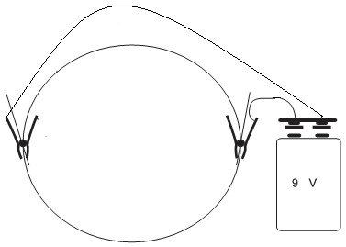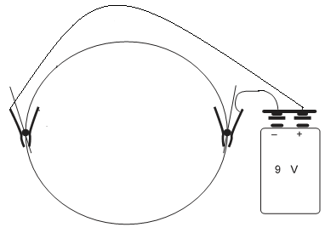1) Draw two sketches representing your observations. List observations. Describe what products form at each electrode. (Identify the anode and cathode each time.) Describe what happens when polarity to the electrodes were switched.

2) Which product appears at the cathode each time? Write the half-reaction for this process.

3) What type of process produces the white precipitate that appears at the anode? __________________

Tin undergoes a change in charge at the anode. Write a half-reaction for this change.

The newly produced tin ion combines with chloride ions to produce the white insoluble solid.

Write the reaction for this process.

Combine the 3 reactions to write the overall reaction for the process that occurs in the petri dish.

Note: This overall reaction is called a ***disproportionation reaction***. Explain why.

4) List all of the species present in the solution in the petri dish (***before*** connecting the leads to start electrolysis):

___________________________________________

Use the table of Standard Reduction Potentials to determine the all the possible half-reactions that can occur at each electrode and write them below with the correct potential value.

CATHODE ANODE

Explain why the 2 half-reactions you listed in numbers 2&3 earlier occur at each electrode.

(Why does oxygen gas or hydrogen gas NOT form?)