Precision and Accuracy in Measurement

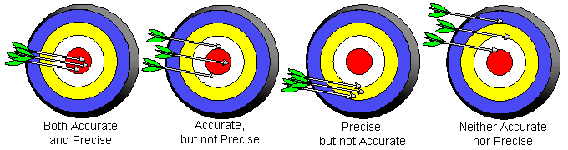
Chemistry experiments often require a number of different measurements and there is always some error in measurement. How much error depends on several factors, such as the skill of the experimenter, the quality of the instrument, and the design of the experiment. The reliability of the measurement has two components: precision
and accuracy. Precision refers to how closely measurements of the same quantity agree. A high-precision instrument is one that produces very nearly the same result each time it is used. Accuracy is how well measurements agree with the accepted/true value. It is possible for a set of measurements to be precise without being accurate. The image above demonstrates combinations of accuracy and precision for shooting arrows at a target.
The table summarizes data for an experiment in which a lab group used four different thermometers to measure the temperature of boiling water. Examine each set and decide which combination of precision and accuracy each one demonstrates.
Reading | Thermometer 1 | Thermometer 2 | Thermometer 3 | Thermometer 4
1 | 99.9 ºC | 97.5 ºC | 98.3 ºC | 97.5 ºC
2 | 100.1 ºC | 102.3 ºC | 98.5 ºC | 99.7 ºC
3 | 100.0 ºC | 99.7 ºC | 98.4 ºC | 96.2 ºC
4 | 99.9 ºC | 100.9 ºC | 98.7 ºC | 94.4 ºC
Average | 100.0 ºC | 100.1 ºC | 98.5 ºC | 97.0 ºC
Range | 0.2 ºC | 4.8 ºC | 0.4 ºC | 5.3 ºC

Since no measuring device is perfect and each person that reads it may give a slightly different reading – NO measurement is absolutely EXACT. All measurements have some uncertainty. When making a measurement in chemistry, you should record the value to one place beyond the smallest marking on the measuring device. This last digit is estimated and therefore is uncertain. The image below shows a nail being measured with 2 different rulers. The one on the left is more precise because it can be read with more certainty (more significant digits).
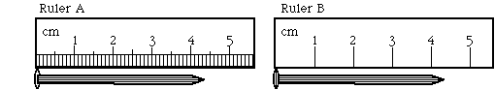

One person may read the length of the nail using the ruler on the right as 4.3cm another person may see it as 4.4 cm. Both of them are “certain” that the nail is more than 4 cm, but they are uncertain about the last digit because they had to estimate. This digit has and uncertainty of 0.1 cm. The reading can then be written to include this uncertainty as 4.3 ±0.1cm. This means the nail could be anywhere from 4.2 to 4.4 cm.
One person may read the length of the nail using the ruler on the left as 4.35 cm and another person may read it as 4.34 cm both of them are “certain” that the nail is more than 4.3 cm, but they are uncertain about the last digit. This ruler has an uncertainty of ±0.01cm, so the reading could be 4.35 ± 0.01cm.
When taking measurements always choose the device that will give you the most certainty in your measurement. Read the instrument carefully to the smallest marked division and always estimate to one more place past this reading.

