How Airbags Rely on Stoichiometry to Improve Automobile Safety

The Safety Advantage of Airbags: The development of airbags began with the idea for a system that would restrain automobile drivers and passengers in an accident, whether or not they were wearing their seat belts. Today, airbags are mandatory in new cars and are designed to act as a supplemental safety device in addition to a seat belt. Airbags have been commonly available since the late 1980's; however, they were first invented in 1953. The automobile industry started in the late 1950's to research airbags and soon discovered that there were many more difficulties in the development of an airbag than anyone had expected. Crash tests showed that for an airbag to be useful as a protective device, the bag must deploy and inflate within 1/25th of a second (40 milliseconds). The system must also be able to detect the difference between a severe crash and a minor fender-bender.

Since model year 1998, all new cars sold in the United States have been required to have airbags on both driver and passenger sides. (Light trucks came under the rule in 1999.) To date, statistics show that airbags reduce the risk of dying in a direct frontal crash by about 30 percent. Then came seat-mounted and door-mounted side airbags. Today, some cars go far beyond having dual airbags to having six or even eight airbags. Before looking at specifics, let's review our knowledge of the laws of motion. First, we know that moving objects have momentum (the product of the mass and the velocity of an object). Unless an outside force acts on an object, the object will continue to move at its present speed and direction. Cars consist of several objects, including the vehicle itself, loose objects in the car and, of course, passengers. If these objects are not restrained, they will continue moving at whatever speed the car is traveling at, even if the car is stopped by a collision.

Overview of How Airbags Work:
Stopping an object's momentum requires force acting over a period of time. When a car crashes, the force required to stop an object is very great because the car's momentum has changed instantly while the passengers' has not -- there is not much time to work with. The goal of any supplemental restraint system is to help stop the passenger while doing as little damage to him or her as possible. What an airbag wants to do is to slow the passenger's speed to zero with little or no damage. The constraints that it has to work within are huge. The airbag has the space between the passenger and the steering wheel or dashboard and a fraction of a second to work with. Even that tiny amount of space and time is valuable, however, if the system can slow the passenger evenly rather than forcing an abrupt halt to his or her motion.
The goal of an airbag is to slow the passenger's forward motion as evenly as possible in a fraction of a second. There are three parts to an airbag that help to accomplish this feat:
The bag itself is made of a thin, nylon fabric, which is folded into the steering wheel or dashboard or, more recently, the seat or door.
The sensor is the device that tells the bag to inflate. Inflation happens when there is a collision force equal to running into a brick wall at 10 to 15 miles per hour. The sensors receive information from an accelerometer built into a microchip.
The airbag's inflation system depends on the decomposition of sodium azide (NaN₃) to produce nitrogen gas which inflates the airbag.

The bag must be prevented from deploying when there is no collision. Hence, the first component of the airbag system is a sensor that can detect head-on collisions and immediately trigger the airbag's deployment. One of the simplest designs employed for the crash sensor is a steel ball that slides inside a smooth bore. The ball is held in place by a permanent magnet or by a stiff spring, which inhibit the ball's motion when the car drives over bumps or potholes. 1However, when the car decelerates very quickly, as in a head-on crash, the ball suddenly moves forward and turns on an electrical circuit, initiating the process of inflating the airbag.
Once the electrical circuit has been turned on by the sensor, a pellet of sodium azide (NaN₃) is ignited. A rapid reaction occurs, generating nitrogen gas (N₂). This gas fills the nylon bag at a velocity of 150 to 250 miles per hour. Ideally, the body of the driver (or passenger) should not hit the airbag while it is still inflating. In order for the airbag to cushion the head and torso with air for maximum protection, the airbag must begin to deflate by the time the body hits it. Otherwise, the high internal pressure of the airbag would create a surface as hard as stone. The gas quickly dissipates through tiny holes in the bag, thus deflating the bag so you can move. Even though the whole process happens in only 1/25th of a second (40 milliseconds), the additional time is enough to help prevent serious injury. The powdery substance released from the airbag, by the way, is regular cornstarch or talcum powder, which is used by the airbag manufacturers to keep the bags pliable and lubricated while they're in storage.

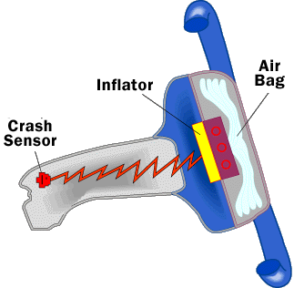
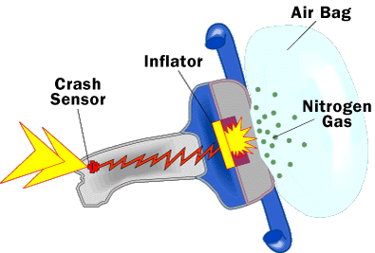
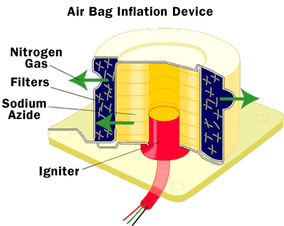
Chemical Reactions Used to Generate the Gas: Inside the airbag is a gas generator containing a mixture of NaN₃, KNO₃, and SiO₂. When the car undergoes a head-on collision, a series of three chemical reactions inside the gas generator produce gas (N₂) to fill the airbag and convert NaN₃, which is highly toxic (the maximum concentration of NaN₃ allowed in the workplace is 0.2 mg/m³ air), to harmless glass. Sodium azide (NaN₃) can decompose at 300ºC to produce sodium metal (Na) and nitrogen gas (N₂). The signal from the deceleration sensor ignites the gas-generator mixture by an electrical impulse, creating the high-temperature condition necessary for NaN₃ to decompose. The nitrogen gas generated then fills the airbag. The purpose of the KNO₃ and SiO₂ is to remove the sodium metal (which is highly reactive and potentially explosive), by converting it to a harmless material. First, the sodium reacts with KNO₃ to produce K₂O, Na₂O, and additional N₂ gas. The N₂ generated in this second reaction also fills the airbag. Heat produced by both reactions helps to expand the N₂ gas to fill the air bag. The metal oxides react with SiO₂ in a final reaction to produce silicate glass, which is harmless and stable. Group I alkali metal oxides, such as Na₂O and K₂O, are highly reactive, so it would be unsafe to allow them to be the end product.
 | Reactants | Products
Initial Reaction. | NaN₃(s) | Na(l), N₂(g)
Second Reaction. | Na(l), KNO₃(s) | K₂O(s), Na₂O(s), N₂(g)
Final Reaction. | K₂O(s), Na₂O(s), SiO₂(s) | K₂Na₂SiO₄(s) (glass)

Additional Considerations: Undetonated-Airbag Disposal: The vast majority of airbags in cars, fortunately, are never deployed within the lifetime of the automobile. What happens to these airbags? Typically, cars are flattened and recycled at the end of their lifetime, and the airbags are not removed from the cars. This can be hazardous, because these airbags still contain sodium azide, whose presence during the automobile-recycling process endangers workers, and can damage recycling equipment and the environment. Sodium azide can react in several ways when it undergoes the conditions of the recycling process itself. Once a car is flattened, it is impossible to see whether or not it contains an airbag. If the container holding the NaN₃ is damaged during flattening, then NaN₃, which is potentially mutagenic and carcinogenic, can be released into the environment. (Recall, the maximum concentration of NaN₃ allowed in the workplace is 0.2 mg/m³ air.) The next step in recycling cars is to shred them into fist-sized pieces so that the different types of metal can be separated and recovered. Sodium azide released during this process may contaminate the steel, iron, and nonferrous metals recovered at this stage. Of greater concern, is the large amounts of heat and friction generated by the shredder. Recall that NaN₃ reacts explosively at high temperatures; hence, there is a risk of ignition when airbags pass through the automobile shredder. This danger is amplified if sodium azide comes in contact with heavy metals in the car, such as lead and copper, because these may react to form a volatile explosive. The pieces of the car may also pass through a wet shredder. Here, another danger arises because if the NaN₃ dissolves in water, it can form hydrazoic acid (HN₃): NaN₃ + H₂O → HN₃ + NaOH. HN₃ is highly toxic, volatile and explosive.
What can be done to prevent these reactions of sodium azide in undetonated airbags? Somehow, the airbags must be prevented from going through the automobile-recycling process. Warning devices that would alert recyclers to the presence of an undetonated airbag in flattened car hulks have been tested, but these are generally expensive to implement, and they would need to be in every automobile airbag. Also, it is extremely difficult or impossible to remove an airbag from a car that has already been flattened, and so the question of what to do with these flattened cars containing airbags remains unanswered. This will become an increasingly large problem, as airbags are mandatory equipment in new automobiles. Hence, the proportion of cars with airbags in recycling plants is increasing. A better solution is to remove the airbag canister before the car is sent for flattening or recycling. This is cheaper, simpler, and more efficient, and allows the car to be recycled safely. This strategy is already used for other hazardous components of cars, such as lead-battery cases. However, there is an added incentive for removing batteries that is not yet applicable for removing airbags from cars before recycling. The lead from batteries can be re-sold, but currently there is no market value for airbag canisters. Thus, strictly-enforced laws or a market-based incentive system may be required to ensure that airbags continue to protect our safety, even after the lifetime of the automobiles that contain them. WATCH: https://www.youtube.com/watch?v=Y2sjYOGSV7E
Airbag Stoichiometry Name ____________________________________ Date ____ Pd ___
1) What types of technologies do you think delayed the use of airbags for 30 years? Why was this technology necessary for airbags to work?

2) Discuss reasons why you think consumers and car companies may have resisted the implementation of safety devices like seat belts in early automobiles.

3) How does the airbag protect you in a crash?

4)What is the purpose of sodium azide in an airbag system?

5) What is the purpose of potassium nitrate and silicon dioxide?

6) Use the information in the table to write balanced equations for the 3 reactions that occur in the gas generator canister of an airbag.

Initial reaction: ______________ → _________ + _________

Second reaction: ___________ + __________ → _________ + _________ + _________

Final Reaction: _________ + _________ + _________ → _______________

7) List 2-3 ways undetonated air bags in cars that are being recycled can be dangerous.

8) Use stoichiometry to answer the following questions.
a) A new airbag for the passenger side of a car contains 198g of sodium azide. Determine the volume of nitrogen gas in liters that will be produced from the initial reaction. (density of nitrogen = 0.92g/L at the reaction conditions)
198gNaN₃ x _______ L(N₂)

b) Determine the grams of sodium produced during the initial reaction.
198gNaN₃ x _______ g Na

c) Use the second reaction to determine the volume of nitrogen gas in liters that will be produced from the sodium produced in the first reaction. (start with the grams of Na from your answer to “b”)
_______ gNa x _______ L(N₂)

What will be the total volume of the airbag when fully inflated?
d) How many grams of potassium nitrate must be placed in the airbag gas generator to react with the sodium produced in the initial reaction (again start with the grams of Na from your answer to “b”) ?
_______ gNa x _______ gKNO₃

e) Explain how you could determine the grams of silicon dioxide needed to be placed in the gas generator? What values would you need to know from the final reaction and how would you calculate them?

f) What could happen if the airbag manufacturer used more or less than 198g of sodium azide in the gas generator?

