AP Chemistry
Stoichiometry Particle Diagrams

- Consider the following unbalanced equation:

…… CO (g) + ……O2 (g) → …… CO2 (g)
  - Balance the chemical equation
  - The particulate diagram represents the products of the reaction. In the other box, accurately depict the reaction mixture. Pay attention to number and types of atoms involved.

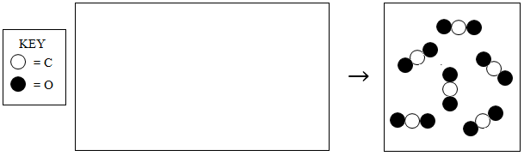

- Consider the following unbalanced equation:

……C2H2 (g) + ……O2 (g) → ……CO2 (g) + ……H2O (g)
  - Balance the equation
  - The particulate diagram represents the reactants of the reaction. In the other box, accurately depict the products. Pay attention to number and types of atoms involved. Use to represent water and to represent carbon dioxide.

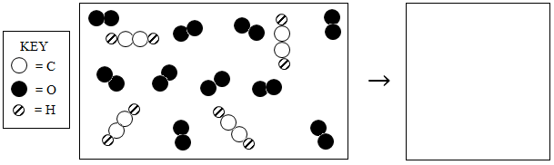

- The diagram below represents hydrogen and nitrogen in a closed container. Draw the resultant mixture once the reaction runs to completion to form ammonia, NH3.

Balanced Equation:

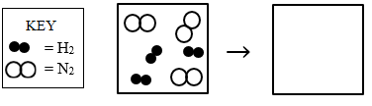
- What is the limiting reactant? What is the evidence and reasoning behind this selection?

- How many molecules of the excess reactant are left over?

- The diagram below represents a mixture of nitrogen monoxide (NO) and oxygen gas (O2) in a closed container. Draw the resultant mixture once the reaction runs to completion to form NO2 gas.

Balanced Equation:

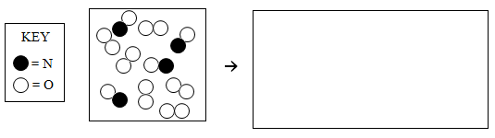
- What is the limiting reactant? What is the evidence and reasoning behind this selection?

- How many molecules of the excess reactant are left over?

- The diagram below represents a mixture of nitrogen dioxide gas (NO2) and oxygen gas (O2) in a closed container. Draw the resultant mixture once the reaction runs to completion to form N2O5 gas. Express N2O5 as 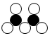

Balanced Equation:

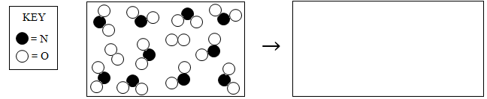

- What is the limiting reactant? What is the evidence and reasoning behind this selection?

- How many molecules of the excess reactant are left over?

- The diagram below represents the resultant mixture once a sample of hydrogen gas, H2, is combusted with a sample of oxygen gas, O2. In the space provided, draw the initial reaction mixture.

Balanced Equation:

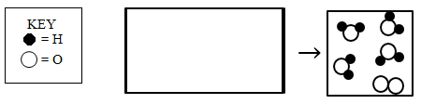
- What is the limiting reactant? What is the evidence and reasoning behind this selection?

- How many molecules of the excess reactant are left over?

