Determination of R: The Gas Law Constant

Objective: To understand how to calculate the ideal gas law, R, and to see how much it differs using a “real” gas at normal laboratory conditions.
Materials: Balance (0.001g and 0.01g) , Bunsen burner/hose, thermometer, 250mL beaker, ring stand, universal clamp, gas law set-up (large test tube, gas bottle, glass/rubber tubing with stoppers, pinch clamp), 100mL beaker,
Potassium Chlorate, Manganese (IV) Oxide, weighing paper

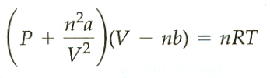
Introduction: Most gases obey the ideal gas equation, PV=nRT, quite well under ordinary conditions, that is, at room temperature and atmospheric pressure. Small deviations from this law are observed, however, because real gas molecules are finite in size and exhibit mutual attractive forces. The van der Waals equation,
where a and b are constants characteristic of a given gas, takes into account these two causes for deviation and is applicable over a much wider range of temperatures and pressures than the ideal gas equation. The term nb in the expression (V-nb) is a correction for the finite volume of the molecules; the correction to the pressure by the term n²a/V² takes into account the intermolecular attractions.

In this experiment you will determine the numerical value of the gas law constant, R, in its common units of
L•atm/mol•K. This will be done using both the ideal gas law and the van der Waals equation together with measured values of pressure, P, temperature, T, volume, V and number of moles, n, of an enclosed sample of oxygen. Then you will perform an error analysis on the experimentally determined constant.
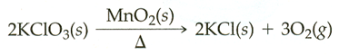
The oxygen will be prepared by the decomposition of potassium chlorate, using manganese (IV) oxide as a catalyst:

If the KClO₃ is accurately weighed before and after the oxygen has been driven off, the precise weight of the oxygen can be obtained by difference. The oxygen can be collected by displacing water from a bottle, and the volume of the gas can be determined from the volume of water displaced. The pressure of the gas may be obtained though the use of Dalton’s law of partial pressures, the vapor pressure of water, and atmospheric pressure. Dalton’s law states that the pressure of a mixture of gases in a container is equal to the sum of the pressures that each gas would exert if it were present alone.
Patmospheric = PO₂ + PH₂O vapor
SAFETY WARNING!!!! KClO₃ is a strong oxidizing agent and will react readily when heated with certain easily oxidizable substances such as rubber. DO NOT HAVE KClO₃ and MnO₂ come in contact with the rubber stopper or a fire or explosion may occur. Make certain that the clamp holding the test tube is secure so that the test tube cannot move.

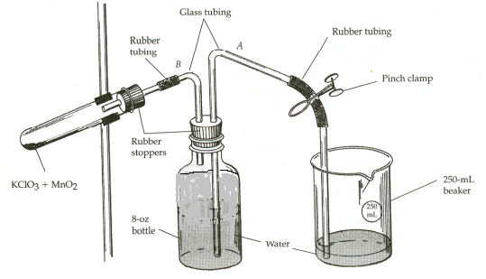

Procedure:
1) Weigh about 0.02 g of MnO₂ and about 0.3 g of KClO₃ on a piece of weighing paper. Transfer it carefully to LARGE test tube and accurately weigh the test tube to the nearest 0.001g (place the test tube in a 100mL beaker that has been tared – do not try to lay the test tube in the pan it may roll off) . Also weigh the dry, 250 mL beaker at this time to the nearest 0.01g. Record the masses in the data table.
2) Assemble the apparatus as illustrated in the figure. Mix the solids in the test tube by rotating the tube and a slight angle before placing it in the clamp. Do NOT attach the test tube to the stopper on tube B at this point.
3) Fill the bottle with water until it is just below the neck. Be sure that tube B does NOT extend below the water level in the bottle.
4) Attach a rubber bulb to tube B and slowly squeeze to apply pressure through it so that water may travel into tube A. Have your partner close the pinch clamp on the rubber tubing when tube A is filled. Try to not let air back into the tube while you are closing the clamp.
5) Attach the test tube by firmly pushing in the stopper on tube B as shown in the figure. AGAIN, note the safety warning about KClO₃ and rubber stoppers. Be certain the test tube is clamped so at angle as shown in the figure.
6) Fill the beaker about half full of water, insert tube A in it and open the pinch clamp. Lift the beaker until the levels of water in the bottle and the beaker are identical. (this will equalize the pressure inside the bottle with the pressure outside) Then close the clamp, discard the water in the beaker, and dry the beaker and return it to its position with the end of tube A inside.
6) Set the beaker with tube A in it on the bench and open the pinch clamp – you can slide the clamp up tube A and let it hang on the tube from the ring (do NOT clamp it on the glass tube). A little water may flow into the beaker, but if the system is airtight and has no leaks, the flow will soon stop and tube A will remain filled with water. If this is not the case, check the apparatus for leaks and start over. Leave any water that has flowed into the beaker - at the end of the experiment, the water levels will be adjusted and this water will flow back into the bottle.
7) Be certain that the pinch clamp is open. Heat the lower part of the test tube gently so that a slow, but steady stream of gas is produced, as evidenced by the flow of water into the beaker. You can hold the burner in by the bottom so you can evenly heat the area where the solids touch the tube. When the rate of gas evolution slows considerably, increase the rate of heating, and heat until no more oxygen is evolved.
8) Allow the apparatus to cool to room temperature, making certain that the end of the glass tube is in the beaker is always below the surface of the water. Some of the water will flow back into the bottle, which is normal.
9) Equalize the water levels in the beaker and the bottle as before and close the pinch clamp back on the rubber tubing
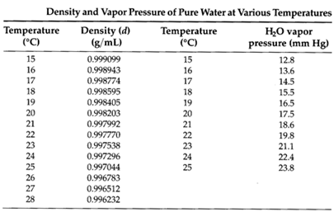
10) Weigh the beaker with the water to the 0.01g and get a temperature to the nearest 0.1ºC of the water – record and convert to kelvin. Find the density of water closest to that temperature, – record in the table. You will use this to calculate the volume of water that was displaced (equal the volume of oxygen produced).
11) Read and record barometric pressure to the nearest 0.1mmHg. Find vapor pressure of water at recorded temperature – record in the table.

12) Remove the test tube from the apparatus and accurately weigh the tube and contents to the 0.001g.
(Use the 100 mL beaker as before.) The difference in mass between this and the original mass of the tube and contents is the mass of the oxygen produced.
13) Clean out the test tube using a brush and a few drops of alconox solution. Rinse with distilled and shake dry.
(If you are unable to completely clean the tube – give it to the instructor.

14) Return all equipment.

Analysis/Calculations

Calculate the maximum and minimum value of R consistent with the experimental reliability of your data from the ideal gas law by following the example below. Assume that the uncertainties (reliablities) for the various measure quantities in this experiment are as follows:

P = ±0.1 mmHg V = ±0.0001 L T = ±0.1K m = ±0.001 g
= ±0.001 atm

The ideal gas law equation for this experiment can be written as: R = (32.00g/mol) PV (where m is the mass of O₂)
mT

The molar mass of O₂/m = the moles of O₂ (n).

To determine the maximum value of R, add the uncertainty to the pressure and volume values subtract the uncertainty from the mass and temperature values before dividing. Similarly, calculate the minimum value of R from the minimum values of P and V and the maximum values for m and T. Determine your average value of R and then calculate the deviation for the max and min. Write the average value with the uncertainty range.

Calculate the percent error for your calculated value of R.

Calculate the gas law constant, R, using the van der Waals equation.

For O₂, a = 1.360 L²•atm/mol² and b = 31.83 cm³/mol.

First convert the “b” value to L/mol.

Check your answers with the instructor before completing the van der Waals calculation.

Calculate a percent error for your van der Waals R value.

