AP Chemistry Name_________________
Hess’ Law

1. Find ΔH for the following reaction : , using the equations below.
ΔH = -563 kJ
ΔH = -1075 kJ
2. Find ΔH for the following equation: , using the equations below.
ΔH = -277 kJ
ΔH = -828 kJ
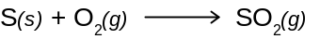 ΔH = -297 kJ
3. Calculate ΔH for the following reaction: , using the equations below.
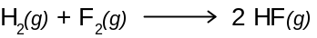 ΔH = -537 kJ
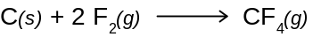 ΔH = -680 kJ
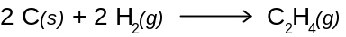 ΔH = 52.3 kJ

For each of the following reactions, find ΔH for the reaction by using the ΔH_{f}° values. Use the Heat of Formation table on Schoology.

- 