Electron Configurations and the Periodic Table
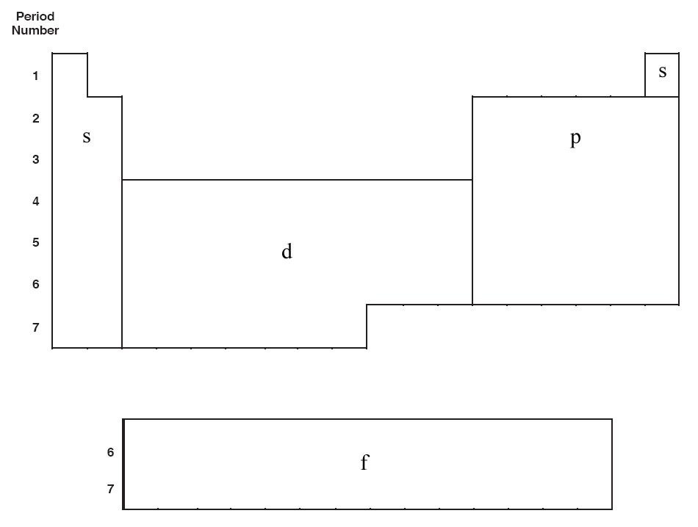
- “s” block, “p” block, “d” block, and “f” block

- Period (Row) Number
  - Equal to the number of the outer main energy level
  - Equal to the energy level for “s” and “p” blocks (Valence electrons)

- Order of filling

- Elements in the same group (vertical column) on the Periodic Table have the same number of valence electrons.

