AP Chemistry
Liquid Chromatography Lab

Introduction
In this experiment, liquid chromatography is used to separate the substances that are present in grape-flavored Kool-Aid®. First, the dyes responsible for the purple color, FD&C Blue #1 and Red #40 are separated. Then, in a second experiment, the other components of Kool-Aid®, the flavorings and citric acid, are separated as well.

Background:
Chromatography is an important analytical tool used to separate the components of a mixture. These components become separated or partitioned between a stationary phase and a moving phase of the chromatography system. The moving phase is either a gas or a liquid and the stationary phase is usually a solid. The mixture to be separated is combined with the mobile phase. As the mobile phase "solution" flows over the stationary phase, the components of the mixture continuously equilibrate between the phases, based on their particular affinity for each phase. A higher attraction for the mobile phase leads to a higher concentration of a component in the mobile phase and a faster transport through the entire system. Components more strongly attracted to the stationary phase take longer to migrate through the system. This results in the components becoming separated into bands that flow through the system at different rates. If the separation, or resolution, is sufficient, the bands will exit the system as distinct fractions (Figure 1).

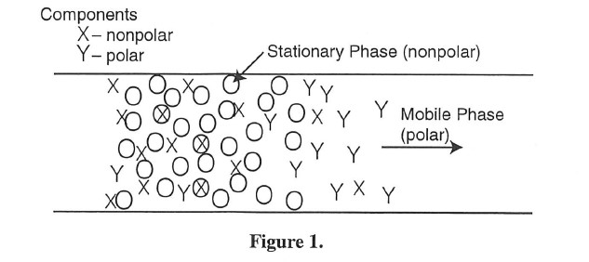

All liquid chromatography systems consist of six basic components (Figure 2);
(1) a separation column, consisting normally of a fine, granular solid packed in a column;
(2) a solvent, the mobile phase that washes along the column;
(3) an injection system, needed to place the sample mixture on the column;
(4) a pump, or solvent delivery system, that forces the solvent through the column;
(5) a detector, use to indicate when the components emerge from the column; and
(6) a recorder.

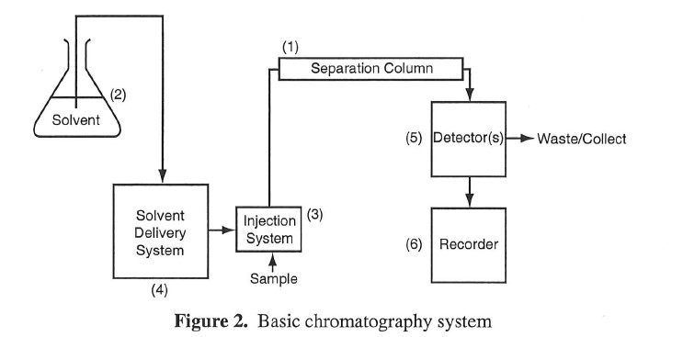

Usually, the solid phase is relatively polar and the solvent nonpolar in liquid chromatography. This experiment utilizes a form of chromatography called reverse phase liquid chromatography (RPC). In RPC, the stationary phase is a nonpolar solid and a polar solvent is used as the mobile phase.
When a mixture is injected into the RPC column and washed through it, several processes occur (see Figure 3). The more polar components of the mixture are attracted more strongly to the polar solvent, so they will move more quickly through the column with the solvent. The less polar components will move more slowly, as they spend more time adsorbed onto the nonpolar column medium. Ideally, the components should emerge at different times. A measure of the degree of separation that is achieved is called the resolution of the system. As the band of each component moves down the column, the band widens due to diffusion. As bands widen they can overlap each other and may prevent clean separation or resolution of the components.

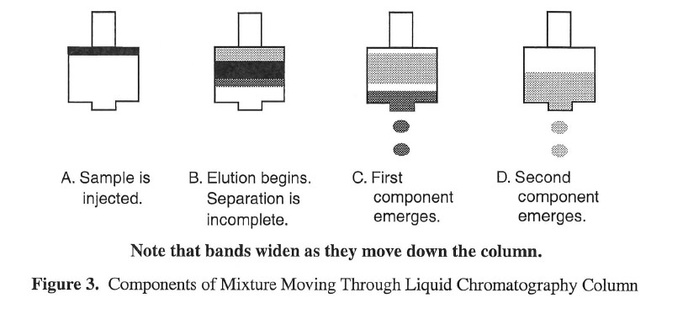

Experiment Overview:
The purpose of this experiment is to use liquid chromatography as a tool to separate the components of unsweetened, grape-flavored Kool-Aid® or any grape flavored drink. Miniature liquid chromatography columns called Sep-Pak C18 columns are used for the separation. The Sep-Pak column is packed with a silica solid which has a C18 hydrocarbon bonded to it, so it is very nonpolar. In Part 1, the two dyes in the drink are separated using dilute isopropyl alcohol as the solvent, or eluant. Measurements are made during the separation that allow for the calculations of the selectivity and the resolution of the separation process. In Part 2, four eluants of different polarities are used to separate the polar components citric acid and salt, the slightly polar dyes, and the nonpolar flavoring oils.

Sample Calculations
Below is typical data for this experiment. 1 mL of a Kool-Aid solution was loaded on a Sep Pac C18 column. The red and blue dyes were eluted from the column with a constant flow of 18% isopropyl alcohol. The eluted solution was collected in a 10-mL graduated cylinder. The volumes of eluant were recorded at the beginning and end of each color band.

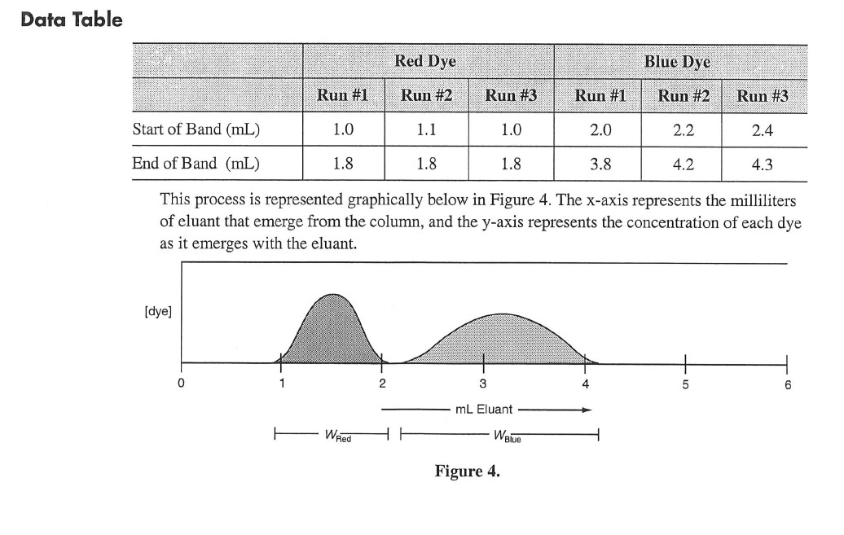
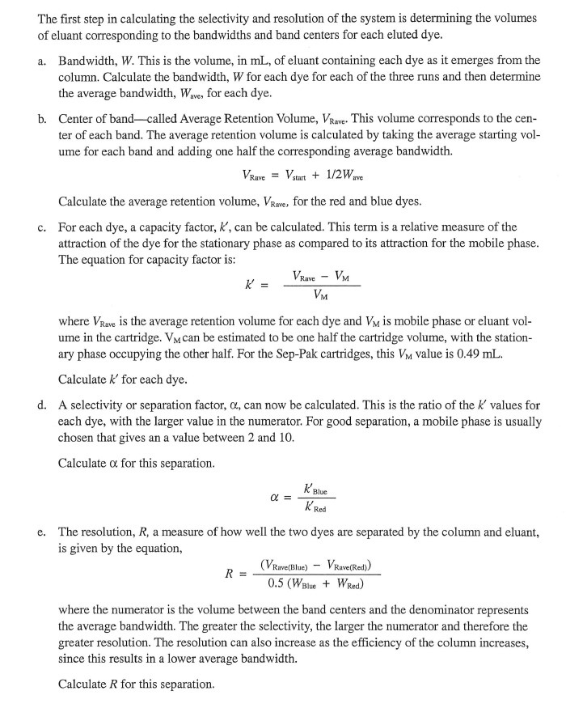

Procedure:
Part 1. Isocratic Separation (Flow rate and solvent concentration are held constant.)

Pretreat the Sep-Pak C18 cartridge.
- Fill the syringe with 10 mL of 70% isopropyl alcohol.
- Attach the tip of the syringe to the long end of the Sep-Pak cartridge and push the isopropyl alcohol through the syringe cartridge at a rate of 5-10 mL per minute. (Go slowly)
- Collect the eluted alcohol in a 10-mL graduated cylinder to monitor the flow rate.
- Repeat steps 2-4 using distilled or deionized water.

Inject the sample.
- Use the 10-mL syringe to slowly inject 1 mL of the Kool-Aid sample onto the column.
Optional: Use a clean 3 mL syringe to inject the Kool-Aid sample.
- Discard the column effluent (the portion that washed out as the sample was injected).
- Remove the cartridge from the syringe.
- If the 10-mL syringe was used in step 1, rinse the syringe with 10 mL of distilled water three times to remove any traces of Kool-Aid sample.

Elute the sample.
- Use the 10-mL syringe to slowly elute the dyes. Fill the syringe with the 18% isopropyl alcohol eluant and attach the syringe to the Sep-Pak cartridge.
- Pump the 18% isopropyl alcohol through the cartridge at a steady rate of 5-10 mL per minute.
- Collect the column eluant in a 10-mL graduated cylinder.
- Record, in the Part 1 data table, the volume of eluant collected as the first and last of the colored drops of each of the dyes emerge. If there is not a perfect separation between the blue and red-colored bands, record data for the beginning and end of the intermediate purple band. The center of the purple band will serve as the end of the first band and beginning of the last.

Regenerate the column and repeat the measurements.
Repeat the measurements two more times. Between injections, wash the column with 10 mL of distilled water at the same flow rate of 5-10 mL per minute. If colored material builds up on the column, repeat the pretreatment procedure (step 2).

Part 2. Step Gradient Separation
In this procedure, the composition of the eluting liquid is changed. Since the column is nonpolar, first a very polar solvent, water, is used. Then its composition is changed to less polar by adding more isopropyl alcohol. This procedure allows the separation of the citric acid and flavoring oils as well as the dyes.

Pretreat the cartridge.
Follow the same pretreatment as in Part 1.

Inject the sample and elute the components.
- Slowly inject 1 mL of the Kool-Aid sample onto the column.
- Elute the polar components of the mixture (citric acid and any sugar present) by passing 5 mL of water through the column.
- Collect the effluent in a small beaker.
- Elute the red dye by passing 10 mL of 5% isopropyl alcohol through the column. Note that large amounts of the 5% isopropyl alcohol can be used without eluting the blue dye. Collect this effluent in a second beaker.
- Use 10 mL of the 25% isopropyl alcohol to elute the blue dye. Collect it in a third beaker.
- Use 10 mL of 70% isopropyl alcohol to elute the nonpolar flavor oils (methyl anthranilate) and other nonpolar additives. Collect this fraction in a fourth beaker.
- Record the color of each eluted fraction in the Part 2 data table.

Evaporate the solvents and examine the components.
- Allow the solutions to evaporate by leaving them in the fume hood until the next laboratory period. Be sure to label those solutions containing isopropyl alcohol as the solvent.
- Observe and describe the contents of each of the beakers. Look for color, odor, and appearance. Enter these observations in the Part 2 data table.

* Clean the Sep Pak by pushing 10 mL of 70% isopropyl alcohol through it. Then push 10 mL of distilled water through it. To dry it out as much as possible, attach it to the syringe with the plunger pushed all the way down. Pull the syringe all the way out to pull water out of the pack and into the syringe.

AP Chemistry Names:_____________________________
Liquid Chromatography Lab
Prelab Questions:
- What is the process of chromatography used for?

- In chromatography, components of a mixture distribute themselves between the stationary phase and the mobile phase. Explain how the components can be separated with these two phases.

- In the liquid chromatography column used in this experiment, the solid has a C18 hydrocarbon bonded to it. Would a C18 hydrocarbon be a polar or a nonpolar substance? Explain.

- Determine the following values. Refer to sample calculation section of the prelab. Enter results in the Part 1 data table.
- Bandwidth, W, for each dye.

b. Average Retention Volume, VRave, for each dye.

- Capacity Factor, k', for each dye.

- Selectivity, a, for the two dyes with this isocratic separation.

- Resolution, R, for the two dyes with this isocratic separation.

Data:
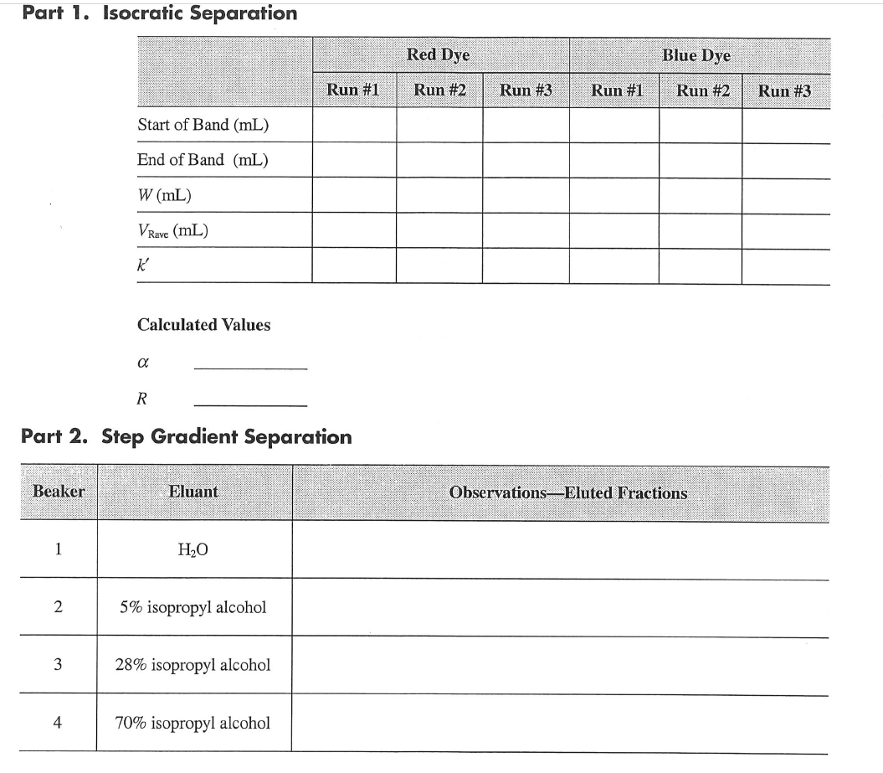
Post Lab Questions:
- What is meant by polarity of molecules? What causes differences in polarity?

- In discussing solubility, the rule "like dissolves like" is frequently used. What does this mean?

- Draw the structural formula of isopropyl alcohol. Explain how it differs in polarity from water.

- For good separation of the dyes, the resolution should be greater than one. What was the value you calculated? Did the two dyes overlap as they emerged from the column, or was the separation a good one?

- In the step gradient separation, four separate fractions were collected. How were these related to the polarities of the column and of the eluting solvent?

