Properties of Solutions

1,2,4-6,11,12,14,1- 33-37a,c,39,40b48d,53,54 ,58,59,63,75,76, 8 77-79,82 9?,0ditional? 83-85,87

The Solution Process
A solution is a homogeneous mixture of solute and solvent.
Solutions may be gases, liquids, or solids. (or combinations)
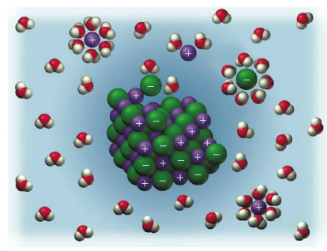
• Each substance present is a component of the solution.
The solvent is the component present in the largest amount.
The other components are the solutes.
•Intermolecular forces become rearranged in the process of making solutions with condensed phases.
Consider NaCl (solute) dissolving in water (solvent):
Water molecules orient themselves on the NaCl crystals.
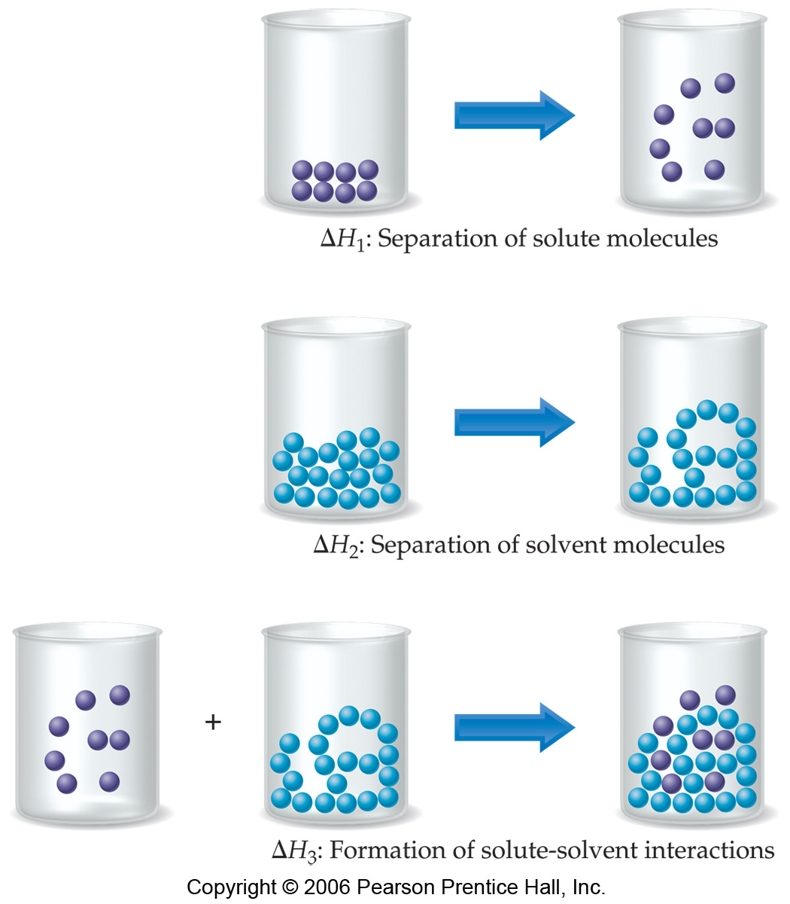
H-bonds between the water molecules have to be broken.
NaCl dissociates into Na⁺ and Cl–.
Ion-dipole forces form between the Na⁺ and the negative end of the water dipole.
Similar ion-dipole interactions form between the Cl– and the positive end of the water dipole.
Such an interaction between solvent and solute is called solvation.
If water is the solvent, the interaction is called hydration.
Energy Changes and Solution Formation
•There are three steps involving energy in the formation of a solution:
1) separation of solute molecules (ΔH₁)
2)
separation of solvent molecules (ΔH₂), and
3) formation of solute-solvent interactions (ΔH₃).
•We define the enthalpy change in the process as:
ΔH_{soln} = ΔH₁ + ΔH₂ + ΔH₃
ΔH_{soln} can either be positive or negative depending on the intermolecular forces.
To determine whether ΔH_{soln} is positive or negative, we consider the strengths of all solute-solute, solvent-solvent, and solute-solvent interactions.
Breaking attractive intermolecular forces is always endothermic.
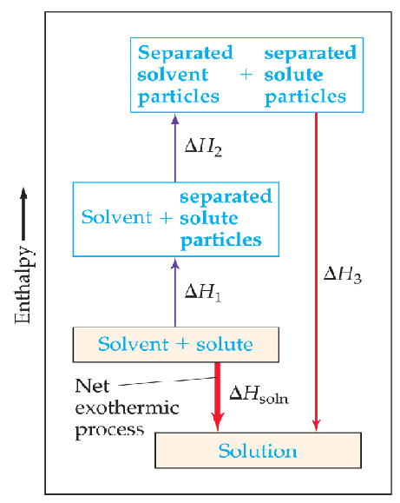
ΔH₁ and ΔH₂ are both positive. Forming attractive intermolecular forces is always exothermic.
ΔH₃ is always negative.

It is possible to have either ΔH₃ > (ΔH₁ + ΔH₂), or ΔH₃ < (ΔH₁ + ΔH₂).
Examples:
MgSO₄ added to water has ΔH_{soln} = –91.2 kJ/mol.
NH₄NO₃ added to water has ΔH_{soln} = + 26.4 kJ/mol.
MgSO₄ is often used in instant heat packs and NH₄NO₃ is often used in instant cold packs.
How can we predict if a solution will form?
In general, solutions form if the ΔH_{soln} is negative.
If ΔH_{soln} is too endothermic a solution will not form.

“Rule of thumb”: polar solvents dissolve polar solutes.
Nonpolar solvents dissolve nonpolar solutes. (“like dissolves like”)
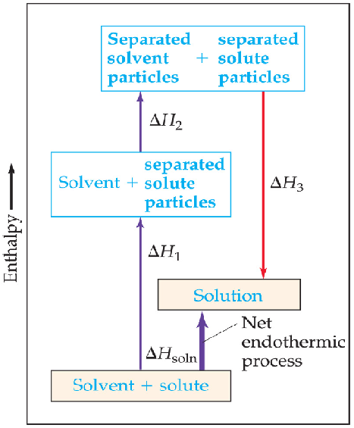
Consider the process of mixing NaCl in gasoline.
Only weak interactions are possible because gasoline is nonpolar.
These interactions do not compensate for the separation of ions from one another.
Result: NaCl does not dissolve to any great extent in gasoline.
Consider the process of mixing water in octane (C₈H₁₈).
Water has strong H-bonds.
The energy required to break these H-bonds is not compensated for by the
interactions between water and octane.
Result: water and octane do not mix.

Solution Formation, Spontaneity, and Disorder
•A spontaneous process occurs without outside intervention.
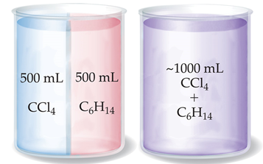
When the energy of the system decreases (dropping a book it falls to a lower potential energy), the process is spontaneous.
Spontaneous processes tend to be exothermic.

However, some spontaneous processes do not involve the movement of the system to a lower energy state (endothermic).
Some endothermic processes occur spontaneously.
The amount of randomness or disorder in the system is entropy.
In most cases, solution formation is favored by the increase in entropy that accompanies mixing.
A mixture of CCl₄ and C₆H₁₄ is less ordered than the two separate liquids.
Therefore, they spontaneously mix even though ΔH_{soln} is very close to zero.
A solution will form unless the solute-solute or solvent-solvent interactions are too strong relative to the solution solvent interactions.

Solution Formation and Chemical Reactions
•Some solutions form by physical processes and some by chemical processes.
Consider:
Ni(s) + 2HCl(aq) →NiCl₂(aq) + H₂(g)
Note that the chemical form of the substance being dissolved has changed during this process
(Ni → NiCl₂).
When all the water is removed from the solution, no Ni is found, only NiCl₂•6H₂O remain.
Therefore, the dissolution of Ni in HCl is a chemical process.
In contrast:
NaCl(s) + H₂O (l) → Na⁺(aq) + Cl–(aq).
When the water is removed from the solution, NaCl is found.
Therefore, NaCl dissolution is a physical process.
Saturated Solutions and Solubility
•As a solid dissolves, a solution forms:
Solute + solvent → solution
• The opposite process is crystallization.

If crystallization and dissolution are in equilibrium (⇄) with undissolved solute, the solution is saturated.
There will be no further increase in the amount of dissolved solute.
Solubility is the amount of solute required to form a saturated solution.
A solution with a concentration of dissolved solute that is less than the solubility is said to be unsaturated.
A solution is said to be supersaturated if more solute is dissolved than in a saturated solution.
Factors Affecting Solubility
•The tendency of a substance to dissolve in another substance depends on:
the nature of the solute;
the nature of the solvent
; the temperature
; and the pressure (for gases only).
Solute-Solvent Interactions
•Intermolecular forces are an important factor in determining solubility of a solute in a solvent.
The stronger the attraction between solute and solvent molecules, the greater the solubility.
For example, polar liquids tend to dissolve in polar solvents.
Favorable dipole-dipole interactions exist (solute- solute, solvent-solvent, and solute-solvent).
Pairs of liquids that mix in any proportions are said to be miscible.
Example: Ethanol and water are miscible liquids.
In contrast, immiscible liquids do not mix significantly.
Example: Gasoline and water are immiscible.

Consider the solubility of alcohols in water.
Water and ethanol are miscible because the broken hydrogen bonds in both pure liquids are re-established in the mixture.
However, not all alcohols are miscible with water.
Why?
The number of carbon atoms in a chain affects solubility.
The greater the number of carbons in the chain, the more the molecule behaves like a nonpolar hydrocarbon.
Thus, the more C atoms in the alcohol, the lower its solubility in water.
Increasing the number of –OH groups within a molecule increases its solubility in water.
The greater the number of –OH groups along the chain, the more solute-water H-bonding is possible.
Generalization: “like dissolves like.”
Substances with similar intermolecular attractive forces tend to be soluble in one another.
The more polar bonds in the molecule, the better it dissolves in a polar solvent.
The less polar the molecule the less likely it is to dissolve in a polar solvent and the more likely it is to dissolve in a nonpolar solvent.
Network solids do not dissolve because the strong intermolecular forces in the solid are not reestablished in any solution.

Pressure Effects
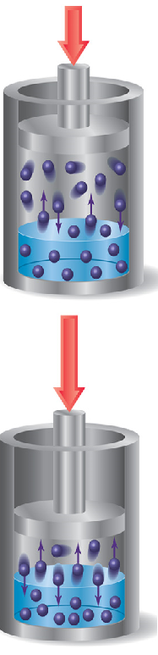
•The solubility of a gas in a liquid is a function of the pressure of the gas over the solution.
Solubilities of solids and liquids are not greatly affected by pressure.
With higher gas pressure, more molecules of gas are close to the surface of the solution and the probability of a gas molecule striking the surface and entering the solution is increased.
Therefore, the higher the pressure, the greater the solubility.
The lower the pressure, the smaller the number of molecules of gas close to the surface of the solution, resulting in a lower solubility.
The solubility of a gas is directly proportional to the partial pressure of the gas above the solution.

This statement is called Henry's law.
Mathematically as:

S_{g}=kP_{g}

where S_{g} is the solubility of gas, P_{g} the partial pressure, and k = Henry’s law constant.
Note that Henry's law constant differs for each solute-solvent pair and differs with temperature.
An application of Henry's law is the preparation of carbonated soda.
Carbonated beverages are bottled under PCO₂> 1 atm.
As the bottle is opened, PCO₂ decreases and the solubility of CO₂ decreases.
Therefore, bubbles of CO₂ escape from solution.

Temperature Effects
•Experience tells us that sugar dissolves better in warm water than in cold water.
As temperature increases, solubility of solids generally increases.
Sometimes solubility decreases as temperature increases [e.g., Ce₂(SO₄)₃].
Experience tells us that carbonated beverages go flat as they get warm.
Gases are less soluble at higher temperatures.
An environmental application of this is thermal pollution.
Thermal pollution: If lakes get too warm, CO₂ and O₂ become less soluble and are not available for plants or
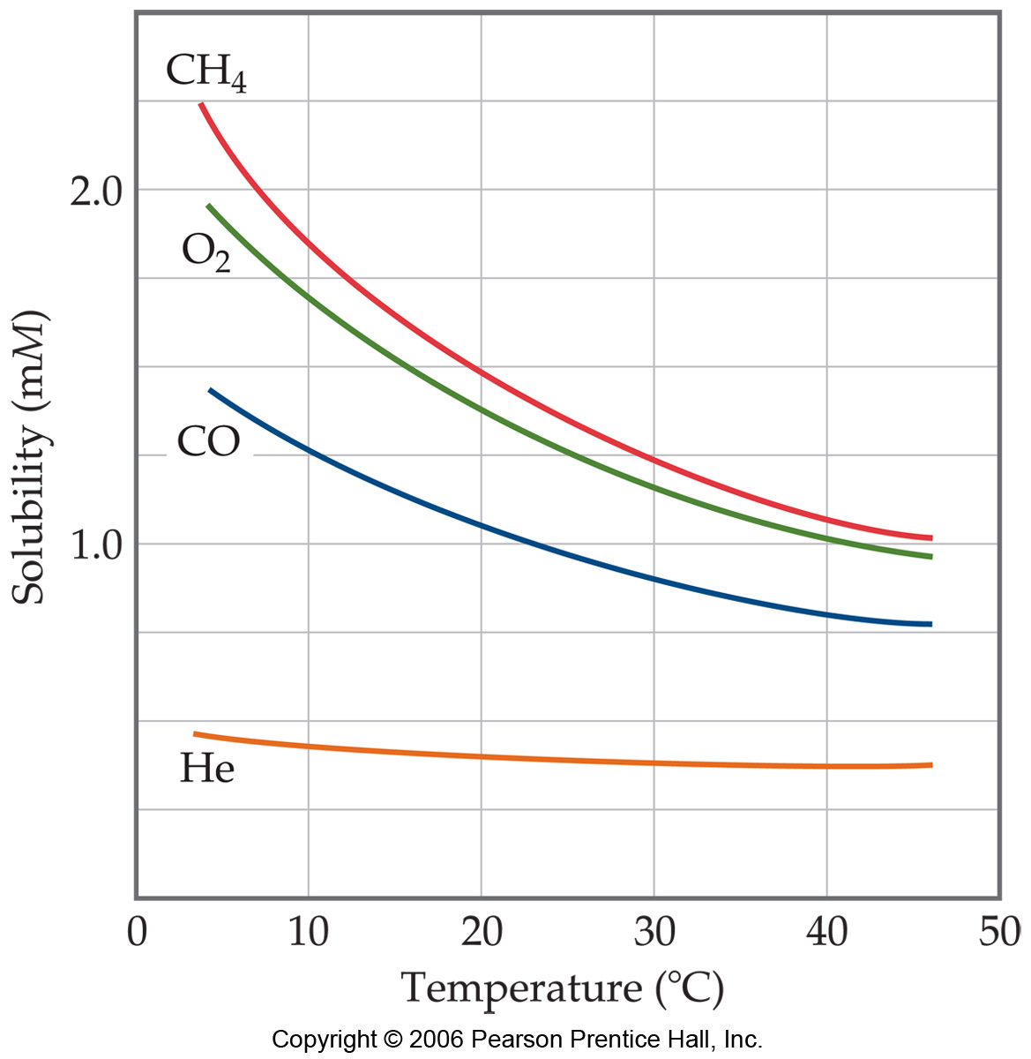
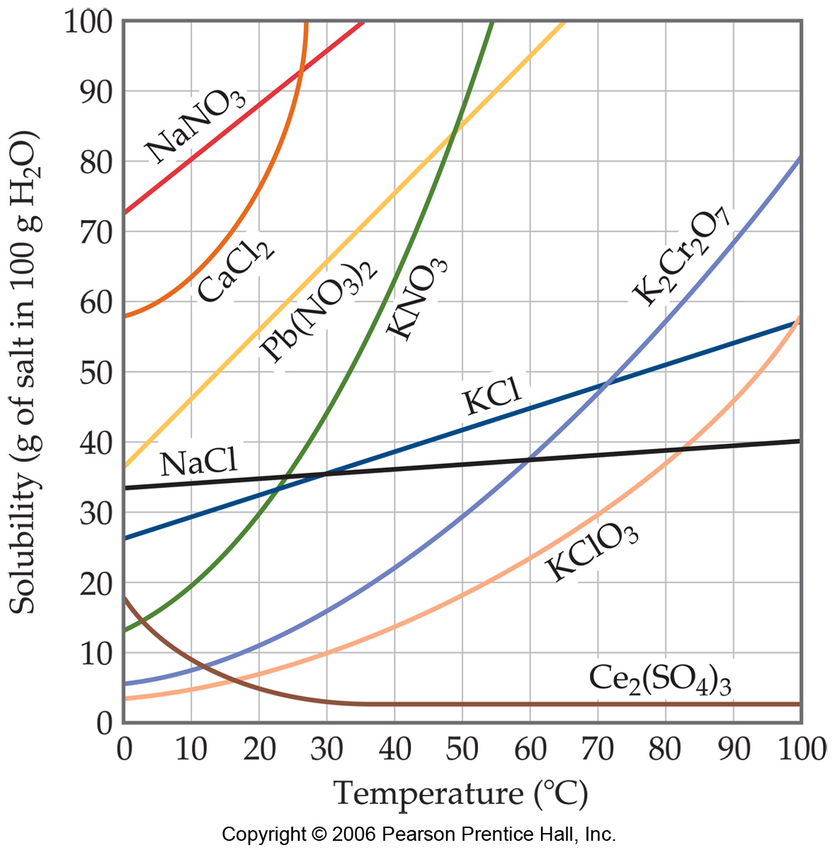
animals.
Fish suffocate.

Ways of Expressing Concentration
•All methods involve quantifying the amount of solute per amount of solvent (or solution).
Concentration may be expressed qualitatively or quantitatively. D
ilute and concentrated are qualitative ways to describe concentration.

Quantitative expressions of concentration require specific information regarding such quantities as masses, moles, or liters of the solute, solvent, or solution.
The most commonly used expressions for concentration are:
mass percentage;
mole fraction
; molarity
; molality.

Mass Percentage, ppm, and ppb
Mass percentage is one of the simplest ways to express concentration.
By definition:

Similarly, parts per million (ppm) can be expressed as the number of mg of solute per kilogram of solution.
By definition:

If the density of the solution is 1g/ml, then 1 ppm = 1 mg solute per liter of solution.

Parts per billion (ppb) can be expressed as the number of µg of solute per kilogram of solution.
By definition:

If the density of the solution is 1g/ml, then
1 ppb = 1 µg solute per liter of solution.

Mole Fraction, Molarity, and Molality
•Common expressions of concentration are based on the number of moles of one or more components.
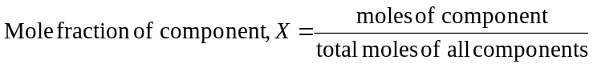 Recall that mass can be converted to moles using the molar mass.
Recall:

Note that mole fraction has no units.
Note that mole fractions range from 0 to 1.
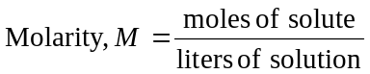 Recall:

Note that molarity will change with a change in temperature (as the solution volume increases or decreases).
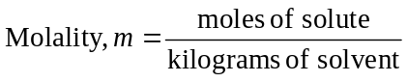 We can define molality (m), yet another concentration unit, as:
Molality does not vary with temperature.
Note that converting between molarity (M) and molality (m) requires density.
The molarity and molality of dilute solutions are often very similar.
Colligative Properties
•Colligative properties depend on the number of solute particles.

There are 4 colligative properties to consider:
vapor pressure lowering (Raoult's Law);
boiling point elevation;
freezing point depression;
and osmotic pressure.
Lowering the Vapor Pressure
•Nonvolatile solutes (with no measurable vapor pressure) reduce the ability of the surface solvent molecules to escape the liquid due to IMFs.
Therefore, vapor pressure is lowered.
The amount of vapor pressure lowering depends on the amount of solute.

Raoult’s law quantifies the extent to which a nonvolatile solute lowers the vapor pressure of the solvent.
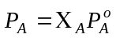 If P_{A} is the vapor pressure with solute, Pº_{A} is the vapor pressure of the pure solvent, and Χ_{Α} is the
mole fraction of A.
An ideal solution is one that obeys Raoult’s law.
Real solutions show approximately ideal behavior when:
the solute concentration is low;
the solute and solvent have similarly sized molecules;
the solute and solvent have similar types of intermolecular attractions.
Raoult’s law breaks down when the solvent-solvent and solute-solute intermolecular forces are much greater or
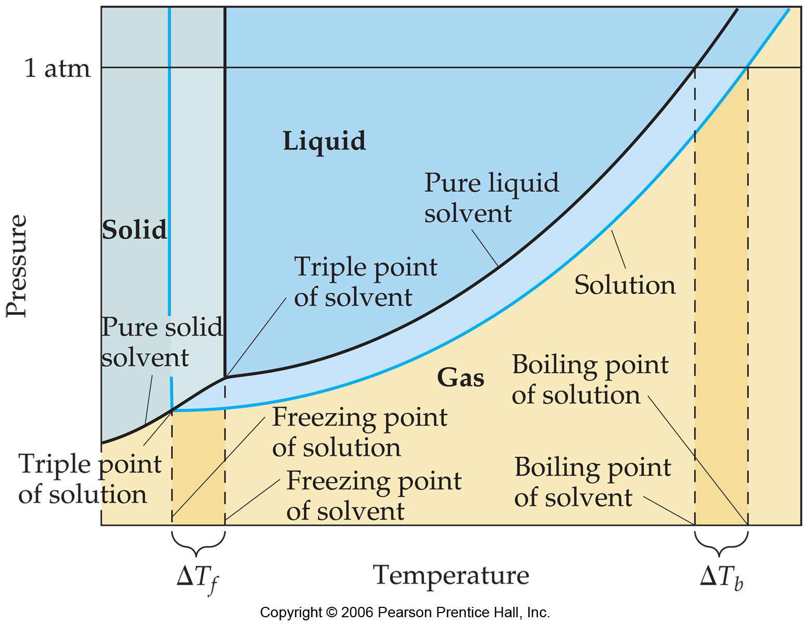
weaker than solute-solvent intermolecular forces.
Boiling-Point Elevation
•A nonvolatile solute lowers the vapor pressure of a solution.
At the normal boiling point of the pure liquid, the solution has a has a vapor pressure less than 1 atm.
Therefore, a higher temperature is required to reach a vapor pressure of 1 atm for the solution (ΔT_{b}).
The molal boiling-point-elevation constant, K_{b}, expresses how much ∆T_{b} changes with molality, m:
ΔT_{b} = K_{b}m
The nature of the solute (electrolyte vs. nonelectrolyte) will impact the colligative molality of the solute.
Freezing-Point Depression
•When a solution freezes, crystals of almost pure solvent are formed first.
Solute molecules are usually not soluble in the solid phase of the solvent.
Therefore, the triple point occurs at a lower temperature because of the lower vapor pressure for the solution.
The melting-point (freezing-point) curve is a vertical line from the triple point.
Therefore, the solution freezes at a lower temperature (ΔT_{f}) than the pure solvent.
The decrease in freezing point (ΔT_{f}) is directly proportional to molality.
K_{f} is the molal freezing-point-depression constant.
ΔT_{f} = K_{f}m
Values of K_{f} and K_{b} for most common solvents can be found in Table 12.8 pg 575.
Osmosis
•Semipermeable membranes permit passage of some components of a solution.
Often they permit passage of water but not larger molecules or ions.
Examples of semipermeable membranes are cell membranes and cellophane.
Osmosis is the net movement of a solvent from an area of low solute concentration to an area of high solute concentration.
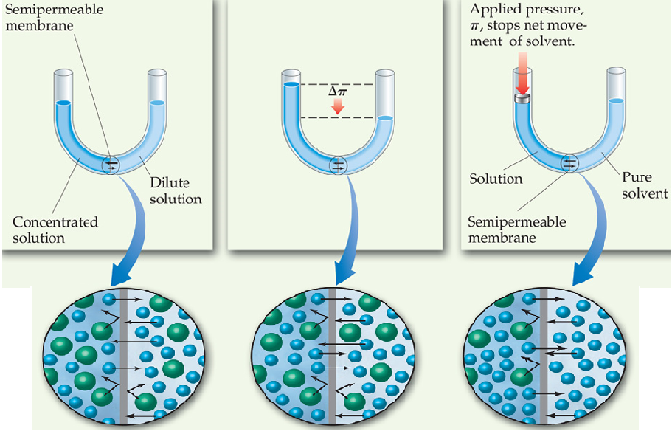
Consider a U-shaped tube with a two liquids separated by a semipermeable membrane.
One arm of the tube contains pure solvent.
The other arm contains a
solution.
There is movement of solvent in both
directions across a semipermeable membrane.
As
solvent moves across the membrane, the fluid
levels in the arms become uneven.
The vapor
pressure of solvent is higher in the arm with pure
solvent.
Eventually the pressure difference due to
the difference in height of liquid in the arms stops
osmosis.
Osmotic pressure, π, is the pressure
required to prevent osmosis.
Osmotic pressure
obeys a law similar in form to the ideal-gas law.
πV = nRT

For n moles, V= volume, M= molarity,
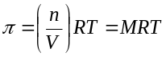 R= the ideal gas constant, and an absolute
temperature, T, the osmotic pressure is:

Two solutions are said to be isotonic if they have the same osmotic pressure.
Hypotonic solutions have a lower π,
relative to a more concentrated solution.
Hypertonic solutions have a higher π, relative to a more dilute solution.
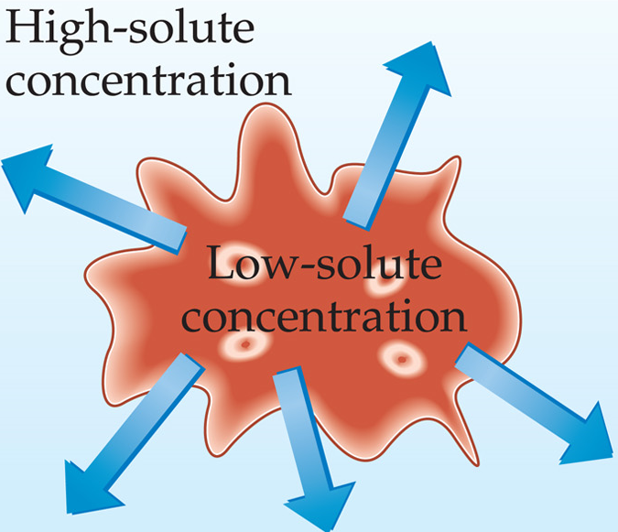
We can illustrate this with a biological system: red blood cells.
Red blood cells are
surrounded by semipermeable membranes.
If red blood cells are placed in a
hypertonic solution (relative to intracellular solution), there is a lower solute concentration in the cell than the surrounding tissue.
Osmosis occurs and water passes through the membrane out of the cell. T
he cell shrivels up.
This process is called crenation.
If red blood cells are placed in a hypotonic solution, there is a higher solute
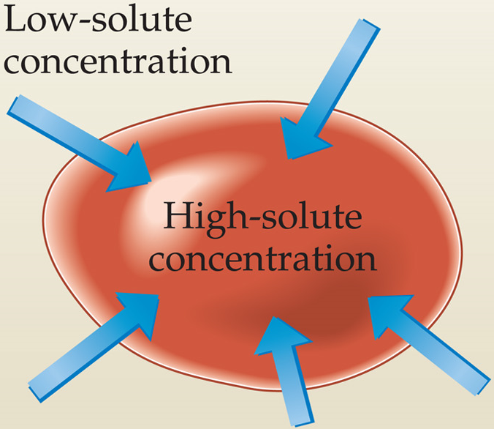
concentration in the cell than outside the cell.
Osmosis occurs and water moves into
the cell.
The cell bursts (hemolysis).
To prevent crenation or hemolysis, IV
intravenous) solutions must be isotonic relative to the intracellular fluids of cells.
Everyday examples of osmosis include:
If a cucumber is placed in NaCl solution, it will lose water to shrivel up and become a pickle.
A limp carrot placed in water becomes firm because water enters via osmosis.
Eating large quantities of salty food causes retention of water and swelling of tissues (edema).
Water moves into plants, to a great extent, through osmosis.
Salt may be added to meat (or sugar added to fruit) as a preservative.
Salt prevents bacterial infection: A bacterium placed on the salt will lose water through osmosis and die.
Active transport is the movement of nutrients and waste material through a biological membrane against a
concentration gradient.
Movement is from an area of low concentration to an area of high concentration.
Active transport is not spontaneous.
Energy must be expended by the cell to accomplish this.
Determination of Molar Mass
Any of the four colligative properties may be used to determine molar mass.
Colligative Properties of Electrolytes
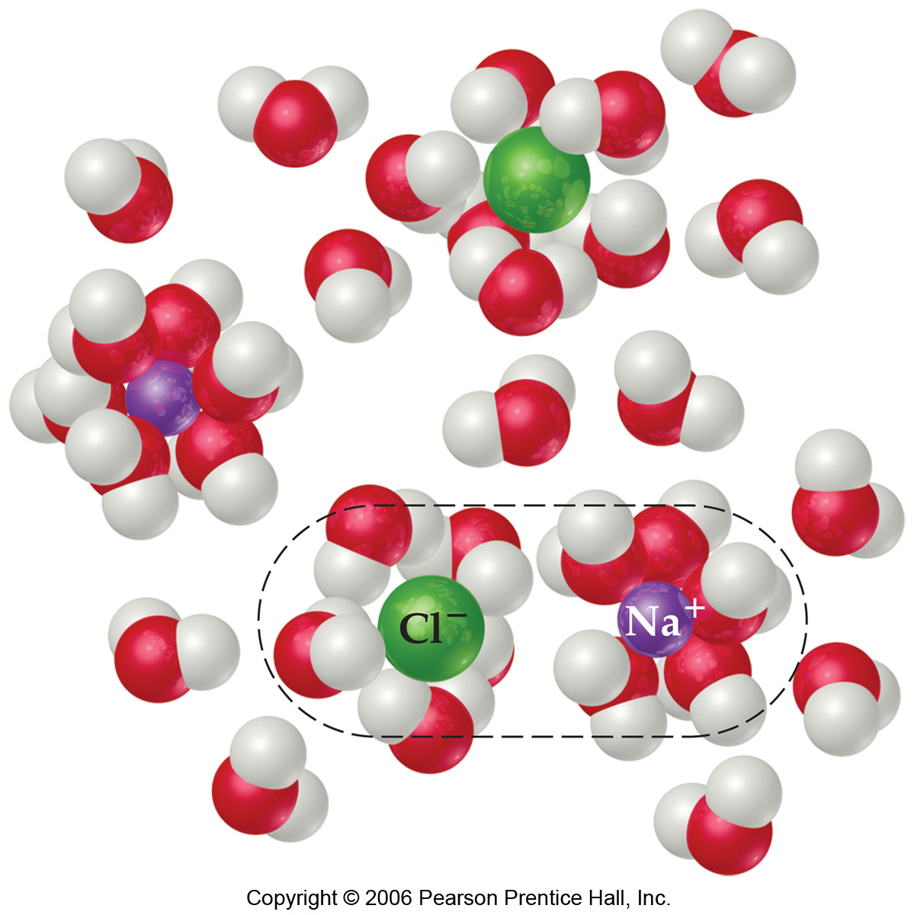
•Since these properties depend on the number of particles dissolved, solutions of electrolytes (which dissociate in solution) should show greater changes than those of nonelectrolytes. However, a 1 M solution of NaCl does not show twice the change in freezing point that a 1 M solution of methanol does. One mole of NaCl in water does not really give rise to two moles of ions. Some Na⁺ and Cl⁻ reassociate for a
short time, so the true concentration of particles is somewhat less than two
times the concentration of NaCl. Reassociation is more likely at higher
concentration. Therefore, the number of particles present is concentration
dependent. We modify the previous equations by multiplying by the
van’t Hoff factor, i. This factor is the ratio of the actual value of a colligative
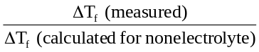 property to the value calculated assuming the substance to be a nonelectrolyte.
Example for freezing-point-depression: i =
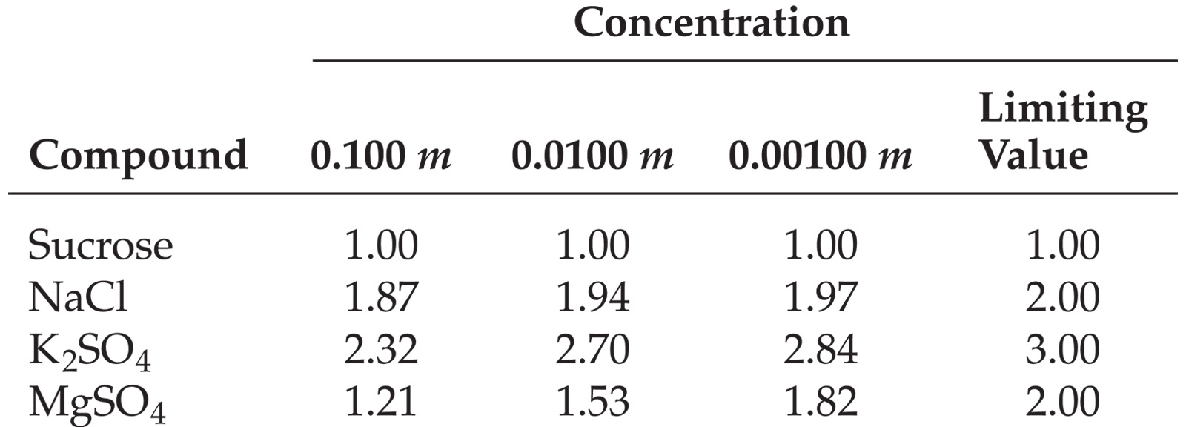
Dilution affects the value of i for electrolytes. The more dilute the solution, the more closely i approaches the ideal or limiting value. The extent of ion pairing (reassociation) in electrolyte solutions decreases upon
dilution. The lower the charges on the ions, the smaller the
departure of i from the limiting value. The extent of ion pairing
decreases as the charges of ions decrease.

Colloids
•Colloids, or colloidal dispersions, are suspensions in which the suspended particles are larger than molecules but too
small to separate out of the suspension due to gravity.
Particle size ranges from 5 to 1000 nm.
There are several types of colloids:
•aerosol: gas + liquid or solid (e.g., fog and smoke) •emulsion: liquid + liquid (e.g., milk)
•foam: liquid + gas (e.g., whipped cream)

•sol: liquid + solid (e.g., paint),
•solid foam: solid + gas (e.g., marshmallow)
•solid emulsion: solid + liquid (e.g., butter), and
•solid sol: solid + solid (e.g., ruby glass with colloidal gold)
The Tyndall effect is the ability of colloidal particles to scatter light.
•The path of a beam of light projected through a colloidal suspension can be seen through the suspension.

Hydrophilic and Hydrophobic Colloids
•Consider colloids in water.
Water-loving colloids are hydrophilic.
Water-hating colloids are hydrophobic.
In the human body, large biological molecules such as proteins are kept in suspension by association with surrounding water molecules.
These macromolecules fold up so that hydrophobic groups are away from the water (inside the folded molecule).
Hydrophilic groups are on the surface of these molecules and interact with solvent (water) molecules.
Typical hydrophilic groups are polar (containing C–O, O–H, N–H bonds) or charged.
Hydrophobic colloids need to be stabilized in water.
One way to stabilize hydrophobic colloids is to adsorb ions on their surface.
Adsorption: When something sticks to a surface we say that it is adsorbed.
If ions are adsorbed onto the surface of a colloid, the colloid appears hydrophilic and is stabilized in water.
Consider a small drop of oil in water.
Add a small amount of sodium stearate.
Sodium stearate has a long hydrophobic hydrocarbon tail and a small hydrophilic head.
The hydrophobic tail can be absorbed into the oil drop, leaving the hydrophilic head on the surface.
The hydrophilic head then interacts with the water and the oil drop is stabilized in water.
A soap acts in a similar fashion.
Soaps are molecules with long hydrophobic tails and hydrophilic heads that remove dirt by stabilizing the colloid in water.
Most dirt stains on people and clothing are oil-based.

A biological application of this principle is when
the gallbladder excretes a fluid called bile.
Bile contains
substances (bile salts) that form an emulsion with fats in our small intestine.
Emulsifying agents help form an emulsion.
Emulsification of dietary fats and fat-soluble vitamins is important in their absorption and digestion by the body. Mayonnaise is an emulsion of oil and vinegar. Egg is used as the emulsifying agent.
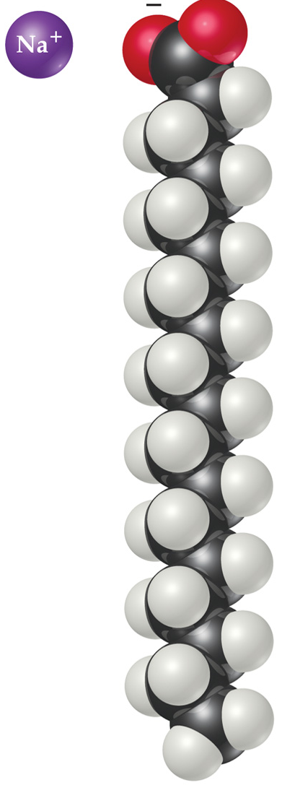
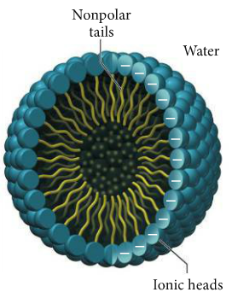
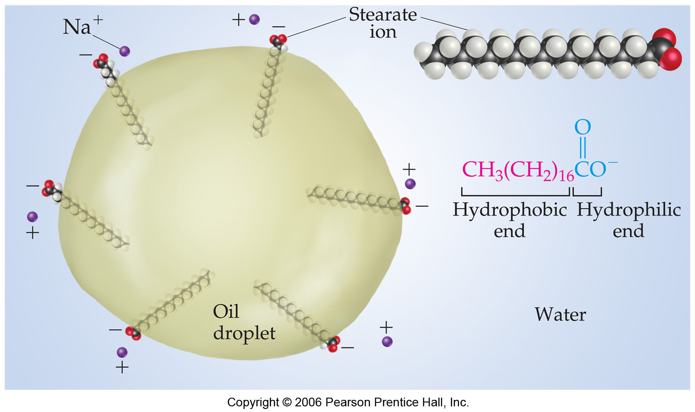

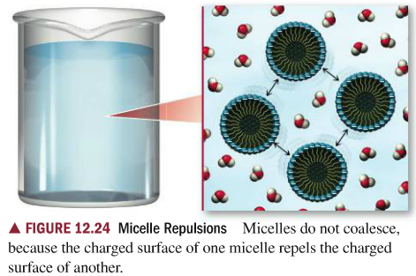

Removal of Colloid Particles
•We often need to separate colloidal particles from the dispersing medium.
This may be problematic.
Colloid particles are too small to be separated by physical means (e.g., filtration).
However, colloid particles often may be coagulated (enlarged) until they can be removed by filtration.
There are methods of coagulation.
Colloid particles move more rapidly when the collodial dispersion is heated, increasing the number of collisions.
The particles stick to each other when they collide.
Adding an electrolyte neutralizes the surface charges on the
colloid particles.
This removes the electrostatic repulsions that prevent the particles from coming together.
Try washing your hands in salt water.
A biological application of another approach to separating colloidal particles from the suspending medium is
dialysis.
In dialysis a semipermeable membrane is used to separate ions from colloidal particles.
In kidney
dialysis, the blood is allowed to pass through a semipermeable membrane immersed in a washing solution.

The washing solution is isotonic in ions that must be retained.
The washing solution does not have the waste
products that are found in the blood.
Wastes therefore dialyze out of the blood (move from the blood into the
washing solution).
The "good" ions remain in the blood.

