Rate Laws from Graphs of Concentration Versus Time (Integrated Rate Laws)

In order to determine the rate law for a reaction from a set of data consisting of concentration (or the values of some function of concentration) versus time, make three graphs.
- [A] versus t (linear for a zero order reaction)
- ln [A] versus t (linear for a 1st order reaction)
- 1 / [A] versus t (linear for a 2nd order reaction)
The graph that is linear indicates the order of the reaction with respect to A. Then, you can choose the correct rate equation:
For a zero order reaction, | rate = k | (k = - slope of line)
For a 1st order reaction, | rate = k[A] | (k = - slope of line)
For a 2nd order reaction, | rate = k[A]² | (k = slope of line)

Examples
For a zero order reaction, as shown in the following figure, the plot of [A] versus time is a straight line with k = - slope of the line. Other graphs are curved for a zero order reaction.

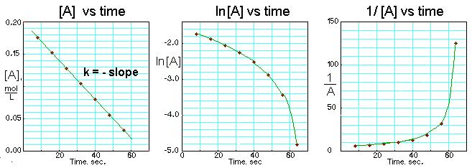

For a first order reaction, as shown in the following figure, the plot of the natural logarithm of [A] versus time is a straight line with k = - slope of the line. Other graphs are curved for a first order reaction.
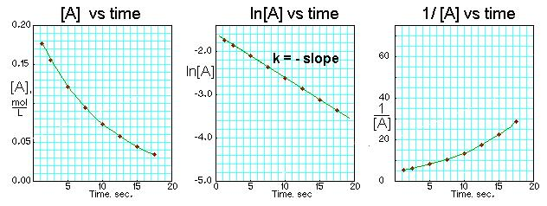

For a second order reaction, as shown in the following figure, the plot of 1/[A] versus time is a straight line with k = slope of the line. Other graphs are curved for a second order reaction.
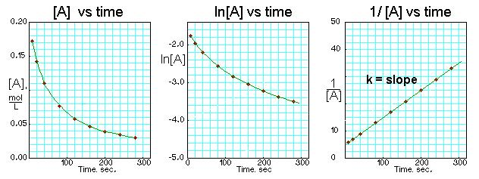

Kinetics-Orders of Reaction

Rate Order | Zero | First | Second
Rate Law | Rate = k | Rate = k[A] | Rate = k[A]²
Integrated Rate Law | [A] = -kt + [A]₀ | Ln [A] = -kt + ln [A]₀ | 1/[A] = kt + 1/[A]₀
Straight Line Plot | [A] vs t | Ln [A] vs t | 1/[A] vs t
Slope | Slope = - k | Slope = - k | Slope = k
Half-Life | t_{1/2} = [A]₀/2k | t_{1/2} = 0.693/k | t_{1/2} = 1/k[A]₀

Integrated Rate Law Examples:

Cyclopropane rearranges to form propene in the gas phase. The reaction is first order with respect to cyclopropane and has a rate constant of 3.36 x 10⁻⁵ s⁻¹ at 720 K. If the initial concentration is 0.0445 M, what is the concentration after 235 minutes?

This reaction was monitored as a function of time:

2N₂O (g) → 2N₂ (g) + O₂ (g)

A plot of 1/[N₂O] vs. time yields a straight line with a slope of 0.55 M⁻¹ s ⁻¹.

- What is the value of the rate constant?

- Write the rate law for the reaction.

- If the initial concentration of N₂O is 0.350 M, what is the concentration after 86 seconds?

