CHEMICAL KINETICS: The area of chemistry concerned with the speeds, or rates, of chemical reactions.
Factors that Affect Reaction Rates: Speeds of reactions depend on the nature of the reactants themselves because reactions involve the breaking and forming of bonds.
- Factors that can change the rate of a reaction.
  - The physical state of the reactants
    - The more readily molecules collide with each other, the more rapidly they react.
    - Reaction is limited to area of contact.
    - For solids, increase reaction rate by increasing the surface area.
  - The concentrations of the reactants.
    - Usually, rate increases as the concentration of one or more reactants increases.
    - As concentration increases the frequency of collisions increases.
  - The temperature at which the reaction occurs.
    - Rate increases as temperature increases.
    - Increasing temperature increases the KE of molecules, leading to more frequent collisions with higher energy.
  - The presence of a catalyst.
    - Catalysts increase reaction rate without being used up.
    - They affect the kinds of collisions (the mechanisms) that lead to the reaction.
Reaction Rates
- The speed of an event is defined as the change that occurs in a given interval of time.
- Reaction Rate: The change in concentration of reactants per unit time. (Speed) Units = Molarity per second (M/s)
- A → B
  - Rate of reaction can be expressed as the rate of disappearance of reactant A or as the rate of appearance of product B.
  - Average rate of appearance of B = 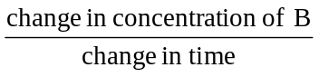= 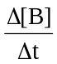
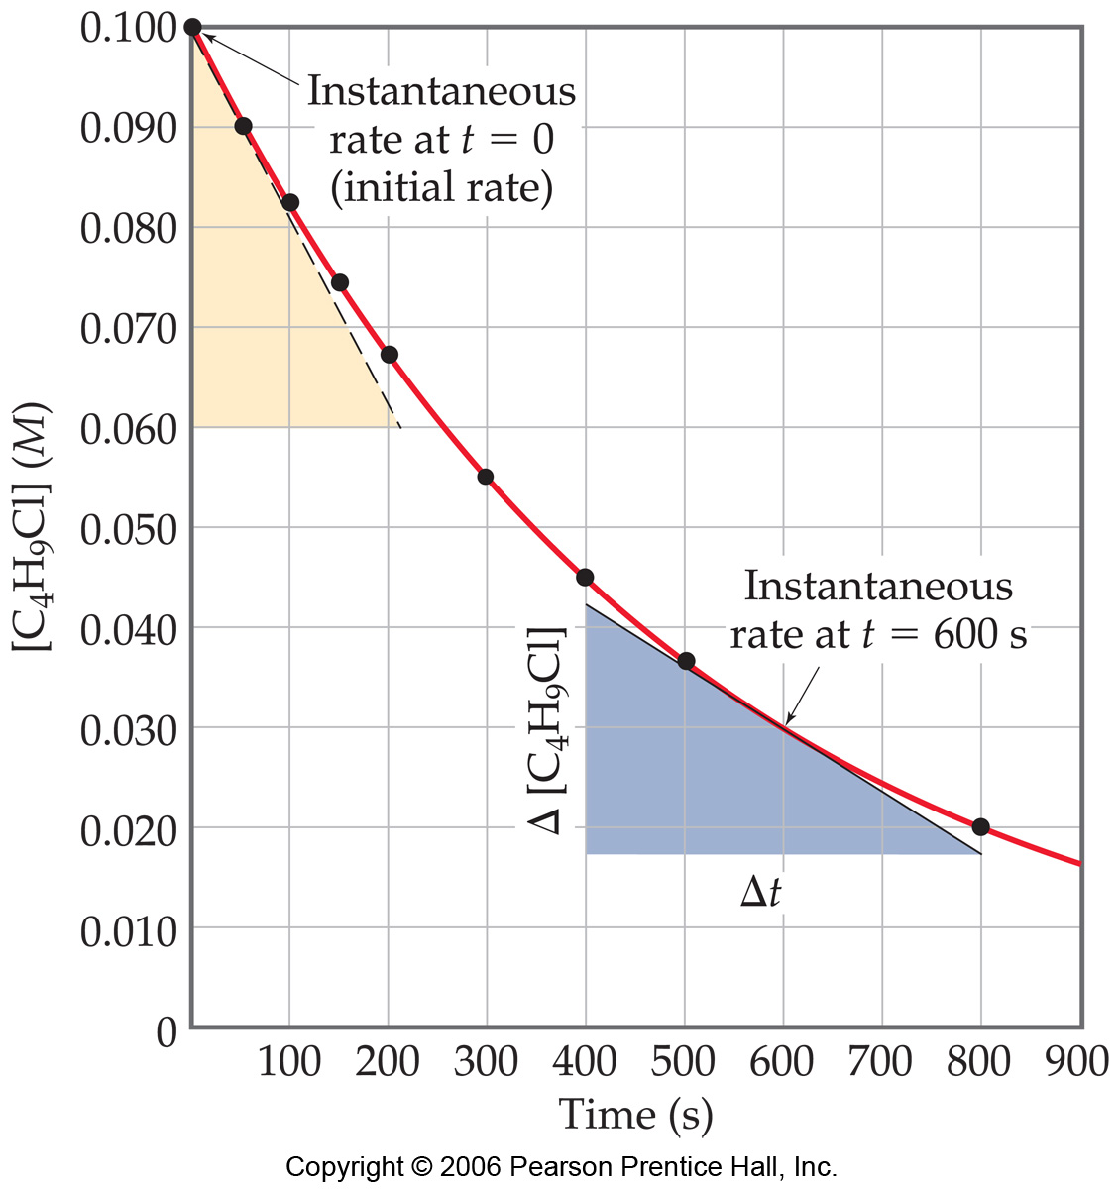
  - Average rate of disappearance of A = – 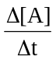
  - Rates are always expressed as positive quantities.

- Change of Rate with Time
  - It is typical for rates to decrease as a reaction proceeds, because the concentration of reactants decreases.
  - Instantaneous Rate: The rate at a particular moment in the reaction. Determined from the slope (or tangent) of this curve at a given point of interest.
    - At 600 s: Instantaneous rate = – 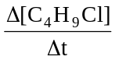 = – 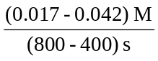 = 6.2 x 10⁻⁵ M/s
    - NOT equal to average rate of the same time period!
- Reaction Rates and Stoichiometry
  - What happens if the ratio is not 1:1?
  - 2HI(g) → H₂(g) + I₂(g)
    - Because 2 mol of HI disappear for each mole of H₂ or I₂ that forms, the rate of disappearance of HI is twice the rate of appearance of either H₂ or I₂.
    - Rate = – 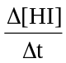 = 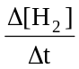 = 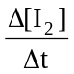
  - In general, for the reaction: a A + b B → c C + d D, the rate is given by:
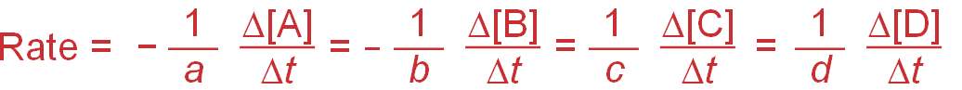

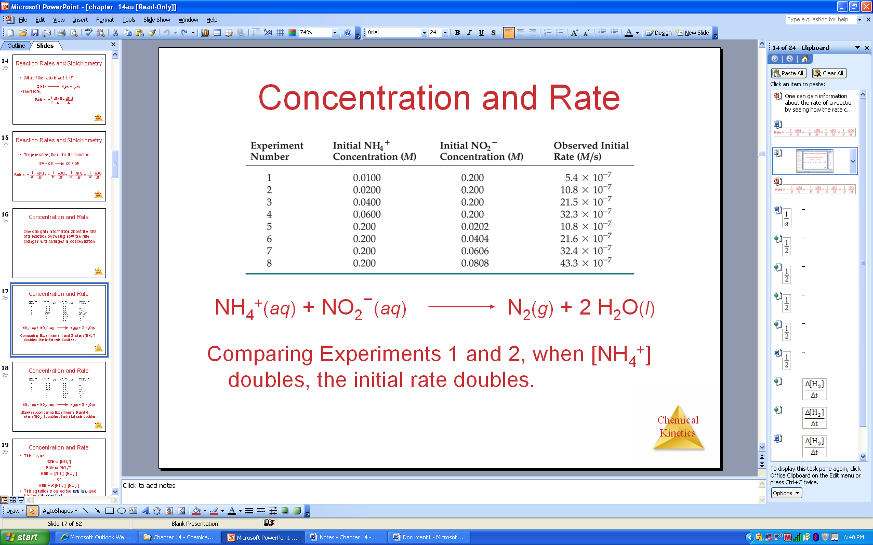
Concentration and Rate:
One can gain information about the rate of a reaction by seeing how the rate changes with changes in concentration.
  - Comparing Experiments 1 and 2, when [NH₄⁺]doubles, the initial rate doubles.
  - Likewise, comparing Experiments 5 and 6, when [NO₂⁻] doubles, the initial rate doubles.
    - Rate ∝ [NH₄⁺] and Rate ∝ [NO₂⁻]
    - Rate ∝ [NH₄⁺] [NO₂⁻] or Rate = k [NH₄⁺] [NO₂⁻]
  - This equation is called the rate law, and k is the rate constant.
    - A rate law shows how rate depends on the concentrations of reactants.
    - The magnitude of the rate constant changes with temperature.
- Exponents in the Rate Law
For the general equation a A + b B → c C + d D, the rate law is:
  - Rate = k[A]^{m}[B]^{n} m and n are whole numbers (usually 0, 1, or 2)
    - The exponents m and n are called reaction orders.
    - If m = 1, when the concentration of A doubles, the rate of the reaction doubles.
    - If m = 2, when the concentration of A doubles, the rate of the reaction quadruples.
  - The exponents tell the order of the reaction with respect to each reactant.
    - For the example above, the reaction is first-order in [NH₄⁺] and first-order in [NO₂⁻]
  - The overall reaction order can be found by adding the exponents on the reactants in the rate law.
    - This reaction is second-order overall.
  - The values of the reaction orders must be determined experimentally. They do not necessarily correspond to the coefficients of the balanced reaction. Common orders are 0, 1, 2. Mostly positive values, but fractions and negative values are possible
- Units of Rate Constants
  - The units of the rate constant depend on the overall reaction order. Rate must be in units of M/s.
  - For a second order rxn: R = k [A]² Solving for the units of k will give M⁻¹ S⁻¹
- Using Initial Rates to Determine Rate Laws (see pgs 604-607 and Example 13.2) Note the RATE, not the rate constant, depends on concentration. The rate constant is affected by temperature and by the presence of a catalyst.
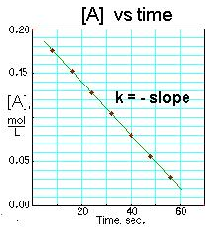
The Change of Concentration with Time
- Zero-Order Reactions
  - A → Products Rate = k[A]⁰ so R = k
  - For a reaction that is zero-order in A, a plot of [A] vs t will yield a straight line: [A]_{t} = -kt + [A]₀ The slope of the line = –k.

- First-Order Reactions
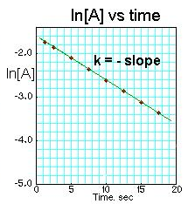
  - First-order reaction: Rate depends on the concentration of a single reactant raised to the first power.
  - A → Products Rate = k[A]
  - Using calculus to integrate the rate law for a first-order process gives
ln 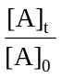= – kt
[A]₀ is the initial conc of A; [A]_{t} is the conc of A at some point t, during the reaction.
  - Manipulating this equation gives: ln [A]_{t} = − kt + ln [A]₀ (which is in the form y = ax + b) Therefore, if a reaction is first-order, a plot of ln [A] vs. t will yield a straight line. The slope of the line will be -k.
  - The y-intercept will be ln[A]₀.

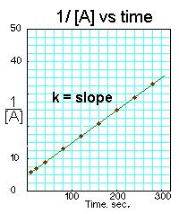
- Second-Order Reactions
- Second-order reaction: Rate depends on the reactant concentration raised to the second power or on the concentrations of two different reactants,
each raised to the first power.
- 2A → Products OR A + B → Products (when [A] = [B]) Rate = k[A]²
- Integrating the rate law for a process that is second-order in reactant A, we get:
  - 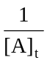 = kt + 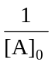 (which is also in the form y = ax + b)
- If a reaction is second-order in A, a plot of 1/[A] vs. t will yield a straight line.
    - The slope of that line will be k.

- Half-Life
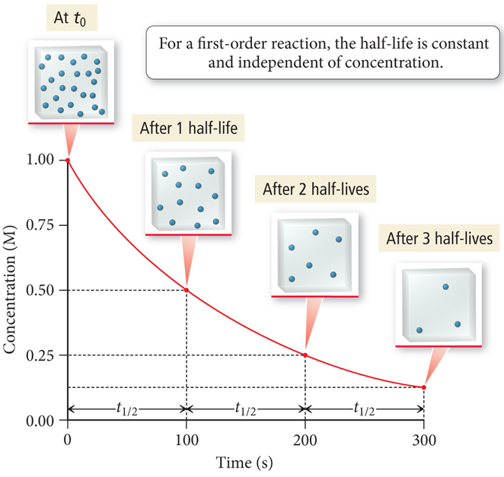
For a first order reaction: ln = – kt
Since half-life is defined as the time required for ½ of the initial concentration to react. [A]_{t ½} = 0.5 [A]₀
ln 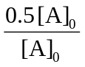= – kt ln 0.5 = -kt _{½}
-0.693 = -kt _{½}
0.693 = t _{½}
k
The half-life does not depend on the initial concentration.

For a second order reaction: = kt +
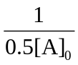 = kt + 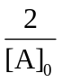 = kt + 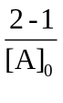 = kt_{½} t_{½} = 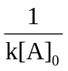
The half-life of a second order reaction is dependent on the initial concentration; t_{½} increases as concentration decreases.
For a zero order reaction t_{½} = [A]₀ Notice t_{½} also depends on the initial concentration; however, unlike
2k a 2nd order reaction the t_{½} is directly proportional to concentration and
it decreases as concentration decreases.

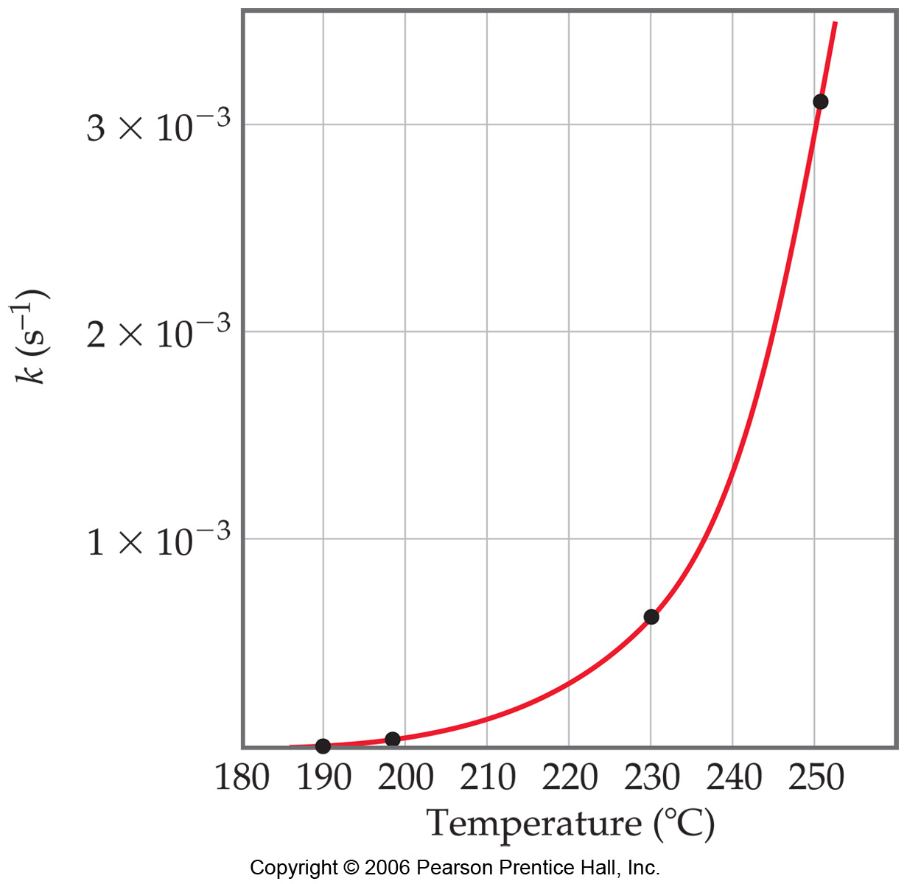
Temperature and Rate
Generally, as temperature increases, so does the reaction rate.
- This is because k is temperature dependent.

- The Collision Model
  - Molecules must collide to react.
  - The greater the number of collisions per second, the greater the reaction rate.
  - As the concentration of reactants increase, the number of collisions increases. This leads to an increase in reaction rate.
  - Increasing temperature increases molecular speeds. As molecules move faster, they collide more frequently and with more energy, increasing reaction rate. Rate approximately doubles with each 10ºC increase in temperature.
  - Only a small fraction of collisions leads to products.
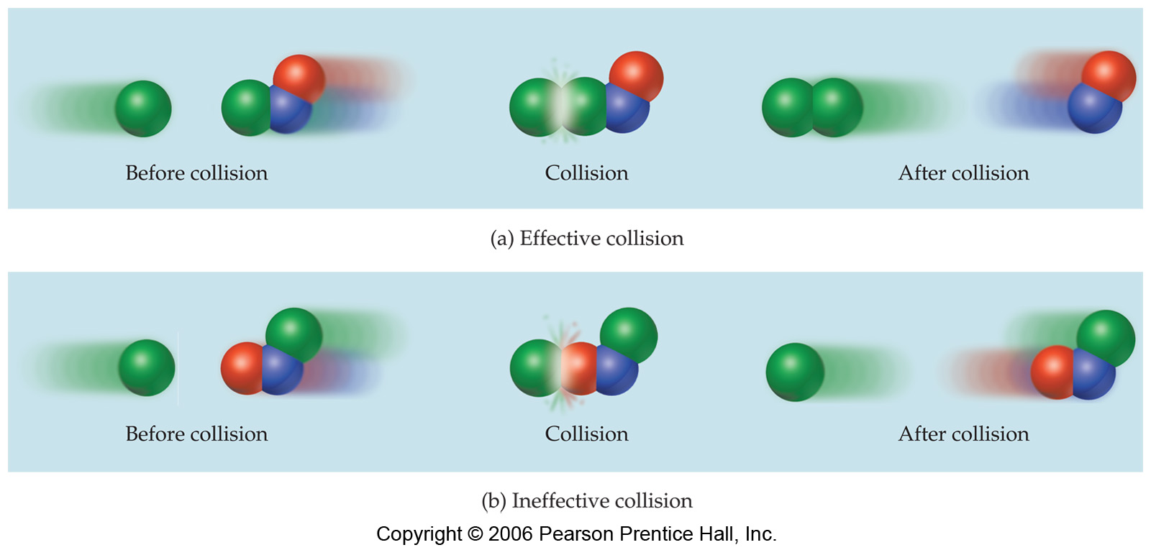
- The Orientation Factor
  - Molecules must be oriented in a certain way during collisions in order for a reaction to occur.
  - Many collisions do not lead to reaction because the molecules are not suitably oriented.
  - Example: Cl + NOCl → NO + Cl₂

- Activation Energy
  - Molecules must possess a certain minimum amount of energy in order to react. According to the collision model, this energy comes from the kinetic energies of the colliding molecules. Upon collision, the kinetic energy of the molecules can be used to break bonds.
  - If molecules are moving too slowly, they bounce off one another without changing.
  - In order to react, colliding molecules must have a total kinetic energy equal to or greater than some minimum value, the activation energy (E_{a}).
  - Just as a ball cannot get over a hill if it does not roll up the hill with enough energy, a reaction cannot occur unless the molecules possess sufficient energy to get over the activation energy barrier.
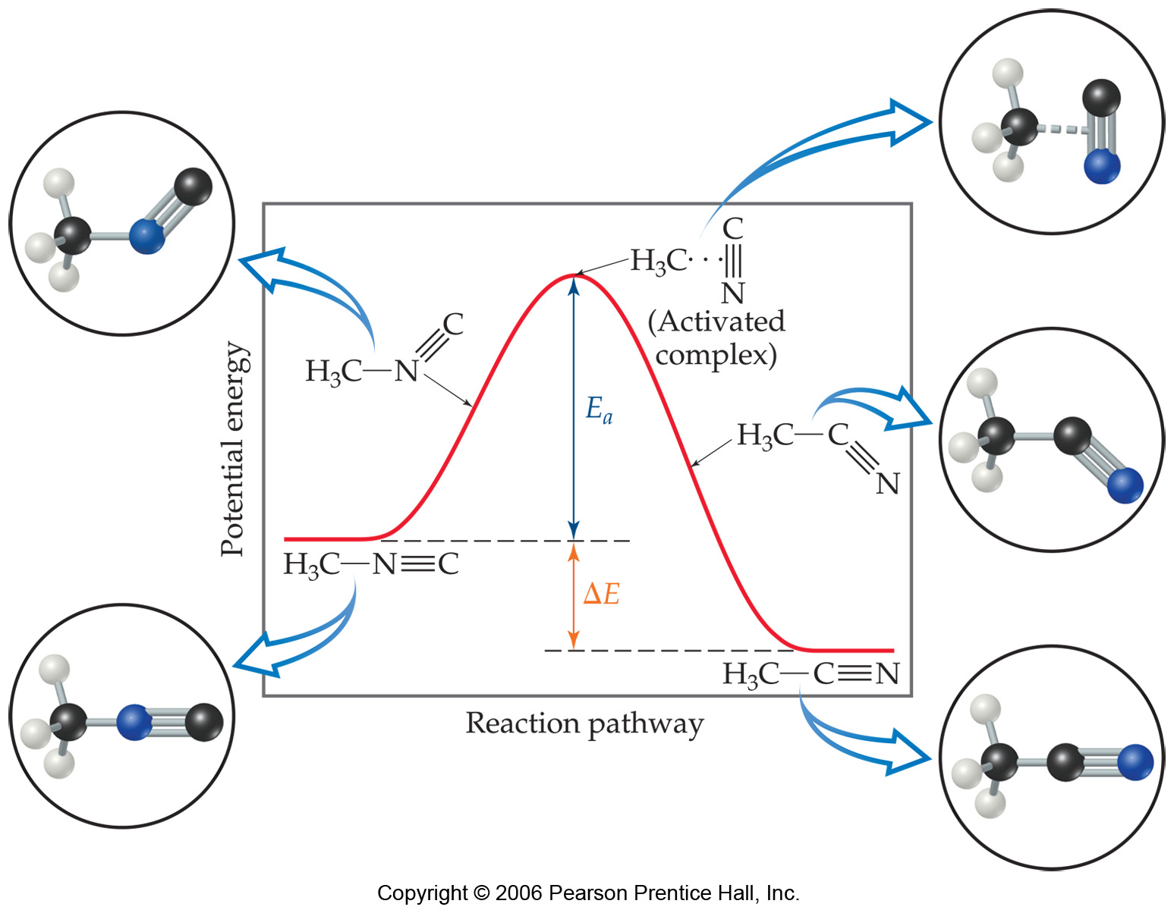
  - It is helpful to visualize energy changes throughout a process on an energy profile diagram like this one for the rearrangement of methyl isonitrile.

    - It shows the energy of the reactants and products (and, therefore, ΔE).
    - The high point on the diagram is the transition state.
    - The species present at the transition state is called the activated complex.
    - The energy gap between the reactants and the activated complex is the activation energy barrier (E_{a}).

Maxwell-Boltzmann Distribution
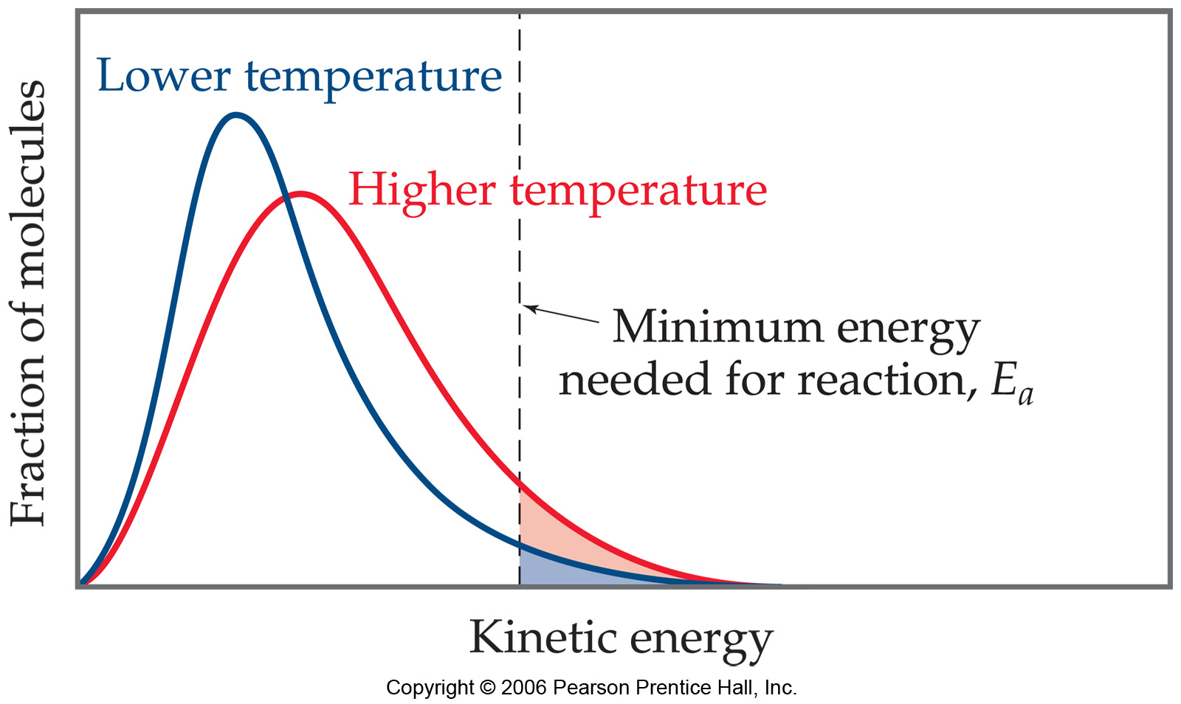
    - Temperature is defined as a measure of the average kinetic energy of the molecules in a sample.
    - At any temperature there is a wide distribution of kinetic energies.
    - As the temperature increases, the curve flattens and broadens.
    - Thus at higher temperatures, a larger population of molecules has higher energy.
    - If the dotted line represents the activation energy, as the temperature increases, so does the fraction of molecules that can overcome the activation energy barrier.
    - As a result, the reaction rate increases.
    - This fraction of molecules can be found through the expression: f = e ^{–Ea/RT}
R is the gas constant (8.314 J/mol K) and T is the Kelvin temperature.

- The Arrhenius Equation
  - k = (A)(e^{–Ea/RT})
    - A is the frequency factor, a number that represents the likelihood that collisions would occur with the proper orientation for reaction. A is constant, or nearly so, as temperature is varied.
  - Reaction rate decreases as E_{a} increases.

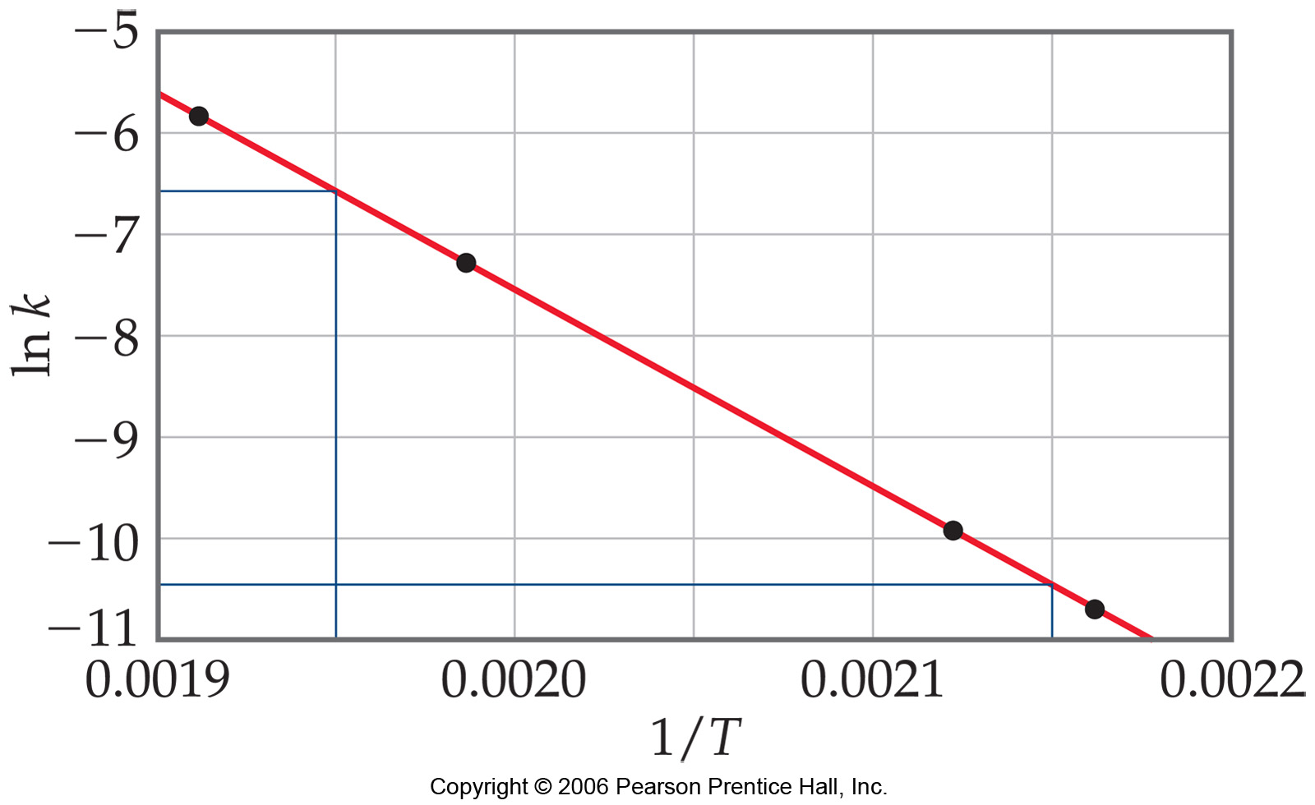
- Determining Activation Energy
Taking the natural logarithm of both sides, the Arrhenius equation becomes:
ln(k) = –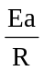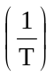+ ln(A)
y = ax + bA graph of ln(k) vs. 1/T will be a line with a slope equal to –Ea/R and a y-intercept equal to ln(A)

Activation energy can be determined by measuring k at a series of temperatures, graphing ln(k) vs. 1/T, and then calculating Ea from the slope of the resulting line.
ln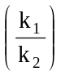 = 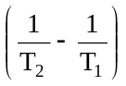
    - The Arrhenius equation provides a convenient way to calculate the rate constant at temperature when we know the activation energy and the rate constant at a different temperature.
Reaction Mechanisms
- A detailed picture, or model, of how the reaction occurs; that is, the order in which bonds are broken and formed and the changes in relative position of the atoms as the reaction proceeds.
- The sequence of events that describes the actual process by which reactants become products.
- Reactions may occur all at once or through several discrete steps.

- Elementary Reactions
  - Elementary Reaction: A process in a chemical reaction that occurs in a single event or step.
  - An overall chemical reaction consists of one or more elementary reactions.
  - The molecularity of a process tells how many molecules are involved as reactants in the process.
    - Unimolecular: Reactions involving one molecule.
    - Bimolecular: Elementary reaction involving the collision or two reactant molecules.
    - Termolecular: Elementary reaction involving the simultaneous collision of three reactant molecules.
- Multistep Mechanisms
  - The net change represented by a balanced chemical equation often occurs by a multistep mechanism, which consists of a sequence of elementary reactions.
  - The chemical equations for elementary reactions in a multistep mechanism must always add to give the chemical equation of the overall process.
  - Intermediate
    - A substance formed in one elementary step of a multistep mechanism and consumed in another.
    - It is neither a reactant nor a product of the overall reaction.
- Rate Laws for Elementary Reactions
  - Every reaction is made up of a series of one or more elementary steps, and the rate laws and relative speeds of these steps will dictate the overall rate law. As a result, the rate law of a reaction cannot be predicted from the coefficients of the balanced chemical equation.

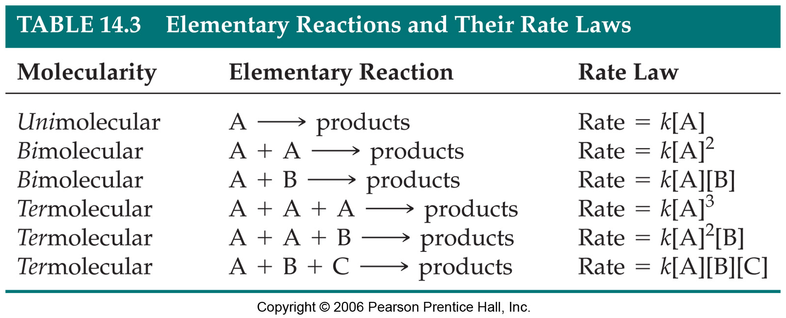
  - The rate law of a reaction can be determined from its mechanism.

  - The rate law of an elementary reaction is based directly on its molecularity.

- The Rate-Determining Step for a Multistep Mechanism
  - In a multistep process, one of the elementary steps will be slower than all others.
  - The overall reaction cannot occur faster than this slowest, rate-determining step.
  - Example: On a toll road with two toll plazas, the overall flow of traffic is limited by the flow through the slower toll plaza.

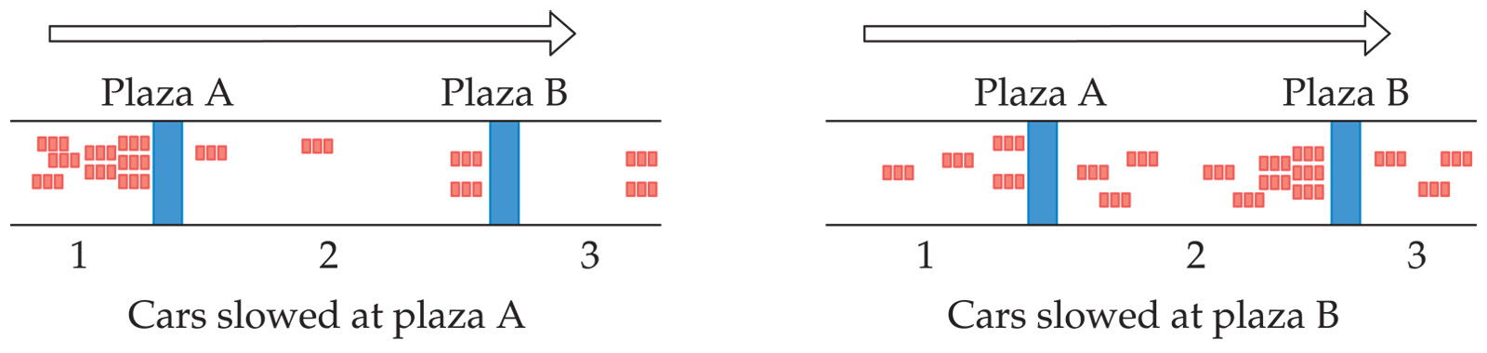

  - The rate-determining step governs the rate law for the overall reaction.

- Mechanisms with a Slow Initial Step
  - NO₂(g) + CO(g) → NO(g) + CO₂(g)
  - The rate law for this reaction is found experimentally to be: Rate = k [NO₂]²
  - CO is necessary for this reaction to occur, but the rate of the reaction does not depend on its concentration.
  - This suggests the reaction occurs in two steps.
  - A proposed mechanism for this reaction is:
    - Step 1: NO₂ + NO₂ → NO₃ + NO (slow) [k = k₁]
    - Step 2: NO₃ + CO → NO₂ + CO₂ (fast) [k = k₂]
  - The NO₃ intermediate is consumed in the second step.
  - As CO is not involved in the slow, rate-determining step, it does not appear in the rate law.
  - The rate law is consistent with the experimental rate law. This supports but does not prove the mechanism.

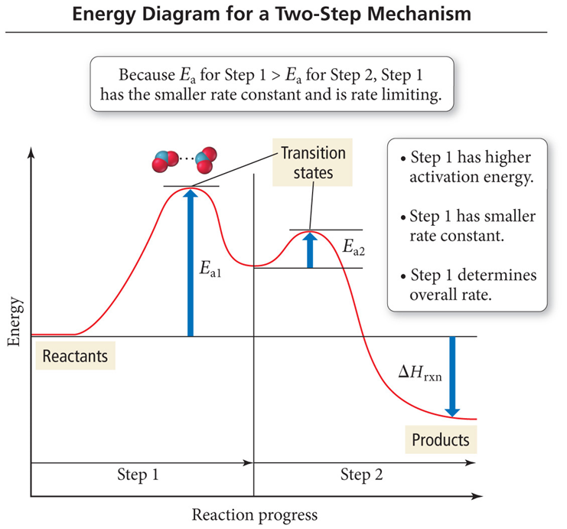

Mechanisms with a Fast Initial Step
  - 2NO(g) + Br₂(g) → 2NOBr(g)
  - The rate law for this reaction is found to be: Rate = k [NO]² [Br₂]
  - One possibility for the reaction mechanism that is consistent with this rate law is that the reaction occurs in a single termolecular step. Because termolecular processes are rare, this rate law suggests a two-step mechanism. A proposed mechanism for this reaction is:
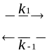 • Step 1: NO(g) + Br₂(g) NOBr₂(g) fast step
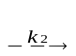
Step 2: NOBr₂(g) + NO(g) 2NOBr(g) slow step
  - The rate of the overall reaction depends upon the rate of the slow step. The rate law for that step is:
    - Rate = k₂ [NOBr₂] [NO]
  - How can we find [NOBr₂]? NOBr₂ is unstable and does not accumulate to a significant extent. As it is formed, NOBr₂ can react two ways:
    - With NO to form NOBr (Step 2)
    - By decomposition to reform NO and Br₂ (Reverse of Step 1)
    - Because Step 2 is slow, we assume that most of the NOBr₂ decomposes.
  - The reactants and products of Step 1 of the reaction mechanism are in equilibrium with each other.
    - Rate (forward) = Rate (reverse)
    - k₁[NO][Br₂] = k_{–1}[NOBr₂]
    - Solving for [NOBr₂] gives:
      - [NOBr₂] = (k₁/ k_{–1})[NO][Br₂]
  - Substituting this expression for [NOBr₂] in the rate law for the rate-determining step gives:
    - Rate = (k₂ k₁/ k_{–1})[NO][Br₂][NO]
    - Rate = k[NO]²[Br₂] The experimental rate constant (k) is equal to (k₂ k₁/ k_{–1}).

Catalysis
- Catalyst: A substance that changes the speed of a chemical reaction without undergoing a permanent chemical change itself in the process.
- Catalysts increase the rate of a reaction by decreasing the activation energy (E_{a}) of the reaction.
- Catalysts change the mechanism by which the process occur. (Figure 13.17 on p. 628)

The energy profiles for the uncatalyzed decomposition of hydrogen peroxide and for the reaction as catalyzed by Br – are compared below.
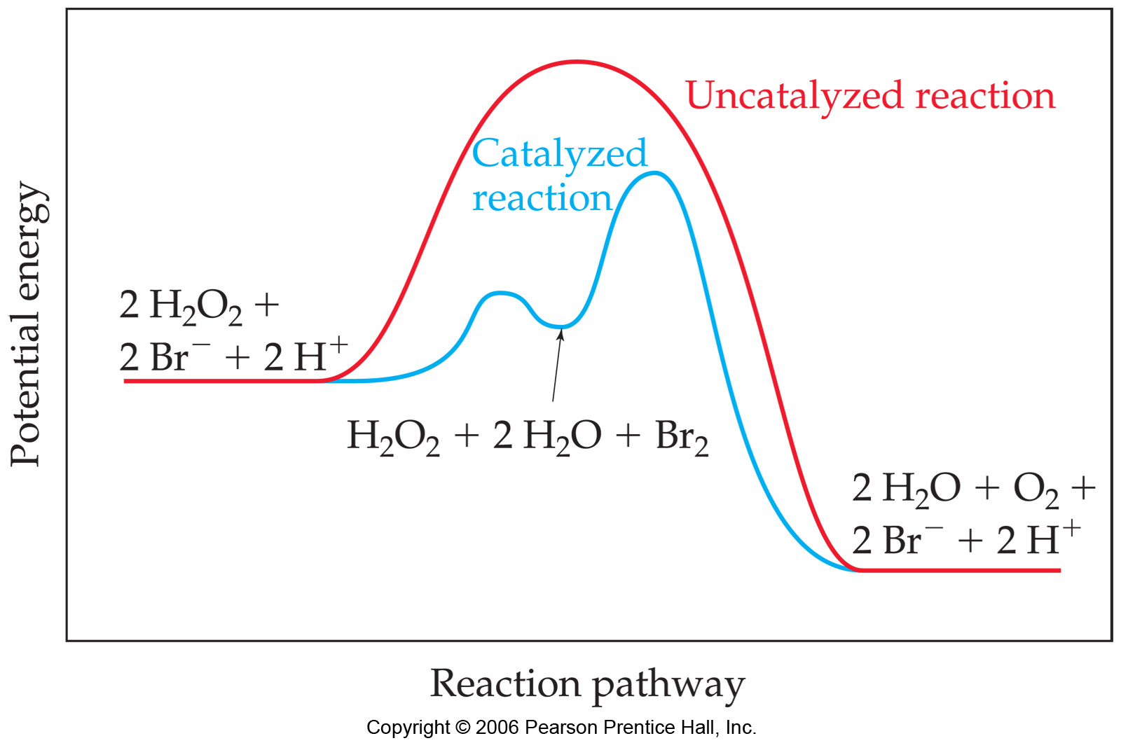
    - The catalyzed reaction involves two successive steps, each of which has a lower activation energy than the uncatalyzed reaction.
    - Notice that the energies of the reactants and products are unchanged by the catalyst.
    - Notice Br⁻ is present in the beginning and regenerated at the end.
Br₂ is an intermediate. When the catalyst adds an intermediate, the activation energies for both steps must be lower than the activation energy of the uncatalyzed reaction.

- Homogeneous Catalysis
  - Homogeneous Catalyst: A catalyst that is present in the same phase as the reacting molecules.
  - Br⁻ is in in the same phase as the hydrogen peroxide (both aqueous).

- Heterogeneous Catalysis
  - Heterogeneous Catalyst: A catalyst that exists in a different phase from the reactant molecules.
    - Usually is a solid in contact with either gaseous reactants or with reactants in a liquid solution.
  - The initial step in heterogeneous catalysis is usually adsorption of reactants. (Adsorption refers to the binding of molecules to a surface.)
    - Adsorption occurs because atoms or ions at the surface of a solid are extremely reactive.
    - Adsorption holds the reactants together and helps bonds to break.
    - Example catalytic converter in a car. (pg 629)

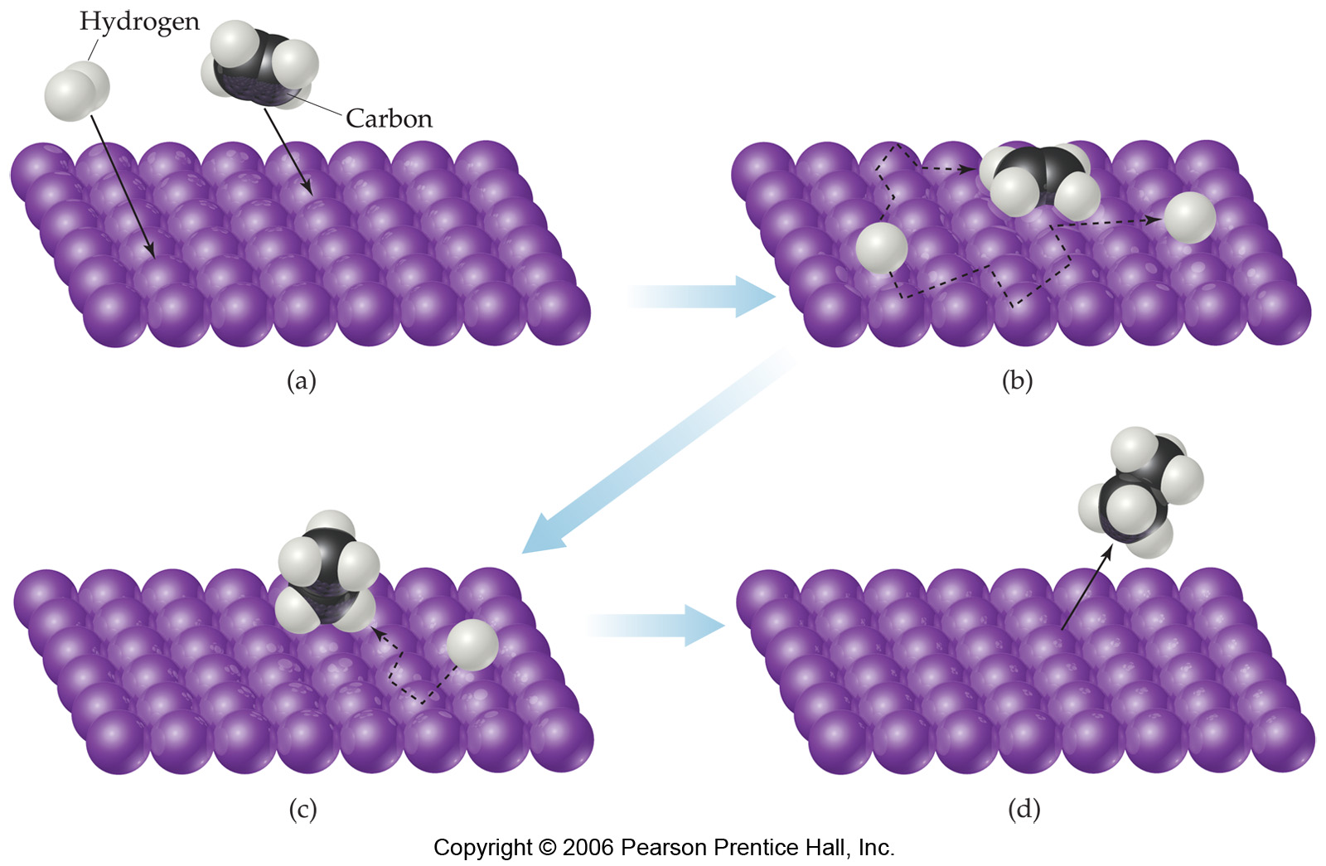
Molecules are adsorbed onto active sites on the catalyst surface.
The number of active sites on a given amount of catalyst depends on several factors such as:
- the nature of the catalyst,
- how the catalyst was prepared, and
- how the catalyst was treated prior to use.

For example, consider the hydrogenation of ethylene to form ethane:
C₂H₄(g) + H₂(g) → C₂H₆(g) ΔH⁰ = −137 kJ/mol
The reaction is slow in the absence of a catalyst.
In the presence of a finely divided metal catalyst (Ni, Pt or Pd) the reaction occurs quickly at room temperature.
First, the ethylene and hydrogen molecules are adsorbed onto active sites on the metal surface. The H–H bond breaks and the H atoms migrate about the metal surface.
When an H atom collides with an ethylene molecule on the surface, the π bond of the C=C bond breaks and a C–H σ bond forms. An ethyl group, C₂H₅, is weakly bonded to the metal surface with a metal-carbon σ bond.
When another C−H bond forms an ethane molecule (C₂H₆)vforms it desorbs (releases) from the surface.
When ethylene and hydrogen are adsorbed onto a surface, less energy is required to break the bonds.
The activation energy for the reaction is lowered. Thus the reaction rate is increased.

Enzymes
  - Enzymes are catalysts in biological systems.
  - The substrate fits into the active site of the enzyme much like a key fits into a lock.
    - The combination of the enzyme and the substrate is called the enzyme-substrate complex.
    - The binding between the substrate and the active site involves intermolecular forces.
    - As the substrate molecules enter the active site, they are somehow activated so that they are capable of a rapid reaction.
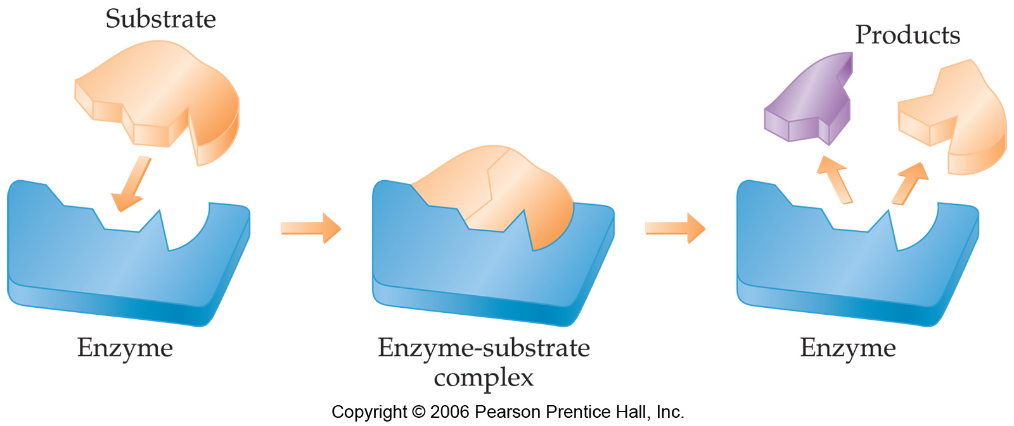
  - After the reaction of the substrate is complete, the products separate from the enzyme.

For example, catalase is an enzyme found in blood and liver cells. It catalyzes the decomposition of hydrogen peroxide: 2H₂O₂ (aq) → 2H₂O (l) + O₂ (g)

This reaction is important in removing peroxide, a potentially harmful oxidizing agent.

If a molecule binds so tightly to an enzyme that substrate molecules cannot displace it, then the active site is blocked and the catalyst is inhibited.
• Such molecules are called enzyme inhibitors.
• Many poisons act by binding to the active site, blocking the binding of substrates.
• Some poisons bind to other locations on the enzyme.
• Binding ultimately causes a change in the enzyme that interferes with enzyme activity.

Nitrogenase, an enzyme in bacteria that lives in root nodules of legumes such as clover and alfalfa, catalyses the reduction of nitrogen to ammonia. The fixed nitrogen is consumed by plants and then eaten by animals.
Animal waste and dead plants are attacked by bacteria that break down the fixed nitrogen and produce N2 gas for the atmosphere.

