Chemical Equilibrium

The Concept of Equilibrium
• Consider colorless frozen N₂O₄.

• At room temperature, it decomposes to brown NO₂.
N₂O₄(g) ⇌ 2NO₂(g)
• At some time, the color stops changing and we have a
mixture of N₂O₄ and NO₂.
• Chemical equilibrium is the point at which the
concentrations of all species are constant.
• Assume that both the forward and reverse reactions are
elementary processes.

• We can write rate expressions for each reaction.
• Forward reaction: N₂O₄(g) → 2ΝΟ₂(g)
• Rate_{f} = k_{f}[N₂O₄] k_{f} = rate constant (forward reaction)
• Reverse reaction: 2NO₂(g) → N₂O₄(g)
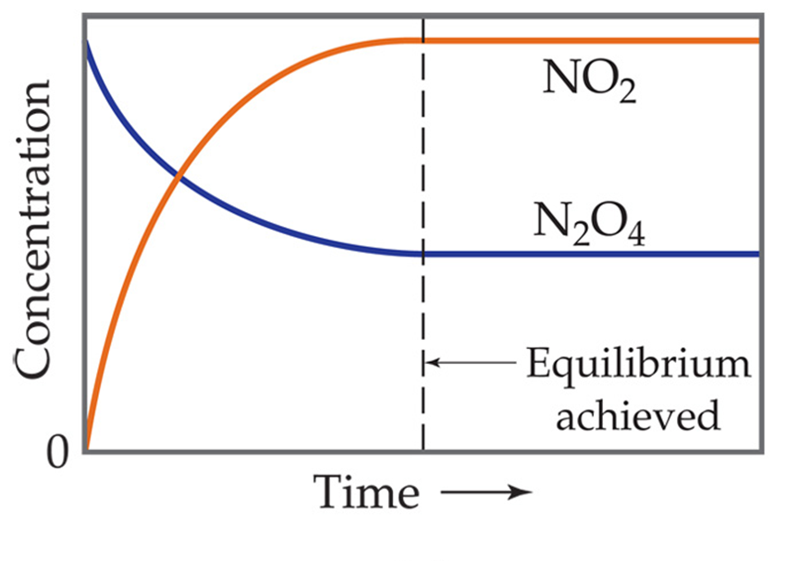
• Rate_{r} = k_{r}[NO₂]² k_{r} = rate constant (reverse reaction)
• Place some pure N₂O₄ into a closed container.
• As N₂O₄ reacts to form NO₂, the concentration of N₂O₄ will decrease and the concentration of NO₂ will increase.
• Thus, we expect the forward reaction rate to slow and the
reverse reaction rate to increase.
• Eventually we get to equilibrium where the forward and
reverse rates are equal.

• At equilibrium:
k_{f}[N₂O₄] = k_{r}[NO₂]²
• Rearranging, we get:
k_{f}/k_{r} = a constant K_{eq}
• At equilibrium the concentrations of N₂O₄ and NO₂ do not change.
• This mixture is called an equilibrium mixture.
• This is an example of a dynamic equilibrium.
• A dynamic equilibrium exists when the rates of the forward and reverse reactions are equal.
• No further net change in reactant or product concentration occurs.
• The double arrow ⇌ implies that the process is dynamic.
The Equilibrium Constant
• Consider the Haber process:
N₂(g) + 3H₂(g) ⇌ 2NH₃(g)
• It is used for the preparation of ammonia from nitrogen and hydrogen.
• The process is carried out at high temperature (500ºC) and pressure (200 atm) in the presence of a catalyst.
• Ammonia is a good source of fixed nitrogen for plants.
• Much of the NH₃ produced industrially is used as a fertilizer.
• If we start with a mixture of nitrogen and hydrogen (in any proportions), the reaction will reach equilibrium with constant concentrations of nitrogen, hydrogen, and ammonia.
• However, if we start with just ammonia and no nitrogen or hydrogen, the reaction will proceed and N₂ and H₂ will be produced until equilibrium is achieved.
• No matter what the starting compositions of reactants and products are, the equilibrium mixture contains the same relative concentrations of reactants and products.
• Equilibrium can be reached from either direction.
• We can write an expression for the relationship between the concentration of the reactants and products at equilibrium.
• This expression is based on the law of mass action.
• For a general reaction,
aA + bB ⇌ dD + eE
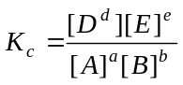 • The equilibrium expression is given by:

• Where K_{c} is the equilibrium constant.

• The subscript “c” indicates that molar concentrations were used to evaluate the constant.
• Note that the equilibrium constant expression has products in the numerator and reactants in the denominator.
• The value of K_{c} does not depend on initial concentrations of products or reactants.
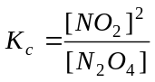
• Consider the reaction:
N₂O₄(g) ⇌ 2NO₂(g)
• The equilibrium constant is given by:
• The value of this constant (at 100ºC) is 6.50 (regardless of the initial concentrations of N₂O₄(g) or NO₂(g).
• The equilibrium expression depends on stoichiometry.
It does not depend on the reaction mechanism.
• The value of K_{c} varies with temperature.
We generally omit the units of the equilibrium constant.
Equilibrium Constants in Terms of Pressure, K_{p}
• When the reactants and products are gases we can write an equilibrium expression using partial pressures rather than molar concentrations.
The equilibrium constant is K_{p} where “p” stands for pressure.
• For the reaction:
aA + bB ⇌ dD + eE
•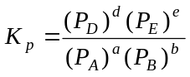 The numerical values of K_{c} and K_{p} will differ.

• They can be interconverted using the ideal gas equation and our definition of molarity:
PV = nRT so P = (n/V)RT
• If we express volume in liters the quantity (n/V) is equivalent to molarity.
• Thus, the partial pressure of a substance, A, is given as:
P = [A]RT
• We can use this to obtain a general expression relating K_{c} and K_{p:}
K_{p} = K_{c}(RT)^{∆n}
• where Δn = (moles of gaseous products) – (moles of gaseous reactants).
Interpreting and Working with Equilibrium Constants
The Magnitude of Equilibrium Constants
• The equilibrium constant, K, is the ratio of products to reactants.
• Therefore, the larger K is, the more products are present at equilibrium.
• Conversely, the smaller K is, the more reactants are present at equilibrium.
• If K >> 1, then products dominate at equilibrium and equilibrium lies to the right.
• If K << 1, then reactants dominate at equilibrium and the equilibrium lies to the left.
The Direction of the Chemical Equation and K
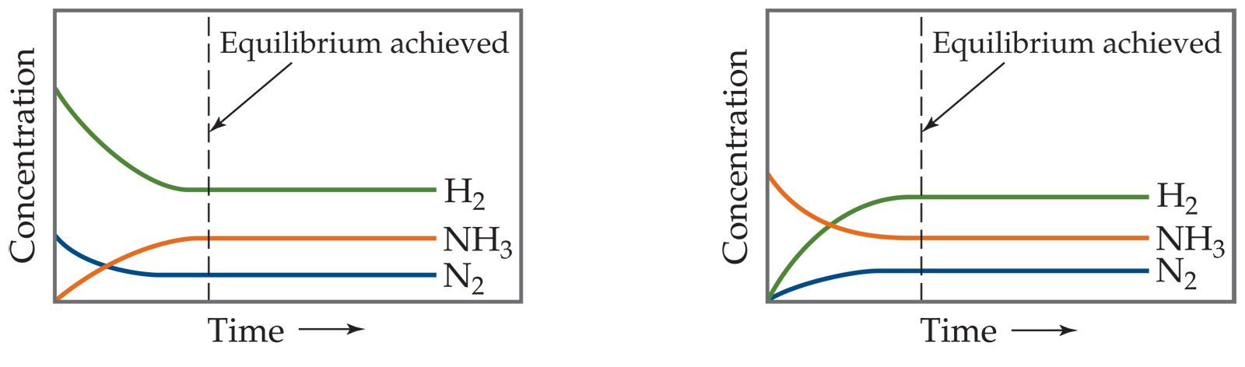
• An equilibrium can be approached from either direction.
It does not matter whether we start with N₂ and H₂ or whether we start with NH₃. We will have the same proportions of all three substances at equilibrium.

• Consider the reaction:
N₂O₄(g) ⇌ 2NO₂(g)

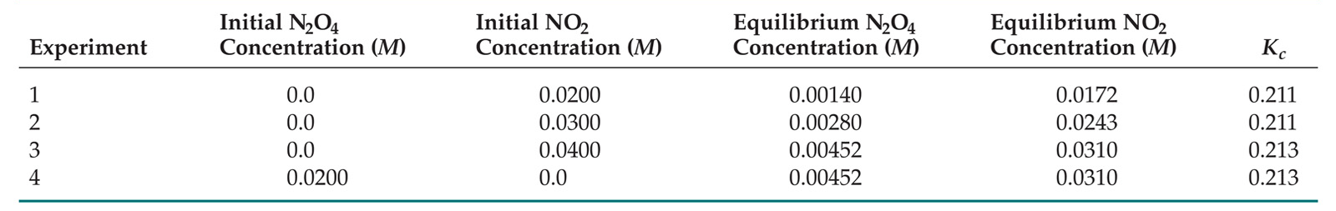
As you can see, the ratio of [NO₂]² to [N₂O₄] remains constant at this temperature no matter what the initial concentrations of NO₂ and N₂O₄ are.

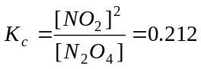• The equilibrium constant for this reaction (at 100ºC) is:

• However, when we write the equilibrium expression for the reverse reaction,
2NO₂(g) ⇌ N₂O₄(g)
• The equilibrium constant for this reaction (at 100ºC) is:

• The equilibrium constant for a reaction in one direction is the reciprocal of the equilibrium constant of the reaction in the opposite direction.

Relating Chemical Equations and Equilibrium Constants
•
The equilibrium constant of a reaction that has been multiplied by a number is the equilibrium constant raised to a power equal to that number.
• The equilibrium constant for a net reaction made up of two or more steps is the product of the equilibrium constants for the individual steps.
Heterogeneous Equilibria
• Equilibria in which all reactants and products are present in the same phase are called homogeneous equilibria.
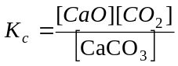• Equilibria in which one or more reactants or products are present in a different phase are called heterogeneous equilibria.
• Consider the decomposition of calcium carbonate:
CaCO₃(s) ⇌ CaO(s) + CO₂(g)
• Experimentally, the amount of CO₂ does not depend on the amounts of CaO and CaCO₃.
Why?
• The concentration of a pure solid or pure liquid equals its density divided by its molar mass.
• Neither density nor molar mass is a variable.
• Thus, the concentrations of solids and pure liquids are constant.
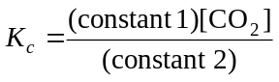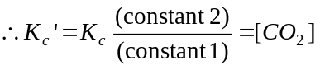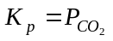 • For the decomposition of CaCO₃
CaO and CaCO₃ are pure solids and have constant concentrations.

• If a pure solid or a pure liquid is involved in a heterogeneous equilibrium, its concentration is not included in the equilibrium constant expression.
• Therefore, we anticipate that the amount of CO₂ formed will not depend on the amounts of CaO and CaCO₃ present.
• Note that although the concentrations of these species are not included in the equilibrium expression, they do participate in the reaction and must be present for an equilibrium to be established!
• Other common examples of heterogeneous equilibria include:
• dissolution of a solid to form a saturated solution.
• Example: PbCl₂(s) ⇌ Pb²⁺(aq) + 2Cl–(aq)
K_{c} = [Pb²⁺][Cl–]²
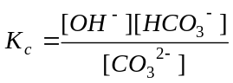 • systems where the solvent is involved as a reactant or product and the solutes are present at low concentrations.
• Example: H₂O(l) + CO₃^{2–}(aq) ⇌ OH–(aq) + HCO₃–(aq)
• Here the concentration of water is essentially constant and
we can think of it as a pure liquid.

Calculating Equilibrium Constants
• Proceed as follows:
• Tabulate initial and equilibrium concentrations (or partial pressures) for all species in the equilibrium.
• If an initial and an equilibrium concentration is given for a species, calculate the change in concentration.
• Use the coefficients in the balanced chemical equation to calculate the changes in concentration of all species.
• Deduce the equilibrium concentrations of all species.
• Use these to calculate the value of the equilibrium constant. (see tables in ppt notes)
Applications of Equilibrium Constants
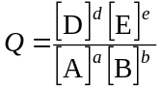Predicting the Direction of Reaction
• For a general reaction:
aA + bB ⇌ dD + eE
• We define Q, the reaction quotient, as:

• Where [A], [B], [D], and [E] are molarities (for substances in solution) or partial pressures (for gases) at any given time.
• We can compare Q_{c} with K_{c} or Q_{p} with K_{p}:
• If Q = K, then the system is at equilibrium.
• If Q < K, then the forward reaction must occur to reach equilibrium.
• If Q > K, then the reverse reaction must occur to reach equilibrium.
• Products are consumed and reactants are formed.
• Q decreases until it equals K.
Calculating Equilibrium Concentrations
• The same steps used to calculate equilibrium constants are used to calculate equilibrium concentrations.
• Generally, we do not have a number for the change in concentration.
• Therefore, we need to assume that x mol/L of a species is produced (or used).
• The equilibrium concentrations are given as algebraic expressions. ICE tables
See sample 648-649 aA.3 Equations pgs 1120-1121
Le Châtelier’s Principle
• Consider the Haber process:
N₂(g) + 3H₂(g) ⇌ 2NH₃(g)
• As the pressure increases, the amount of ammonia present at equilibrium increases.
• As the temperature increases, the amount of ammonia at equilibrium decreases.
• Can this be predicted?
• Le Châtelier’s principle: If a system at equilibrium is disturbed by a change in temperature, a change in pressure, or a change in the concentration of one or more components, the system will shift its equilibrium position in such a way as to counteract the effects of the disturbance.
Change in Reactant or Product Concentration
• If a chemical system is at equilibrium and we add or remove a product or reactant, the reaction will shift so as to reestablish equilibrium. See Sample
• For example, consider the Haber process again:
N₂(g) + 3H₂(g) ⇌ 2NH₃(g)
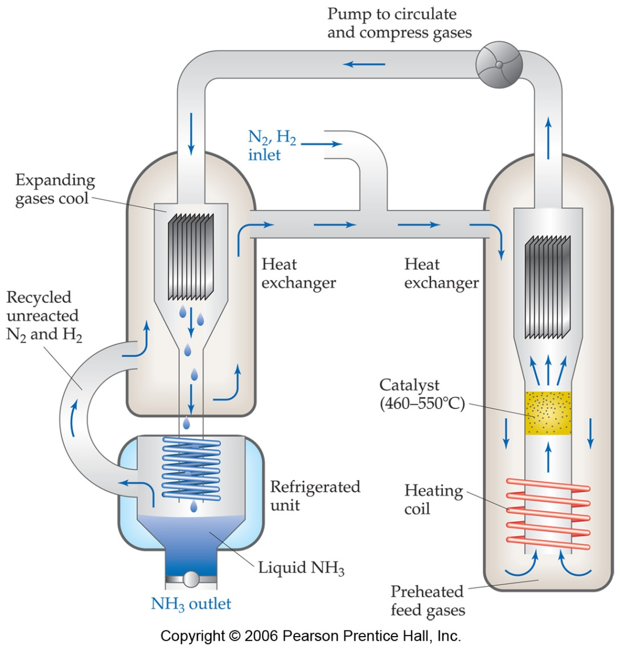
• If H₂ is added while the system is at equilibrium,
Q < K.
• The system must respond to counteract the
added H₂ (Le Châtelier’s principle).
• That is, the system must consume the H₂ and produce products until a new equilibrium is established.
• Therefore, [H₂] and [N₂] will decrease and [NH₃] will increase until Q = K.
• We can exploit this industrially.
• Suppose that we wanted to optimize the amount of ammonia we formed from the Haber process.
• We might flood the reaction vessel with reactants
and continuously remove product.
• The amount of ammonia produced is optimized because the product (NH₃) is continuously removed and the reactants (N₂ and H₂) are continuously being added.

Effects of Volume and Pressure Changes
• Consider a system at equilibrium.
• If the equilibrium involves gaseous products or reactants, the concentration of these species will be changed if we change the volume of the container.
• For example, if we decrease the volume of the container, the partial pressures of each gaseous species will increase.
• Le Châtelier’s principle predicts that if pressure is increased, the system will shift to counteract the increase.
• That is, the system shifts to remove gases and decrease pressure.
• An increase in pressure favors the direction that has fewer moles of gas.
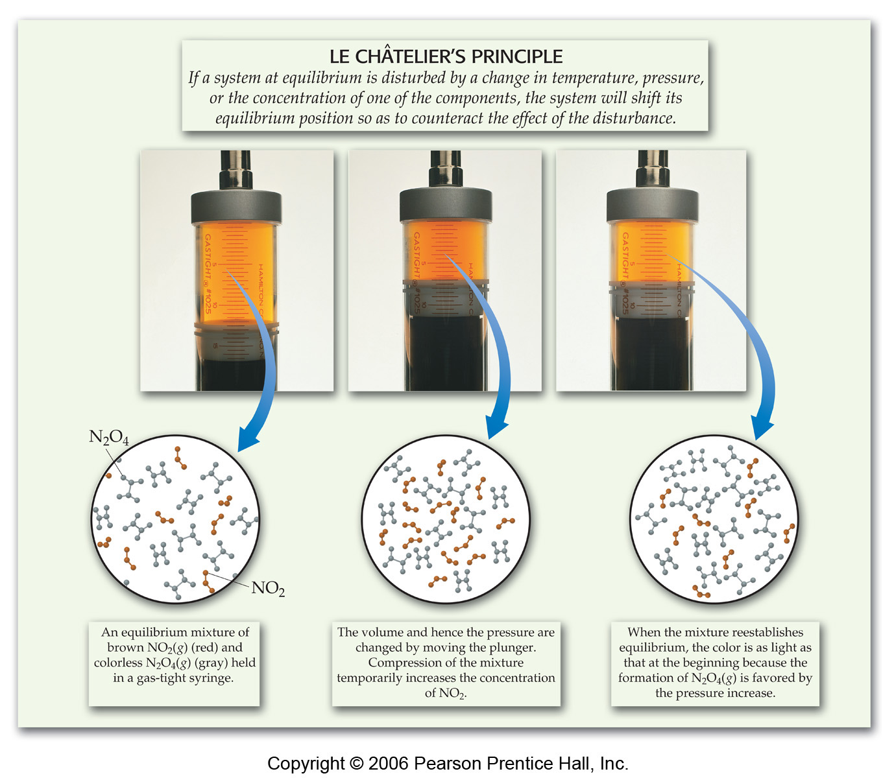
• Consider the following system:
N₂O₄(g) ⇌ 2NO₂(g)

• An increase in pressure (by decreasing the volume) favors the formation of colorless N₂O₄.
• The instant the pressure increases, the concentration of both gases increases and the system is not at equilibrium.
• The system changes to reduce the number moles of gas.
• A new equilibrium is established.
• The mixture is lighter in color.
• Some of the brown NO₂ has been converted into colorless N₂O₄(g)
• In a reaction with the same number of moles of gas in the products and reactants, changing the pressure has no effect on the equilibrium.
• In addition, no change will occur if we increase the total gas pressure by the addition of a gas that is not involved in the reaction.
Effect of Temperature Changes
• The equilibrium constant is temperature dependent.
• How will a change in temperature alter a system at equilibrium?
• It depends on the particular reaction.
• For example, consider the endothermic reaction:

Co(H₂O)₆²⁺(aq) + 4Cl–(aq) ⇌CoCl₄^{2–}(aq) + 6H₂O(l) ΔH > 0

• Co(H₂O)₆²⁺ is pale pink and CoCl₄^{2–} is a deep blue.

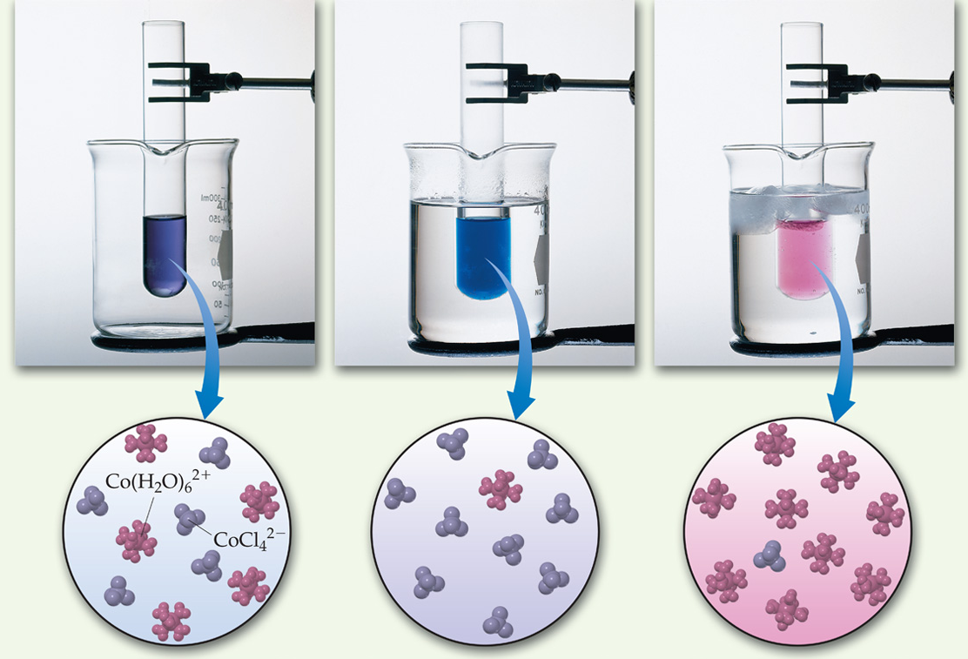

• At room temperature, an equilibrium mixture (light purple) is placed in a beaker of warm water.
• The mixture turns deep blue.
• This indicates a shift toward products (blue CoCl₄^{2–}).
• This reaction is endothermic.
• For an endothermic reaction (ΔH > 0), heat can be considered as a reactant.
• Thus, adding heat causes a shift in the forward direction.
• The room-temperature equilibrium mixture is placed in a beaker of ice water.
• The mixture turns bright pink.
• This indicates a shift toward reactants (pink Co(H₂O)₆²⁺).
• In this case, by cooling the system we are removing a reactant (heat).
• Thus, the reaction is shifted in the reverse reaction.
• A change in temperature causes a change in the value of K.
• If we increase the temperature of an endothermic reaction, K increases.
• If we increase the temperature of an exothermic reaction, K decreases.
The Effect of Catalysts
• A catalyst lowers the activation energy barrier for the reaction.
• Therefore, a catalyst will decrease the time taken to reach equilibrium.
• A catalyst does not effect the composition of the equilibrium mixture.

