Aqueous Ionic Equilibria

The Common Ion Effect
• The dissociation of a weak electrolyte is decreased by the addition of a strong electrolyte that has an ion in common with the weak electrolyte.
• For example, consider the ionization of a weak acid, acetic acid.
HC₂H₃O₂(aq) ⇌ H⁺(aq) + C₂H₃O₂–(aq)
• If we add additional C₂H₃O₂– ions by the addition of a strong electrolyte, (e.g., NaC₂H₃O₂) the equilibrium is shifted to the left.
• This causes a reduction in the [H⁺] and a decrease in the percent ionization of the acetic acid.
• By adding sodium acetate, we have disturbed the acetic acid equilibrium.
• In effect, we have added a product of this equilibrium (i.e., the acetate ion).
• This phenomenon is called the common-ion effect.
• The extent of ionization of a weak electrolyte is decreased by adding to the solution a strong electrolyte that has an ion in common with the weak electrolyte.
• Common ion equilibrium problems are solved following the same pattern as other equilibrium problems.
• However, the initial concentration of the common ion (from the salt) must be considered.
Buffered Solutions
• A buffered solution, or buffer, is a solution that resists a drastic change in pH upon addition of small amounts of strong acid or strong base.
Composition and Action of Buffered Solutions
• A buffer consists of a mixture of a weak acid (HX) and its conjugate base (X– ).
HX(aq) ⇌ H⁺(aq) + X– (aq)
• Thus, a buffer contains both:
• an acidic species (to neutralize OH–) and
• a basic species (to neutralize H⁺).
• When a small amount of OH– is added to the buffer, the OH– reacts with HX to produce X– and water.
• But the [HX]/[ X–] ratio remains more or less constant, so the pH is not significantly changed.
• When a small amount of H⁺ is added to the buffer, X– is consumed to produce HX.
• Once again, the [HX]/[ X– ] ratio is more or less constant, so the pH does not change significantly.
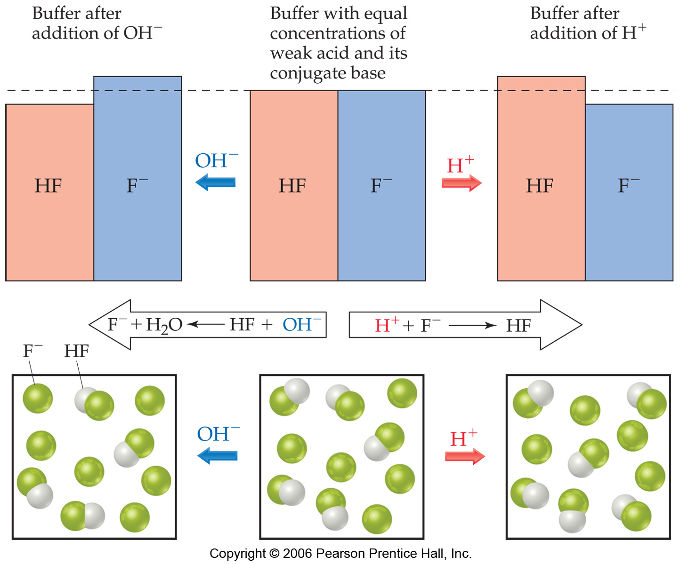
Example:

Calculating the pH of a Buffer
• The pH of the buffer is related to K_{a} and to the relative concentrations of the acid and base.
• We can derive an equation that shows the relationship between conjugate acid-base concentrations, pH and K_{a}.
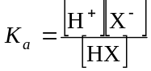• By definition:
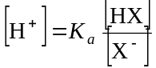• Rearranging, we get:

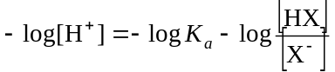• If we take the negative log of each side of the equation we get:
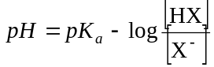• By definition:

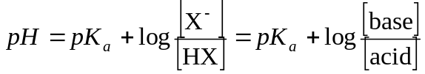• An alternate form of this equation is:

• The above equation is the Henderson-Hasselbalch equation.
• Note that this equation uses the equilibrium concentrations of the acid and conjugate base.
• However, if K_{a} is sufficiently small (i.e., if the equilibrium concentration of the undissociated acid is close to the initial concentration), then we can use the initial values of the acid and base concentrations in order to get a good estimate of the pH.
Buffer Capacity and pH Range
• Buffer capacity is the amount of acid or base that can be neutralized by the buffer before there is a significant change in pH.
• Buffer capacity depends on the concentrations of the components of the buffer.
• The greater the concentrations of the conjugate acid-base pair, the greater the buffer capacity.
• The pH range of a buffer is the pH range over which it is an effective buffer.
• The pH range of a buffer is generally within one pH unit of the pK_{a} of the buffering agent.
Addition of Strong Acids or Bases to Buffers
• We break the calculation into two parts.
• This is a stoichiometry calculation.
• The addition of a strong acid or base results in a neutralization reaction:
X– + H₃O⁺ → HX + H₂O
HX + OH– →X– + H₂O
• By knowing how much H₃O⁺ or how much OH– was added, we know how much HX or X– was formed.
• This is an equilibrium calculation.
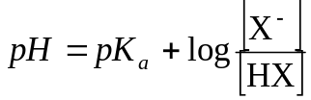 • With the concentrations of HX and X– (taking into account the change in volume of the solution) we can calculate the pH from the Henderson-Hasselbalch equation:
• This is the equilibrium calculation.

Acid-Base Titrations
• In an acid-base titration:
• a solution of base of known concentration is added to an acid (or an acid of known concentration is added to a base).
Acid-base indicators, or pH meters, are used to signal the equivalence point.
• The equivalence point is the point at which stoichiometrically equivalent quantities of acid and base have been added.
The plot of pH versus volume during a titration is called a pH titration curve.
Strong Acid–Strong Base Titrations
• Consider adding a strong base (e.g., NaOH) to a solution of a strong acid (e.g., HCl).
• We can divide the titration curve into four regions.
• 1. Initial pH (before any base is added)
• The pH is given by the strong acid solution.
Therefore, pH < 7.
• 2. Between the initial pH and the equivalence point
• When base is added before the eq. point the pH is controlled by excess strong acid
Therefore, pH < 7.
• 3. At the equivalence point
• The amount of base added is stoichiometrically equivalent to the amount of acid originally present.
• The cation of a strong base or the anion of a strong acid do not undergo hydrolysis.
Therefore, pH = 7.00.
• 4. After the equivalence point
• The pH is determined by the excess base in the solution.
Therefore, pH > 7.
• How can we analyze the titration (i.e., how will we know when we are at the equivalence point)?
• Consider adding a strong base (e.g., NaOH) to a solution of a strong acid (e.g., HCl).
• We know the pH at the equivalence point is 7.00.
• To detect the equivalence point, we use an indicator that changes color somewhere near pH 7.00.
• Usually, we use phenolphthalein which changes color between pH 8.3 and 10.0.
• In acid, phenolphthalein is colorless.
• As NaOH is added, there is a slight pink color at the addition point.
• When the flask is swirled and the reagents mixed, the pink color disappears.
• At the end point, the solution is light pink.
• If more base is added, the solution turns darker pink.
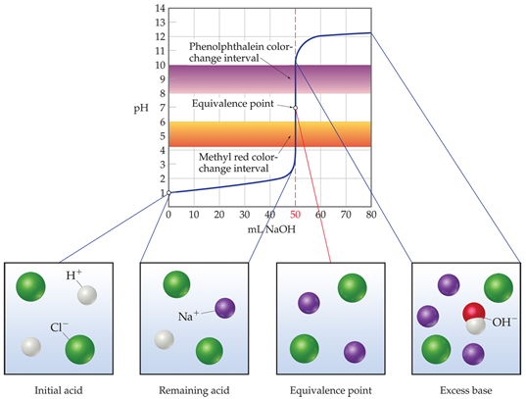
• The equivalence point in a titration is the point at which the acid and base are present in stoichiometrically equivalent quantities.
• The end point in a titration is the point where the indicator changes color.
• The difference between the equivalence point and the end point is called the titration error.

• The shape of a strong base-strong acid titration curve is very similar to a strong acid-strong base titration curve.
• Initially, the strong base is in excess, so the pH > 7.
• As acid is added, the pH decreases but is still greater than 7.
• At the equivalence point, the pH is given by the salt solution (i.e., pH = 7).
• After the equivalence point, the pH is given by the strong acid in excess, so pH is less than 7.

Weak Acid-Strong Base Titration
• Consider the titration of acetic acid, HC₂H₃O₂, with NaOH.
• Again, we divide the titration into four general regions:
• 1. Before any base is added:
• the solution contains only weak acid.
Therefore, pH is given by the equilibrium calculation.
• 2. Between the initial pH and the equivalence point
• As strong base is added it consumes a stoichiometric quantity of weak acid:
HC₂H₃O₂(aq) + OH–(aq) →C₂H₃O₂–(aq) + H₂O(l)
• However, there is an excess of acetic acid.
• Therefore, we have a mixture of weak acid and its conjugate base.
Thus, the composition of the mixture is that of a buffer.
The pH is given by the buffer calculation.
• First the amount of C₂H₃O₂– generated is calculated, as well as the amount of HC₂H₃O₂ consumed (stoichiometry).
• Then the pH is calculated using equilibrium conditions (Henderson-Hasselbalch equation).
• 3. At the equivalence point, all the acetic acid has been consumed and all the NaOH has been consumed.
However, C₂H₃O₂– has been generated.
Therefore, the pH depends on the C₂H₃O₂– concentration.
• The pH > 7 at the equivalence point.
• More importantly, the pH of the equivalence point always is > 7 for a weak acid-strong base titration.
• 4. After the equivalence point:
the pH is given by the concentration of the excess strong base.
• The pH curve for a weak acid-strong base titration differs significantly from that of a strong acid-strong base titration.
• For a strong acid-strong base titration:
• the pH begins at less than 7 and gradually increases as base is added.
• Near the equivalence point, the pH increases dramatically.
• For a weak acid-strong base titration:
• the initial pH rise is steeper than the strong acid-strong base case.
• However, then there is a leveling off due to buffer effects.
• The inflection point is not as steep for a weak acid-strong base titration.
• The shape of the two curves after the equivalence point is the same because pH is determined by the strong base in excess.
• The pH at the equivalence point differs also.
• The pH is 7.00 for the strong acid-strong base equivalence point.
• The pH is >7.00 for the weak acid-strong base equivalence point.
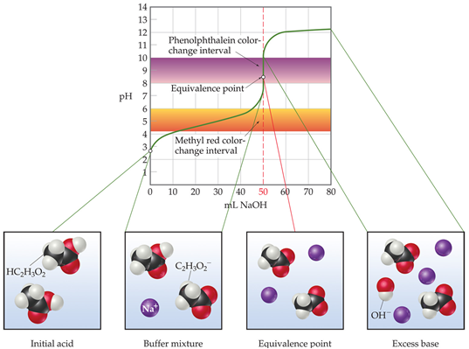
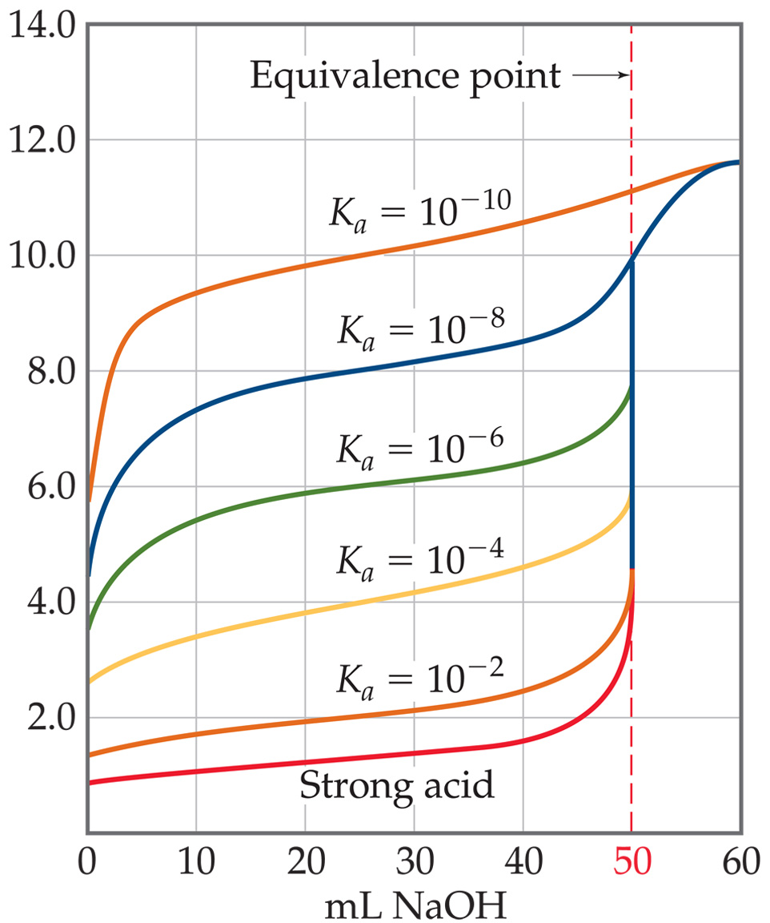

Read: pgs 780-783 to see how indicators work

Titrations of Polyprotic Acids
• In polyprotic acids, the ionizable protons dissociate in a series of steps.
• Therefore, in a titration there are n equivalence points corresponding to each ionizable proton.
• In the titration of H₃PO₄ with NaOH there are three equivalence points:
• one for the formation of H₂PO₄–,
one for the formation of HPO₄^{2–}, and
one for the formation of PO₄^{3–}.
Solubility Equilibria
The Solubility-Product Constant, K_{sp}
• Consider a saturated solution of BaSO₄ in contact with solid BaSO₄.
• We can write an equilibrium expression for the dissolving of the slightly soluble solid.
BaSO₄(s) ⇌ Ba²⁺(aq) + SO₄^{2–}(aq)
• Because BaSO₄(s) is a pure solid, the equilibrium expression depends only on the concentration of the ions.
• K_{sp} is the equilibrium constant for the equilibrium between an ionic solid solute and its saturated aqueous solution.
• K_{sp} is called the solubility-product constant, or the solubility product.
• K_{sp} for BaSO₄ is:
K_{sp} = [Ba²⁺][ SO₄^{2–}]
• In general the solubility product is equal to the product of the molar concentration of ions raised to powers corresponding to their stoichiometric coefficients.
Solubility and K_{sp}
• Solubility is the amount of substance that dissolves to form a saturated solution.
• This is often expressed as grams of solute that will dissolve per liter of solution.
• Molar solubility is the number of moles of solute that dissolve to form a liter of saturated solution.
• We can use the solubility to find K_{sp} and vice versa.
• To convert solubility to K_{sp}:
• Convert solubility into molar solubility (via molar mass).
• Convert molar solubility into the molar concentration of ions at equilibrium (equilibrium calculation).
• Use the equilibrium concentration of ions in the K_{sp} expression.
• To convert K_{sp} to solubility:
• Write the K_{sp} expression.
• Let x = the molar solubility of the salt.
• Use the stoichiometry of the reaction to express the concentration of each species in terms of x.
• Substitute these concentrations into the equilibrium expression and solve for x.
• This calculation works best for salts whose ions have low charges.

Factors That Affect Solubility
• Three factors that have a significant impact on solubility are:
• the presence of a common ion,
• the pH of the solution, and
• the presence or absence of complexing agents.
Common-Ion Effect
• The solubility of a slightly soluble salt is decreased when a common ion is added.
• This is an application of Le Châtelier’s principle.
• Consider the solubility of CaF₂:
CaF₂(s) ⇌ Ca²⁺(aq) + 2F–(aq)
• If more F– is added (i.e., by the addition of NaF), the equilibrium shifts to offset the increase.
• Therefore, CaF₂(s) is formed and precipitation occurs.
• As NaF is added to the system, the solubility of CaF₂ decreases.
• In general, the solubility of a slightly soluble salt is decreased by the presence of a second salt that produces a common ion.

Solubility and pH
• Again we apply Le Châtelier’s principle:
Mg(OH)₂(s) ⇌ Mg²⁺(aq) + 2OH–(aq)
• If OH– is removed, then the equilibrium shifts toward the right and Mg(OH)₂ dissolves.
• OH– can be removed by adding a strong acid:
OH–(aq) + H⁺(aq) ⇌ H₂O(aq)
• As pH decreases, [H⁺] increases and the solubility of Mg(OH)₂ increases.
• Another example:
CaF₂(s) ⇌ Ca²⁺(aq) + 2F–(aq)
• If the F– is removed, then the equilibrium shifts towards the right and CaF₂ dissolves.
• F– can be removed by adding a strong acid:
F–(aq) + H⁺(aq) ⇌ HF(aq)
• As pH decreases, [H⁺] increases and solubility of CaF₂ increases.
• The effect of pH on solubility can be dramatic.
• The effect is most significant if one or both ions involved are at least somewhat acidic or basic.
• In general:
• the solubility of slightly soluble salts containing basic ions increases as pH decreases.
• the more basic the anion is, the greater the effect.
Formation of Complex Ions
• Recall that metal ions may act as Lewis acids in aqueous solution (water may act as the Lewis base).
• Such an interaction may have a significant impact on metal salt solubility.
• For example, AgCl has a very low solubility.
• K_{sp} for AgCl = 1.8.x 10^{–10}
• However, the solubility is greatly increased if ammonia is added.
• Why?
• Consider the formation of Ag(NH₃)₂⁺:
Ag⁺(aq) + 2NH₃(aq) ⇌ Ag(NH₃)₂⁺(aq)
• The Ag(NH₃)₂⁺ is called a complex ion.
• NH₃ (the attached Lewis base) is called a ligand.
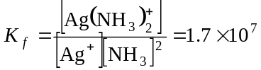 • The equilibrium constant for the reaction is called the formation constant, K_{f}:
• Consider the addition of ammonia to AgCl (white salt):
AgCl(s) ⇌ Ag⁺(aq) + Cl–(aq)
Ag⁺(aq) + 2NH₃(aq) ⇌ Ag(NH₃)₂⁺(aq)
• The overall reaction is:
AgCl(s) + 2NH₃(aq) ⇌ Ag(NH₃)₂⁺(aq) + Cl–(aq)
• Effectively, the Ag⁺(aq) has been removed from solution.
• By Le Châtelier’s principle, the forward reaction (the dissolving of AgCl) is favored.
Amphoterism
• Substances that are capable of acting either as an acid or a base are amphoteric.
• The term is similar to one discussed earlier: amphiprotic, which relates more generally to any species that can either gain or lose a proton.
• Amphoteric metal oxides and bases will dissolve in either a strong acid or a strong base.
• Examples are hydroxides and oxides of Al³⁺, Cr³⁺, Zn²⁺, and Sn²⁺.
• The hydroxides generally form complex ions with several hydroxide ligands attached to the metal:
Al(OH)₃(s) + OH–(aq) ⇌ Al(OH)₄–(aq)
• Hydrated metal ions act as weak acids.
• As strong base is added, protons are removed:
Al(H₂O)₆³⁺(aq) + OH–(aq) ⇌ Al(H₂O)₅(OH)²⁺(aq) + H₂O(l)
Al(H₂O)₅(OH)²⁺(aq) + OH–(aq) ⇌ Al(H₂O)₄(OH)₂⁺(aq) + H₂O(l)
Al(H₂O)₄(OH)₂⁺(aq) + OH–(aq) ⇌ Al(H₂O)₃(OH)₃(s) + H₂O(l)
Al(H₂O)₃(OH)₃(s) + OH–(aq) ⇌ Al(H₂O)₂(OH)₄–(aq) + H₂O(l)
• The addition of an acid reverses these reactions.

Precipitation and Separation of Ions
• Consider the following:
BaSO₄(s) ⇌ Ba²⁺(aq) + SO₄^{2–}(aq)
• At any instant in time, Q = [Ba²⁺][ SO₄^{2–} ].
• If Q > K_{sp}, precipitation occurs until Q = K_{sp}.
• If Q = K_{sp} equilibrium exists (saturated solution).
• If Q < K_{sp}, solid dissolves until Q = K_{sp}.
Selective Precipitation of Ions
• Ions can be separated from each other based on the solubilities of their salts.
• Example: If HCl is added to a solution containing Ag⁺ and Cu²⁺, the silver precipitates (K_{sp} for AgCl is 1.8 x 10^{–10}) while the Cu²⁺ remains in solution.
• Removal of one metal ion from a solution is called selective precipitation.
• The sulfide ion is often used to separate metal ions.
• Example: Consider a mixture of Zn²⁺(aq) and Cu²⁺(aq).
• CuS (K_{sp}= 6 x 10^{–37}) is less soluble than ZnS (K_{sp}= 2 x 10^{–25}).
• Thus, CuS will be removed from solution before ZnS.
• As H₂S is bubbled through the acidified green solution, black CuS forms.
• When the precipitate is removed, a colorless solution containing Zn²⁺(aq) remains.
• When more H₂S is added to the solution, a second precipitate of white ZnS forms.
Qualitative Analysis for Metallic Elements
• Quantitative analysis is designed to determine how much metal ion is present.
• Qualitative analysis is designed to detect the presence of metal ions.
• Typical qualitative analysis of a metal ion mixture involves:
• 1. separation of ions into five major groups on the basis of their differential solubilities.
• insoluble chlorides
• acid-insoluble sulfides
• base-insoluble sulfides and hydroxides
• insoluble phosphates
• alkali metals and ammonium ion
• 2. separation of individual ions within each group by selectively dissolving members of the group.
• 3. specific tests to determine whether a particular ion is present or absent.

