Determination of K_{a} for an Unknown Monoprotic Acid
PURPOSE: Determine the K_{a} and molar mass of an unknown monoprotic weak acid by titration.

General Theory: According to the Brønsted-Lowry acid-base theory, the strength of an acid is related to its ability to donate protons. All acid-base reactions are then competitions between bases of various strengths for these protons. For example, the strong acid HCl reacts with water according to:
HCl_{(aq)} + H₂O_{(l)} ⎯→ H₃O⁺_{(aq)} + Cl⁻_{(aq)}
This is a strong acid and is completely dissociated (in other words, 100 percent dissociated) in dilute aqueous solution. Consequently, the [H₃O⁺] concentration of a 0.1 M HCl solution is 0.1 M. Thus, HCl is a stronger acid than water and completely donates a proton to water to form H₃O⁺.

By contrast, acetic acid, HC₂H₃O₂ (abbreviated HOAc), is a weak acid and is only slightly dissociated:
H₂O(l) + HOAc(aq) H₃O⁺(aq) + OAc⁻(aq)
Its acid-ionization constant, is therefore very small: K_{a} = 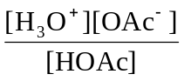 = 1.8 x 10⁻⁵
Acetic acid only partially dissociates/ionizes in aqueous solution, and an appreciable quantity of undissociated acetic acid remains in solution. For any weak acid HA the dissociation/ionization reaction and dissociation expression are:
HA(aq) + H₂O(l) H₃O⁺(aq) + A⁻(aq) K_{a} = 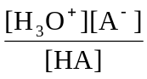
Solving for [H₃O⁺] yields: [H₃O⁺] = K_{a}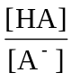
Taking –log of each side yields:
–log [H₃O⁺] = –log K_{a} – log by definition pH = –log [H₃O⁺] therefore:
pH = pK_{a} – log 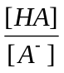 or pH = pK_{a} + log 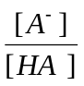 (where pK_{a} = –log K_{a}) Henderson-Hasselbalch Eqn
If we titrate the weak acid HA with a base, there will be a point in the titration at which the number of equivalents of base is just one-half the number of equivalents of acid present (at ½ V_{eq}). This is the point at which 50 percent of the acid has been titrated to produce A⁻ and 50 percent remains as HA. At this point [HA] = [A⁻], the ratio [A⁻]/[HA] = 1, and log [A⁻]/[HA] = 0. Hence, at this point in a titration, that is, at one-half the equivalence point, the equation becomes
pH = pK_{a} @ ½ V_{eq} By titrating a weak acid with a strong base and recording the pH versus the volume of base added, one can determine the dissociation constant, K_{a}, of the weak acid. From the titration curve (Figure 1), we see that at the point denoted as half the equivalence point, where [HA] = [A⁻], the pH is 4.3. Thus at this point pH = pK_{a}, or
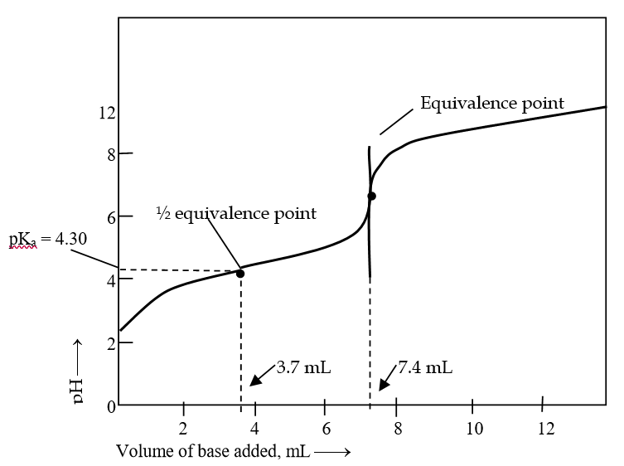
pK_{a} = 4.30 K_{a} = 10^{– 4.30} K_{a} = 5.0 x 10⁻⁵

Figure 1:
titration of
a weak acid
with a strong
base

Part I: Preparation and Standardization of the NaOH Solution (Completed by instructor.)

It will be necessary to prepare 500 mL of an approximately 0.1 M NaOH by diluting the appropriate amount of 6.0 M NaOH(aq) to about 500 mL. Shelf reagents are not prepared to any high degree of accuracy, and even if they were, could not be kept long at a particular concentration due to gradual changes from exposure to carbon dioxide. If a solution is prepared from a shelf reagent by dilution, no matter how carefully measurements are made, the result will be a solution of undetermined concentration. It must be standardized to know its concentration beyond two significant figures. Potassium hydrogen phthalate, (KHC₈H₄O₄), abbreviated KHP, is a monoprotic weak acid that is commonly used as the primary standard.
It reacts with sodium hydroxide according to: KHC₈H₄O_{4(aq)} + NaOH_{(aq)} → H₂O_{(l)} + Na KC₈H₄O_{4(aq)}
Titration with of a known mass of KHP to the endpoint with a carefully measured volume of NaOH is performed. The equation allows one to determine the number of moles of NaOH needed to reach the endpoint. Given the volume of NaOH dispensed to reach the endpoint one can then calculate the molarity of the NaOH.

1. Measure out about 0.35 gram of KHP into a dry 125mL Erlenmeyer flask on an analytical balance and record the weight to four significant figures. Record the exact amount used.
2. Dissolve the KHP in approximately 50mL of deionized water. Add 2-3 drops of phenolphthalein and titrate the KHP solution with the NaOH solution from a buret to a light pink color. Determine very precisely the volume of base required to reach the endpoint by approximating between the marks on the burette for a fourth significant figure.
3. Repeat the titrations until you have three reliable trials. A proper standardization requires a minimum of three trials that agree within plus or minus 0.5% of each other. A quick check of the reproducibility of your titrations is to calculate the ratio of g KHP/mL NaOH to four significant figures. This ratio should vary only in the last significant figure. Repeat the standardization process until three trials do agree within these limits. Calculate the molar concentration of the base from the data from each trial and then calculate the average concentration.

Part II: Develop a Titration Curve to Determine the Molarity and K_{a}
A. Data Collection

NOTE: Set up the LabQuest II with pH probe, drop counter/syringe reservoir, magnetic stirrer.
1. Connect the pH sensor to Channel 1 on the LabQuest II. Mount the drop counter on a ring stand and connect it to DIG 1 on the side. Set up the equipment as shown.

2. Perform a two-point calibration of the pH electrode with pH = 4 and pH = 7 buffers. Rinse the electrode with DI water after taking it out of the storage solution and in between buffers (shake off excess).
NOTE: pH 7 should have a voltage near 1.75 and pH 4 should be near 2.50
3. The reservoir has been filled with standardized NaOH(aq) solution and the drop rate has been set to 1-2 drops/second by adjusting the top valve.

4. IMPORTANT: Align the spout of the reservoir such that it is centered in both directions above the drop counter slot.
5. If your unknown is a solid accurately (to 0.001g) weigh about 0.35g of your assigned unknown weak acid in a clean 150mL beaker. Add about 50mL of deionized water to the beaker. Put a stir bar in the beaker and place the beaker on the magnetic stirrer. Turn on the stirrer at a moderate rate to dissolve the sample. (Unknowns 5,7, and 11 do not dissolve easily in water, first add 10-15mL of ethanol.) Add 5 drops of thymol blue to the solution. For liquid unknowns use an accurately measured (to 0.01mL) 20mL sample – dilute to 50mL with DI water and add the indicator.
6. Adjust the positions of the drop counter and reservoir so they are both lined up near the center of the magnetic stirrer. Lower the pH sensor/drop counter assembly into the beaker. Make sure the height is adjusted such that the stir bar does NOT hit the bottom of the pH probe or it will break! Adjust the reagent reservoir so its tip is just above the drop counter slot. If the level of solution is high enough to cover the bottom of the pH sensor, if not add more deionized water to the beaker. Make sure the magnetic stirrer is stirring at a moderate rate. Wait for the acid to completely dissolve and for the pH to become steady. (See the instructor if this does NOT occur.)
Record the initial pH of your solution.

7. You are now ready to perform the titration.
- Tap Start (green arrow) to start data collection. No data will be collected until the first drop goes through the drop counter slot. (you should see the red light blinking as it records each drop

- Open the bottom valve slowly. When the first drop passes through the drop counter slot, check that the red light blinks and look at the graph to see that the first data pair was recorded. CLOSE the bottom valve if the light does NOT blink or the point does not record and adjust the position of the reservoir.

- Observe the titration curve on the screen and note the color of the solution during the titration. You may slow the drop rate as you approach the equivalence point to allow the pH sensor to more accurately sense the change in pH as each drop is added. (The indicator should change color near the equivalence point, but it is only a guide.)

- Continue the titration past the equivalence point and until the pH levels off. (Observe the curve!) Close the stopcock and tap Stop (red square) to stop the data collection.

8. Save your file.

9. Dispose of the titrated solution in the sink. Remove the pH sensor, rinse with deionized water and replace the bottle with the storage solution.
B. Analysis of Titration Curves:
Examine your titration data to identify the region where the pH made the greatest increase. The equivalence point is in this region.
- To examine the data pairs on the displayed graph, select any data point.
- As you move the “examine” line, the pH and volume values of each data point are displayed to the right of the graph.
- Identify the equivalence point as precisely as possible and record the volume of NaOH and pH.
- Determine the ½ equivalence point and record the volume and pH.
An alternate way of determining the precise equivalence point of the titration is to take the first and second derivatives of the pH-volume data:
Determine the peak value on the first derivative vs. volume plot.
- Tap the XY table, then select the Table tab and choose New Calculated Column from the Table menu.
- Enter d1 as the Calculated Column Name. Select the equation 1st Derivative (Y, X). Use Volume as the Column for X and pH as the Column for Y. Select OK.
- On the displayed plot of d1 vs. volume, examine the graph to determine the volume at the peak value of the first derivative.

Determine the zero value on the second derivative vs. volume plot.
- Tap the XY Table and then select the Table tab and choose New Calculated Column from the Table menu.
- Enter d2 as the Calculated Column Name. Select the equation 2nd Derivative (Y, X). Use Volume as the Column for X and pH as the Column for Y. Select OK.
- On the displayed plot of d2 vs. volume, examine the graph to determine the volume when the 2nd derivative equals approximately zero.
Sketch your 3 graphs on a separate piece of paper.

Identify the equivalence point and ¼, ½, and ¾ equivalence point on your graph. Determine the volume of NaOH at the equivalence point and ½ equivalence point. Determine the pH at all points. Record your values in the data table.
Name __________________________________ Partner ______________________________ Date _______
Determination of Ka for an Unknown Monoprotic Acid

Prelab Questions

1) Why isn’t the pH at the equivalence point always equal to 7 in a neutralization titration?
When would it be 7?

2) Calculate the pK_{a} of an acid whose K_{a} is 6.5 x 10⁻⁶.

When does pKa = pH?

3) The pH at one-half the equivalence point in an acid-base titration was found to be 2.39 - what is the value of K_{a} for this unknown monoprotic acid? Can you identify this acid?

4) If 30.15 mL of 0.0995 M NaOH is required to neutralize 0.180 g of an unknown acid, HA, what is the
molecular weight of the unknown acid? Identify this acid.

Data
Unknown acid # _____ Mass of acid __________g Concentration of Standardized NaOH __________M
or Volume used ________ mL Initial pH of weak acid solution _______

Volume of NaOH at equivalence point mL _______ pH at equivalence point _______

Volume of NaOH at ½ equivalence point _______mL pH at ½ equivalence point _______
pH at ¼ equivalence point _______ pH at ¾ equivalence point _______

Calculations
Calculate the pKa and Ka for your unknown acid using the ½ equivalence point.
(Identify your unknown acid and calculate % error for your pKa)

Calculate the molar mass of your unknown acid using the equivalence point. (calculate % error)

Analysis
1) Write the net ionic equation for the titration of your unknown with NaOH.

2) When a weak acid is titrated with a strong base, a buffer region (zone) forms. Explain why this region forms. Does your titration curve exhibit a buffer region? Identify it on the curve.

3) Use the Henderson-Hasselbalch equation to calculate the theoretical pH at ¼ and ¾ of the equivalence point. Compare these values to the actual measured pH values from your data.
(Hint: What is the ratio of [A⁻]/[HA] at these points.)

4) Calculate the Ka of your acid based on the initial pH reading of your solution before titration. Assume the volume of the solution to be 50.0mL at this point. Write a net ionic for the dissociation of your acid (or acidic ion). Create an ICE table to determine the equilibrium concentrations in order to calculate Ka.

Calculate the percent dissociation of your acid (or acidic ion).

Error Analysis
1) Explain how the calculated value of the pKa and molar mass of your unknown acid would be affected if the following errors occurred.
a) The pH meter was incorrectly calibrated to read lower than the actual pH.

b) During the titration, several drops of NaOH missed the reaction beaker and fell on the bench top.
(note: the drops were recorded by the drop counter)

c) Some acid was lost before it was transferred to the beaker to be titrated.

d) Extra distilled water was added to the beaker during the titration.

Name | Formula | Molar Mass | Ka
Salicylic acid | C₆H₄(OH)COOH | 138.1 | 1.1 x 10⁻³
Acetic acid | CH₃COOH | 60.1 | 1.8 x 10⁻⁵
Potassium dihydrogen phosphate (monobasic potassium phosphate) | KH₂PO₄ | 136.1 | 6.2 x 10⁻⁸
Benzoic Acid | C₆H₅COOH | 122.2 | 6.5 x 10⁻⁵
Potassium hydrogen tartrate  (cream of tartar) | KHC₄H₄O₆ | 188.1 | 4.6 x 10⁻⁵
Sulfamic acid | NH₂SO₃H | 97.1 | 1.01 x 10⁻¹
Lactic acid | CH₃CH(OH)COOH | 90.1 | 1.4 x 10⁻⁴
Potassium hydrogen sulfate (bisulfate) | KHSO₄ | 136.2 | 1.0 x 10⁻²
Acetylsalicylic acid  (2-acetoxybenzoic acid) | 2-CH₃CO₂C₆H₄COOH | 180.2 | 3.2 x 10⁻⁴
Potassium hydrogen phthalate (KHP) | KHC₈H₄O₄ | 204.2 | 3.9 x 10⁻⁶
Propanoic acid | CH₃CH₂COOH | 74.1 | 1.9 x 10⁻⁵
Sodium hydrogen sulfite (bisulfite) | NaHSO₃ | 104.1 | 1.02 x 10⁻⁷

