Electrochemical Cells

Introduction: Oxidation-reduction reactions form a major class of chemical reactions. From the reactions of oxygen with sugars, fats, and proteins that provide energy for life to the corrosion of metals, many important reactions involve the processes of oxidation and reduction. In this three-part lab, these reactions are studied by constructing various electrochemical cells and measuring the voltage generated. From these measurements, a reduction series is generated, the concentration of copper ions in solution determined, and the K_{sp} of silver chloride calculated.

Concepts: Half-cell reaction Standard reduction potential Nernst equation Spontaneous reaction

Background: An electrochemical cell is produced when an oxidation reaction and a reduction reaction occurs spontaneously, and their resulting electron transfer between the two processes occurs through an external wire. The oxidation and reduction reactions are physically separated from each other and are called half-cell reactions. A half-cell can be prepared from almost any metal in contact with a solution of its ions. Since each element has its own electron configuration, each element develops a different electrical potential, and different combinations of oxidation and reduction half-cells result in different voltages for the completed electrochemical cell.

The standard reduction potential is the voltage that a half-cell, under standard conditions (1 M, 1 atm, 25 °C), develops when it is combined with the standard hydrogen electrode, that is arbitrarily assigned a potential of zero volts. A chart of reduction half-cell reactions, arranged in order of decreasing standard reduction potential, shows the relative ease of reduction of each substance listed. The more positive the reduction potential, the easier the reduction. A spontaneous cell (a battery) can be constructed if two half-cells are connected internally using a salt bridge, and externally using a metallic connector. In an electrochemical cell, the reaction listed in the standard reduction potential chart with the more positive voltage occurs as a reduction, and the reaction listed with the less positive voltage reverses and occurs as an oxidation reaction. The cell voltage can be found by adding the voltages listed in the table, with the value of the voltage for the oxidation reaction becoming the negative of its reduction reaction voltage.

As an example, consider a cell made up of copper and aluminum half-cells.
Cu²⁺(aq) + 2e⁻ → Cu(s) E° = 0.34 V A1³⁺(aq) + 3e⁻ → Al(s) E° = -1.66 V
The copper reaction has the more positive potential and remains a reduction reaction. The aluminum reaction with the less positive (more negative) potential is reversed and becomes an oxidation reaction. Its potential is now an oxidation potential: Al (s) → Al³⁺(aq) + 3e⁻ E° = +1.66 V
The half-cell equations and voltages can be added to find the overall reaction and the cell voltage:
Cu²⁺(aq) + 2e⁻ → Cu(s) E° = 0.34 V
Al (s) → Al³⁺(aq) + 3e⁻ E° = +1.66 V
3Cu²⁺(aq) + 2Al(s) → 3Cu(s) + 2Al³⁺(aq) E°_{cell} = +2.00 V

A positive value for E°_{cell} indicates the oxidation-reduction reaction, as written, is spontaneous.
A cell representation such as the following: Zn(s)│Zn²⁺(1.0 M)║Cu²⁺(0.0010 M)│Cu(s) means that a cell is constructed of zinc metal dipping into a 1.0 M solution of Zn²⁺. The symbol "│" refers to a phase boundary. The symbol "║" indicates a salt bridge between the zinc ion solution and the copper ion solution. The second half cell is copper metal dipping into a 0.0010 M solution of copper ions. The anode is on the left (where oxidation occurs) and the cathode is on the right (where reduction occurs).

In this laboratory a "standard" table of electrode potentials is constructed. A value of 0.00 volts is assigned to the electrode made from zinc metal in a 1.0 M solution of zinc ions. The voltage values should correlate with those found in published tables, differing only by the value of E° for the standard zinc electrode. Published standard values are measured in solutions that have very small electrical resistance. The resistance of the experimental cell will probably cause a lowering of measured values from the ideal values.

The table of standard potentials assumes that all ion concentrations are 1.0 M, gas pressures are 1 atm, and temperature is 25 °C. Calculations of potentials under nonstandard conditions can be made using the Nernst equation:
E = E° - RT lnQ
nF
where E = the measured cell potential, E° = the standard cell potential, R is the gas constant (8.314 J/ mol•K),
T is the temperature (K), n = the number of moles of electrons transferred as shown by the oxidation-reduction equation, and F is the Faraday constant (96,485 C/mol). Q is the reaction quotient: the actual concentrations of products and reactants substituted into the equilibrium constant expression. Using base 10 or common logarithms the expression can be written:
E = E° - 2.303 RT log Q
nF
Combining the constants 2.303, R, and F, and using a temperature of 25 °C (298K) the expression can be simplified to:
E = E° - 0.0592 V log Q
n
A measurement of the cell potential, E, under nonstandard conditions, can be used to calculate the value of Q, which can then be used to determine unknown concentrations of ions actually present in a solution.

Experiment Overview

The purpose of Part 1 of this laboratory is to construct a "standard" table listing the reduction potentials of a series of metal ions, in order of ease of reduction. The series of microscale half-cells is constructed by placing a piece of metal into a 1.0 M solution of its ions for each metal in the series. The metals chosen are copper, iron, lead, magnesium, silver, and zinc. The half-cells are connected by a salt bridge constructed of a strip of filter paper soaked in a solution of sodium nitrate. The zinc half-cell is chosen as the reference standard and is assigned a value of 0.00 volts. All potentials are measured with respect to the zinc electrode. These voltage values should correlate with those found in published tables, but they will differ by the value of E° for the standard zinc electrode.
In Part 2, the Nernst equation is applied to the voltage measurement of a cell with nonstandard silver ion concentration. A solution of 0.10M Ag¹⁺ is prepared, and the voltage of the cell: Zn(s)│Zn²⁺(1.0 M) ║ Ag¹⁺(0.10 M)│Ag(s) is measured. The measured voltage is compared to that calculated from the Nernst equation.
A concentration cell will also be prepared by creating a concentration difference between two zinc cells.

In Part 3, the solubility product constant of silver chloride, AgCl, is determined from the Nernst equation and the voltage of a cell in which the zinc half-cell is connected to a solution containing a trace of Ag⁺ ions in a 1.0 M solution of sodium chloride, NaCl.

Materials
Copper(II) nitrate solution, Cu(NO₃)₂, 1.0 M Copper electrode, Cu
Iron(III) nitrate solution, Fe(NO₃)₃, 1.0 M Iron electrode, Fe
Lead(II) nitrate solution, Pb(NO₃)₂, 1.0 M Lead electrode, Pb
Magnesium nitrate solution, Mg(NO₃)₂, 1.0 M Magnesium electrode, Mg
Silver nitrate solution, AgNO₃, 1.0 M and 0.10 M Silver electrode, Ag
Zinc nitrate solution, Zn(NO₃)₂, 1.0 M Zinc electrode, Zn
Sodium chloride solution, NaCl, 1.0 M Sodium nitrate solution, NaNO₃, 1.0 M
Water, distilled or deionized
Equipment
Beaker, 50-mL Steel wool, sand paper
Filter paper Voltmeter, with wire clips
Graduated cylinder, 10-ml,
Reaction plate, 24-well Beral pipet

Safety Precautions
Silver nitrate solution is toxic by ingestion and irritating to body tissue. It also stains skin and clothing. Lead nitrate solution is toxic by ingestion and inhalation; irritating to eyes, skin, and mucous membranes. Zinc nitrate solution is slightly toxic by ingestion; it is corrosive to body tissue. Copper(II) nitrate solution is slightly toxic by ingestion and irritating to skin, eyes, and mucous membranes. Iron(III) nitrate solution is corrosive to body tissue. Magnesium nitrate solution is a body tissue irritant. Wear chemical splash goggles and chemical resistant gloves and apron. Wash hands thoroughly with soap and water before leaving the laboratory.

Part 1. Determine Reduction Potentials
1) Fill the wells ½ to ¾ full with the appropriate STANDARD 1.0M solutions.
(A6, C6, and D2 will be filled in later during the procedure.)
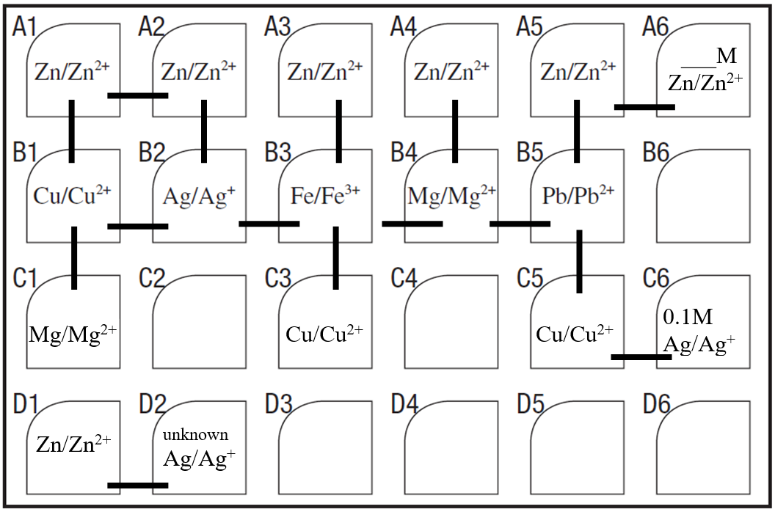

2) Obtain 1 of each of the following electrodes: Cu, Ag, Fe, Mg, and Pb. Get 2 Zn electrodes.
If necessary, polish the with sandpaper or steel wool if needed.

3) Take a small strip of filter paper that has been soaked in NaNO₃ solution, and drape it between wells A1 and B1 so that the ends dip into the solutions in each well. This acts as the salt bridge. Place the zinc electrode in A1. Place the Cu electrode in B1.

4) Turn on the voltmeter and make sure it is set to 20DCV. Connect the negative (black wire) clip of the voltmeter to the zinc electrode and the red wire clip to the copper electrode. Observe the voltage reading (make sure it is stable).
When the voltmeter reads a positive voltage, the electrode connected to the positive terminal is the cathode and is undergoing reduction, while oxidation is occurring at the electrode connected to the negative (or common) terminal, the anode. (Reverse the connection to see what happens to the voltage.) For the lab, the Zn/Zn²⁺cell is the standard electrode. Record the voltage in the Part 1 Data Table.

5) Remove the filter paper salt bridge (place it on a paper towel for disposal later). Repeat the procedure for the rest of the cells A2-A5. The zinc electrode will always be in row A2-A5. Use a fresh salt bridge for each cell and be sure you are placing the correct electrodes in cells B2-B5. One cell will have a negative voltage. Record the volatages in the data table.

6) Test the voltage potential between two Zn cells (A1 – A2). What should it be? Record the voltage.

7) Use your measured reduction potentials from the data table to predict the reaction equations for the following cells.
Record which electrode will be the anode and which will be the cathode. Write and balance the net ionic equation for the cell in the table. Predict the potential difference (voltage) for each cell and record it in the table.
Cu│Mg; Cu│Ag; Ag│Fe; Fe│Cu; Fe│Mg; Mg│Pb; Pb│Cu

8) Measure the actual potential difference (voltage) for each of the cells using a similar procedure as above and record the Measured Potential (voltage) in the table. All the voltages should be positive when connected correctly.

Part 2. Change Ion Concentration

1) Half fill well “C6” with 0.1M AgNO₃. Place a silver electrode in cell “C6” and place a copper electrode in well “C5”.
Connect the wells with a salt bridge.

2) Connect the leads so that the voltage reading is positive. Record which electrode is the anode and which is the
cathode. Record the measured potential. (The predicted potential will be calculated later using the Nernst Equation.)
Complete the cell representation.

3) Add 4 drops of 1.0M ZnNO₃ to well “A6” and then dilute with 36 drops of distilled water.
(What is the concentration? Hint: Use M₁V₁=M₂V₂ with drop numbers. V₁= 4 M₁= 1.0M V₂ = 40 )
Use 2 zinc electrodes and a salt bridge to measure the potential between cells A5 and A6 and record it in the table.
(The predicted potential will be calculated later using the Nernst Equation.) Complete the cell representation.

Part 3. Solubility Product of AgCl

1) Pour approximately 10 mL of 1.0 M NaCl solution into a 50-ml, beaker.

2) Add one drop of 1.0 M AgNO₃ to the NaCl solution and stir well. Almost all of the silver ions will combine with
chloride ions to precipitate AgCl. Since there is such a large excess of Cl⁻ ions, it can be assumed that the concentration of Cl⁻ is still 1.0 M. The concentration of Ag⁺, which is limited by the K_{sp} of AgCl, will be very small.

3) Pipet some of the solution well D2 and add a silver metal electrode. Measure the potential difference between this
half-cell and the zinc half-cell D1. A representation of the cell is: Zn(s)│Zn²⁺(1.0 M)║Ag⁺(unknown M)│Ag(s)

4) Record the voltage in the Part 3 Data Table.

Name______________________________________ Partner __________________________________ Date _____
Pre-Lab Questions
1) Why is it necessary to have a “reference” electrode when measuring reduction potentials? What is the “standard”
electrode? What will be the reference electrode for this lab?

2) The following potentials in volts were measured using a nickel Cu²⁺(aq) + 2e⁻ → Cu(s) + 0.62
electrode as the reference standard: Ni²⁺(aq) + 2e⁻ → Ni(s) + 0.00
a) Which metal ion is most easily reduced? _____ Fe²⁺(aq) + 2e⁻ → Fe(s) − 0.15
Which metal is most easily oxidized? _____ How do you know? Al³⁺(aq) + 3e⁻ → Al(s) −1.38

b) The copper and aluminum electrodes are connected to form a battery. Which one is the anode and which one is the
cathode? (Which one is oxidized and which one is reduced?)

c) Show how the half-reactions can be added to produce the balanced net ionic equation for the overall reaction.
Calculate Eº for the cell.

3) A solution is prepared in which a trace or small amount of Fe²⁺ is added to a much larger amount of solution in which
the [OH⁻] is 1.0 x 10⁻² M. Some Fe(OH)₂ precipitates. The value of K_{sp} for Fe(OH)₂ = 8.0 x 10⁻¹⁰
a) Assuming that the [OH⁻] is 1.0 x 10⁻² M, calculate the [Fe²⁺] ions in the solution. Ksp = [Fe²⁺][OH¹⁻]

b) A battery is prepared using the above solution with an iron wire dipping into it as one half-cell. The other half-cell is the standard nickel electrode. Show how the half-reactions can be added to produce the balanced net ionic equation for the overall reaction. Calculate Eº for the cell.

- Use the Nernst equation to calculate the potential of the above cell.

Part 1: Data Tables Voltage of Each Half-Cell versus the Zinc
 | Voltage  (voltmeter) | Anode | Cathode
Zn vs Cu
Zn vs Ag
Zn vs Fe
Zn vs Mg
Zn vs Pb
Zn vs Zn
Record the voltage for each cell using the voltmeter.

Predicted and Measured Cell Potentials
Anode | Cathode | Equation for the Cell Reaction | Predicted Potential from Experimental Data | Measured Potential

Part 2: Data Table
Cell Representation | Measured Potential | Anode | Cathode | Predicted Potential
____(s)│____ (____M)║____ (_____M)│____(s)
____(s)│____ (____M)║____ (_____M)│____(s)

Part 3. Data Table
Cell Representation | Voltage | Anode | Cathode
Zn(s)│Zn²⁺(1.0 M) ║Ag⁺(unknown M) Ag(s)
Equation for Cell Reaction | Calculated [Ag⁺] | Calculated K_{sp} AgCl | Known K_{sp} AgCl

Calculations and Analysis
Part 1 Write reduction equations for each ion of the 6 metals, arranging the equations in decreasing order of measured potential in the table below. Include zinc in the table, using 0.00 volts as the potential of the Zn│Zn²⁺ half-cell. Record the accepted standard potentials using hydrogen electrode as standard, and calculate the difference between the two standard values.

Reduction Equations for Each Ion Arranged in Decreasing Order of Potential:
Reduction Equation | Electrode Potential using Zinc as the Standard, E°_{Zn} | Accepted Electrode Potential using Hydrogen as Standard, E° | E°_{Zn} - E°

Part 2 Write balanced net ionic equations for the reactions occurring in the cells in Part 2. Use the Nernst equation to calculate what the expected (predicted) voltages should be. Record the values in the Part 2 Data Table. Compare the values to the measured voltages.

Part 3 Write a balanced net ionic equation for the reaction occurring in the cell. Use the Nernst equation to calculate
the concentration of the Ag⁺ ion. Record this value in the Part 3 Data Table. Calculate the value of the solubility product Ksp of AgCl. Look up the known Ksp value for AgCl. Record this value in the Part 3 Data Table. How does the calculated value compare to the known value?

Post-Lab Questions
1) Did the ranking of reduction equations agree with that in a published chart of E° values? Explain.

2) What is the purpose of the salt bridge? What would happen if it were not present? What type of salt must be used?

3) How should the values found using the zinc electrode as a standard compare with those in the E° table that are based
on the standard hydrogen electrode (by how much should they differ)? (Hint: take an average) Did they?

4) What factors can cause a difference between experimental and reported values?

5) What does a negative value for a standard potential indicate? (as compared to the standard zinc electrode)
Which metal produced a negative value? Why? Calculate ∆Gº for the cell. What does the value indicate?

6) How did the change in concentration of the silver ions in Part 2 affect the cell potential? Is this change in agreement
(qualitatively) with that which would be predicted by LeChatelier's Principle?
Did the calculated and measured values agree?

7) Explain how the Zn concentration cell produces voltage.

8) Briefly explain how the AgCl solubility product was determined.

Why might your value be slightly lower due to the common ion effect from Cl⁻?

Write the equation for the cell reaction that occurs when the iron and copper electrodes are connected to the voltmeter.

_________________________________________________________________

Complete the diagram below.
1) Label the symbols of each element that compose the anode and cathode. Label the solution in each beaker.
2) Record the half reaction that occurs in each “cell” under the appropriate beaker. Indicate which is oxidation and which is reduction. Label the voltage for each cell with the correct sign. (The sum of these 2 should equal the recorded reading.)
3) Indicate what is occurring to the metal ions in the solution within each “cell” by drawing one of each metal ion in the beaker and use arrows to show their direction of movement.
4) Use and arrow to indicate the direction of electron flow as the cell operates and the voltage reading measured.
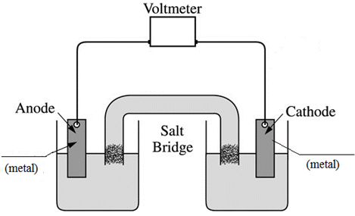
5) Draw one Na⁺ ion and one NO₃⁻ ion within the salt bridge and use arrows to show the direction of movement of the ions as the cell operates.
0.10M __________ 0.1M ___________

______________________________ ______________________________

_____ V _____ V

9) Calculate ∆Gº for the cell. What does the value indicate?

