AP Chemistry Name__________________
Determining Entropy and Spontaneity

For each of the following reactions, determine if the entropy is positive or negative. Then, based on the given ∆H, determine the spontaneity of the reaction (Spontaneous at all temperatures, Nonspontaneous at all temperatures, or Spontaneous at _______ temperatures)
- ∆H= -64.87 kJ/mol

- ∆H= -802.34 kJ/mol

- 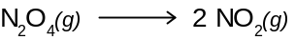 ∆H= 58.02 kJ/mol

- ∆H= -498.12 kJ/mol

- ∆H= 221.2 kJ/mol

- ∆H= -2855.51 kJ/mol

- ∆H= 89.4 kJ/mol

- 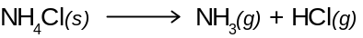 ∆H= 175.91 kJ/mol

- ∆H= -35.33 kJ/mol

- 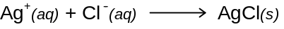 ∆H= -65.7 kJ/mol
- ∆H= -56.13 kJ/mol

