Pintos Project 1

Task 1: Alarm Clock (Efficient Sleep/Wakeup)

The problem with the naive solution:
A naive timer sleep implementation would repeatedly check the current time in a loop until enough ticks pass. That wastes CPU cycles and makes tests unhappy.

Data structure:

A global list called sleep_list stores all sleeping threads. Each thread inserts itself into the list based on its wake-up time, with the earliest wake-up time placed at the front.
Key code: timer sleep()
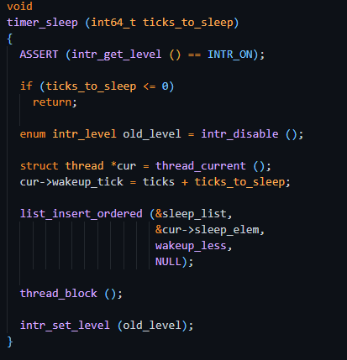

Step-by-step (timer sleep):
1) Verify interrupts are on. Pintos requires this for sleeping.
2) If ticks to sleep <= 0, return immediately (nothing to do).
3) Disable interrupts so the timer interrupt cannot run while we edit sleep list.
4) Compute wakeup time: current ticks + ticks to sleep.
5) Insert the current thread into sleep list in sorted order (earliest wake first).
6) Block the thread. It will stop running and be removed from the ready list.
7) When the thread wakes up later, it continues after thread block() and restores the interrupt level.
When a thread calls timer sleep(ticks to sleep), we want it to stop running right away and only run again after the requested number of timer ticks. The implementation does this by computing an absolute wake-up time (current ticks + ticks to sleep), storing it in the thread (cur->wakeup tick), and inserting the thread into a global sleep list that is kept sorted by earliest wake-up time. We disable interrupts while touching sleep list so the timer interrupt can’t access the list at the same time. After inserting itself into sleep list, the thread calls thread block(), which removes it from the CPU/ready list and puts it in the blocked state. The thread will remain blocked until the timer interrupt wakes it up later.

Key code: timer interrupt() wakeups

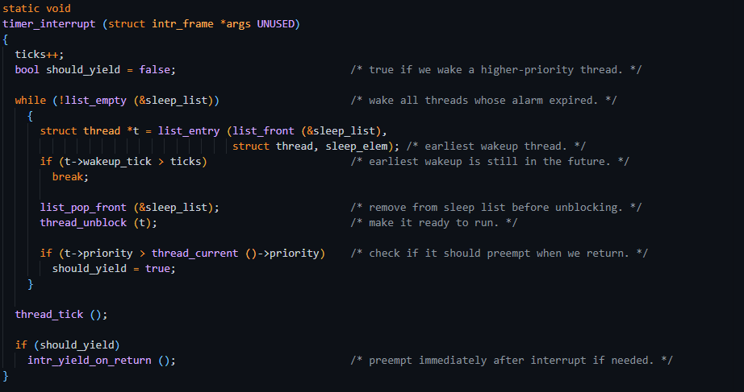Step-by-step (timer interrupt):
1) Increment the global tick counter.
2) While the earliest sleeper's wakeup tick <= current ticks, pop it from the list and unblock it.
3) If we woke a higher-priority thread than the currently running one, request a yield when the interrupt returns.
This design is efficient because we do not scan every sleeping thread each tick: the list is sorted, so we stop as soon as the front thread is not ready to wake.

Task 2: Priority Scheduling (Highest Priority Runs)

Core idea:
Keep the ready list sorted by priority. That way, the highest-priority thread is always at the front.

Key code: ready list ordering and insertion helpers

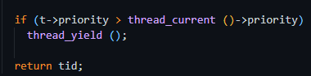
Immediate preemption: after creating/unblocking a new thread, if its priority is higher than the currently running thread, the current thread yields so the higher priority thread can run right away.

Where we use it:
When a thread becomes READY (unblocked), it is inserted in order:
We disable interrupts while editing ready_list because the timer interrupt (or other kernel code) could try to use the scheduler lists at the same time. Disabling interrupts makes the list update atomic and prevents race conditions.
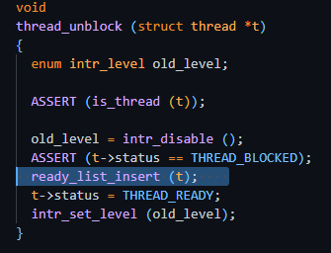
Using the ready_list_insert when the thread is unblocked it adds it back to the list which is sorted to handle the priority.
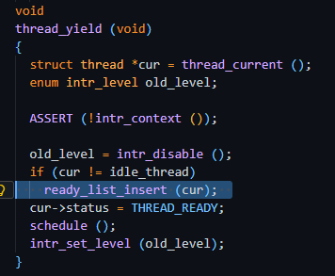
When a running thread yields, it re-enters the ready list in order. Similar to the instance when unblocking.

Task 3: Priority Donation (Locks)

Donation fix:
When B blocks on A's lock, B temporarily boosts A's effective priority so A runs sooner and releases the lock.

Thread fields used:
Each thread keeps `base_priority` (what you set) and `priority` (effective, after donation). It also keeps a `donations` list and `waiting_lock` pointer to support chained donation.

Relevant (from struct thread):

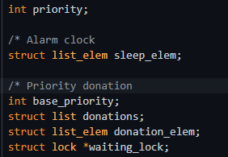
struct list_elem sleep_elem: Link used to put this thread into the global sleep_list when it calls timer_sleep()
int base_priority: The thread’s original priority set by thread_set_priority(). (used to restore priority when donations go away)
struct list donations: List of threads currently donating priority to this thread (because they are blocked on locks this thread holds)
struct list_elem donation_elem: Link used when this thread is stored inside someone else’s donations list.
struct lock *waiting_lock: The lock this thread is currently waiting to acquire (used to support chained/nested donation).

Donation helper functions in synch.c:
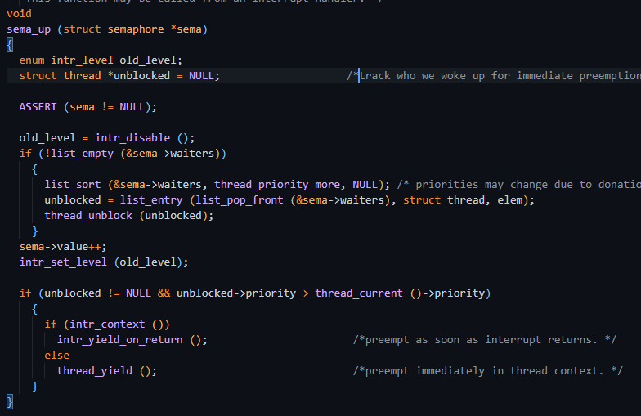
sema_up() now does priority-aware unblocking: it sorts the semaphore’s waiters list by thread priority, pops the highest priority waiter, and calls thread_unblock() on it. The new unblocked variable is used to check if the woken thread outranks the current thread; if so, we preempt via intr_yield_on_return() in interrupt context or thread_yield() otherwise. Interrupts are disabled while touching the waiter list to avoid races.”

Key code: lock acquire (donate before blocking)
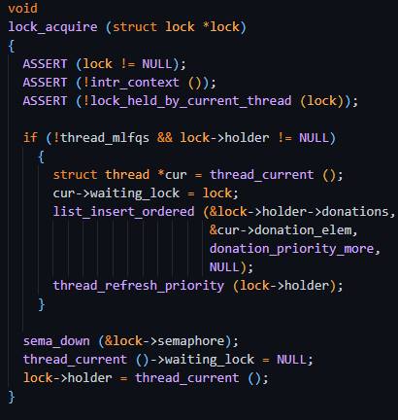
lock_acquire() now performs priority donation before blocking. If the lock is already held and MLFQS is off, the current thread records waiting_lock, inserts itself into the lock holder’s donations list (ordered by donor priority), and calls thread_refresh_priority() so the holder’s effective priority is boosted. Then it blocks on sema_down(). After it finally acquires the lock, it clears waiting_lock and becomes the new lock->holder.
Run through
When a thread attempts to acquire a lock:
1. If the lock is already held, the current thread records the lock it is waiting for.
2. The thread is inserted into the lock holder’s donation list.
3. The holder’s priority is updated if necessary.
4. The thread blocks using sema_down().
Once the thread successfully acquires the lock, it clears waiting_lock and becomes the new lock holder.

Key code: lock release (remove donations caused by this lock) 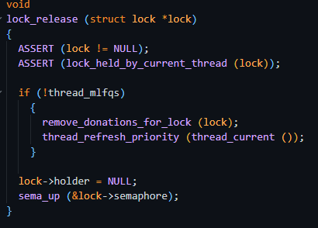
lock_release() undoes priority donation when a lock is released. If MLFQS is off, it removes any donor threads that were waiting on this specific lock (remove_donations_for_lock(lock)) and recomputes the current thread’s effective priority (thread_refresh_priority). Then it clears lock->holder and calls sema_up() to wake the highest-priority waiter for the lock’s semaphore. Essentially opposite of lock acquire.
When releasing a lock:
1. Any donations related to that lock are removed.
2. The thread recomputes its effective priority.
3. lock->holder is cleared.
4. sema_up() wakes the highest-priority waiting thread.
This essentially reverses the work done during lock_acquire().

Chained donation (nested locks):
If a donated thread is itself waiting on another lock, its higher effective priority can be propagated up the chain. This implementation uses a bounded depth (depth < 8) to avoid infinite loops.

Task 4: thread_set_priority / thread_get_priority

What the task asks for:
A thread must be able to change its own priority and read its current effective priority. With donation, reading should return the donated (effective) priority.

thread_set_priority (detailed):

thread_set_priority(new_priority) updates the thread’s base priority, then recomputes the effective priority (what the scheduler uses) by taking the max of base_priority and any active donations. Interrupts are disabled during the update so ready/donation lists aren’t modified mid-change. Afterward it calls maybe_yield_to_higher() so if another ready thread is now higher priority, it runs immediately
When a thread changes its priority:
1. base_priority is updated.
2. The effective priority is recalculated using any active donations.
3. Interrupts are disabled during the update.
4. The scheduler checks if another thread should run instead and yields if necessary.

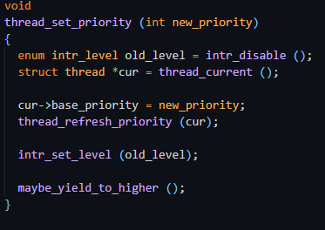

thread_get_priority:
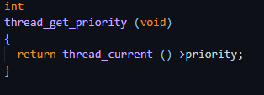
Simple get and return function

Priority-Aware Semaphores and Condition Variables

Why we need this:

Even with priority scheduling, incorrect behavior can occur if semaphores or condition variables wake threads in FIFO order. Instead, the highest-priority waiting thread should be woken cond_wait (store waiters ordered by priority): 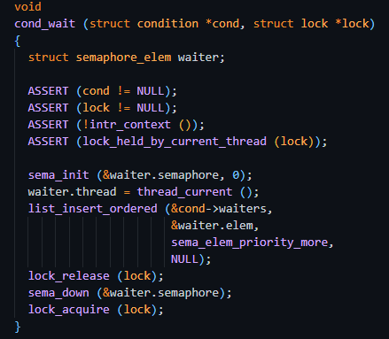

cond_wait() blocks the current thread until the condition is signaled. The thread is added to cond->waiters in priority order, releases the lock, blocks on a private semaphore, and then reacquires the lock after waking.

cond_signal (wake highest priority waiter):
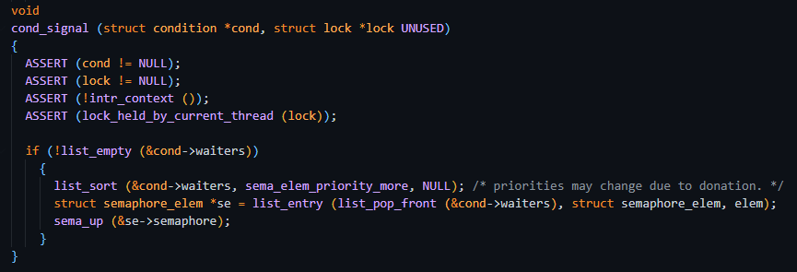
cond_signal() wakes one waiting thread, specifically the highest-priority one. The wait list is sorted before selecting the thread because a thread’s priority may change while it is waiting due to priority donation.

