Project Team C - Student N4: Kenlo DINH VAN (26641652)

Assigned transcendental function F4: logb(x) (logarithmic function)

Description:

The **logarithmic** function is the **inverse** of the exponential function (one-to-one function).

The graph of an inverse function is usually a reflection of the original function (using the line y = x)

John Napier expressed y as a function of x for the logarithm in 1614 resulting in:

logb(x) = y

which can be read: “x is equal to b (base) to the power y”, which is equivalent to "y is the base-b logarithm of x."

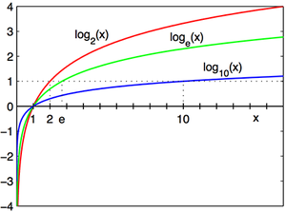

**Domain**: x > 0 (set of positive real numbers)

**Co-domain**: Set of real numbers **R**

Specificity of the base: b ≠ 1 and b > 0

**Unique characteristics**:

Exponential expressions can be written as logarithmic expressions and logarithmic expressions can be written as exponential expressions. ex: 32=9 => log3(9) = 2

* when b = 10 the function is called common logarithm and denoted log(x)
* when b = *e* = 2.7182818… the function is called natural logarithm and denoted ln(x)

Logarithmic identities:

* Product: logb(x*y) = logb x + logb y
* Quotient: logb(x/y) = logb x - logb y
* Power: logb(xp) = p logb x
* Root: $\log_{b}\sqrt[p]{x}= \frac{\log_{b} x}{p}$

[1] <https://en.wikipedia.org/wiki/Logarithm>

[2] <http://dwb4.unl.edu/Chem/CHEM869R/CHEM869RMats/Logs/Logs.html>