**TASK – 5**

**Capture and analyze network traffic using wireshark.**

1. Installation of wireshark.
2. Start capturing on active network interface. (here WiFi)
3. Browsing a website to generate traffic.
4. Stop capture.
5. Filtering captured packets by protocol.

**Filter: TCP**

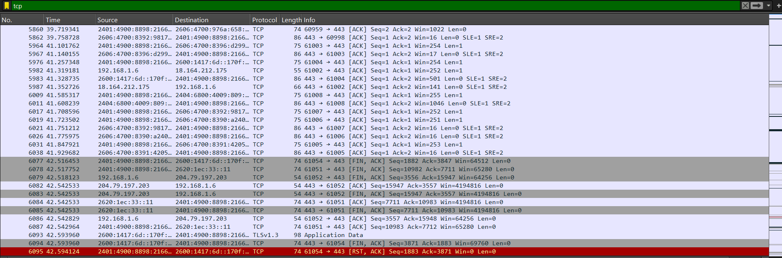

**Filter: DNS**

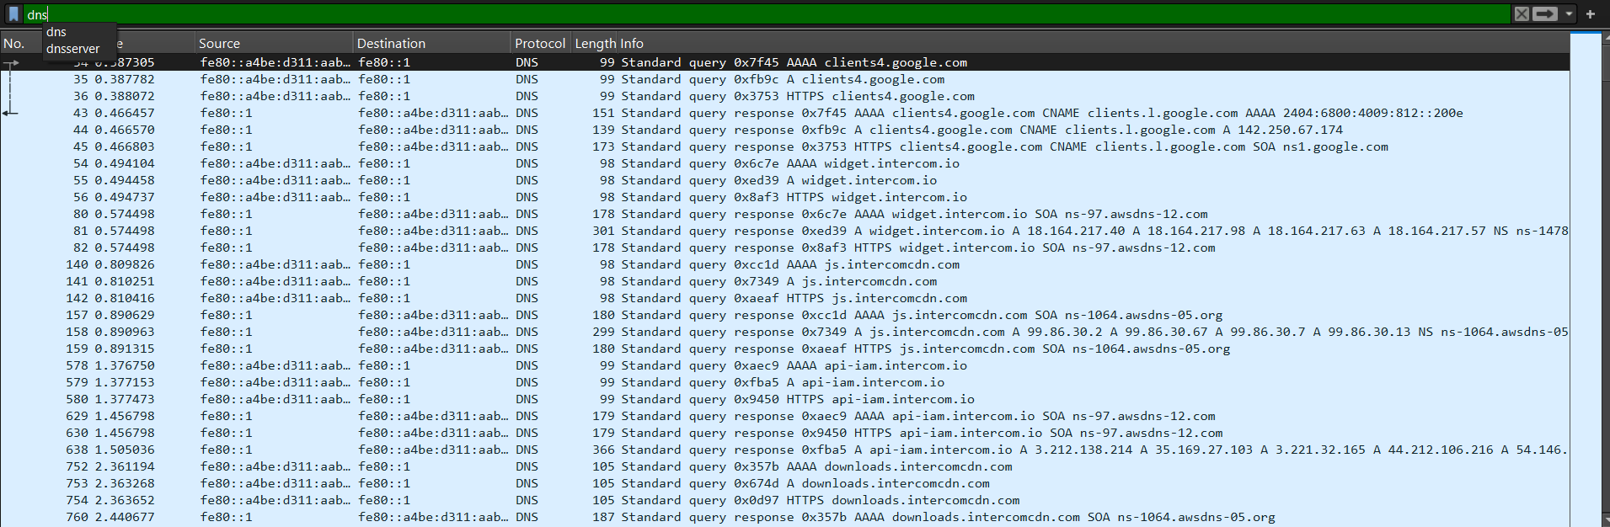

**Filter: UDP**

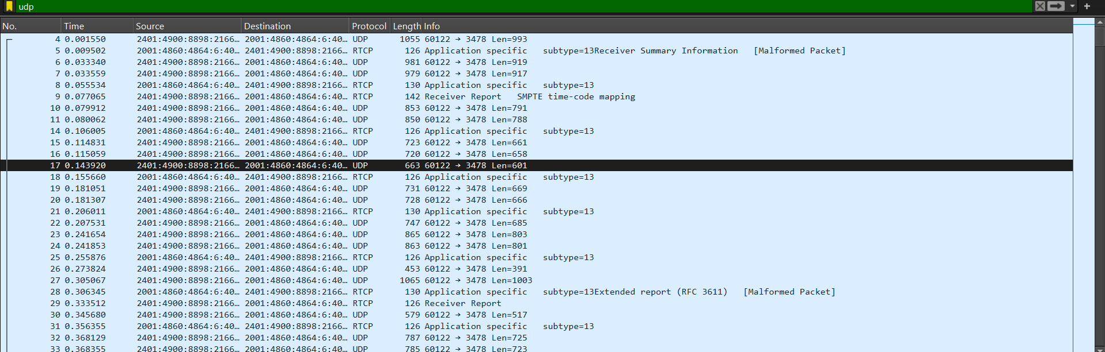

1. **Exporting file as a pcap file.**

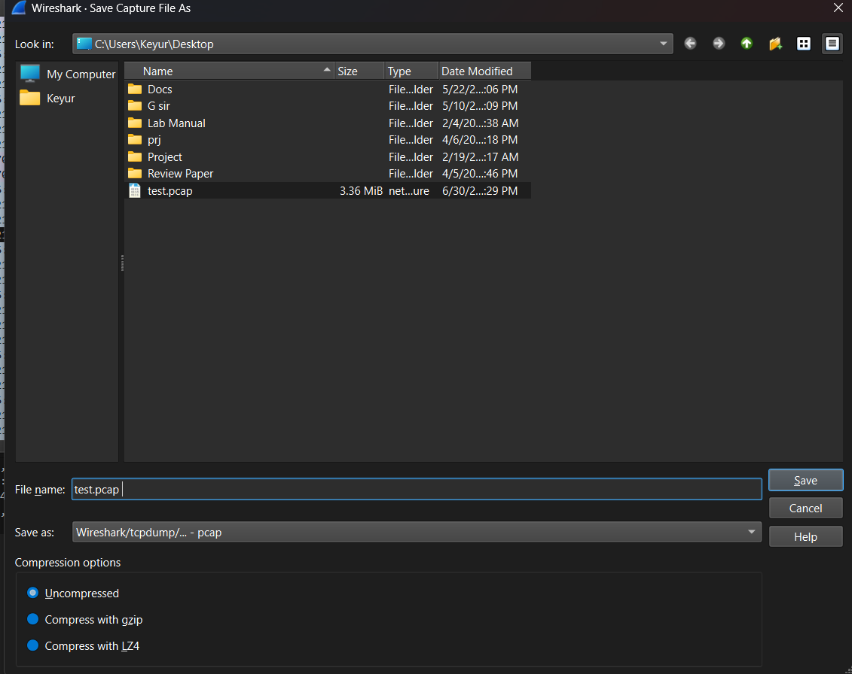

1. **Identifying 3 protocols in the capture**

* TCP: Transmission Control Protocol
* UDP: User Datagram Protocol
* DNS: Domain Name System

1. **Summary:**

The operation of performing packet capturing task by using Wireshark tool, captured the all ongoing and outgoing traffic of the selected interface (Wifi).

All the captured packets give the protocols which are being used at the capturing time.