**Task- 1**

1. **Installation of NMAP in Kali Linux.**

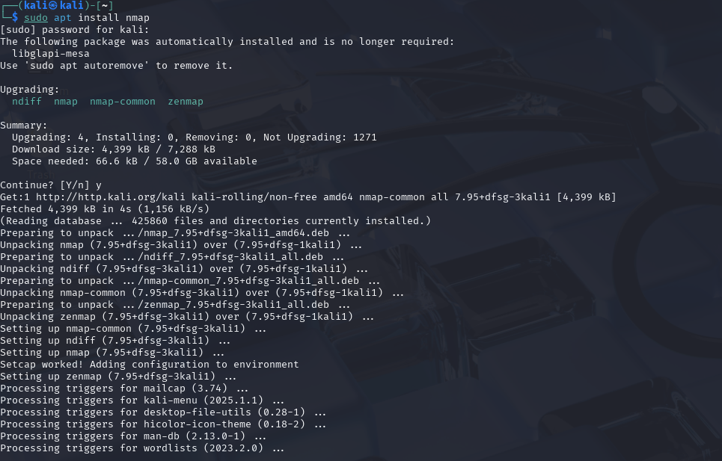

1. **Finding IP address of the system.**

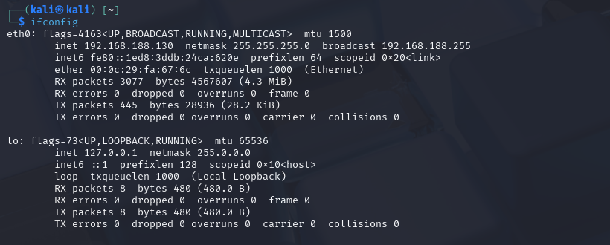

1. **Capturing packets and checking the open ports and which can be exploited.**

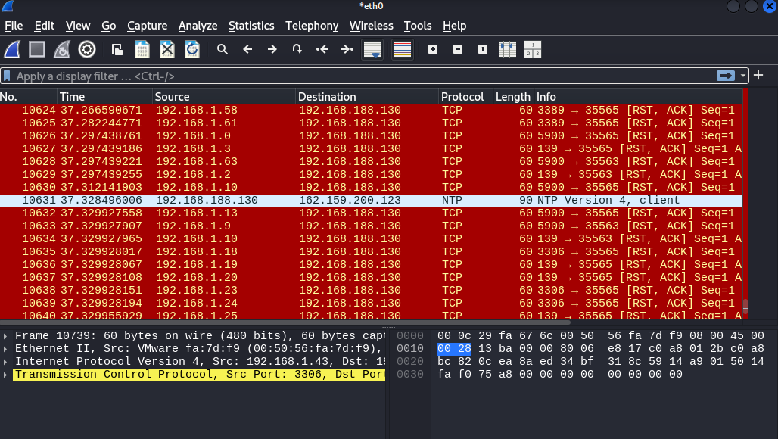

1. **Scanning the local network with the nmap tool.**

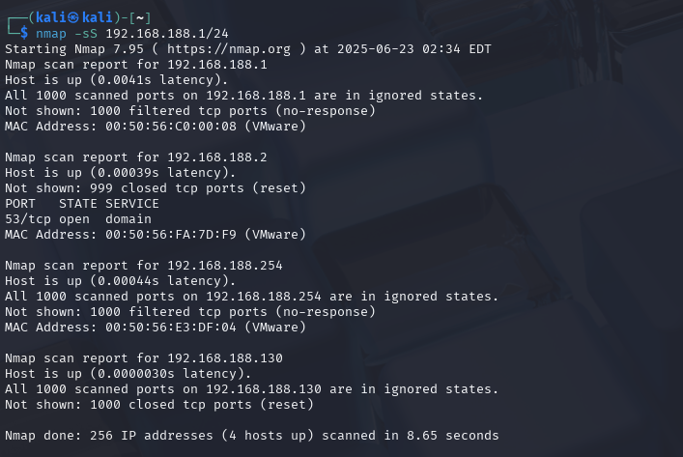

**Found Open ports are:** TCP (53) state: Open

**Open TCP port can be vulnerable to many threats:**

Brute Force Attacks

Exploitation of Vulnerable Services

Denial of Service (DoS/DDoS)

Man-in-the-Middle (MitM) Attacks

Malware Delivery

Application-Layer Attacks