**TASK- 4**

1. **Current firewall rules:**

Command: netsh advfirewall firewall show rule name=all

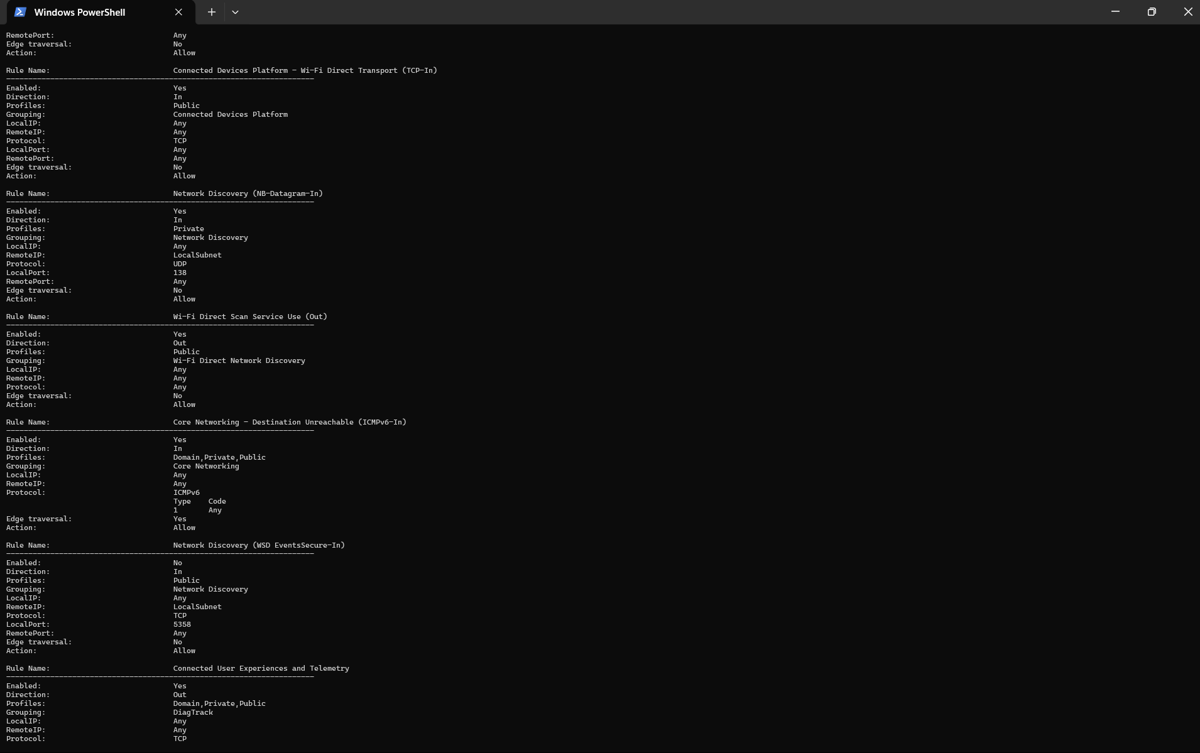

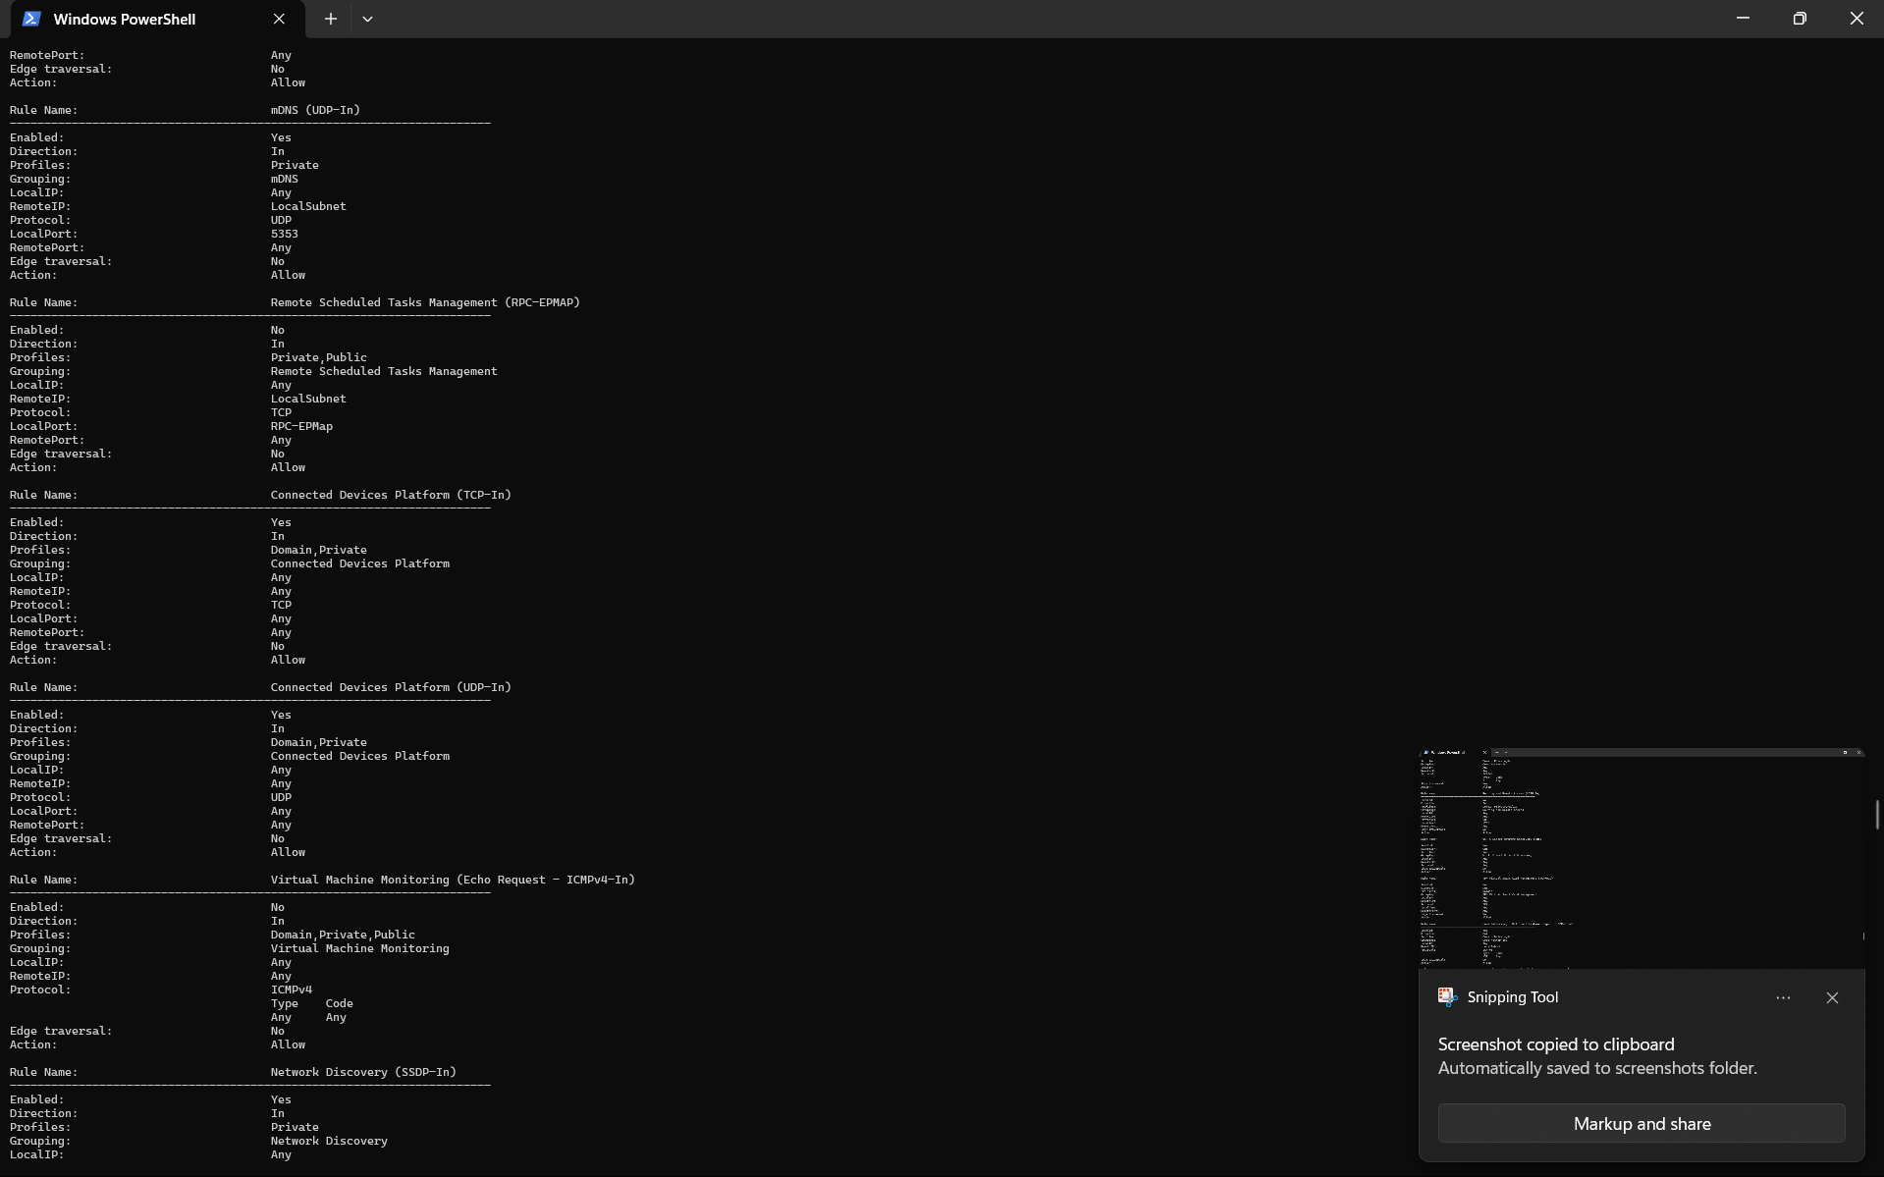

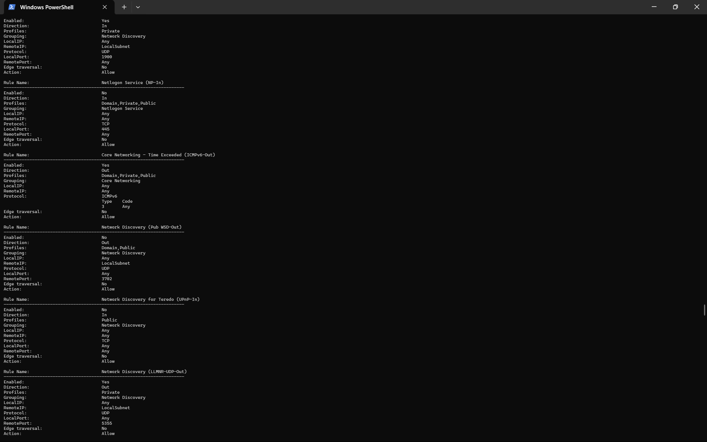



1. **Blocking the port 23- TELNET**

Command: netsh advfirewall firewall add rule name="Block Telnet" dir=in action=block protocol=TCP localport=23

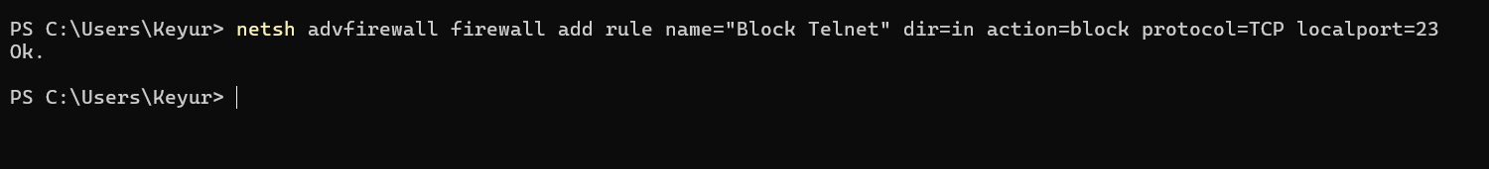

1. **Blocking the port 22- SSH**

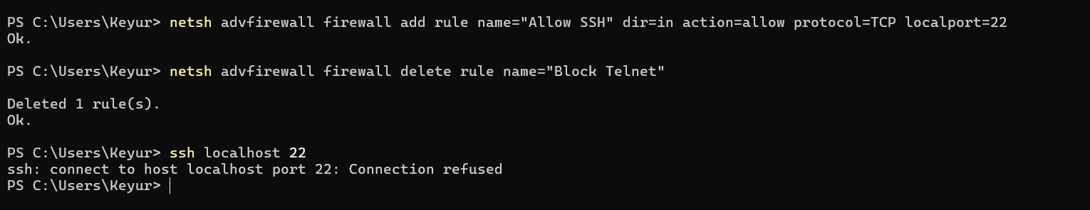

1. **Removing the test block rules.**

netsh advfirewall firewall delete rule name="Block Telnet"

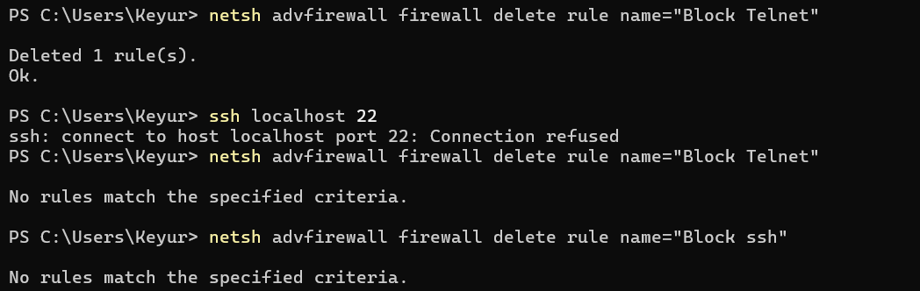

* Windows Firewall evaluates inbound and outbound rules against each network profile (Domain, Private, Public). It filters traffic based on:
* Application
* Port Number
* Protocol (TCP/UDP)
* Traffic Direction (Inbound/Outbound)
* IP Addresses

Each packet is matched against the rules. If no rule matches, the default behaviour applies (usually block inbound, allow outbound).