**USER MANUAL**

**EDITORS**

Kristina Myftaraga / 200069406

Fundamental Data Structures

Prof. Vladimir Georgiev

**INSTRUCTIONS:**

* Run the program as you would any other C++ Console project
* Once the user enter our web-like program, he faces an Online Store. The menu offers a set of iterations.

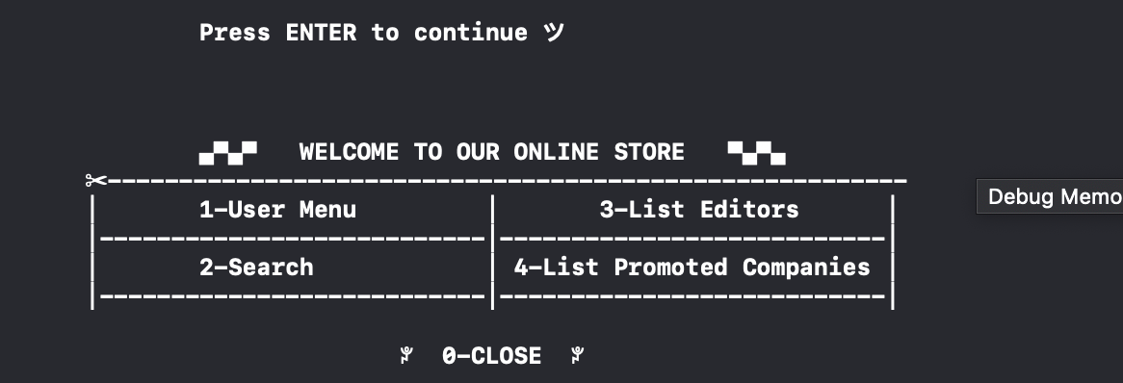

1. User Menu

The user can Log in and register. We will take an example. Emma is registering (2) filling the required information that program shows. Her data will be saved in the Users file.

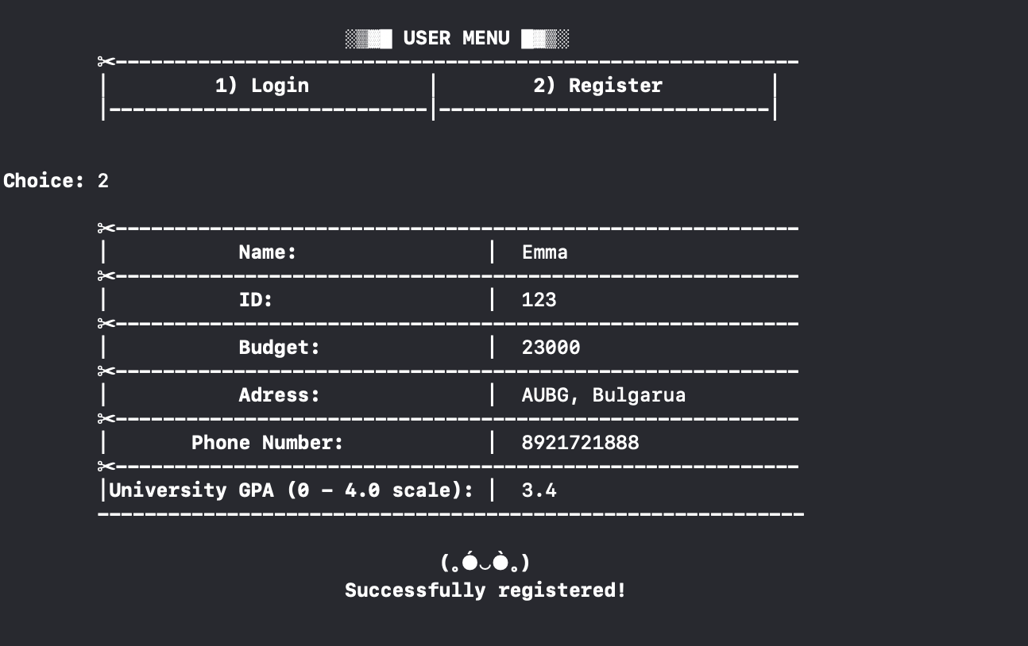

Next, Emma Log in with name and ID.

Emma is not part of our partner companies. In this sceenario she can apply to one of them.

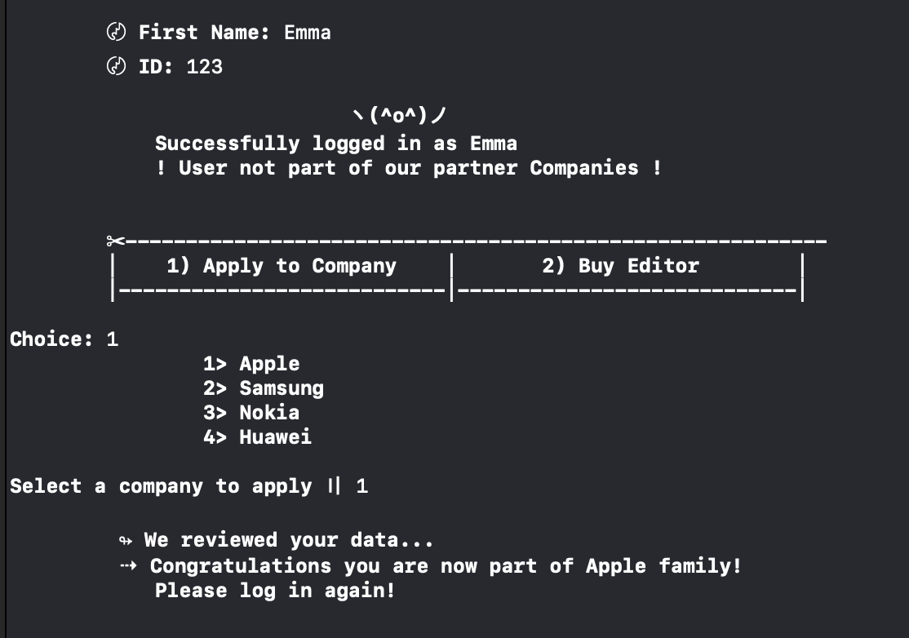

Once she is part of our partner companies, she has to log in again and this time she can add one editor as well.

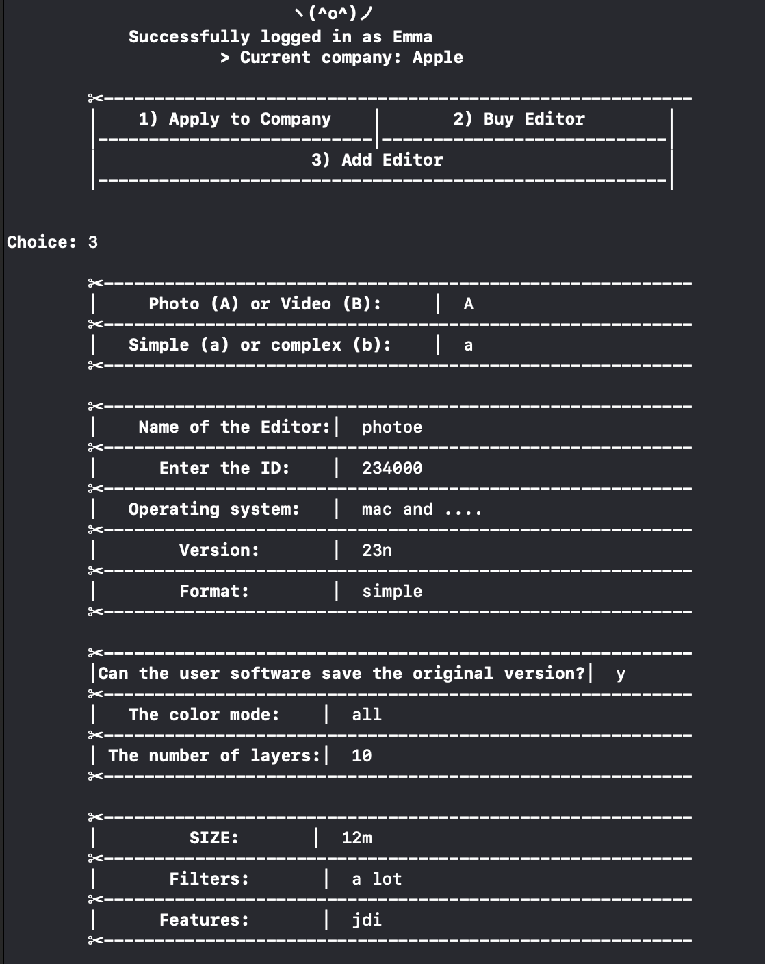

Below will be shown the spots necessary to be filles for one User to add one Editor.



In case she does not want to be part of our companies she can only buy one of the editors. The program shows the current budget, prices of each of our editors and the remaining budget after she decides to purchase one.

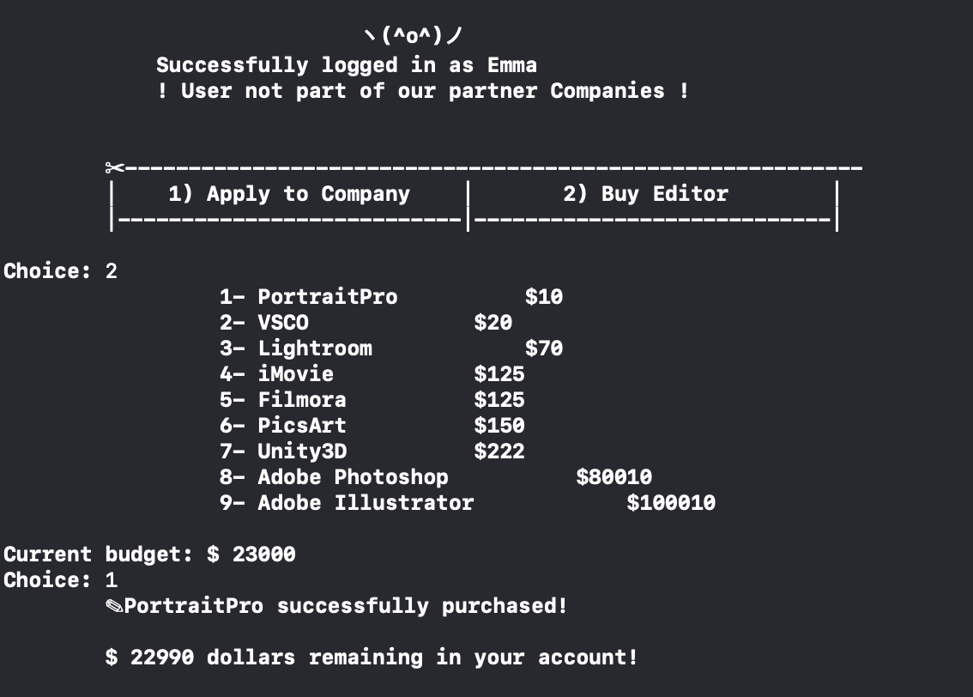

1. Search menu for Editors and Companies.

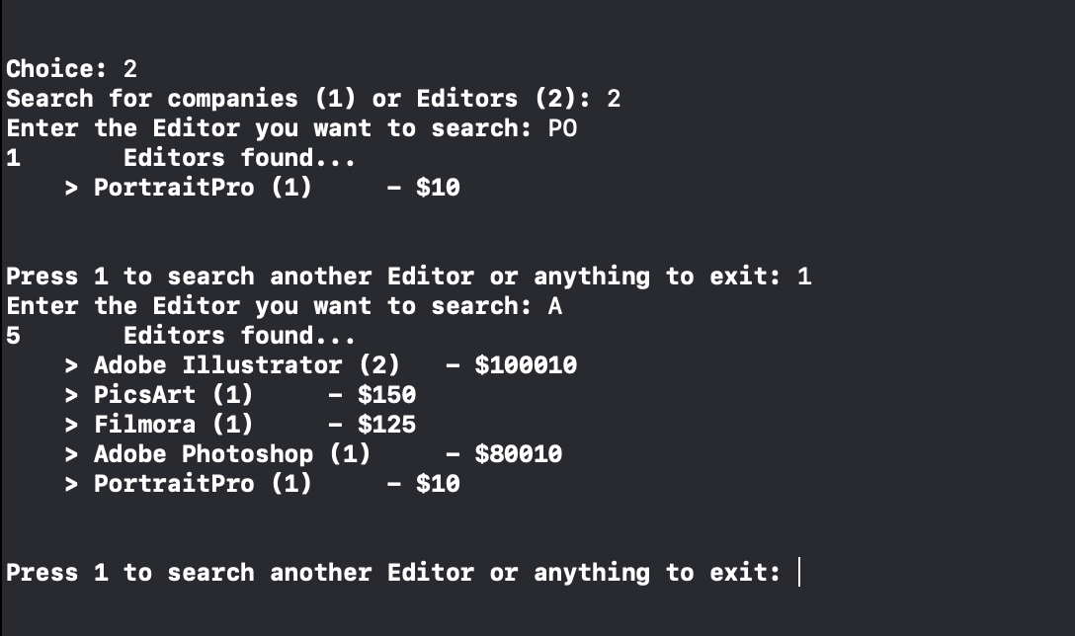

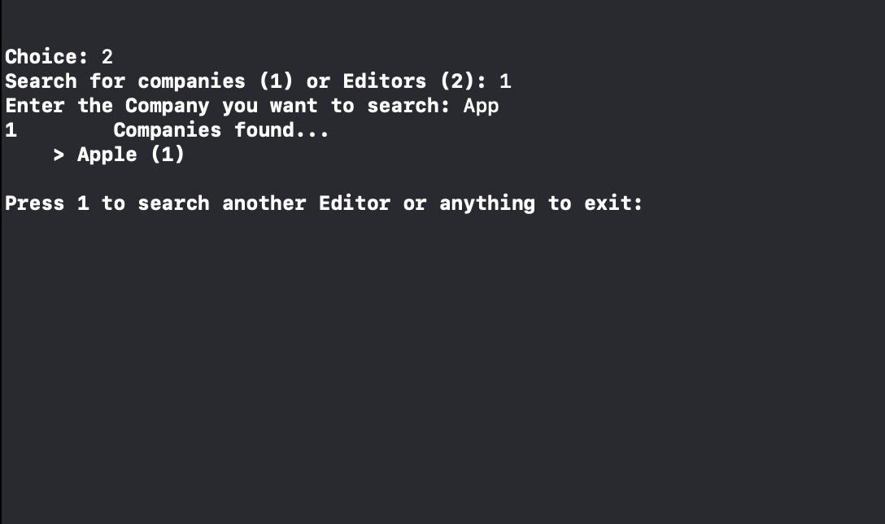

1. List Editors. There is no need for the user to log in or register, he can just open online store and check the available Editors and get description for whichever he wants.

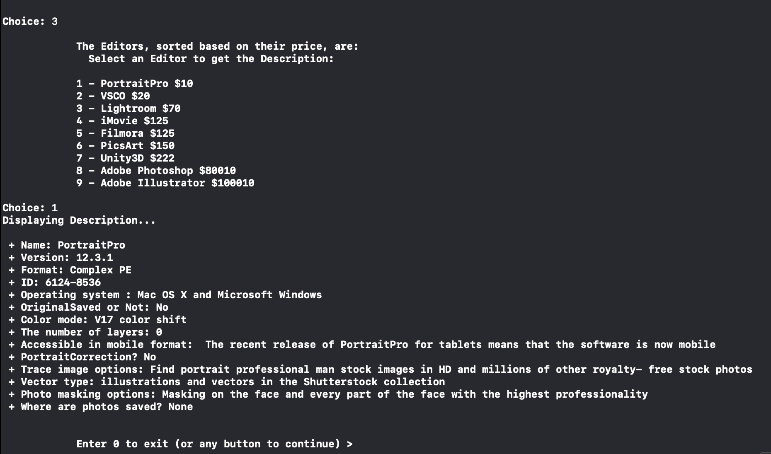

1. List Companies. With no need to log in or register, User might be interested learning about our Partner Companies. Here he can see them listed and some contact information.

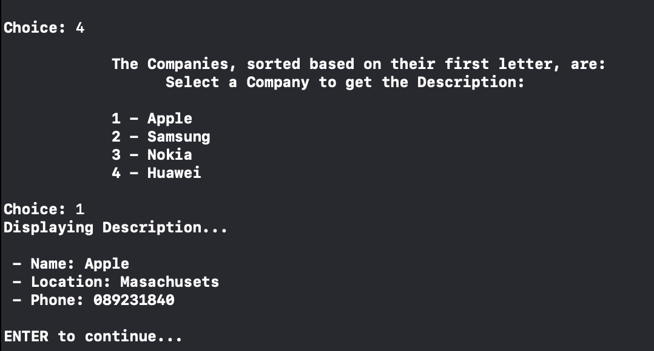

* All these small menus are available for the user to make his experience in our Online Store better and easier. He might just want to have a look at the Editors and their prices; Companies and their contact information; or he might just want to Search and have a prompt answer if we have what he wants.
* The User menu is built in order for them to have a personal account and purchase, add an Editor or apply to a company.

