Report on

Music store management

By

Kunal Atram

(205119049)

MCA first year

2019-2020

Subject:-Database management system

Department of Computer Applications

National Institute of Technology Tiruchirappalli

**INTRODUCTION:**

Music Library Management System have to manage various musical items comes with number of models and variety. Maintaining all musical records such as create order, calculate bill, add new music in database, edit the music description, and delete any item from large music library was not an easy task on regular basis.

This is a music store management project in C++ with mysql database that can create order, calculate bill, add new music in database, edit the music description, and delete any item also it shows the total music in stock, and it can find the specific music. It stores all data in MySQL database.

This project aims to cover the basic implementations of database management system covered in acaemics.

**Features:**

The program can create order, find music, sold items, item in stock, all items, add new Item, and remove Item

1. Create Order

Here the user can create an order, choose items, delete items and buy the item and finally show the price of total items. The user can also choose same item.

1. Find Music

User can find their song with four different categories Name, Category, Type, and Artist.

1. Sold Items

It shows how many item and which items were sold.

1. Item in Stock

It shows the item that is in the stock that means the quantity of the item is more then zero.

1. All Items

Shows all the items in the database.

1. Add New Item

Add new item in the database.

1. Edit Item

Edit any item content.

1. Remove Item

Can delete any item from database.

1. Exit

Exit the program.

**Database Overview:**

**MySQL:**

MySQL is an open-source relational database management system. Its name is a combination of "My", the name of co-founder Michael Widenius's daughter, and "SQL", the abbreviation for Structured Query Language.

MySQL has stand-alone clients that allow users to interact directly with a MySQL database using SQL, but more often MySQL is used with other programs to implement applications that need relational database capability. MySQL is a component of the LAMP web application software stack (and others), which is an acronym for Linux, Apache, MySQL, Perl/PHP/Python. MySQL is used by many database-driven web applications

In this project we have discussed the mysql server connection with cpp programming language. This is more commonly used dbms in corporate world.

**Details for MySQL Database used:**

Database and Table Name:

* Table: musicinfo_tb, solditem_tb
* Database: cpp_musicstore_db

Here musicinfo_tb is the table in our database which consist information of all the available data in the music store.this table have attributes m_id which consist id of item,m_catagory,m_type,m_name,m_artist,m_price,m_price,m_quantity.

Solditem_tb hold the information of items that are sold.it consist attributes m_id,m_catagory,m_type,m_name,m_artist,m_price,m_price,m_quantity.

Cpp_musicstore_db is a database in mysql which constist the above table.

**Implementation:**

**Program Details:**

In the beginning of the program Global variables, Class db_response, Function main.

Global variables used in this Music Store Manager Program:

* qstate represent the state of the query. If 0 is successful 1 is failed.
* conn is the mysql connection variable.
* row is for getting the current row of the database.
* res is for getting all the values form the database.

**Function main**

* Here firstly the clear screen command then the title command and the color command.
* db_response::ConnectionFunction() is create the connection to the database.
  + The program features
  + Create Order.
  + Find Music.
  + Sold Items.
  + Item in Stock.
  + All Items.
  + Add New Item.
  + Edit Item.
  + Remove Item.

The switch case is used for switching between this functions:

* AddNewItemInDatabase():this function allows user to add in item in database which is present in the store.
* ShowAllItems():this function displays all the items in the store including items which are not in stock.
* ItemInStock():this function displays all the available items.
* FindMusic():this function allows user to search particular item in database.
* EditItem():this function allows user to update the item information.
* RemoveItem();this function allows user to delete the item.
* SoldItems():this function displays all sold items.

**Result:**

1.first it displays main menu.if we insert 2.

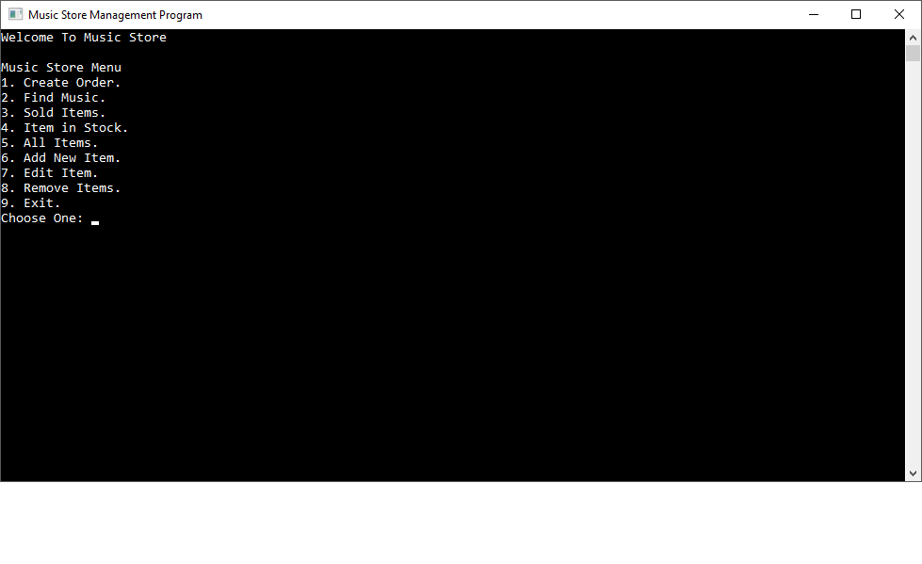

**Screenshot 1: Main menu**

2.insert choice by the way you want to find.

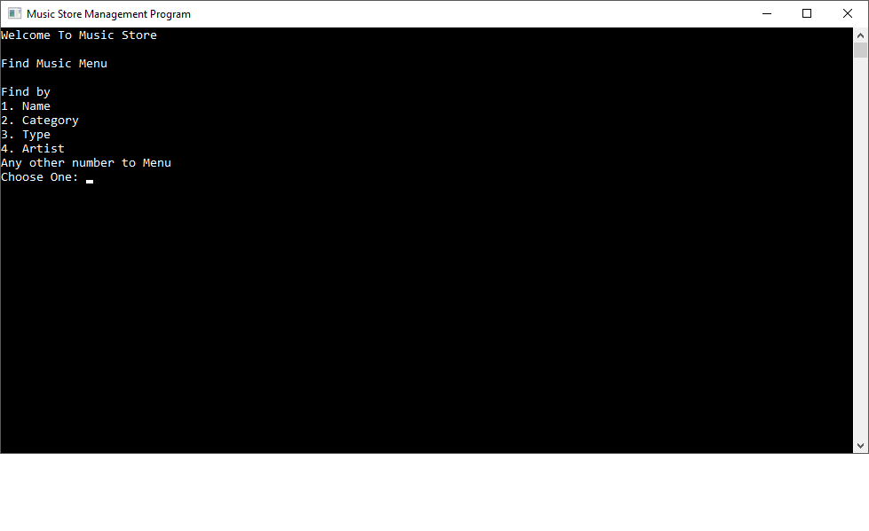

Screenshot 2.find by

3. displays the items

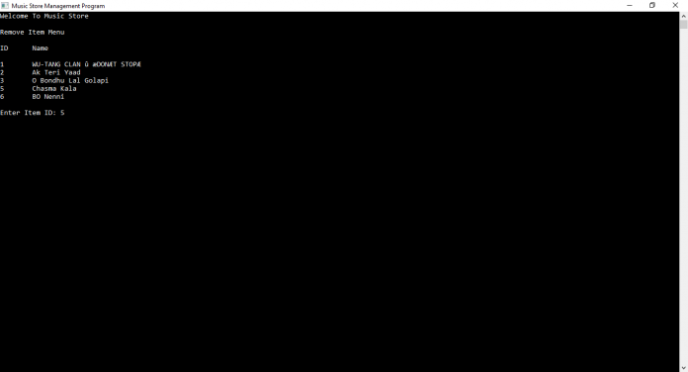

Screenshot 3.items

**Conclusion:**

In this project we have succefully connected c++ program with mysql database.which helps us to maintains all the data in the store by regular basis.