Report on

CAR RENTAL SYSTEM

By

Kunal Atram

(205119049)

MCA first year

2019-2020

&

Sonam kumari

(205119099)

MCA first year

2019-2020

Subject:-Object Oriented Programming

Department of Computer Applications

National Institute of Technology Tiruchirappalli

Intoduction:

Car rental system is based on concept of rent car and provide information of customer to the rental company.First it will ask user to provide his need then we give him available options about user’s need.By that user can compaire choices suitable for their needs.Now this project contains limited features but we can add more features according to our need.

Talking about the features first it displays the pickup locations.From given pickup locations user has to select one choice.Then it displays the available cars with features and its cost per day .From that user has to give the choice for the car. After selecting a car, the system displays selected car details which contain maximum power, mileage and many more. Then the user has to provide the information such as Car number and number of days to rent the car. After all these procedures, the system calculates rent.Then user has to enter some personal information fort security purpose(eg.name,licence number,email etc).Then it displays information of user and booked car with total fair.

This project developed by using concept of object oriented programming of c++.For run this project you can use any IDE.

In this project using oop concept we have created classes for each important term .we have created classes location,information and separate classes for each location and cars.Because each location and cars have some different functionalities.

In this project we use inheritance concept .Each pickup location inherits some properties from location class.We also used inheritance in classes of each cars.Beacause different pickup locations have different availability for cars.But instead of creating cars classes multiple times we created only once and specific car class inherits only those locations at which car is available.All classes of cars inherits the class information.

In this project we used polymorphism concept of OOP.Here in information class and classes of cars have same member function show().Member function show() of information class displays the information of customer and member function show() of classes of cars shows cars features and total fair of booking.Here we have used concept of function overriding.

In the main function we have created objects of classes that are usefull in this program.By using that objects we have carried all the procedure of program.Using object of particular class we have performed some operation such as calculation of fair of rental car.Each car have defferent fair according to its features.So we have to use different calculation methods.These different calculation methods we have performed using different objects of car that user has selected.

Implementation:

Project flow:

1)Here we have created class locations.Which has member function pickuplocation().It will display the available pickup locations to user.User have to select one nearest pickup location from his/her address and number of days for rent the car.Then in int main by using switch case we create the object of the class of particular pickup location.By using it will access class of selected pickup location.

2)We have created different classes for different pickup locations.After entering the pickup location it will display available cars on that pickup location with features and cost per day.user has to select suitable car according to his/her requirements.Again after choice of user we have created object of the class of that particular car that user has selected.Then we access the member function of calculatecost() for calculation of total cost for rent.

3)Then we have created information class which will perform some necessary operations such as taking users personal information.First we have to call the member function of information class info() which takes information of user. Then user has to enter some personal information for security purpose.such as name os customer,driving licence number,mobile number,email and permanent address.Here we have use validation concept that asks user to insert only valid information otherwise we can’t procede further.So user has to enter valid driving licence number,mobile number and email ,otherwise system will not allow you to procede.User has to provide valid information to the system.

4)After providing valid personal information to the system.We use object of car class to call member function calculationcost().system calculates the total cost according to provided number of days.Then by using the concept of function overriding It will display booking information with total fair and customers provided personal information .It will provide the customers information and booking information to the company.

Above given steps shows how program works.

The flow diagram of car rental system is given below.

Flow diagram:

1.Show pickup locations.

2.Take user’s choice.

3.Take number of days.

Location 1 Location2 Location3

1.Show available cars on location 2

2.Take user’s choice for car

1.Show available cars on location 3

2.Take user’s choice for car

1.Show available cars on location 1

2.Take user’s choice for car

1.Take customers personal informatin

1.Take customers personal informatin

1.Take customers personal informatin

1.Show customers information and booking information with cost.

Fig 1.flow diagram from car rental system program.

Result:

1.It will ask user to enter choice for pickup location and days.

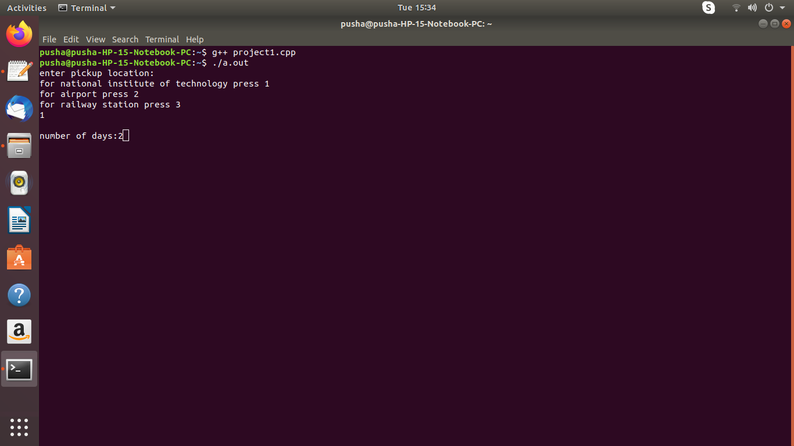

Screenshot 1.location menu

2.It will display the available cars at given pickup location.

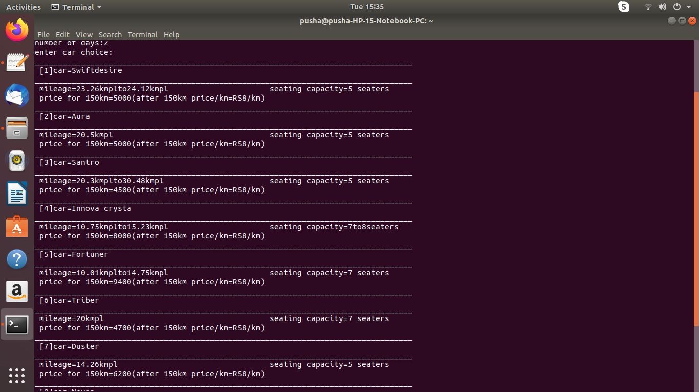

Screenshot 2.cars menu

3.Asks user to enter personal information.

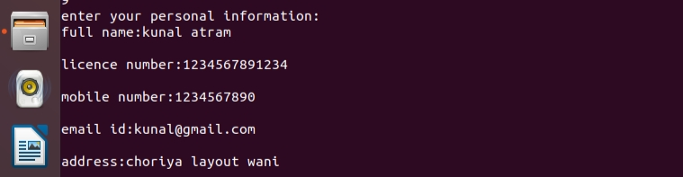

Screenshot 3.personal information

4.display information of customer and booking information with total fair.

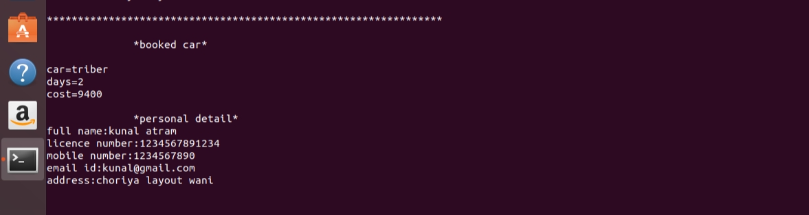

Screenshot 4.output

Conclusion:

In this program user can successfully rent car from given pickup location and rental company will have valide information about customer for security purpose.