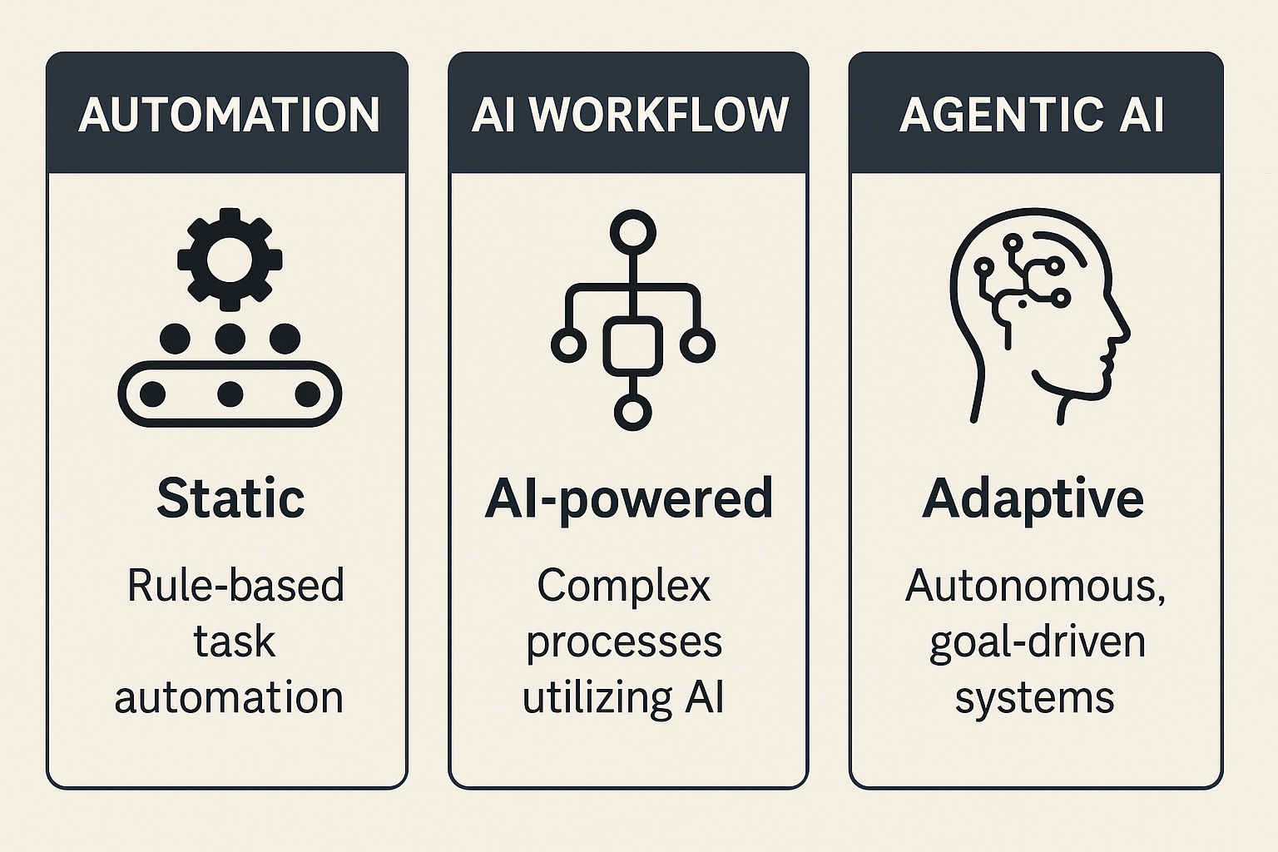
Term | Description | Key Features | Examples
Automation | Rule-based systems that follow predefined instructions to complete repetitive tasks. | - Static  - No learning  - Trigger-based workflows | - Email auto-replies  - Zapier workflows  - Excel macros
AI Workflow | A sequence of steps where AI models are used to process, analyze, or generate outputs, often in combination with automation. | - Includes ML models  - Can include data analysis, prediction, generation  - Often task-specific | - AI-driven document review  - Fraud detection pipelines  - AI-enhanced customer support chat
Agentic AI | Autonomous agents that use reasoning, memory, and goal-setting to operate with minimal human input. They make decisions, plan, and adapt over time. | - Goal-oriented  - Operates over long time horizons  - Can react, plan, and revise actions | - AutoGPT, Devin AI  - AI that autonomously books travel, writes code, or manages a project

