AscoGraph documentation
the Antescofo Graphical Editor

written by Thomas Coffy
thomas.coffy@ircam.fr
october 2013

Content:

1 - Description of the user interface
2 - Navigation
3 – Importing MusicXML scores
4 - Connection with Max/MSP or Puredata
5 – Editing Curves
6 – View options
7 - Transport

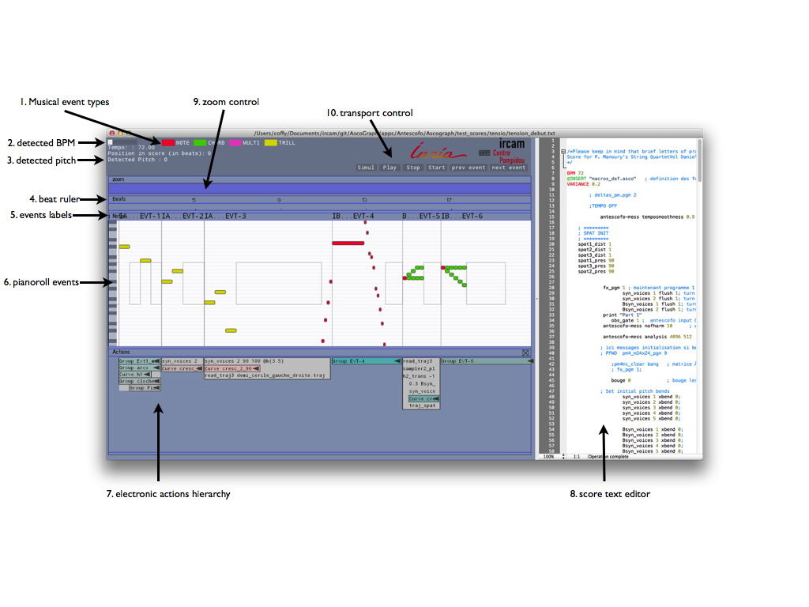
1 - Description of the user interface
User Interface content:
- Musical event types: shows the color of each possible Antescofo event type: NOTE, CHORD, MULTI, or TRILL.
- Detected BPM: shows the current tempo (in beats per minutes) detected by Antescofo.
- Detected pitch: shows the last pitch recognized by Antescofo.
- Beat ruler: provides an axis showing time measured in beats.
- Events labels: shows labels associated to the events parsed from the score.
- Pianoroll events: graphical display of the events of the score. As in classical MIDI pianorolls this view shows lower notes on the lower part, and high pitched notes on the upper parts. The size of the pianoroll is automaticly fitted to the note range of the score.
- Electronic actions hierarchy: actions associated to events such as groups, messages, curves, loops, etc are displayed on the separated Actions track. When nested groups are found in the textual score, they are displayed as a hierarchical ensemble of nested boxes. By clicking on the black arrow, one can open the box, and see the content of a group. Delays are displayed by decaying the beginning of a group to the right.
- Score text editor: shows the Antescofo score. Parsing is done on saving: when pressing cmd-s or hitting the “Save score” menu item.
- Zoom bar use to control the view range of the timeline,
- Transport buttons use to control antescofo~ directly while editing the score.

2 – Navigation

AscoGraph offers fast methods for zooming and scrolling in the graphical score display:

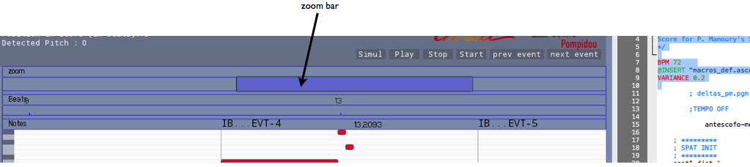

The zoom bar allows 2D zooming and scrolling in the score:
- click and drag vertically for zooming: up for zooming out, or down for zooming in.
- click and drag horizontally for scrolling.

As well, interaction between the text editor and the graphical pianoroll is easy in both ways:
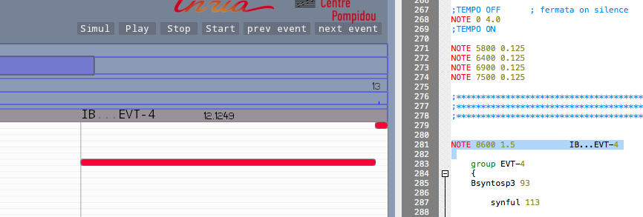

- selecting (double click) an event in the pianoroll view highlights the corresponding event in the text score,
- selecting (double click also) an event in the text score hightlights the corresponding event in the pianoroll.

3 – Importing MusicXML scores

Importing MusicXML score files is now made really easy using AscoGraph :

simply drag'n'drop (or open a score from the menu) a MusicXML file.

AscoGraph will automatically convert it to the Antescofo events notation.

4 - Connection with Max/MSP or Puredata

In order to visualize graphically the score following, a synchronisation is needed between AscoGraph and Antescofo~.
In order to enable to OSC synchronisation between antescofo~ external running in Max (or Pd) and AscoGraph, a message “ascograph on” shall be sent to antescofo~.

OSC synchronisation between AscoGraph and Antescofo provides :
- visual feedback for score following,
- automatic loading of score when saving,
- display of BPM, position in score and detected pitch.
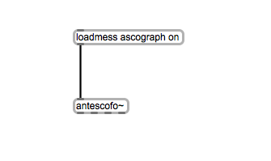

Default values are:
default host: localhost,
default AscoGraph port is 6789,
and default Antescofo~ port is 5678.

For changing OSC ports (for example for running Antescofo~ on a remote laptop and AscoGraph on a other machine), one can change ports and host by hitting the “OSC setup” in the AscoGraph menu.
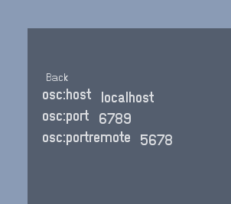

On the antescofo~ side, to change OSC host and ports, the “ascograph” command should be used:
for example to use AscoGraph on a remote host called “remotehost” with Ascograph listening on port 12121, with a receiving port on antescofo~ on port 23232, use the following Max (or Pd) message sent to antescofo~ :

ascograph remotehost 12121 23232

5 – Editing Curves

Antescofo~ curves are an easy way to handle continuous changes for values, with efficient and multiple interpolation types possibilies, and user defined interpolation grain.
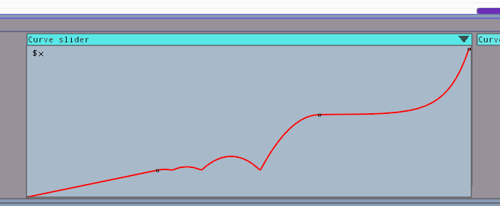

For easily creating curves object, the “Create” menu can be used:
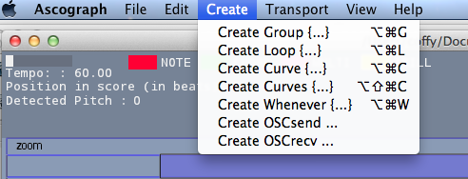

Multicurves splitting
Multicurves are curves object in Antescofo handling the continues changes of several values over time.
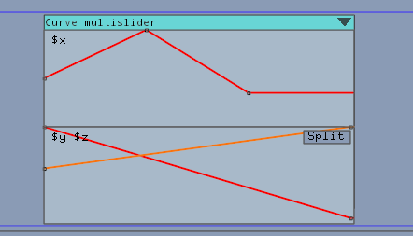

The only way to edit graphically a multicurve is to split it into single curves. This can be done automatically by pressing the Split button on a multicurve. So, after pressing Split the above multicurve becomes :

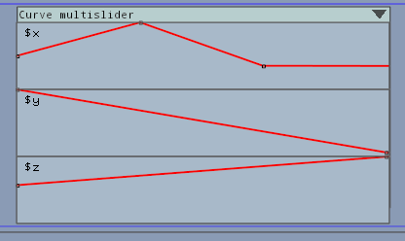

Changing the interpolation type:
To change the interpolation type, pressing CTRL while clicking on a keyframe will display a menu allowing to select interpolation type for the selected keyframe.

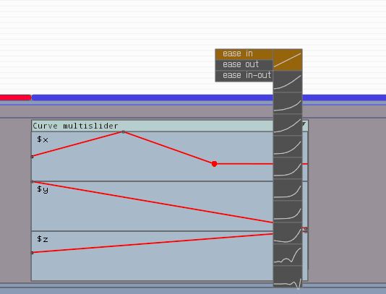

Applying changes to textual score
To apply graphical changes to the score, the button “Apply” must be pressed. This would regenerate the textual Antescofo score (in the editor), with the corresponding changes.

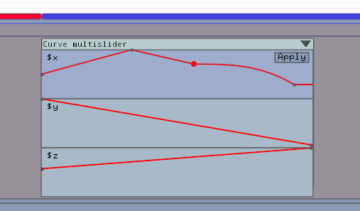

Important notice:

After pressing “Apply” or after every graphical curve editing, the score must be saved manually.

6 – View Options
Colors setup
To change the AscoGraph user-interface colors, the “Color setup” is available from the AscoGraph menu.
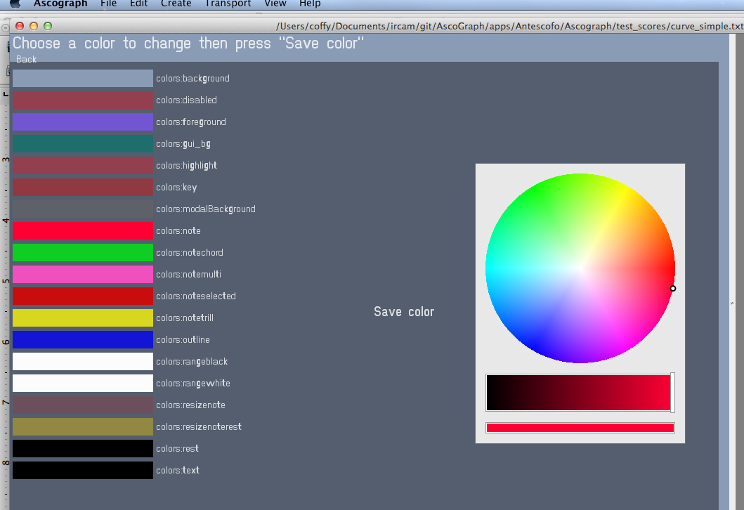

View menu explanations

The “View” menu is the location for changing the visual behaviour of AscoGraph, here is a description of every features:

Toggle View: changes the pianoroll view to a staff view,

Toggle Editor: makes the textual editor disappear (or appear),

Automatic Scroll: toggles the automatic scroll of the pianoroll and text editor while Antescofo~ is running and following the score.

Toggle Line Wrapping: toggles line wrapping in the text editor.

7 – Transport

Transport commands are available from the Transport menu, they are the same than the messages send in Max (or Pd) to control Antescofo transport:
- Play: runs a score without activating the listening machine module.
- Start: runs antescofo~ in full mode.
- Stop: stops antescofo~
- Play string (or cmd-P) is used to send a selection of text directly to be executed by antescofo~. This can be very helpful while testing a score, while composing.
- Previous and next event: go to the previous or next event in score.

