Campus Radio Portal

ER Model Diagram
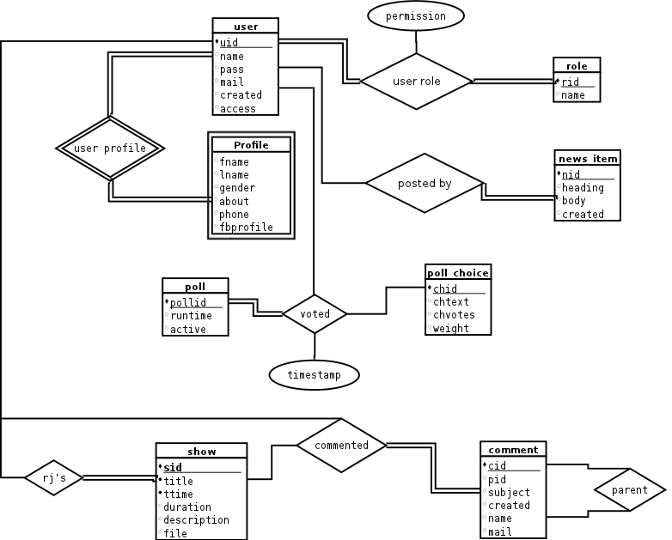
Kartik Singhal & Aviral Nigam

