**Assignment1: Write a Program to Detect Eyes, Nose and Mouth.**

**Program to Detect Eyes-**

EDetect = vision.CascadeObjectDetector('RightEye');

I = imread('HarryPotter1.jfif');

BB = step(EDetect,I);

imshow(I);

hold on

for i = 1:size(BB,1)

rectangle('Position',BB(i,:),'LineWidth',2,'LineStyle','-','EdgeColor','r');

end

title('Eyes Detection');

hold off;

**Output:**

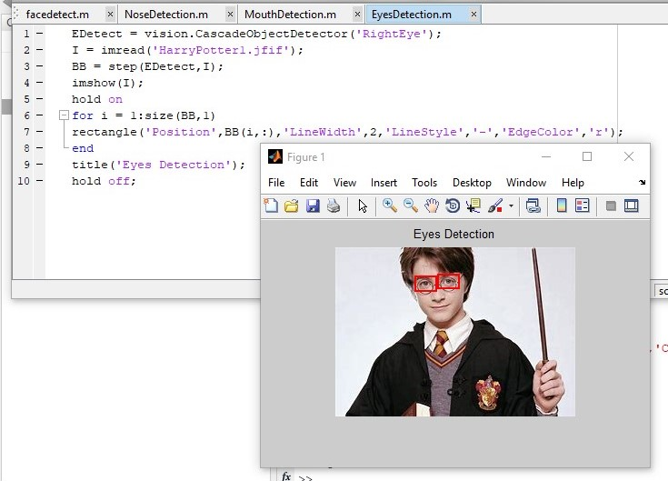

**Program to Detect Nose-**

NDetect = vision.CascadeObjectDetector('Nose');

I = imread('HarryPotter1.jfif');

BB = step(NDetect,I);

imshow(I);

hold on

for i = 1:size(BB,1)

rectangle('Position',BB(i,:),'LineWidth',2,'LineStyle','-','EdgeColor','r');

end

title('Nose Detection');

hold off;

**Output:**

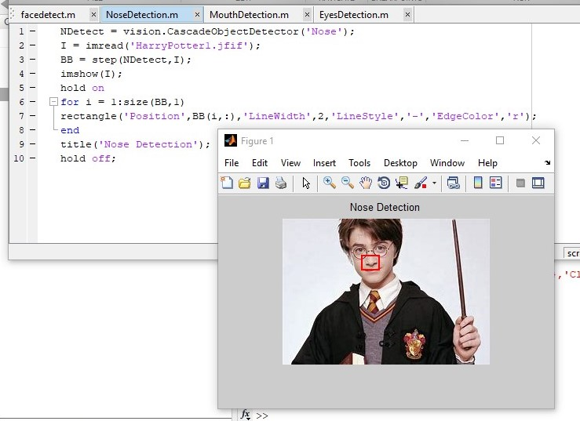

**Program to Detect Mouth-**

MDetect = vision.CascadeObjectDetector('Mouth');

I = imread('HarryPotter1.jfif');

BB = step(MDetect,I);

imshow(I);

hold on

for i = 1:size(BB,1)

rectangle('Position',BB(i,:),'LineWidth',2,'LineStyle','-','EdgeColor','r');

end

title('Mouth Detection');

hold off;

**Output:**

