SeedBall

1. HOME PAGE:

Slider

How It Works

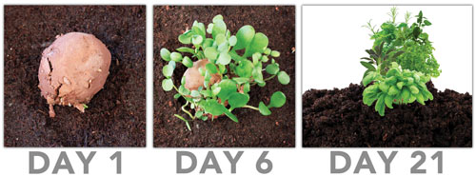

Why Seedball

Seed balls make gardening easy, fun, and accessible!

* Wildflower seed balls help pollinators and can help grow endangered wildflowers
* Garden with seed balls all year! Learn which plants to sow and when, and you'll be getting green in the dreary midwinter!
* Protects seeds from wind, birds, squirrels, and other critters.
* Easy dispersal means more uniform coverage.
* Little hands and old eyes struggle handling tiny seeds. Marble-sized seed balls eliminate this discouraging challenge.
* They're simply good, green, fun!

Categories Seed Ball

Listing Top Pick Seedball

Seedball Name Image

Delivery Date :

Time to grow : 6days

Custom Seedball ( Color, Shape )

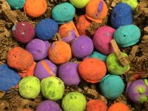

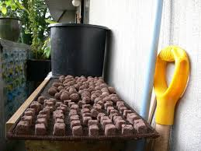

Custom Seedball Box

