Implementation Plan
RMC-Spark: Resilient Multi-Cluster Spark Analytics
for the paper “Resilient Data Science Programming for Fault-Tolerant Distributed Analytics in Multi-Cluster Spark Environments”
Team ID | 26FSPDSCPMID4098
Members | 26MML0054 · 26MML0006 · 26MML0047 · 26MML0015 (PoC)
Course | Programming for Data Science (MACSE502), SCOPE, VIT
Repository | rmc-spark/ (reference implementation already written; 56 automated tests passing)
Duration | 8 weeks (a 3-week compressed schedule is given in Section 8)
Version | October 2026

How to use this plan. The system is built in eight phases, P0 to P7. Each phase lists its goal, owner, tasks, the files that implement it, the commands to run and a 'done when' checklist. A reference implementation of every file already exists in rmc-spark/, so for each phase you can either study and run the existing module or rewrite it yourself following the specification in Section 5, then prove it with the same tests and checks. Do not move to the next phase until the 'done when' list of the current one is complete.
1. What We Are Building 3
2. Technology Stack 4
Hardware budget (16 GB laptop) 4
3. Environment Setup (Phase P0 details) 5
Repository layout and owners 5
4. Build Phases 6
P0 — Environment, repository and team setup 6
P1 — Testbed: two Spark clusters, storage and monitoring 6
P2 — Data and workloads 7
P3 — rds library: resilient, resumable stages 8
P4 — Resilience controller (C1–C5) 8
P5 — Fault injection (chaos harness) 9
P6 — Experiments 9
P7 — Analysis, figures, paper integration and deliverables 10
5. Module Specifications 11
Key configuration (configs/clusters.yaml) 11
6. Testing Strategy 13
7. Experiment Protocol 14
Expected results to check (hypotheses) 14
8. Timeline and Responsibilities (8 weeks) 15
Compressed 3-week schedule (if the deadline is near) 15
9. Risks and Troubleshooting 16
10. Definition of Done and Deliverables 17
Command cheat sheet 17

1. What We Are Building
RMC-Spark is a resilience layer above two (or more) unmodified Apache Spark clusters. A controller watches every cluster, scores its health, and when a cluster fails it moves stalled jobs to a healthy cluster. A small PySpark library, rds, makes every pipeline stage idempotent and commits it to shared object storage, so the moved job restores finished stages instead of recomputing them. Every decision is logged with its cause.
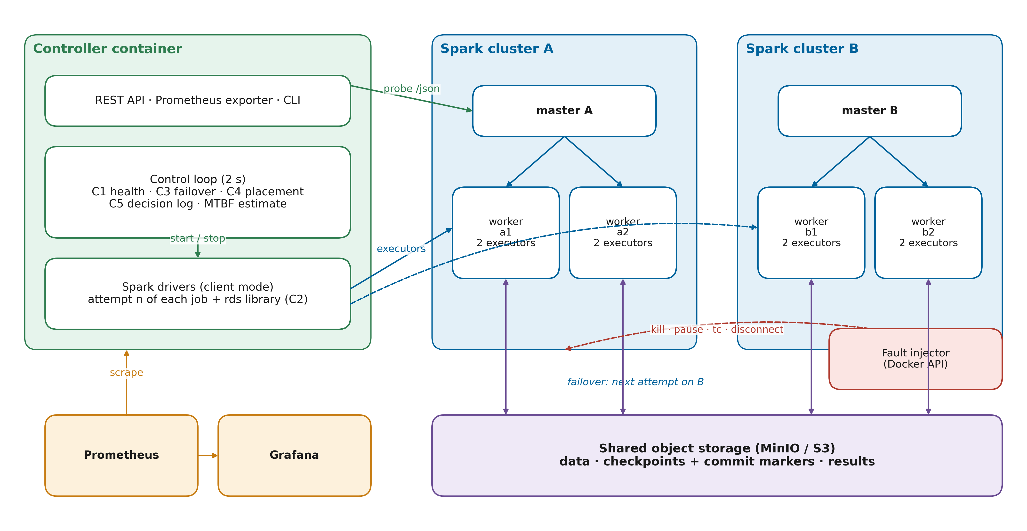
Figure 1. Target architecture (Fig. 6 of the paper).
Component | Purpose | Implemented in
Testbed | 2 Spark clusters (1 master + 2 workers each), MinIO, Prometheus, Grafana, controller | docker-compose.yml, docker/
rds library (C2) | Resumable stages, commit markers, adaptive (Young/Daly) checkpointing, event log | rds/
Controller C1 | Probes, EWMA anomaly detection, health score, HEALTHY/SUSPECT/FAILED state machine | controller/monitor.py, anomaly.py, health.py, statemachine.py
Controller C3 | spark-submit drivers in client mode; retry, migrate or keep decisions | controller/jobs.py, core.py
Controller C4 | Placement cost J = αL + β(1−H) + γT | controller/orchestrator.py
Controller C5 | Decision log, reliability score R, REST API, Prometheus metrics | controller/decisions.py, reliability.py, api.py, cli.py
Workloads | ETL, ML (GBT), iterative PageRank, streaming, 2 case studies | jobs/
Fault injection | 9 faults via Docker API (kill, partition, tc delay, CPU throttle, disk fill, driver crash) | chaos/inject.py
Experiments & analysis | Matrix runner, metrics, statistics, 600-DPI figures and tables | experiments/, analysis/

2. Technology Stack
Layer | Technology (version) | Why
Containers | Docker Desktop 28 + Compose v2 (WSL2, 12 GB) | Several real clusters on one laptop; faults are real container operations
Compute | Apache Spark 3.5.3 standalone, official apache/spark image, Java 17 | Stable; PySpark included; Prometheus metrics servlet
Language | Python 3.10 in containers (3.10+ on host for tests) | Course focus: data science programming in PySpark
Storage | MinIO (S3-compatible) via Hadoop S3A 3.3.4 + AWS SDK 1.12.262 | Shared checkpoints readable by every cluster
Monitoring | Prometheus + Grafana (provisioned dashboard) | Operator view and screenshots/videos
Controller | FastAPI, uvicorn, requests, prometheus-client, PyYAML, docker SDK | API, probes, metrics, fault injection
Analysis | pandas, numpy, scipy (Mann-Whitney U), matplotlib (600 DPI) | Tables 11–15, Figures 21–24
Testing | pytest (56 tests: unit + controller simulation) | Logic verified without Docker
Paper tooling | Anaconda Python (lxml, matplotlib), Node docx | Figure generation and manuscript build

Hardware budget (16 GB laptop)
Container | Memory limit | Count | Total
Spark master | 768 MB | 2 | 1.5 GB
Spark worker (2 cores, 1280 MB to executors) | 1.75 GB | 4 | 7.0 GB
Controller (hosts the drivers) | 2.5 GB | 1 | 2.5 GB
MinIO / Prometheus / Grafana | 512 / 384 / 256 MB | 3 | 1.15 GB
Total |  |  | ≈ 12.2 GB → WSL2 memory = 12 GB

3. Environment Setup (Phase P0 details)
- Install Docker Desktop, Git, VS Code (Python + Docker extensions), Anaconda (or Python 3.10+).
- Create C:\Users\<you>\.wslconfig:
[wsl2]
memory=12GB
processors=10
- Run wsl --shutdown, restart Docker Desktop, check docker info (Total Memory ≈ 12 GiB).
- Clone the repository and run the unit tests (no Docker needed): python -m pytest → 56 passed.
- First build downloads ≈ 1.5 GB (base image, Maven jars, Python packages); do it on a good connection.
- Open http://localhost:8080, :8090, :8000/docs, :9001 (MinIO, rmcadmin/rmcadmin123), :9090, :3000 after docker compose up -d.

Repository layout and owners
Path | Content | Owner
docker-compose.yml, docker/ | Testbed definition, Spark config, Prometheus, Grafana | 26MML0006
configs/clusters.yaml | Cluster registry + every controller threshold | 26MML0015
rds/ | Resilient stage library | 26MML0006
controller/monitor, anomaly, health, statemachine, reliability, decisions | C1, C5 | 26MML0054
controller/jobs, core, orchestrator, api, cli, workloads | C3, C4, integration | 26MML0015
jobs/, scripts/, datasets/ | Workloads, data generation, case studies | 26MML0006 / 26MML0047
chaos/ | Fault injection | 26MML0006
experiments/, analysis/ | Matrix runner, metrics, statistics, figures | 26MML0006 / 26MML0054
tests/ | Unit and simulation tests | module owner
paper/ | Manuscript sources, figures, build scripts, guides | 26MML0047 + all

4. Build Phases
Phases are sequential; within a phase, tasks of different owners can run in parallel. Each phase ends with a short demo to the team and a merged pull request.
Phase | Title | When | Owner
P0 | Environment, repository and team setup | Week 1 (days 1–2) | 26MML0015 (PoC) + all
P1 | Testbed: two Spark clusters, storage and monitoring | Week 1 (days 3–5) | 26MML0006
P2 | Data and workloads | Week 2 | 26MML0006 (W1, W3, W4), 26MML0047 (case studies)
P3 | rds library: resilient, resumable stages | Week 2–3 | 26MML0006
P4 | Resilience controller (C1–C5) | Week 3–4 | 26MML0054 (C1, C5), 26MML0015 (C3, C4, core)
P5 | Fault injection (chaos harness) | Week 4 | 26MML0006
P6 | Experiments | Week 5–6 | 26MML0006 (run), 26MML0054 (monitor data quality)
P7 | Analysis, figures, paper integration and deliverables | Week 7–8 | 26MML0054 (analysis), 26MML0047 (paper), 26MML0015 (integration, videos)

P0 — Environment, repository and team setup
When | Week 1 (days 1–2)
Owner | 26MML0015 (PoC) + all
Goal | Every member can run the tests and has the repository; GitHub is the single source of truth.
Files | README.md, pytest.ini, .gitignore, tests/

Tasks
- Install Docker Desktop (WSL2 back-end), Git, VS Code, Python 3.10+ (Anaconda is fine).
- Create C:\Users\<you>\.wslconfig with memory=12GB and processors=10, then wsl --shutdown and restart Docker Desktop.
- PoC creates a private GitHub repository rmc-spark, pushes the rmc-spark/ folder, adds the three members as collaborators.
- Everyone clones, creates a branch per task (feat/<area>-<short-name>), and runs python -m pytest (56 tests must pass).
- Agree on conventions: Black-compatible formatting, one PR per task, PoC reviews and merges, no direct pushes to main.

Commands
git clone <repo-url>
cd rmc-spark
python -m pip install pytest requests
python -m pytest

Done when
- ☐ All four members see 56 passed.
- ☐ docker info shows ≥ 12 GB memory.
- ☐ Branch protection on main enabled.

P1 — Testbed: two Spark clusters, storage and monitoring
When | Week 1 (days 3–5)
Owner | 26MML0006
Goal | Two independent Spark 3.5.3 standalone clusters (A, B), MinIO, Prometheus, Grafana and the controller container start with one command.
Files | docker/Dockerfile, docker/spark-defaults.conf, docker/metrics.properties, docker/prometheus.yml, docker/grafana/*, docker-compose.yml

Tasks
- Build the image from docker/Dockerfile (Spark 3.5.3 + hadoop-aws 3.3.4 + AWS SDK 1.12.262 + iproute2/procps + Python libs).
- Start the stack with docker-compose.yml; check that rmc-minio-init creates the buckets data, checkpoints, results and exits 0.
- Verify both Spark UIs show 2 ALIVE workers / 4 cores; verify Prometheus targets are UP and the Grafana dashboard loads.
- Run a smoke Spark job from the controller against each master (SparkPi or jobs/datagen.py with small sizes) to prove driver↔executor connectivity in client mode.
- Record the resource usage (docker stats) and adjust mem_limit / worker --memory if containers are OOM-killed (exit 137).

Commands
docker compose build
docker compose up -d
docker compose ps
docker compose exec controller python -m controller.cli status

Done when
- ☐ http://localhost:8080 and :8090 show 2 workers each.
- ☐ http://localhost:8000/metrics shows rmc_cluster_health{cluster="A"} 1.0.
- ☐ A Spark job submitted from the controller to master A and to master B finishes.
- ☐ Screenshots saved for Section XIII (Fig. 19).

P2 — Data and workloads
When | Week 2
Owner | 26MML0006 (W1, W3, W4), 26MML0047 (case studies)
Goal | All workloads run cleanly on one cluster and their clean runtimes are known.
Files | jobs/datagen.py, jobs/common.py, jobs/etl_taxi.py, jobs/ml_pipeline.py, jobs/iterative_rank.py, jobs/streaming_rate.py, jobs/ingest_local.py, scripts/download_data.py, controller/workloads.py

Tasks
- Generate the synthetic data with jobs/datagen.py (4 M taxi trips, 2 M-edge skewed graph) into s3a://data/.
- Run each workload once without faults: etl_taxi, ml_taxi, iterative_rank, streaming (submit through the controller CLI with --mode none --policy never).
- Measure clean runtimes (3 runs each); if a workload takes < 60 s or > 6 min, adjust its size (--taxi-rows, --iterations, --sample, --target-batches).
- Case studies: python scripts/download_data.py --case-studies, ingest with jobs/ingest_local.py, run case_fraud and case_maintenance, record AUC.
- Optional: download one NYC TLC month and run etl_taxi --source tlc to show the pipeline works on real data.

Commands
docker compose exec controller spark-submit --master spark://spark-master-a:7077 --conf spark.driver.host=controller --total-executor-cores 4 --executor-memory 576m jobs/datagen.py
docker compose exec controller python -m controller.cli submit etl_taxi --mode none --policy never

Done when
- ☐ Each workload SUCCEEDED 3× with stable runtimes (spread < 15 %).
- ☐ A table of clean runtimes exists (needed for fault_at_s in P6).
- ☐ Case-study AUC values recorded.

P3 — rds library: resilient, resumable stages
When | Week 2–3
Owner | 26MML0006
Goal | Stages are idempotent, commit atomically to MinIO, checkpoint according to the policy, and a re-run with the same job id resumes.
Files | rds/policy.py, rds/stage.py, rds/events.py, rds/cli.py, tests/test_policy.py

Tasks
- Read and understand rds/policy.py (never / always / adaptive Young-Daly) and run tests/test_policy.py.
- Understand rds/stage.py: restore-if-committed → compute → persist+count → policy → write data → write _RDS_COMMIT marker.
- Manual resume test: start etl_taxi with --policy always, kill the driver after the second stage (python -m chaos.inject driver_crash via API or docker compose restart controller), resubmit with the same --job-id → events must show stage_restored.
- Check the event log results/events/<job_id>.jsonl contains stage_completed with compute_s, write_s, reason, tau_s.
- Verify linear-chain skipping on iterative_rank (later iteration committed → earlier ones stage_skipped).

Commands
python -m pytest tests/test_policy.py -q
docker compose exec controller python -m controller.cli submit iterative_rank --mode smart --policy adaptive

Done when
- ☐ Resumed run shows restored stages and produces the same output as an uninterrupted run.
- ☐ Checkpoint decisions in the event log match τ* from the formula.

P4 — Resilience controller (C1–C5)
When | Week 3–4
Owner | 26MML0054 (C1, C5), 26MML0015 (C3, C4, core)
Goal | The controller detects a failed cluster, explains why, and moves stalled jobs to a healthy cluster where they resume.
Files | controller/*.py, configs/clusters.yaml, tests/test_detection.py, tests/test_reliability_and_jobs.py, tests/test_controller_sim.py

Tasks
- C1 – monitor.py, anomaly.py, health.py, statemachine.py: confirm health 1.0 when idle; stop master A and watch H drop to 0.30 and state go SUSPECT → FAILED (3 polls).
- C3 – jobs.py: spark-submit in client mode, process-group kill, retry vs failover rules (on_attempt_exit, while_running).
- C4 – orchestrator.py: placement cost J; test with one cluster busy and one idle.
- C5 – decisions.py, reliability.py: decision log entries and reliability score in GET /clusters.
- core.py + api.py + cli.py: control loop every 2 s, REST API, Prometheus metrics; Grafana panels move during a fault.
- Live failover demo: submit etl_taxi --mode smart, inject cluster_outage on A after ~40 s, verify job ends SUCCEEDED on A>B with restored stages.

Commands
docker compose exec controller python -m controller.cli submit etl_taxi --mode smart --policy adaptive
docker compose exec controller python -m controller.cli chaos cluster_outage --cluster A
docker compose exec controller python -m controller.cli decisions --limit 20
docker compose exec controller python -m controller.cli restore

Done when
- ☐ Decision log shows transition A→FAILED with causes, a failover A→B with all J_k, and job_end SUCCEEDED.
- ☐ Master-only kill produces a keep decision (job not migrated).
- ☐ Recorded as execution video #3.

P5 — Fault injection (chaos harness)
When | Week 4
Owner | 26MML0006
Goal | All nine faults can be injected and fully restored, repeatably.
Files | chaos/inject.py, controller/api.py (/chaos endpoints)

Tasks
- Test each fault manually on an idle cluster and observe the effect: executor_kill, worker_kill, master_kill, cluster_outage, network_partition, network_delay, straggler, disk_full, driver_crash.
- Check transient faults auto-restore after --duration (60 s) and that restore brings both clusters back to 2 ALIVE workers.
- Check tc works (needs cap_add: NET_ADMIN) and that network reconnect restores the hostname alias.
- Note the observed controller reaction per fault (state reached, time) — this becomes text for Section XV.

Commands
docker compose exec controller python -m chaos.inject network_delay --cluster A --duration 60
docker compose exec controller python -m chaos.inject restore

Done when
- ☐ A fault/observation table for all 9 faults.
- ☐ After every restore, controller.cli status shows both clusters HEALTHY within 30 s.

P6 — Experiments
When | Week 5–6
Owner | 26MML0006 (run), 26MML0054 (monitor data quality)
Goal | Raw, reproducible measurements for all configurations, workloads and faults.
Files | experiments/run_matrix.py, experiments/configs/smoke.yaml, experiments/configs/full.yaml, results/raw/

Tasks
- Smoke test: experiments/configs/smoke.yaml (B1 vs P, etl_taxi, none + cluster_outage). Expected: B1 FAILED at deadline, P SUCCEEDED on A>B.
- Calibrate full.yaml: fault_at_s ≈ 40 % of each clean runtime, expected_runtime_s = measured clean runtime, deadlines ≈ 4× clean runtime.
- Dry run to see the size and time estimate; reduce repetitions or faults if time is short (minimum: 3 reps of none, cluster_outage, master_kill, executor_kill, network_delay).
- Run the full matrix in the background; check runs.csv every few hours for RUNNER_ERROR rows and fix causes.
- Run the two case studies with a cluster outage (manual or a small yaml).
- Freeze the results: copy results/raw/full/ (without logs) to the repository.

Commands
docker compose exec controller python -m experiments.run_matrix experiments/configs/smoke.yaml
docker compose exec controller python -m experiments.run_matrix experiments/configs/full.yaml --dry-run
docker compose exec -d controller python -m experiments.run_matrix experiments/configs/full.yaml

Done when
- ☐ Smoke result as expected.
- ☐ runs.csv contains all planned runs with no RUNNER_ERROR (or documented re-runs).
- ☐ experiment.json saved with exact configuration.

P7 — Analysis, figures, paper integration and deliverables
When | Week 7–8
Owner | 26MML0054 (analysis), 26MML0047 (paper), 26MML0015 (integration, videos)
Goal | Results turned into Tables 11–15 and Figures 21–24/28; manuscript completed; deliverables submitted.
Files | analysis/*.py, paper/content/*.txt, paper/build_paper.py, paper/make_figures.py

Tasks
- Run analysis.report → Table 11/12 CSV+MD, Fig 21–24 (600 DPI), runs_enriched.csv.
- Decide each hypothesis H1–H5 (p-value, Cliff's δ); write Section XV–XVII, XIX text; fill all yellow [[...]] in paper/content/*.txt.
- Copy Fig 21–24 into paper/Diagrams/ with the same names; draw Fig 28 (benefit sensitivity); rebuild the manuscript.
- Record the five execution videos (README §11); push code, configs, dataset scripts and raw results to GitHub; add the link to Data Availability.
- Similarity check (≤ 10 %), final proof-read, Word Ctrl+A, F9 to refresh page numbers, submit.

Commands
docker compose exec controller python -m analysis.report results/raw/full --out results/report
python paper/make_figures.py
python paper/build_paper.py

Done when
- ☐ No [[ left in the manuscript.
- ☐ All deliverables of the guidelines uploaded (manuscript, diagrams, code link, datasets, videos).
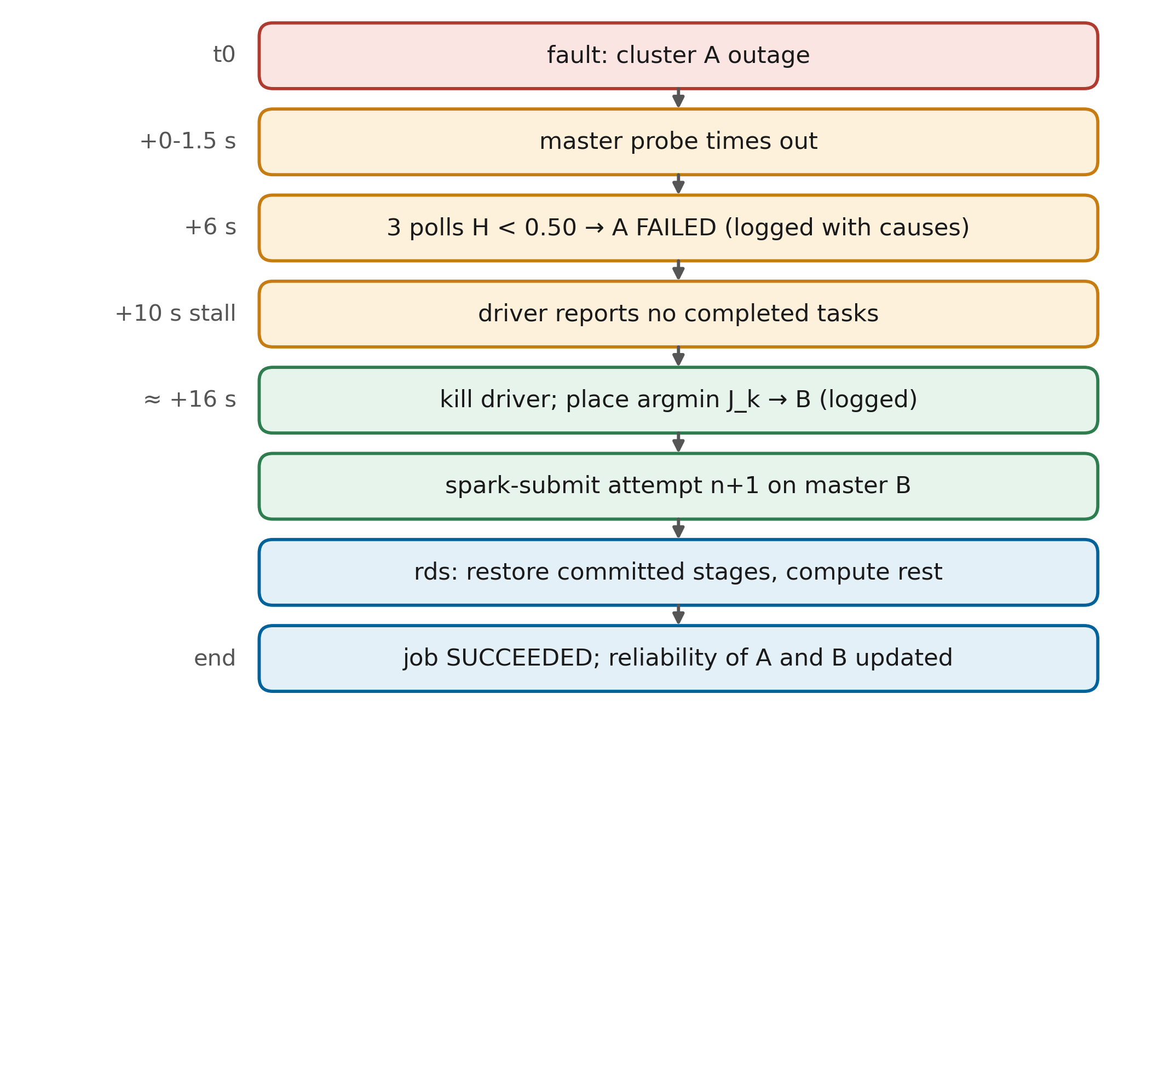
Figure 2. Behaviour to demonstrate at the end of P4 (failover workflow).

5. Module Specifications
Use this section if you rebuild a module yourself. Keep the public interface identical so the tests and the other modules keep working.
Module | Responsibility | Key interface | Tests
rds/policy.py | Checkpoint decision | young_interval(C,M), daly_interval(C,M), AdaptivePolicy(mtbf).decide(work, cost) -> Decision(checkpoint, reason, interval_s), make_policy(name, mtbf) | test_policy.py
rds/stage.py | Resumable stages | ResilientPipeline(spark, ctx, linear=False); decorator @pipe.stage(name, kind='dataframe'|'model', loader=None); pipe.finish(); marker <root>/<job>/<stage>/_RDS_COMMIT | manual resume test (P3)
rds/cli.py | Job arguments | base_parser() adds --job-id --attempt --cluster --policy --mtbf --checkpoint-root --data-root --results-root --events-dir | —
controller/anomaly.py | EWMA z-score | EwmaZScore(alpha, warmup).update(x, z_gate) -> z; ramp(x, low, high) | test_detection.py
controller/health.py | Health score | HealthModel(weights, expected_workers, ...).assess(Observation) -> HealthReport(health, anomalies, contributions, critical) | test_detection.py
controller/statemachine.py | Failure detectors | HealthStateMachine(cluster, suspect, failed, n_fail, n_rec).update(ts, H, causes); TimeoutDetector(cluster, timeout).update(ts, reachable) → Transition | test_detection.py
controller/orchestrator.py | Placement | place(views, alpha, beta, gamma, exclude) -> Placement(cluster, scores, reason) | test_detection.py
controller/reliability.py | Reliability | ClusterReliability.observe(ts, failed, health), .record_job(ok), .score(weights, mttr_ref); system_mtbf(trackers) | test_reliability_and_jobs.py
controller/jobs.py | Driver processes | JobSpec, JobManager.start_attempt / kill_attempt / crash_driver / refresh_progress; pure rules on_attempt_exit(...), while_running(...) | test_reliability_and_jobs.py, test_controller_sim.py
controller/core.py | Control loop | Controller(cfg).submit(JobSpec), .tick(now), .run_forever(stop), .snapshot() | test_controller_sim.py
controller/api.py | REST + metrics | GET /clusters /jobs /decisions /metrics; POST /jobs /chaos /chaos/restore | manual (P4)
chaos/inject.py | Faults | FaultInjector(cfg).inject(fault, cluster, duration_s, controller, job_id), .restore_all() | manual (P5)
experiments/run_matrix.py | Matrix runner | reads YAML → writes runs.csv, decisions.jsonl, cluster_timeseries.csv, events/, logs/ | smoke run (P6)
analysis/report.py | Results | python -m analysis.report <raw_dir> --out <dir> → Tables 11/12, Figs 21–24 | test_analysis.py + real data

Key configuration (configs/clusters.yaml)
Key | Value | Meaning
poll_interval_s / probe_timeout_s | 2.0 / 1.5 | Control-loop period; master probe timeout
health_weights | unreachable 0.45, workers_lost 0.25, latency 0.10, stall 0.15, executor_loss 0.05 | Weights of H (sum normalised to 1)
latency_ewma_alpha, z_low, z_high | 0.2, 3, 8 | Latency anomaly ramp
stall_limit_s | 120 | No completed task for 120 s → stall anomaly 1
suspect / failed threshold | 0.95 / 0.50 | SUSPECT below 0.95; FAILED after 3 polls below 0.50
recovered_consecutive | 5 | Polls ≥ 0.95 before HEALTHY again
migrate_stall_s | 10 | Stall needed before a job leaves a FAILED cluster
naive_timeout_s | 30 | Baseline B3 timeout
placement α, β, γ | 0.4, 0.5, 0.1 | Load, health, transfer weights
mtbf_prior_s / weight | 900 / 1 | Prior of the online MTBF estimate
spark_submit | driver 512m; executor 576m, 1 core; 4 cores/job | Per-job resources

6. Testing Strategy
Level | What | How | When
Unit | Formulas, health model, state machine, placement, reliability, recovery rules, metrics, statistics | python -m pytest (56 tests, < 5 s, no Docker) | Every commit / PR
Simulation | Whole controller with fake clock, probes and drivers: outage, timeout baseline, keep decision, explanations | tests/test_controller_sim.py | Every PR touching controller/
Integration | Real Spark + MinIO: job runs, resumes, fails over | P3 resume test, P4 live demo, smoke.yaml | End of P3, P4, start of P6
Fault validation | Each of 9 faults has the expected effect and is restored | P5 checklist | End of P5
Experiment sanity | No RUNNER_ERROR, clean runs stable, deadlines not hit by healthy runs | Inspect runs.csv, decisions.jsonl | Daily during P6
Rule: a pull request is merged only if python -m pytest passes and, for changes in controller/ or rds/, the smoke experiment still gives B1 FAILED / P SUCCEEDED.

7. Experiment Protocol
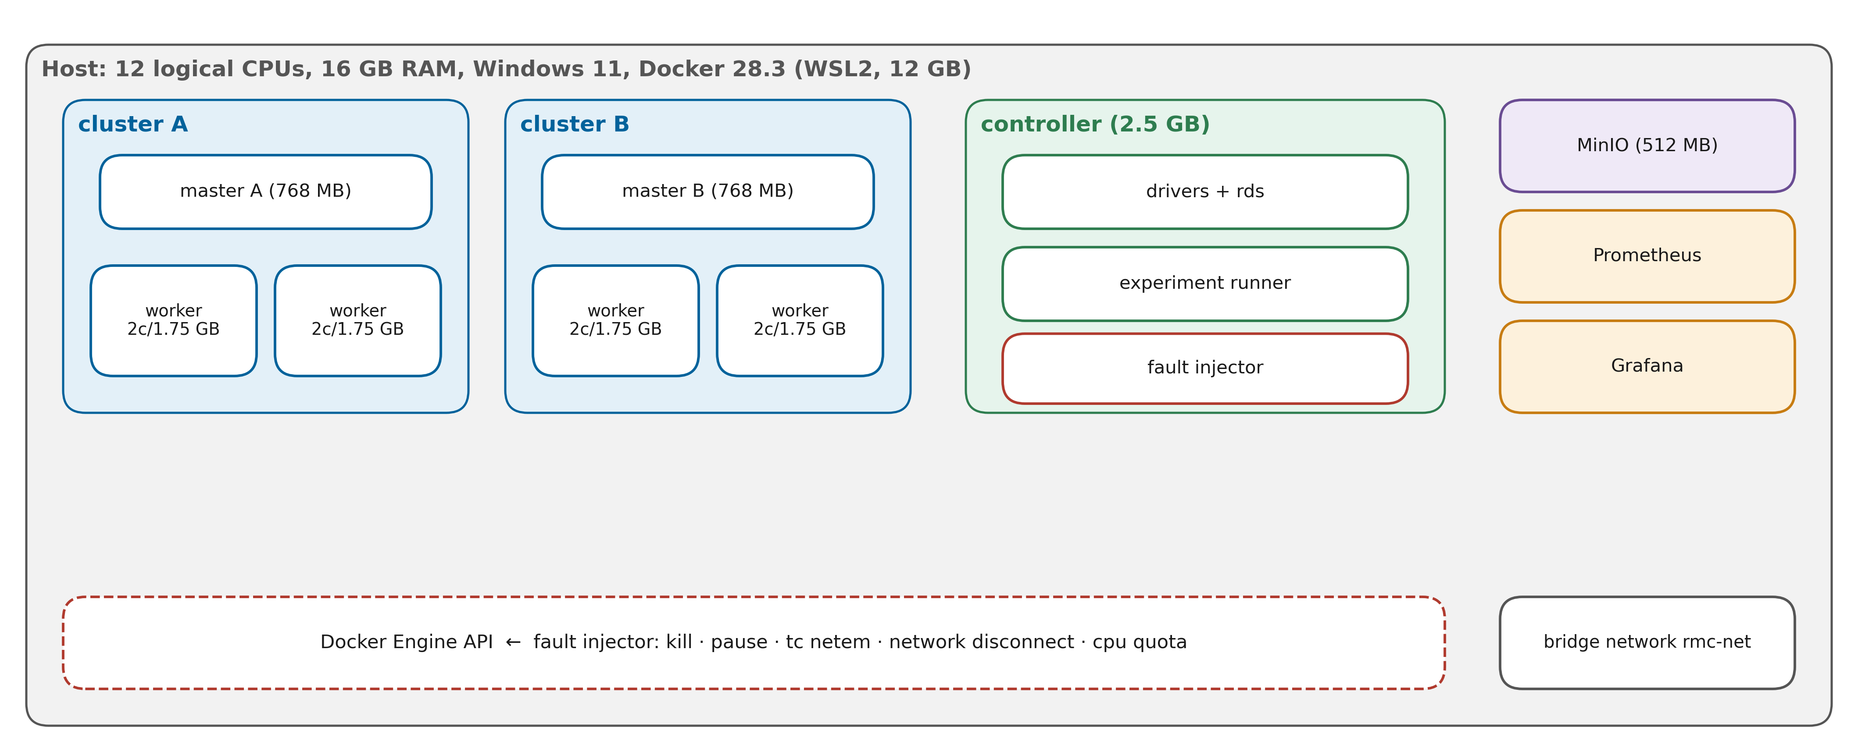
Figure 3. Experimental testbed (Fig. 19 of the paper).
Item | Setting
Systems | B1 vanilla (none/never) · B2 fixed checkpoint (none/always) · B3 naive HA (naive/never) · A1 ablation (smart/always + speculation) · P RMC-Spark (smart/adaptive + speculation)
Workloads | etl_taxi · ml_taxi · iterative_rank · streaming (+ case_fraud, case_maintenance)
Faults | none · executor_kill · worker_kill · master_kill · cluster_outage · network_partition · network_delay · straggler (transient faults reverted after 60 s)
Repetitions | 3 per cell, shuffled within each repetition (seed 2026) → 480 runs
Fault time | ≈ 40 % of the clean runtime of the workload, on the job's current cluster; every run starts on cluster A
Between runs | restore_all → wait until both clusters HEALTHY → 10 s cool-down
Outputs | results/raw/full/: runs.csv, decisions.jsonl, cluster_timeseries.csv, events/*.jsonl, logs/, experiment.json
Metrics | success rate, duration, delay, downtime, availability, detection & failover latency, recomputed work, checkpoint cost, overhead, utilisation, streaming recovery
Statistics | Mann-Whitney U (two-sided), Cliff's δ, 95 % bootstrap CI (5000 resamples)

Expected results to check (hypotheses)
# | Expectation | If not observed
H1 | P completes more jobs than B1/B2 under cluster outage and partition | Check failover in decisions.jsonl; check deadline long enough
H2 | P recovers faster than B3 | Check stall rule (10 s) and detection (3 polls) timings
H3 | Master-only kill: P keeps the job, B3 restarts it | Check driver progress probing (ui port, REST)
H4 | Less recomputed work for P/A1 on iterative_rank | Check committed stages and linear skipping
H5 | P overhead < A1 and B2 in clean runs | Report honestly; discuss checkpoint cost vs τ*

8. Timeline and Responsibilities (8 weeks)
Week | 26MML0015 (PoC) | 26MML0054 | 26MML0006 | 26MML0047
1 | P0 repo, conventions, review | P0 setup; study C1 code | P0 + P1 testbed | P0; literature check, datasets README
2 | Study core/jobs; API demo | C1 tests + Grafana panels | P2 workloads, clean runtimes | P2 case-study downloads + runs
3 | P4 C3/C4 live failover | P4 C1/C5 validation | P3 rds resume tests | Security controls (optional spark.authenticate)
4 | P4 integration, video #3 | Reliability score check | P5 fault validation | Section XII/XVIII drafting
5 | Monitor matrix | Data-quality checks on runs.csv | P6 smoke + calibrate + start full | Case studies with outage
6 | Fix runner issues, re-runs | Start analysis on partial data | P6 full matrix completion | Section XVII drafting
7 | Videos, GitHub release | P7 analysis, Tables 11–12, Figs 21–24 | Appendix configs | Fill results text, Fig 28
8 | Final integration, submission | Results text Sections XV, XIX | Section XIII/XVI final | Similarity check, references, proof-read

Compressed 3-week schedule (if the deadline is near)
Week | Must finish
1 | P0 + P1 + P2 (all workloads clean) + P3 resume test
2 | P4 live failover + P5 quick fault check + P6 reduced matrix: 5 systems × 2 workloads (etl_taxi, iterative_rank) × 4 faults (none, cluster_outage, master_kill, network_delay) × 3 reps = 120 runs (≈ 10–12 h)
3 | P7: analysis, fill manuscript, videos, GitHub, submission

9. Risks and Troubleshooting
Risk / symptom | Impact | Mitigation
Containers exit 137 (out of memory) | Runs fail | 12 GB WSL; lower worker --memory/mem_limit; close other apps
dockerDesktopLinuxEngine connect error | Nothing runs | Start Docker Desktop; wait for 'Engine running'
ClassNotFoundException S3AFileSystem | No storage | docker compose build --no-cache (jars missing)
Driver UI port in use (4040–4049) | Submit fails | Do not use the API while the matrix runs; docker compose restart controller
Workers not re-registering after restore | Next run unhealthy | Runner waits for HEALTHY; else restart worker containers
Streaming job ends immediately | Wrong result | Use a new job id or delete its checkpoint in MinIO
Matrix takes too long | Late results | Use the compressed matrix (Section 8); run overnight with -d
Laptop sleeps during runs | Broken runs | Disable sleep; keep charger connected
Noisy timings on shared host | Weak statistics | Close other apps; shuffle order (already); report medians
Results do not support a hypothesis | Weaker paper | Report honestly and explain — negative results are acceptable

10. Definition of Done and Deliverables
- ☐ All 56 unit/simulation tests pass on main.
- ☐ Live failover demo works and is recorded.
- ☐ All nine faults validated and restorable.
- ☐ Full (or compressed) matrix completed; raw data committed to GitHub.
- ☐ Tables 11–15 and Figures 21–24, 28 generated from data; manuscript has no [[ placeholders.
- ☐ Deliverables (guidelines): manuscript .docx, Diagrams folder, GitHub link, datasets folder/scripts, execution videos, data availability statement.
- ☐ Similarity ≤ 10 %; references unchanged or re-verified.

Command cheat sheet
# unit tests (host)
python -m pytest
# testbed
docker compose build
docker compose up -d
docker compose ps
docker compose down # add -v to wipe MinIO data
# data
docker compose exec controller spark-submit --master spark://spark-master-a:7077 --conf spark.driver.host=controller --total-executor-cores 4 --executor-memory 576m jobs/datagen.py
# controller
docker compose exec controller python -m controller.cli status
docker compose exec controller python -m controller.cli submit etl_taxi --mode smart --policy adaptive
docker compose exec controller python -m controller.cli chaos cluster_outage --cluster A
docker compose exec controller python -m controller.cli decisions --limit 20
docker compose exec controller python -m controller.cli restore
# experiments
docker compose exec controller python -m experiments.run_matrix experiments/configs/smoke.yaml
docker compose exec -d controller python -m experiments.run_matrix experiments/configs/full.yaml
# analysis + paper
docker compose exec controller python -m analysis.report results/raw/full --out results/report
python paper/make_figures.py
python paper/build_paper.py

