**Page:** WL_TEMPLATE_UOA

**Type:** Standard Page

**In Component:** WL_TEMPLATE_GEN

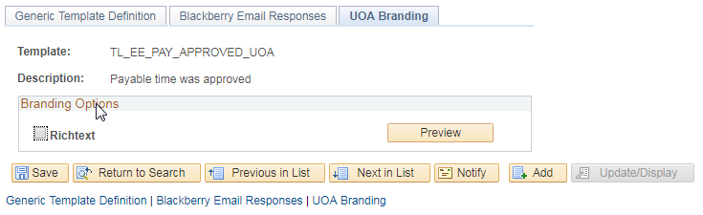

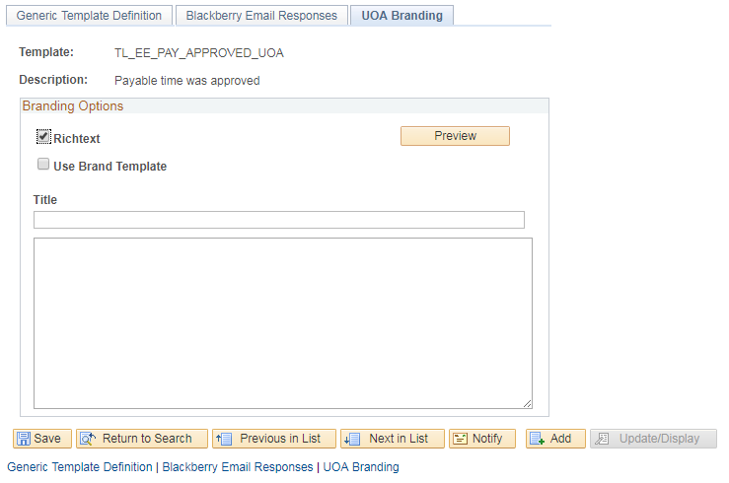

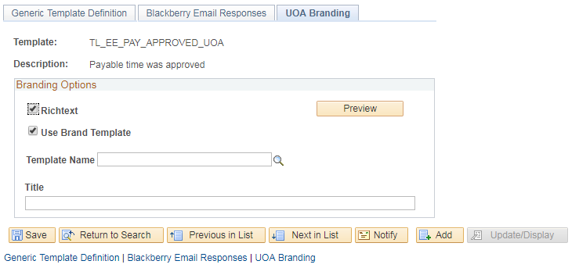

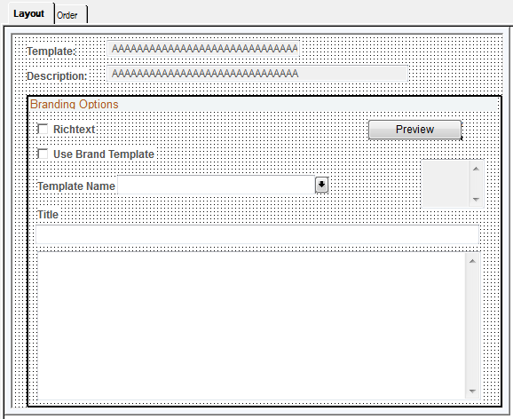

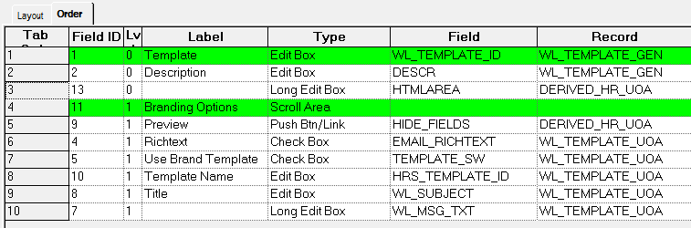

**Page:** WL_TEMPLATE_UOA_SP

**Type:** Secondary Page

**Used in Standard Page:** WL_TEMPLATE_UOA

Comments: Contains a HTMLAREA mapped against DERIVED_HR_UOA.HTMLAREA

